Authentication Use Case and Screen Specifications
This document covers four authentication use cases and six supplied screen mockups. Differences between the mockups and current code are stated in each screen section.

UC-01 Login
Primary Actors | Registered User, External Partner, Employee, Administrative Staff, Accountant Staff, HOD, CEO | Secondary Actors | None
Description | As a user, I want to sign in so that I can access functions allowed by my role.
Preconditions | • The user has an account.  • The sign-in screen is available.
Postconditions | • A JWT is returned and stored in the browser.  • The user is routed to the home page or to signature-key creation.
Normal Sequence/Flow | 1. The user opens the Sign In screen.  2. The user enters an email address and password.  3. The user selects Sign In.  4. The system authenticates the credentials and returns a JWT, role, name, department, and signature-key status.  5. The browser stores the returned values.  6. The browser navigates to signature-key creation if no active key exists; otherwise it navigates to the home page.
Alternative Sequences/Flows | • A1 Invalid credentials  • 1. The authentication request fails.  • 2. The user remains on the sign-in screen.  • A2 No active signature key  • 1. Authentication succeeds but hasSignatureKey is false.  • 2. The browser opens Create Signature instead of the home page.

UC-04 Change Password
Primary Actors | Registered User, External Partner, Employee, Administrative Staff, Accountant Staff, HOD, CEO | Secondary Actors | None
Description | As an authenticated user, I want to change my password to protect my account.
Preconditions | • The user is authenticated.  • The user knows the current password.
Postconditions | • The account password is updated when validation succeeds.
Normal Sequence/Flow | 1. The user opens Change Password.  2. The user enters the current password, a new password, and confirmation.  3. The user selects Update Password.  4. The system verifies the current password and validates the new password.  5. The system updates the password and displays success.
Alternative Sequences/Flows | • A1 Incorrect current password  • 1. The system rejects the change.  • 2. The screen displays an error.  • A2 Invalid or mismatched new password  • 1. The system rejects the change.  • 2. The user corrects the new password or confirmation.

UC-05 Forgot Password
Primary Actors | Registered User, External Partner, Employee, Administrative Staff, Accountant Staff, HOD, CEO | Secondary Actors | Gmail
Description | As a user, I want to request password recovery using my email address.
Preconditions | • The user can access the Forgot Password screen.  • An email address is available for the account.
Postconditions | • The system stores a five-minute OTP and sends it through email.
Normal Sequence/Flow | 1. The user opens Forgot Password from Sign In.  2. The user enters an email address.  3. The user selects Send Reset Link.  4. The system generates and emails an OTP.  5. The screen continues to the reset step when the request succeeds.
Alternative Sequences/Flows | • A1 Request fails  • 1. The backend cannot process the email request.  • 2. The screen remains on the recovery step.

UC-06 Reset Password
Primary Actors | Registered User, External Partner, Employee, Administrative Staff, Accountant Staff, HOD, CEO | Secondary Actors | Gmail
Description | As a user, I want to reset my password after recovery verification so that I can sign in again.
Preconditions | • The user has initiated password recovery.  • The user has the emailed OTP required by the current API.
Postconditions | • The password is replaced when the OTP and new password are valid.
Normal Sequence/Flow | 1. The user opens the Reset Password screen.  2. The user provides an email address and OTP.  3. The user enters and confirms a new password.  4. The user selects Reset Password.  5. The system validates the OTP and password and updates the account.  6. The user returns to Sign In.
Alternative Sequences/Flows | • A1 Invalid or expired OTP  • 1. The system rejects the reset.  • 2. The user requests or enters a valid OTP.  • A2 Invalid or mismatched password  • 1. The system rejects the reset.  • 2. The user corrects the password fields.

Authentication Screen and Field Specifications

3.1.1.1 Sign In Screen
UI layout
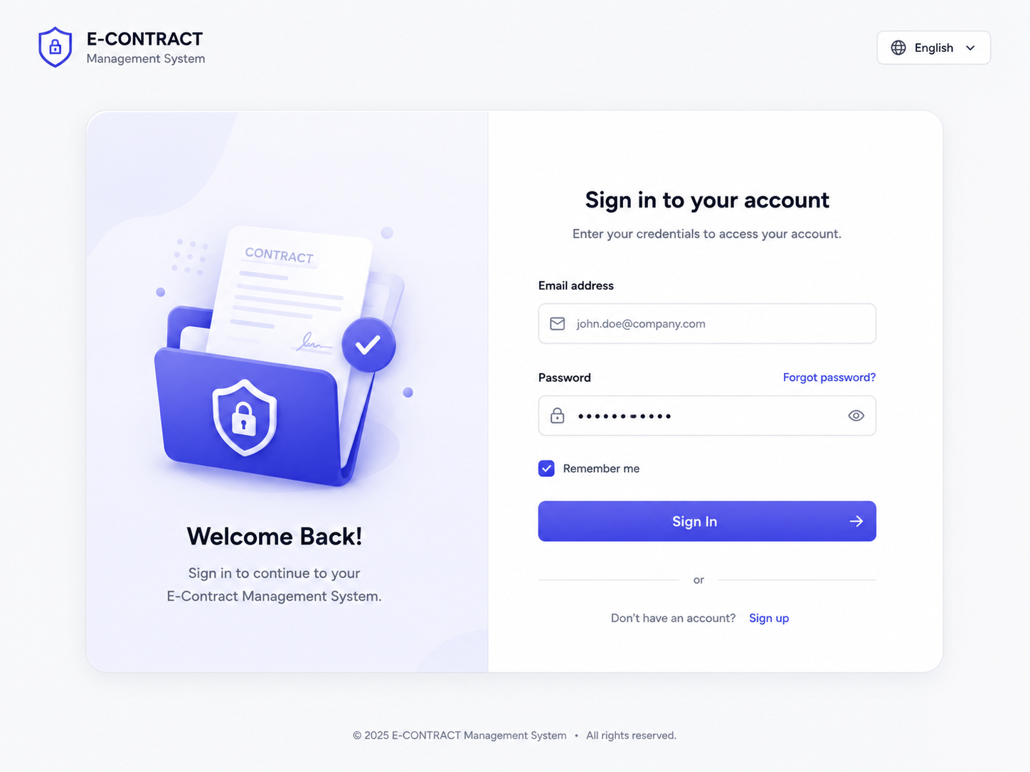
Function and related use case
Collects account credentials and starts authentication. Related use case: UC-01 Login.
Screen components and fields
Field Name | Description
Credentials
Email address | Email input; required to identify the account. No length limit is defined in the current login form.
Password | Masked text input; required for authentication. The eye button changes visibility.
Remember me | Checkbox shown in the mockup and frontend; current login code does not use this value when storing the token.
Sign In | Submits email and password to POST /auth/login.
Navigation
Forgot password? | Opens the Forgot Password screen.
Sign up | Opens the registration mockup; the current router does not define /register.
Source alignment note: The current frontend sends credentials and stores a JWT, role, name, and department. It routes users without an active signature key to Create Signature.

3.1.1.2 Access Granted Screen
UI layout
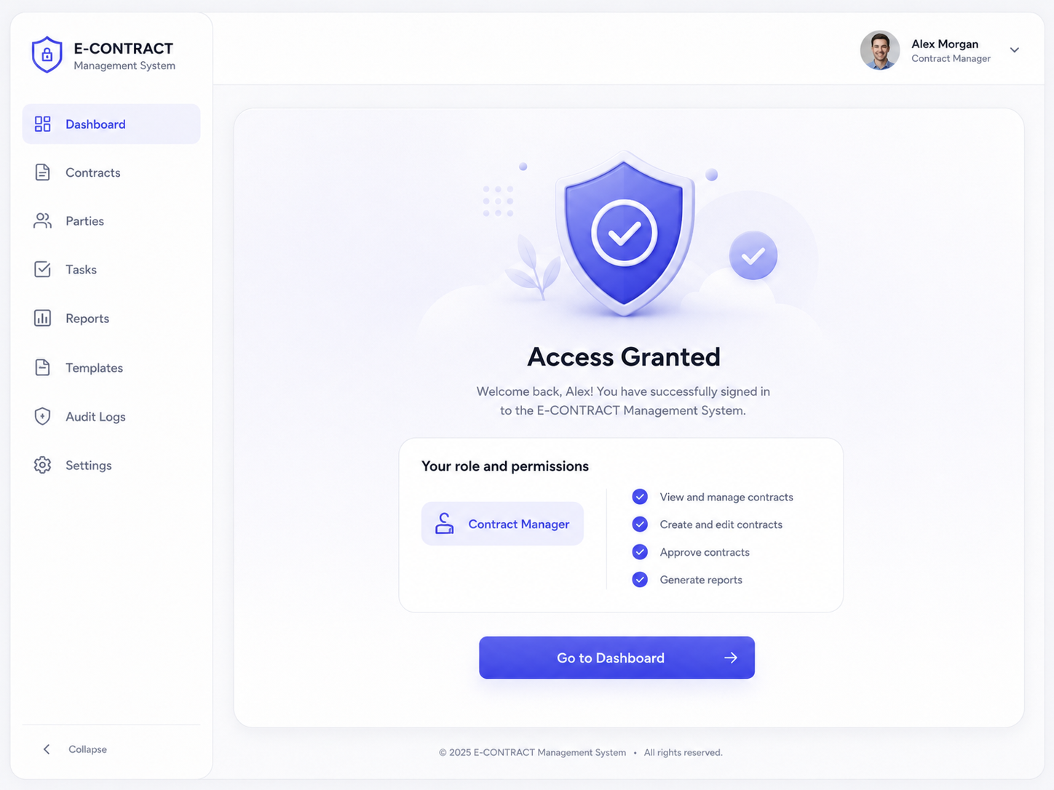
Function and related use case
Shows successful sign-in and the user’s role before entering the dashboard. Related use case: UC-01 Login.
Screen components and fields
Field Name | Description
Account information
User name | Read-only display of the signed-in user name.
Role | Read-only display of the assigned role.
Permissions | Read-only list of permitted actions shown in the mockup.
Go to Dashboard | Opens the dashboard after successful authentication.
Source alignment note: This is a mockup success screen, not a separate use case. The current login frontend navigates directly to /home_page or Create Signature; it does not render this intermediate screen.

3.1.1.3 Change Password Screen
UI layout
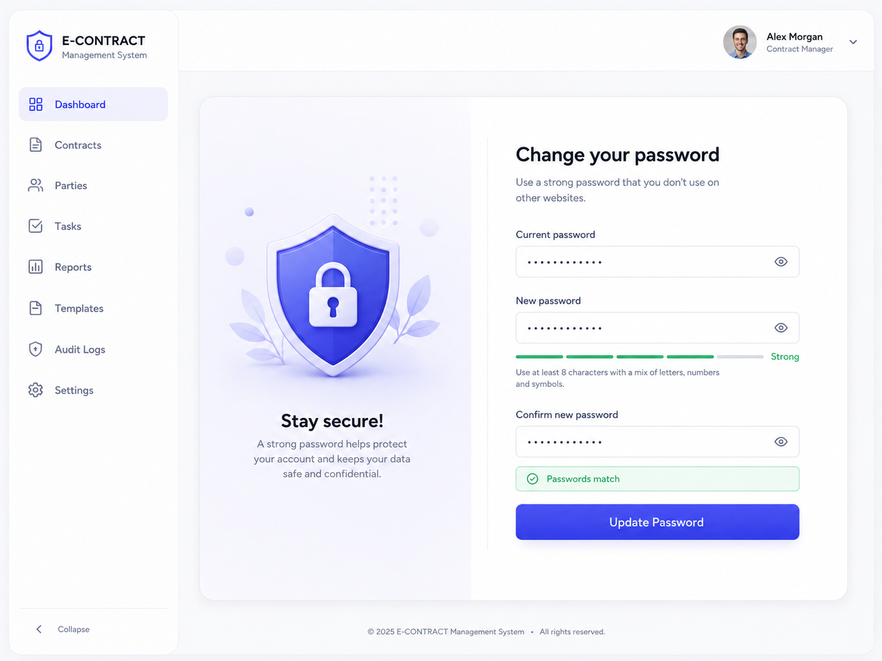
Function and related use case
Allows an authenticated user to replace the account password. Related use case: UC-04 Change Password.
Screen components and fields
Field Name | Description
Password fields
Current password | Masked input sent as oldPassword.
New password | Masked input sent as newPassword. Backend requires at least 9 characters, including lowercase, uppercase, digit, and special character.
Confirm new password | Masked input for matching newPasswordConfirm.
Password strength | Visual indicator shown in the mockup; backend validation uses the rules above.
Update Password | Submits the password change request.
Show or hide password | Toggles visibility of password inputs.
Source alignment note: The current implementation places password changing in User Profile Management rather than on this standalone mockup page.

3.1.1.4 Forgot Password Screen
UI layout
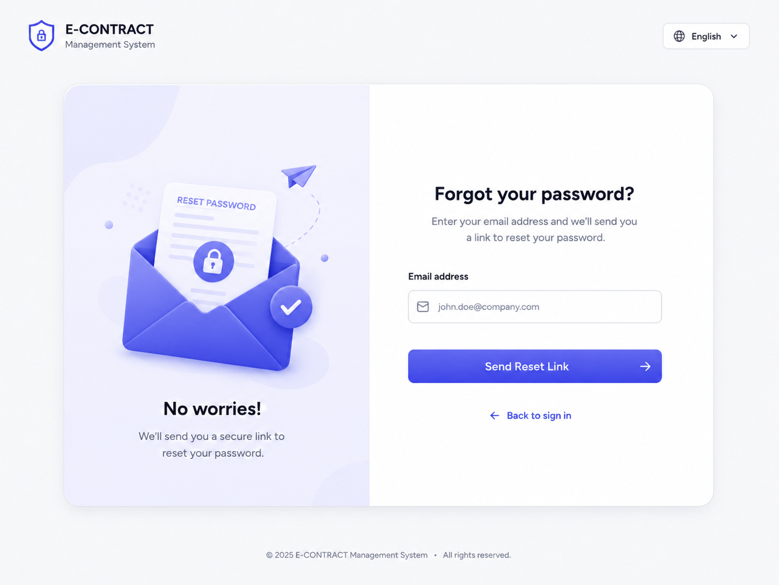
Function and related use case
Starts account recovery using an email address. Related use case: UC-05 Forgot Password.
Screen components and fields
Field Name | Description
Recovery form
Email address | Email input sent to POST /auth/forgot-password.
Send Reset Link | Starts the recovery request. The mockup says link, while the current reset API requires an OTP.
Back to sign in | Returns to /login.
Source alignment note: The current frontend navigates directly to /reset-password after a successful request. Its rendered heading and button text differ from the mockup.

3.1.1.5 Reset Password Screen
UI layout
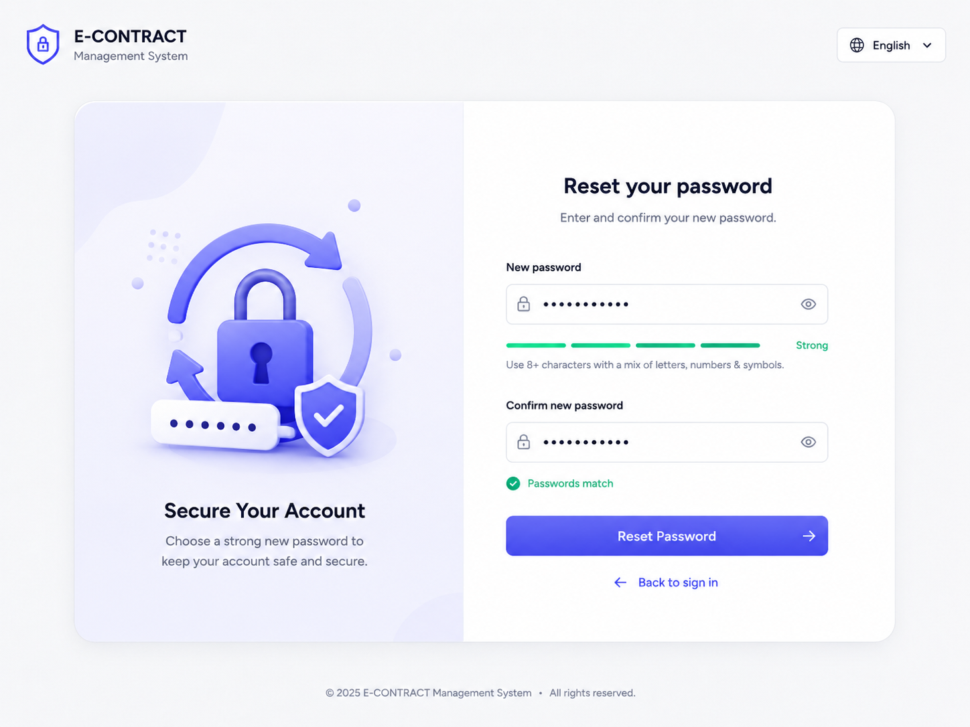
Function and related use case
Collects the information needed to replace a forgotten password. Related use case: UC-06 Reset Password.
Screen components and fields
Field Name | Description
Reset form
Email address | Required by the current reset API, although omitted from the mockup.
OTP | Required by the current reset API, although omitted from the mockup.
New password | Masked input; backend requires at least 9 characters with lowercase, uppercase, digit, and special character.
Confirm new password | Masked input; must match the new password.
Password strength | Visual indicator shown in the mockup.
Reset Password | Submits email, OTP, newPassword, and newPasswordConfirm.
Back to sign in | Returns to /login.
Source alignment note: The current ResetPasswordForm contains email and OTP inputs but labels both as email; its heading and button text also differ from the mockup.

3.1.1.6 Create Account Screen
UI layout
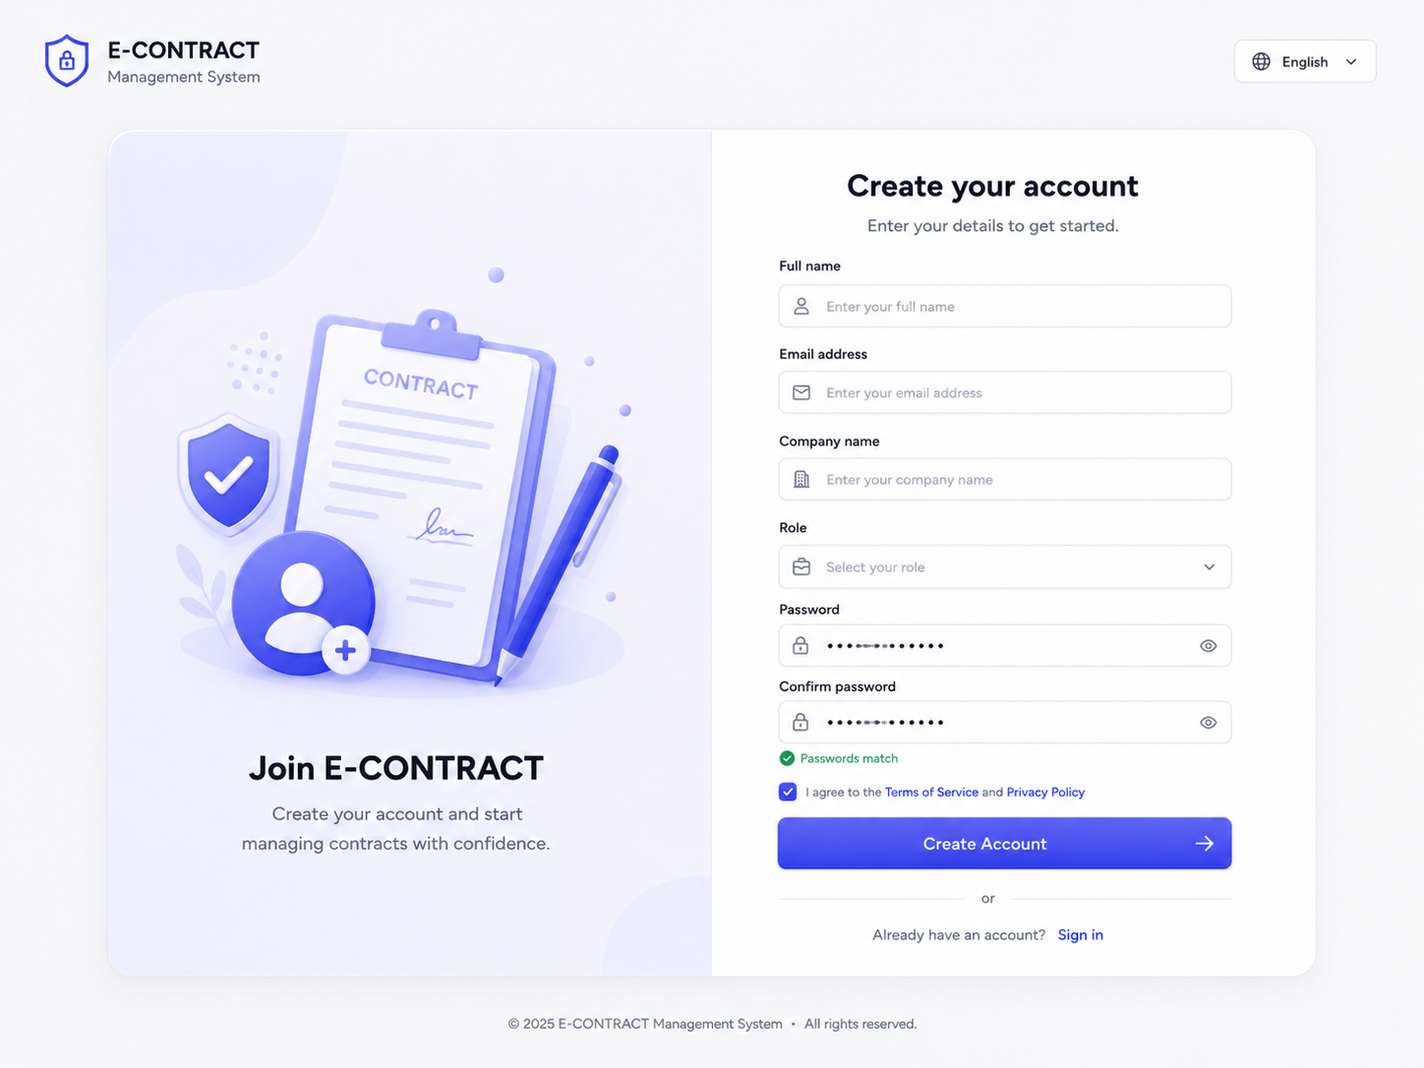
Function and related use case
Collects information for a new account in the mockup. Related use case: Mockup only — no registration use case in the supplied diagrams.
Screen components and fields
Field Name | Description
Account information
Full name | Text input shown in the mockup. The backend request instead has separate firstName and lastName fields.
Email address | Email input; maps to RegisterRequest.email.
Company name | Text input shown in the mockup; absent from RegisterRequest.
Role | Dropdown shown in the mockup; absent from RegisterRequest.
Password | Masked input; maps to RegisterRequest.password.
Confirm password | Masked input shown in the mockup; absent from RegisterRequest.
Terms agreement | Checkbox shown in the mockup; absent from RegisterRequest.
Create Account | Submits registration information in the mockup.
Sign in | Returns to the Sign In screen.
Source alignment note: The backend has POST /register, but the current RegisterPage is commented out and /register is not present in AppRouter. This screen is a proposed design, not an active frontend flow.

