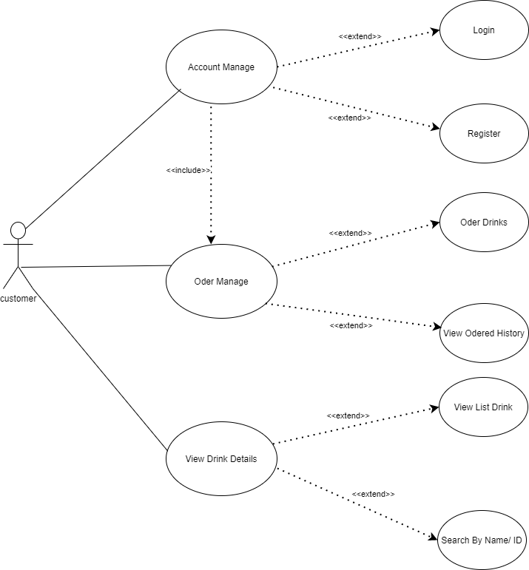

**Mô tả CN Đăng Nhập :**

|  |  |
| --- | --- |
| **Name** | Login |
| **ID** | CN1 |
| **Description** | Customers use accounts to log in to the system |
| **Object** | Customer |
| **Function** | Customers log into the system to use full functions. |
| **Trigger** | Customers open the program and choose to log in |
| **Pre-conditions** | Customers already have an account in the system |
| **Post-condition** | Success : Customer successfully logged into the system.  Error : Client login failed. |
| **Main event** | The function starts when the customer chooses to log in to the system  1. The system requires customers to enter their account and password.  2. Customers enter their account and password.  3. The system checks the account and password and allows the customer to enter the system.  4. End function. |
| **Sub event** | AC1: <Incorrect username/password>  1. Notice “Invalid account or password, enter Y if you want to re-enter”  -> Enter “Y” : Return to step 2 of the main thread.  -> Enter another “Y” : End the function. |

**Mô Tả CN đăng ký :**

|  |  |
| --- | --- |
| **Name** | Register |
| **ID** | CN2 |
| **Description** | Customers register an account to log in to the system |
| **Object** | Customer |
| **Function** | Customers register for an account to log in to the system to fully use the functions. |
| **Trigger** | Customers open the program and choose to register |
| **Pre-conditions** | Customers do not have an account in the system hệ |
| **Post-condition** | Success : Customer successfully registered.  Error : Client registration failed. |
| **Main event** | The function starts when the customer chooses to register  1. The system requires the customer to enter the account name, email.  2. Customer enters account, password, email.  3. The system of checking accounts and emails allows customers to create accounts, requiring additional information to complete registration  4. Customers enter required information  5. End function. |
| **Sub event** | AC1: <Username/email already exists>  1. Notice "Account or email already exists, enter Y if you want to re-enter"  -> Enter “Y” : Return to step 2 of the main thread.  -> Enter another “Y” : End the function. |
| **Exception** | EX : The information entered is incorrect  Invalid format message and request to re-enter |

**Mô tả CN xem danh sách đồ uống**

|  |  |
| --- | --- |
| **Name** | See list of drinks |
| **ID** | CN3 |
| **Description** | Customers see the list of drinks |
| **Object** | Customer |
| **Function** | Customers can see a list of beverage samples |
| **Trigger** | The customer chooses to view the product list. |
| **Pre-conditions** | Customer has run the program |
| **Post-condition** | Customers see the list of successful drinks |
| **Main event** | 1. Customer selects the drink view function.  2. Customers choose the function to view the list of drinks.  3. The system displays the list of drinks.  4. End function. |

**Mô tả chức năng xem chi tiết đồ uống**

|  |  |
| --- | --- |
| **Name** | View beverage information |
| **ID** | CN4 |
| **Description** | Customers view beverage information |
| **Object** | Customer |
| **Function** | Customers can view detailed information of a beverage |
| **Trigger** | Customers open the program and choose to view beverage information |
| **Pre-conditions** | Customer has run the program |
| **Post-condition** | Success : Customer successfully viewed beverage information  Error : The client could not find the information. |
| **Main event** | The function starts when the customer chooses to view the drink  1. The system asks the customer to enter the code/name of the drink  2. Customer enters code/phone name.  3. Beverage code/name checking system and detailed information display of drinks  4. End function. |
| **Sub event** | AC1: <Incorrect code/beverage name entered>  1. Product not found message |
| **Exception** | EX: Entered wrong code format  Incorrect input message and request to re-enter |

**Mô tả chức năng xem thông tin cá nhân**

|  |  |
| --- | --- |
| **Name** | View customer information |
| **ID** | CN5 |
| **Description** | Customers see their information |
| **Object** | Customer |
| **Function** | Customers can review their information |
| **Trigger** | Customers want to review personal information |
| **Pre-conditions** | Customer is logged in |
| **Post-condition** | Success : Customer view successful information |
| **Main event** | The function starts when the customer has logged into the system and selected the function to view personal information  1. Customer information display system  2. End function. |

**Mô tả CN đặt mua đồ uống**

|  |  |
| --- | --- |
| **Name** | Order drink |
| **ID** | CN6 |
| **Description** | Customers order drinks |
| **Object** | Customer |
| **Function** | Customers order drinks |
| **Trigger** | Customers want to order drinks |
| **Pre-conditions** | Customer has logged into the system |
| **Post-condition** | Success : The customer ordered a drink successfully  Error: Customer order failed. |
| **Main event** | The function starts when the customer has logged into the system and selected the function to add drinks to the cart  1. The system asks the customer to enter the drink code  2. Customers enter the drink code  3. The system checks the drink code, requires entering the quantity.  4. Customer enters quantity  5. The system checks the quantity, displays the invoice and confirms the order with the customer  6. Customer confirms order.  7. End function. |
| **Sub event** | AC1: <Wrong drink code entered>  1. Notice "Invalid drink code, enter Y if you want to re-enter"  -> Enter “Y” : Return to step 2 of the main thread.  -> Enter another “Y” : End the function.  AC2: <Incorrect quantity>  1. Notice: "Existing quantity, enter Y if you want to re-enter"  -> Enter “Y” : Go back to step 4 main thread  -> Enter another “Y” : End the function. |

Mô tả Chức năng xem lịch sử mua hàng

|  |  |
| --- | --- |
| **Name** | View purchase history |
| **ID** | CN7 |
| **Description** | Customers view phone purchase history |
| **Object** | Customer |
| **Function** | Customers can review their purchased drinks |
| **Trigger** | Customers want to review their purchased drinks |
| **Pre-conditions** | Customer is logged in |
| **Post-condition** | Success : Customers view success history |
| **Main event** | The function starts when the customer has logged into the system and selected the function to view purchase history.  1. The system displays purchase history  2. End function. |