**Project organization:**

1. **Software process model:**

In this project, in order to set up a successful plan on developing software, we choose the Scrum Agile Framework allowing steps by steps. Benefits that Scrum Framework brings to us and reason that we choose are listed below:   
- Time-saving: daily meetings to ensure that all the process is on the correct stage, as establish at the beginning of the project.   
- Easy to use: it is a suitable model for working in team with small and medium project. For our current project, it is set to medium project.   
- Fast response to change or update: The project manager may change the requirements or extend/reduce scope and we can adapt better. Sometimes we might prefer some update to PM to change the task suitable for team.   
- Encourage teamwork: roles and tasks are all planned and divided to members also assigned effectively.   
- Functional testing is needed and each task finished with the document shown the test case and status code.

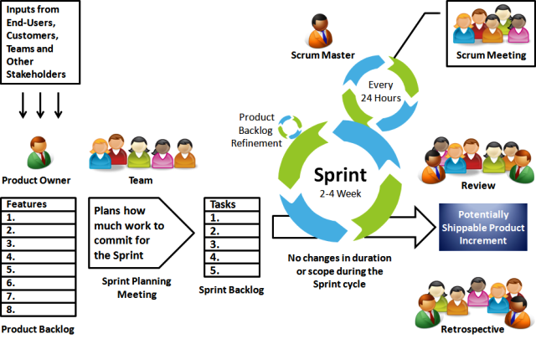

Figure 1. Scrum framework

Roles and Responsibility:

|  |  |  |  |
| --- | --- | --- | --- |
| **No.** | **Full name** | **Role in Group** | **Responsibilities** |
| 1 | Ngô Đăng Hà An | Supervisor | * Receive the report and send feedback on the process of work |
| 2 | Jason Ngo | Project Manager | * Give questions for the problem uncleared and specified the solution. * Approved or Given feedback on the updated solution that team recommend |
| 2. | Nguyen Viet Thang | Team Leader,  BA,  Developer,  Tester | * Manage process * Clarify requirements * Design GUI * Code * Write document and report * Test |
| 3. | Tran Dang Hung | Team member,  Developer,  Tester | * Clarify requirements * Design GUI * Code * Write document and report * Create test plan * Test |
| 4 | Nguyen Hoc Huy | Team member,  Developer,  Tester | * Plan Scrum implementations * Design database * Write document and report * Code * Test |

Table . Roles and responsibilities details

**Tools and Technologies:**

|  |  |
| --- | --- |
| **Tool/Technique** | **Name/Version** |
| Front-end | HTML5, CSS3, Bootstrap, AngularJS |
| Back-end | PHP, Laravel Framework Framework |
| Design Pattern | Requests and Repository Pattern (Laravel Framework) |
| Managing Database | XAMPP Server with MySQL |
| Source Control | Sourcetree (server github.com) / Tortoise GIT |
| Modeling Tool | StarUML v2.8.1 |
| Web Browser | Google Chrome |