**I. FRONT END**

1. There are many deprecated package used and were warned during installation. Please update them with newer ones.

2. Statistics for “Chamber in operation/idle time” does not show chart. See below screenshot.

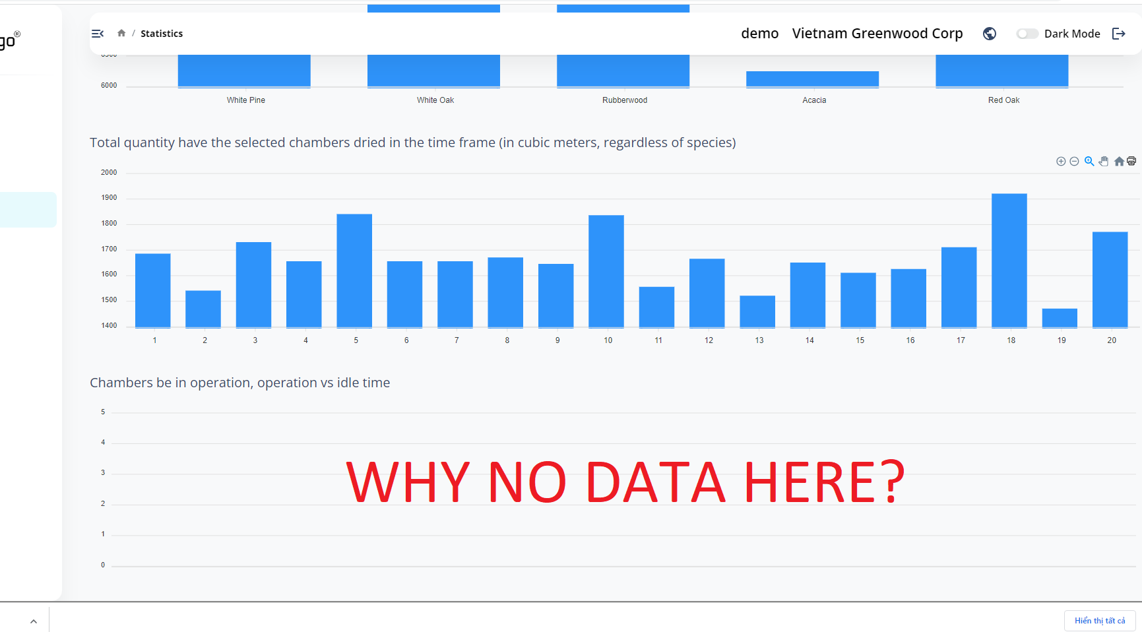

2. Historical/Ongoing lot data table is not resposive/or must require a horizontal scollbar to view all data horizontally. See below

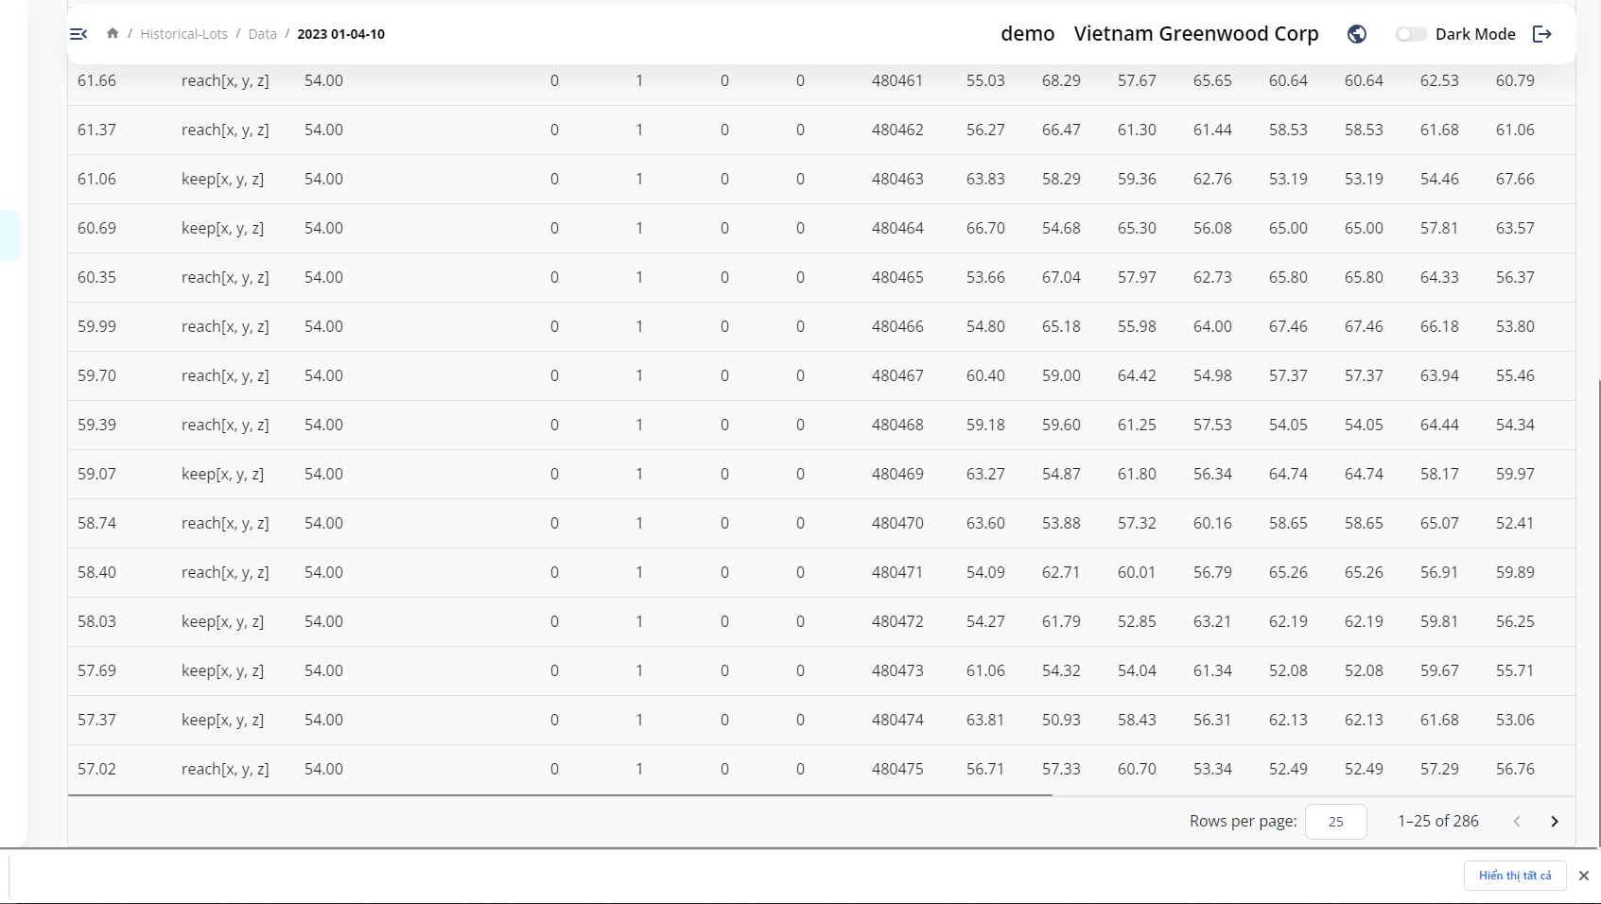

3. Historical/Ongoing Lot listing **Colum Filtering** only effective for the current page, which is not right. For example, Filtering the table by Chamber = 1must show ALL records of chamber 1, not just those records in the first 25 rows. See below

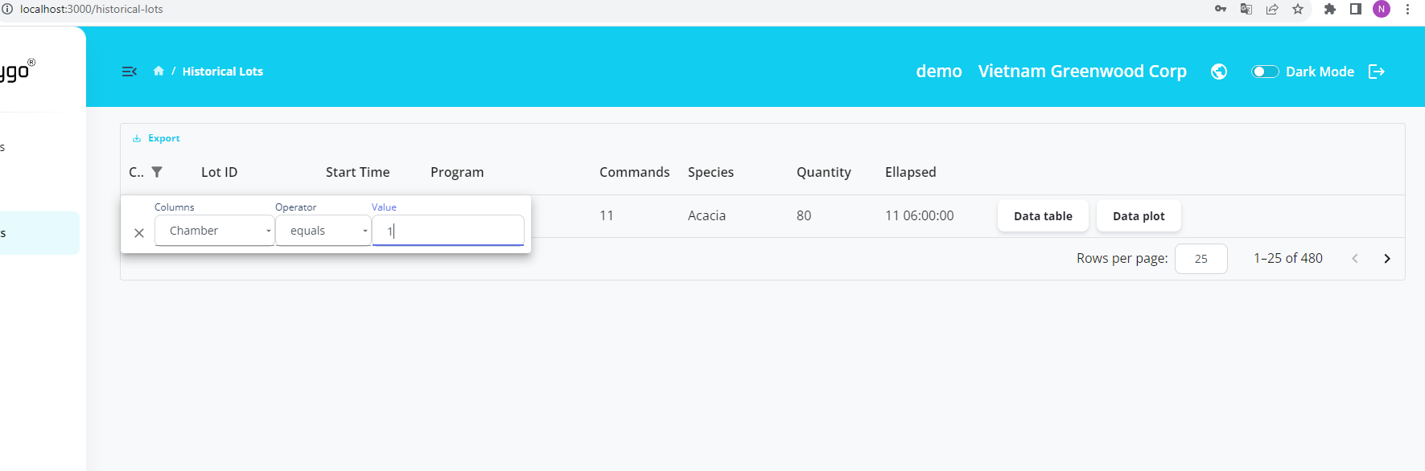

4. Historical/Ongoing Lot listing missing column “Lot.complete_time”. Also, the filtering options for Datetime columns are not right, therefore it is not possible to Filter data for a time period.

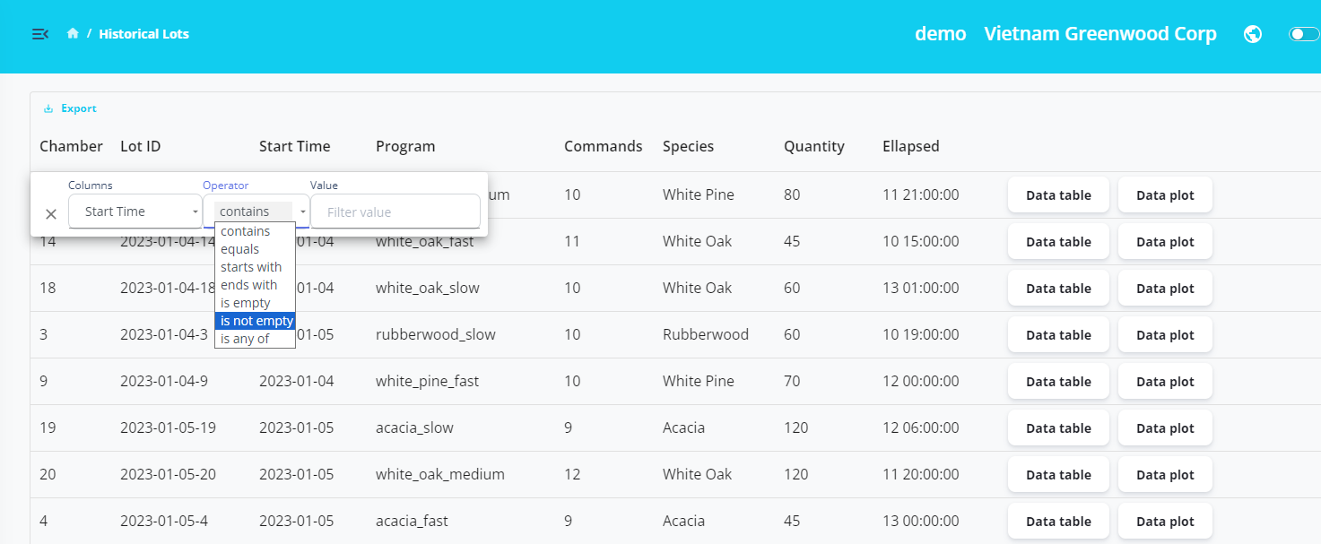

5. Data plot has the following issues:

- There are data points every 1 hour apart in the mock-up data (real data can be 2 or 3 hours apart), but the chart only show data points for every 1 days.

- The type of chart is not right, the charts shoud be curves that connect data points, not in the form of “steps”. Please refer to the job description.

