

CAPSTONE PROJECT REGISTER

Class: Duration time: from ..…….../2026 To ..….…./2026
(*) Profession: Software Engineer Specialty: <JS> <IS> <SE>
(*) Kinds of person make registers: Lecturer Students

1. Register information for supervisor (if have)
No. | Fullname | Phone | E-Mail | Title
Supervisor | Nguyễn Văn Chiến | 0986964972 | ChienNV33@fe.edu.vn | Mr.
Supervisor | Phạm Thanh Trí | 0937 359 396 | tript9@fe.edu.vn | Mr.

2. Register information for students (if have)
 | Full name | Student code | Phone | E-mail | Role
1 | Trần Viết Trà Lâm | SE182432 | 0908948249 | lamtvtse182432@fpt.edu.vn | Leader
2 | Ngô Quang Minh | SE182368 | 0373910787 | minhnqse182368@fpt.edu.vn | Member
3 | Phan Nguyễn Mạnh Cường | SE182365 | 0704595827 | cuongpnmse182365@fpt.edu.vn | Member
4 | Nguyễn Nhật Trường | SE182445 | 0987315027 | truongnnse182445@fpt.edu.vn | Member
5 | Đỗ Thành Đạt | SE182419 | 0931339228 | datdtse182419@fpt.edu.vn | Member

3. Register content of Capstone Project

3.1. Capstone Project name:
- English: SaaS Smart Restaurant Management Platform with QR Code Ordering
- Vietnamese: Nền tảng SaaS quản lý nhà hàng thông minh với gọi món QR
- Abbreviation: S2O (Scan2Order)

Context:
● The F&B industry in Vietnam and worldwide is rapidly moving toward operational optimization, digital transformation, and labor cost reduction. This creates a strong demand for SaaS-based solutions that are easy to deploy, scalable, and cost-effective.
● Traditional paper menus come with multiple limitations: high printing costs, inconvenience when updating prices or promotions, easy wear and tear, and service delays when customers must wait for staff to take orders.
● QR code ordering is becoming increasingly popular thanks to its convenience, speed, and modern customer experience. However, most restaurants still rely on fragmented or self-built solutions that are inefficient and hard to maintain.
● Restaurants need a unified, stable, and cost-efficient technology platform to manage their operations. Building and maintaining a custom system for each restaurant is expensive, complex, and does not scale.
● Many existing solutions lack multi-tenant architecture, making it difficult to serve multiple restaurants on one shared platform while still ensuring isolated data and customizable experiences for each business.
● Modern consumers expect more than just a QR menu at the table—they want an all-in-one mobile application where they can explore multiple restaurants, make reservations, read reviews, and enjoy a personalized dining journey. Current systems rarely deliver this experience.
● The absence of an integrated AI assistant and intelligent recommendation engine makes it difficult for customers to discover suitable dining options based on weather, location, personal preferences, or behavior insights—representing a major opportunity for a SaaS platform built with AI at its core.
● Most restaurants do not have a dedicated QA chatbot capable of automatically answering common customer inquiries (opening hours, menu availability, best-selling dishes, seating options, policies, etc.), resulting in unnecessary workload for staff.

Proposed Solutions: Building an Online QR Menu Platform using a Multi-Tenant SaaS Model, combining a web app for restaurants and a mobile/web app for customers, with the following feature groups:
- Business Customer (Restaurant):
  - Online menu management: images, prices, descriptions, and item availability in real time.
  - Generate QR codes for each table and each branch.
  - Receive and process customer orders, fully synchronized with the kitchen/bar.
  - Staff roles and permissions, revenue reports, inventory tracking, and real-time analytics.
  - Multi-branch management with separate configuration for each location.
  - Data isolation for each restaurant through a multi-tenant architecture.
- Web App for Customers
  - Scan QR codes to view the menu instantly at the table.
  - Select items, place orders, and track order status in real time.
  - No app installation required — runs directly on the browser.
- Mobile App for Customers
  - A universal mobile app where customers can explore multiple restaurants on the platform.
    - Discover restaurants available on the system
    - View menus before visiting the restaurant.
    - Make table reservations directly through the app.
    - View reviews, photos, and featured dishes.
    - Save favorite restaurants, view booking history, and dining history.
  - AI Features:
    - AI Recommendation Engine — suggests restaurants based on:
– current location
– weather conditions
– personal preferences
– preferred time and price range
    - AI Chatbot QA — answers restaurant-specific questions:
– opening hours
– menu availability
– table availability
– best-selling dishes
– reservation assistance
- SaaS Platform (Multi-Tenant Architecture):
  - A single platform serving multiple restaurants, each with isolated data and custom configurations.
  - Restaurants can activate and operate immediately after registration — no individual deployment required.
  - Feature updates and improvements are delivered uniformly to all tenants.
  - Reduces infrastructure cost, maintenance effort, and supports large-scale expansion.
- Administrator (Web App):
  - System-wide management, restaurant onboarding approval, tenant configuration, data monitoring, and platform governance.

Functional requirement
- Guest
MainFlow:
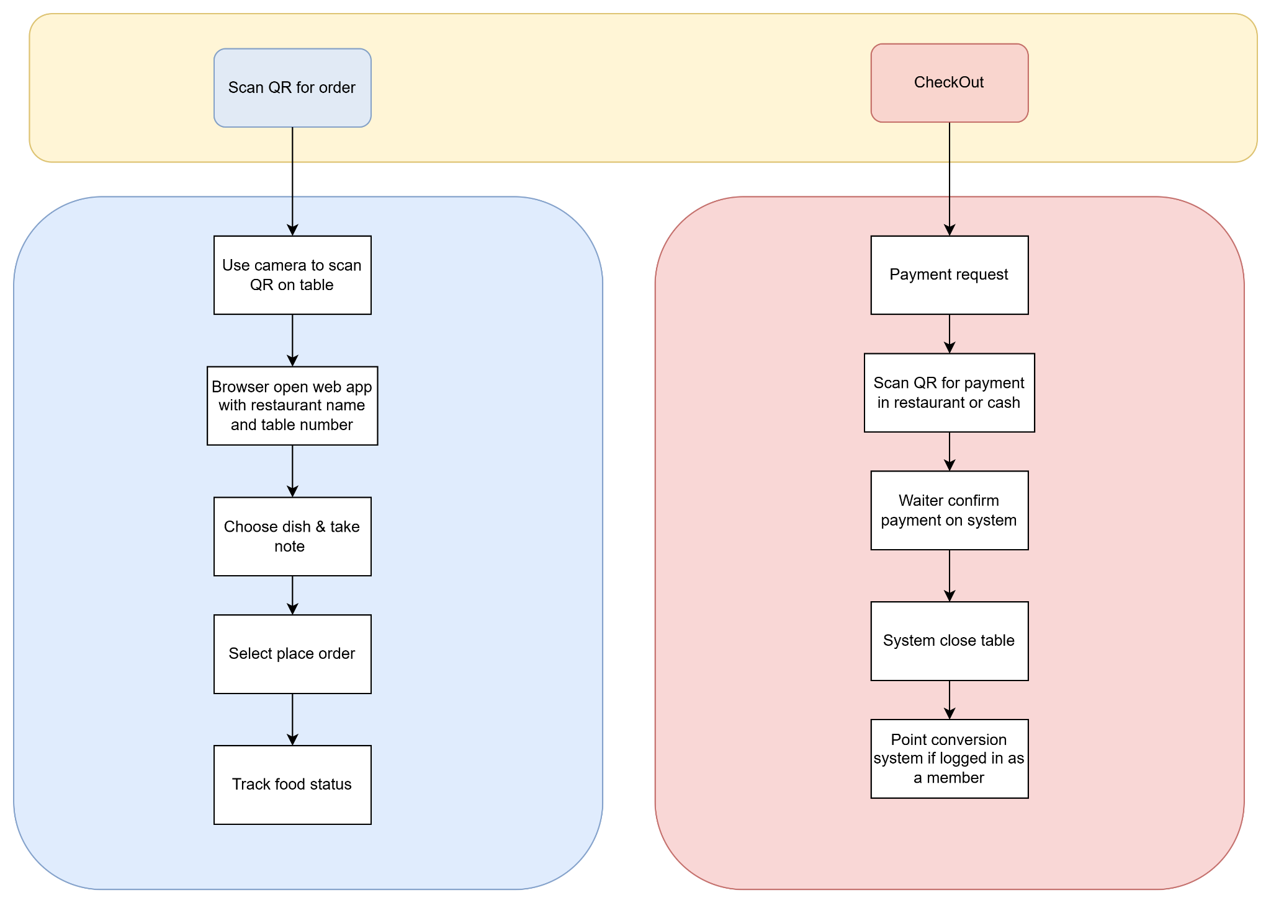
  - (Web App — accessed via restaurant QR code, with session timeout)
    - Orders dishes.
    - Add notes to ordered dishes.
    - View order history.
    - Track the status of ordered dishes.
    - View the menu.
    - Search / filter menu items by category.
    - Request payment / request bill.
- Customer
  - (Web App — accessed via restaurant QR code, with session timeout)
    - Orders dishes.
    - Add notes to ordered dishes.
    - View order history.
    - Track the status of ordered dishes.
    - View the menu.
    - Search / filter menu items by category.
    - Request payment / request bill.
    - Authentication via mobile app.
  - Mobile App
MainFlow:
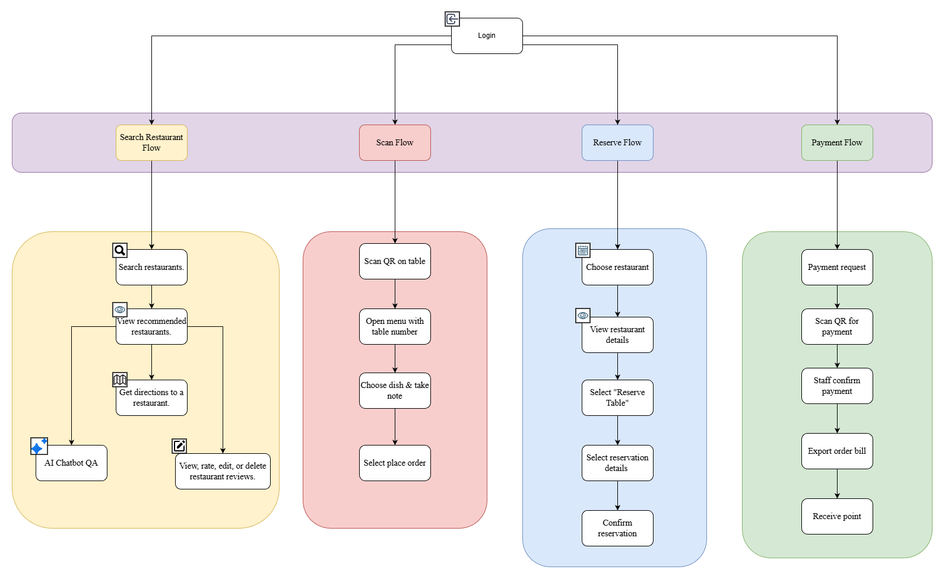
    - View restaurants.
    - View recommended restaurants.
    - Search for restaurants.
    - Get directions to a restaurant.
    - Scan QR codes (menu).
    - Log in / register.
    - View, rate, edit, or delete restaurant reviews.
    - Make table reservations.
    - View history of dishes, restaurants visited, and total spending.
    - Membership tiers: iron, silver, gold, diamond, etc.
    - AI Chatbot QA — answers restaurant-specific questions
- Business Customer (Restaurant)
MainFlow:
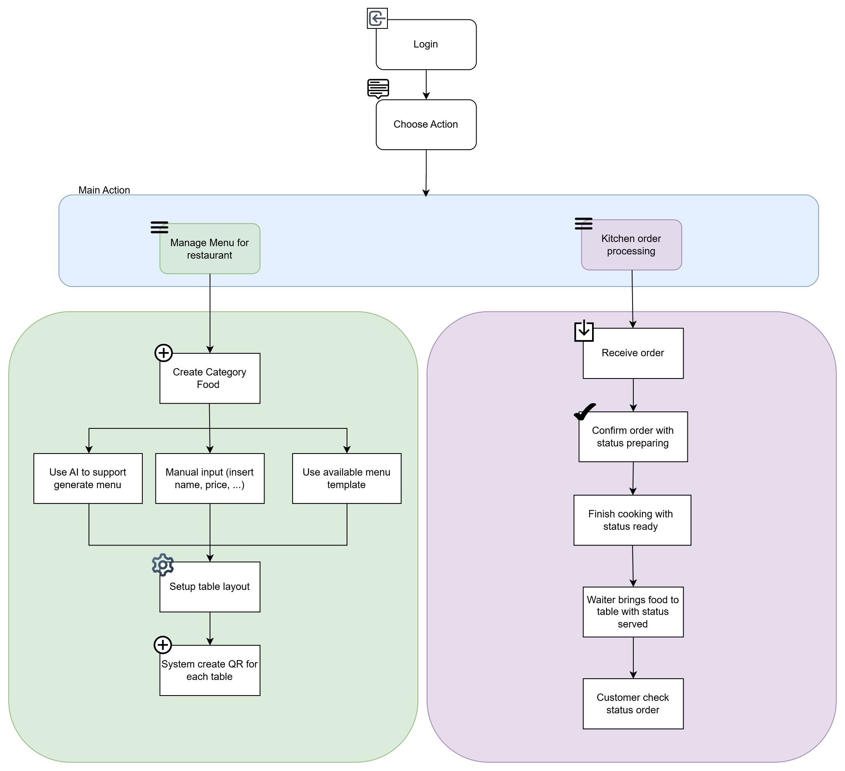
  - Web
    - Manage and customize menu items.
    - Manage orders for each table.
    - Manage table status (occupied, available, reserved).
    - Manage discounts for each dish per restaurant.
    - View restaurant revenue.
    - Generate QR codes for each table.
    - Issue bills for tables.
    - Update or change bank payment QR codes.
    - Manage role-based access (chef, manager, cashier).
    - Convert completed payment amounts into reward points; customers can redeem points to order items in the points menu.
    - Using AI assistance to create a menu.
- Admin

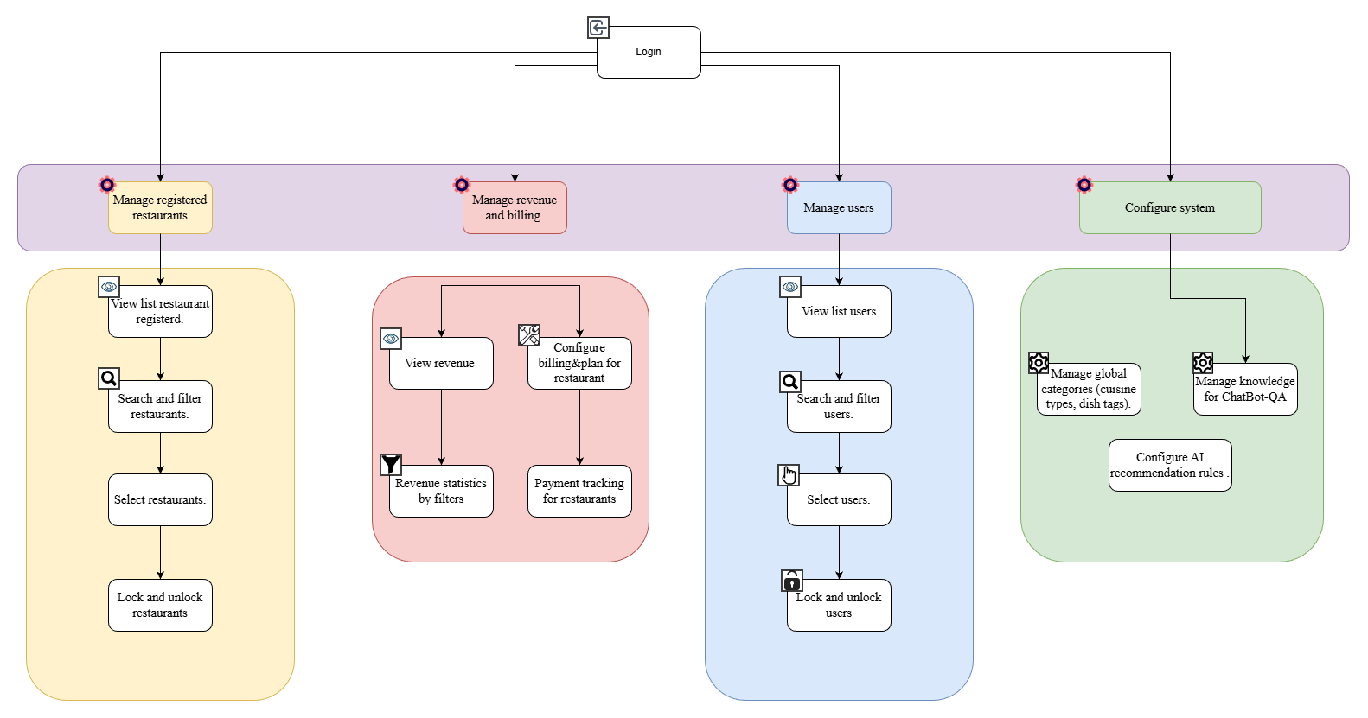
  - Web
    - Manage registered restaurants.
    - Manage revenue.
    - Manage users.
    - Configure the recommendation algorithm AI used for restaurant recommendations in the mobile app.

Non-functional requirement:
  - The system must support a scalable multi-tenant architecture with strict data isolation and high performance.
  - Cloud-based deployment with Docker, Redis, and real-time communication must ensure low latency and high availability.
  - Security standards must be enforced, including encryption, JWT authentication, and role-based access control.
  - The platform must provide reliable monitoring, logging, and CI/CD for easy maintenance and continuous deployment.

3.2. Main proposal content (including result and product)

Theory and practice (document):
  - Students should apply the software development process and UML 2.0 in the modeling system.
  - The documents include User Requirements, Software Requirement Specifications, Architecture Design, Detail Design, System Implementation, Testing Document, Installation Guide, source code, and deployable software packages.
  - Server-side technologies:
    - Server: C# .NET, Python.
    - Database Design: PostgreSQL, MongoDB, Qdrant.
    - Caching: Redis.
  - Client-side technologies:
    - Web Client: React/NextJS.
    - Mobile App: React Native.
  - AI module:
    - AI Chatbot QA: Retrieval-augmented generation + LLM.
    - Recommendation system: Vector Search + Embedding (Semantic Matching) + Rule-Based.

Products:
- Mobile application.
- Web application.

Proposed Tasks:
- Task package 1: Develop the Web application for the Admin system.
- Task package 2: Develop the Web application for Restaurant Management.
- Task package 3: Develop the Web application for Guest (QR Menu).
- Task package 4: Develop the Mobile application for Customers.
- Task package 5: Develop the AI modules (Chatbot QA & Recommendation Engine).
- Task package 6: Develop the Web API for the system (Multi-Tenant SaaS Architecture).
- Task package 7: Build – Deploy – and Test the system.
- Task package 8: Prepare all required documents: System Analysis & Design, Test Plan, Installation Manual, User Manual.

4. Other comments (propose all relative things if have).

Supervisor (If have)  (Sign and full name) | HCM, date …… ………. /20 …  On behalf of Registers  (Sign and full name)

Nguyễn Văn Chiến

