Project URL : http://projects.arcinfotec.com/odhub/odhub/
Professional Information :
Username/Password : rocky@gmail.com/rocky
Username/Pasword : roc@gmail.com/welcome1
Here roc@gmail.com is the child user of rocky@gmail.com
Client Information :
Username/Password : santanu.cs1@gmail.com/welcome1
Step1 :
- Login to professional account using the credential given above.
- Post a new project using the following link : http://projects.arcinfotec.com/odhub/odhub/site/project/post_project
- Now logout from the client account and login to the professional account using rocky@gmail.com credential.
- After login visit the link http://projects.arcinfotec.com/odhub/odhub/site/project/. Here at the bottom , you can see new added project is coming.
- There click on the top right corner link as mentioned in bottom picture.
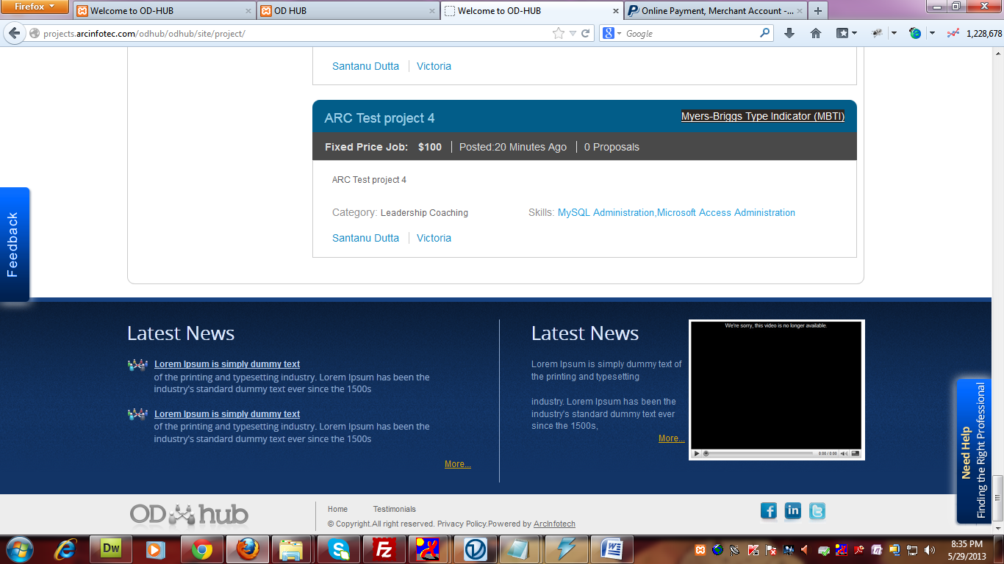
- After that from project details page, please award the project. At present file-attachment is working , but that needs to display in client section
- Now logout from professional section and log in to client section. And visit the URL “http://projects.arcinfotec.com/odhub/odhub/site/client/project_list”
- There you can see , on view button , on your project one proposal is coming. Click on the view button.

- After that you will get an button to award the project. Click on the award button. After that it will redirect you to one page, and there you can mentioned project cost and delivery date.
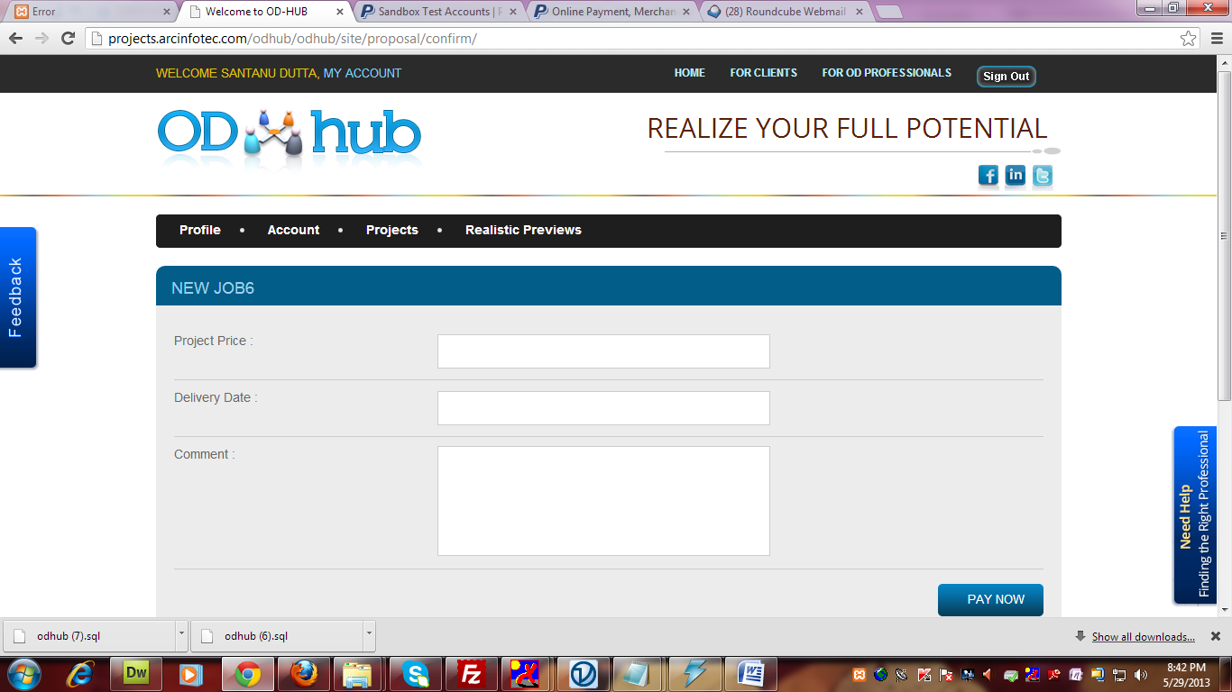

- After filling all the information , click on pay now buttons. It will redirect you to the paypal site. There use the following credential for payment.
Username/Password : santanu.cs5@gmail.com/welcome1
- After completing this login to professional section using rocky@gmail.com. And after that go the http://projects.arcinfotec.com/odhub/odhub/site/professional/show_home
- There you can see “My Awarded Projects” section. From this section , using “Refer” button, you can refer the project to child user and from “My Client”, send invoice section professional can send invoice to client.
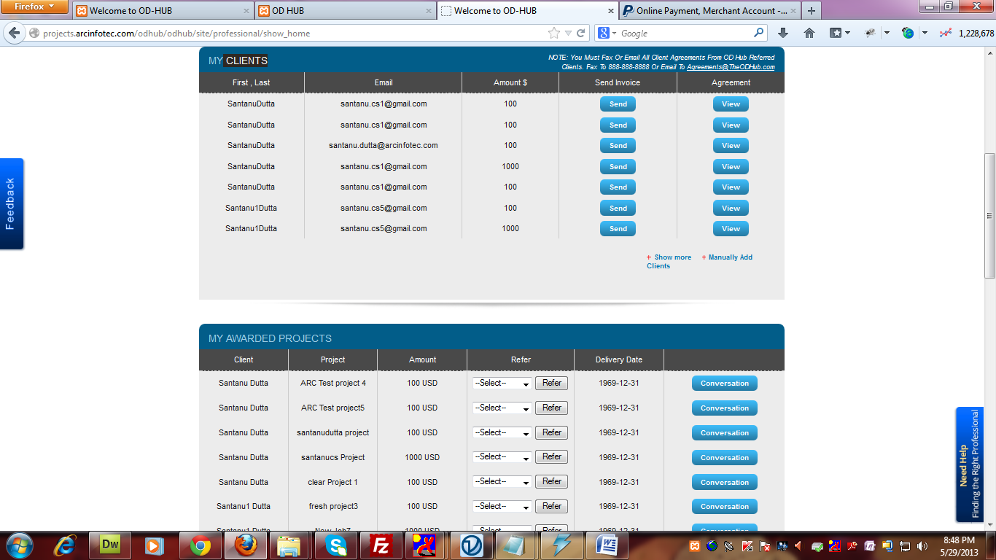
- By clicking on the send invoice button , invoice will send to the respective client.

- That invoice details , client can view by using the following URL “http://projects.arcinfotec.com/odhub/odhub/site/client/show_home” from “My Invoice”after login to his account
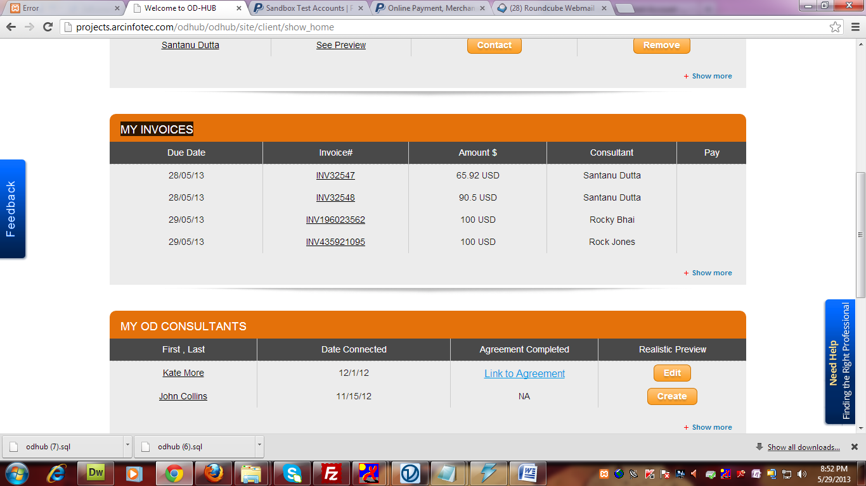
- After doing the payment, professional can see his referral commission using the following URL : http://projects.arcinfotec.com/odhub/odhub/site/professional/show_home under My Referral section at bottom.
