**Watch product**

Trademark:Calvin Klein

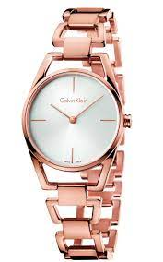Machine Type:Automatic - Handwinding

Status:New Wire

Type:Leather cord

Glass Type:Sapphire

Size:40 mm

Warranty period:2 Years

Category:Watches

Sex:Men

Designs:Fashion

Color:White

Shell Color:Pink Gold

Shell:Stainless Steel

Waterproof:50m