**FPT International School**

**PROJECT REPORT**

**<Aura Watches>**

Batch: C1706L

Semester: 1

Group: 1

Nguyen Hoang Long

Nguyen Dinh Thang

Nguyen Van Minh Thanh

**Table of Contents**

1. Problem Definition

1.1 Overview

i. Introduction

ii. Implementation Environment

1.2 User Stories

1.2.1 Admin

a) Register

b) Manage Products

c) Manage Categories

d) Manage Users

1.2.2 Customers

e) Search Product

f) View Product

g) Purchase Product

2. Flowchart

2.1 Register

2.2 Manage Product

2.3 Manage Categories

2.4 Manage Users

2.5 Search Products

2.6 Purchase Products

3. UI\UX

3.1 Homepage

3.2 Shop

3.3 …

3.4 …

3.5 …

3.6 ...

3.7 ...

3.8 ...

3.9 ...

3.10 ... 15 4. Summary 1

**1. Problem Definition**

**1.1 Overview**

i.Introduction

Aura watches is into business of manufacturing and selling watches. They have been

advertising about their clocks and watches through newspapers, pamphlets,

television. Now with changing times, they have decided to go online as customers

today use Internet extensively. They have planned for a website with complete

details about their watches and clocks.

The Web site is to be created based on the following requirements.

1) The Home Page should have suitable logo, and decent colour combination.

2) The site should display a menu which will contain the options as Products,

Technology, Store Locator, Support etc.

3) Various pages having information about different types of watches and clocks,

Technology used in the watches etc.

4) The information should be categorized according to different Product Line-up

e.g. “SPORTZ”, “PREMIER” etc.

5) When a user selects any product line-up, complete list of watches for that

product line-up will be displayed.

6) Details of the watches should be displayed on the Web Page along with the

title and it should be stored in Individual Word documents which can be

downloaded or viewed by the User who wishes to see the same.

7) Price List for all watches should be available for download.

8) There should be a “Contact Us” page which will have the Address of the

Stores selling watches and the mail address which when clicked will invoke

the local mail client from where they can send an email..

ii.Implementation Environment

● HTML5

● Boostrap

● CSS

● JavaScript

● JQuery

**1.2 User Stories**

**1.2.1 Staff**

a) Price list download

As an staff, I want Price List for all watches should be available for download.

b) Product information download

As an staff, I want products details can be downloaded or viewed by the User who wishes to see the same.

**1.2.2 Customers**

e) Search Product

As a customer, I want to find products to purchase for myself.

f) View Product

As a customer, I want to view the details of your product to consider to purchase or not.

g) Purchase Product

As a customer, I want to purchase your product, can change quantity of the product, and see the total of my deal

**2.Diagram**

**Web map**

About us

Punchline Product

Home page

Clocks

Watches

Products

Contact us

**3. UI\UX**

**3.1 Homepage**

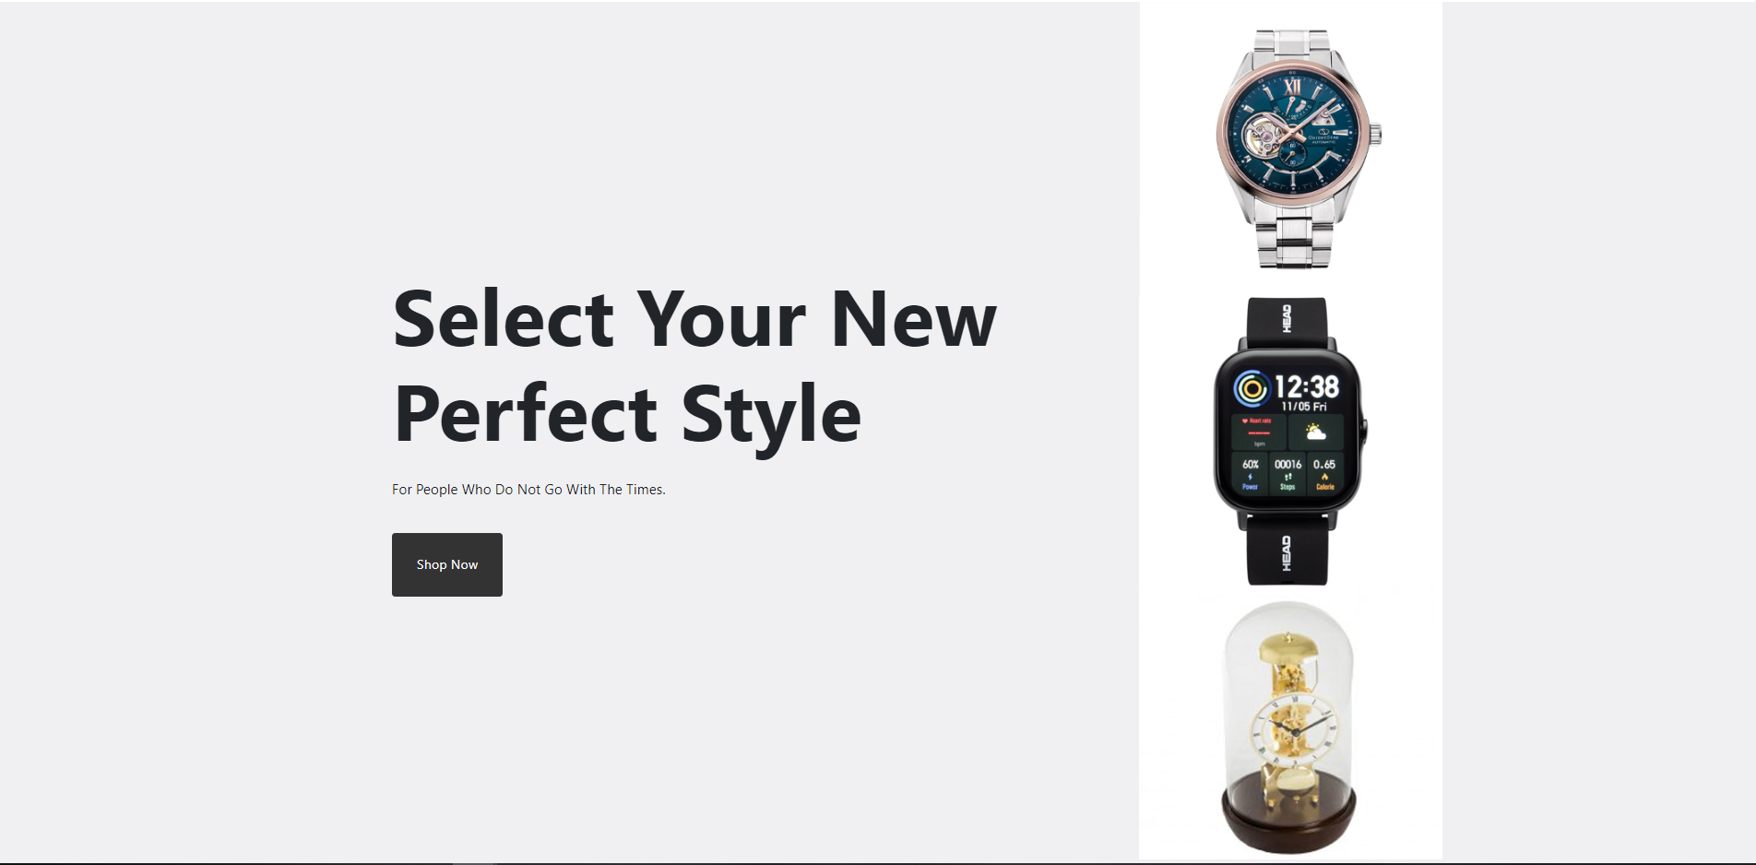

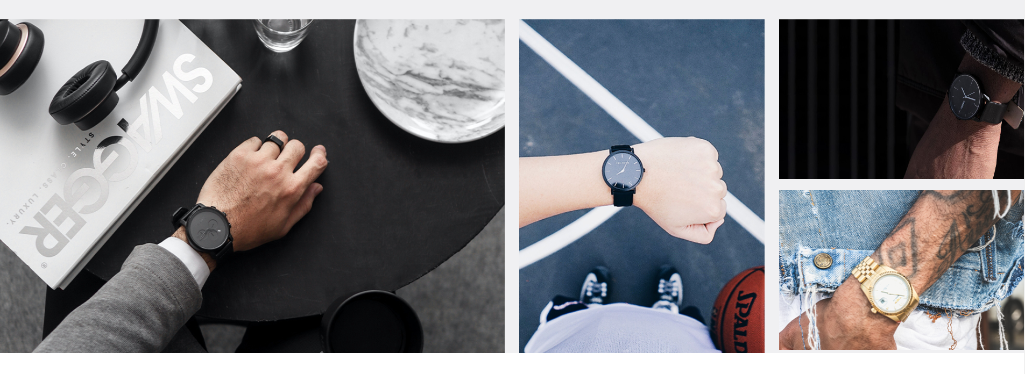

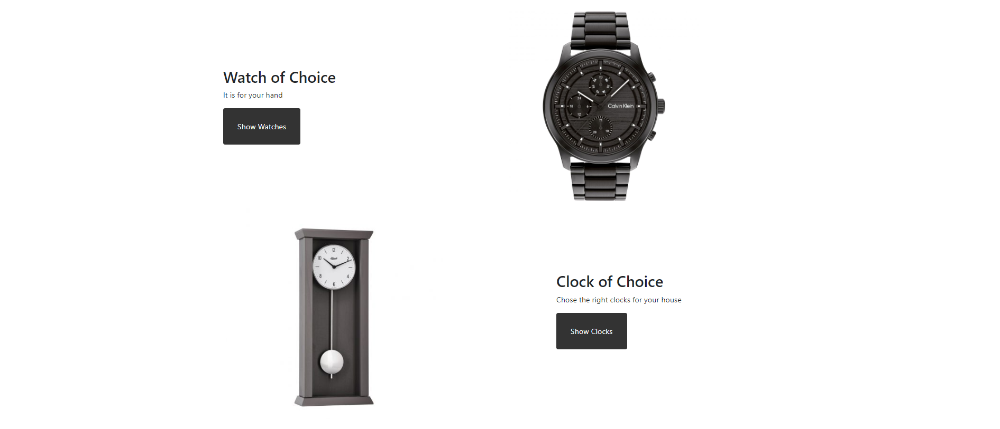

**3.2 Shop**

**a) Watches**

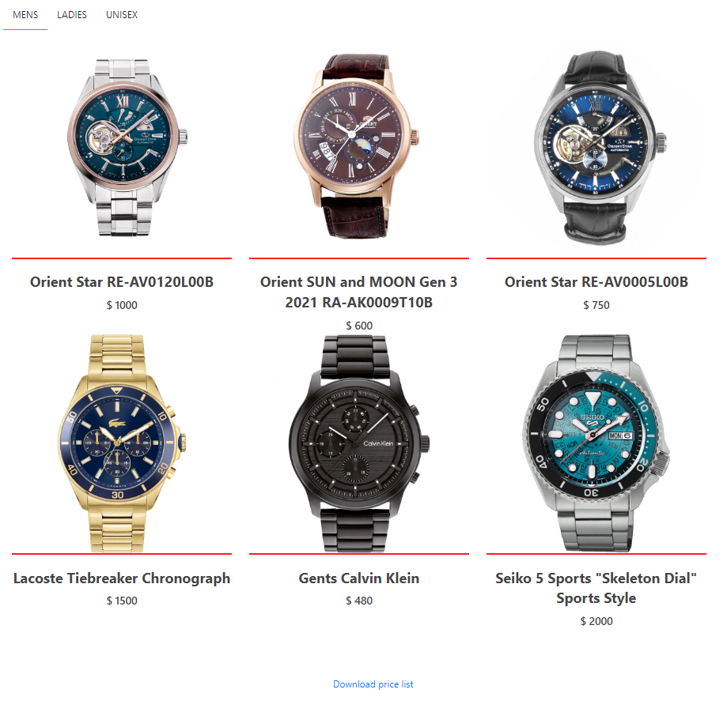

**b) Clocks**

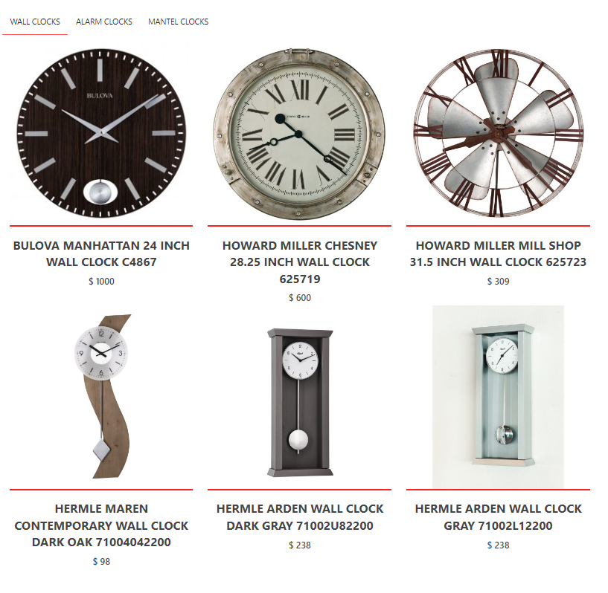

**3.3 About us**

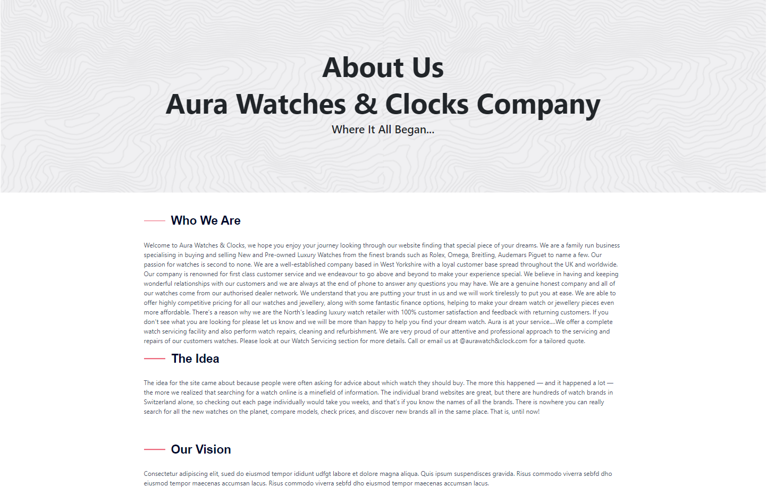

**3.4 Contact us**

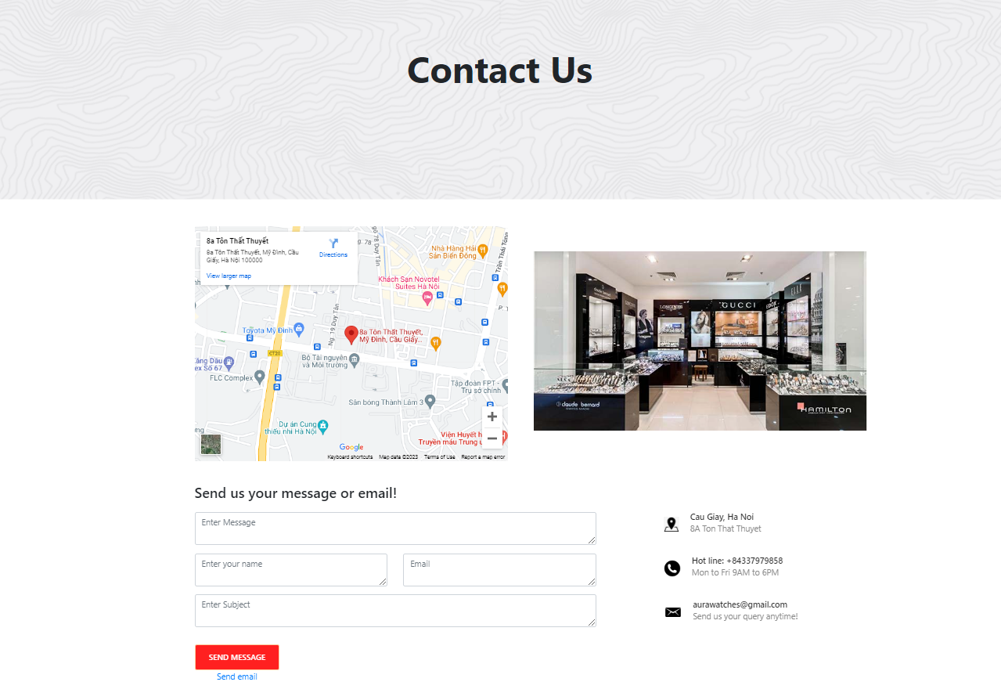

**3.5 Product details**

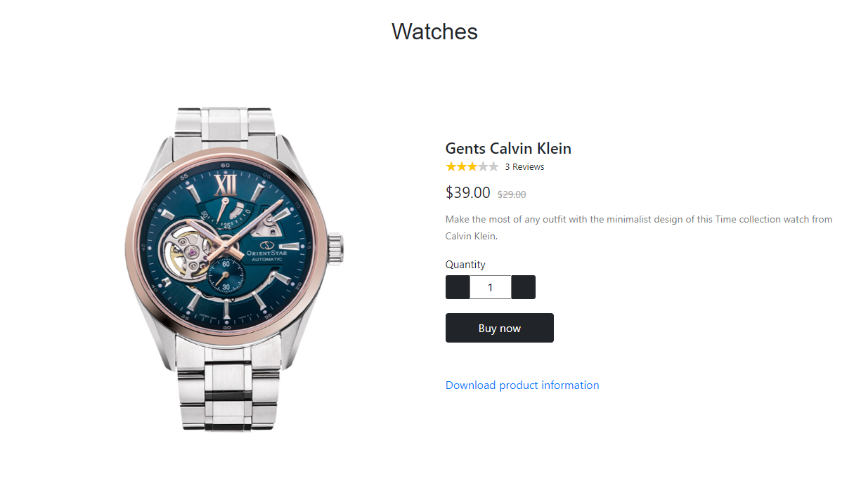

**3.5 Technology**

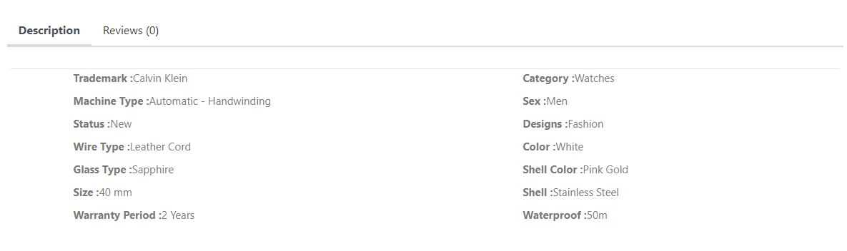

**3.6 Feedback**

