**Require 1:**

Functional requirements: Engineers need to ask customers about the features that are required in the software, such as login, search, order placement, payment, and account management.

Non-functional requirements: Engineers need to ask customers about requirements that are not related to the software's functions, but are still important. For example, security, performance, scalability, mobility, and usability.

User target: Engineers need to ask customers about the target users of the software, including their demographics, needs, and skills.

Usage environment: Engineers need to ask customers about the usage environment of the software, including operating systems, browsers, device types, and network connections.

Timeline and budget: Engineers need to ask customers about the timeline for completion and budget for the software development project.

Legal requirements: Engineers need to ask customers about legal requirements, including data privacy, copyright, and compliance with local regulations.

Maintenance and support requirements: Engineers need to ask customers about maintenance and support requirements after the software has been deployed, including requirements for maintenance, updates, and technical support.

**Require 2:**

**Functional Requirements:**

The ticket vendor machine should be able to accept cash and credit card payments.

The machine should be able to dispense tickets in different denominations.

The machine should be able to provide a receipt for each transaction.

The machine should be able to display the available tickets and their prices.

The machine should be able to handle different types of tickets, such as one-way, round-trip, and monthly passes.

The machine should be able to print the date and time of the transaction on the ticket.

The machine should be able to cancel a transaction if requested by the user.

The machine should be able to notify the user of any errors or problems during the transaction process.

**Non-functional Requirements:**

The machine should be easy to use and intuitive for all users.

The machine should be accessible to people with disabilities.

The machine should be reliable and available at all times.

The machine should be secure and protected against theft and vandalism.

The machine should be able to handle high traffic volumes without slowing down or crashing.

The machine should be able to provide prompt and efficient customer service.

The machine should be able to accommodate software updates and maintenance without disrupting service.

**Domain Requirements:**

The ticket vendor machine should comply with all relevant laws and regulations for ticket sales.

The machine should be able to handle different languages and currencies depending on the location.

The machine should be able to handle different types of tickets depending on the transportation system, such as buses, trains, and subways.

The machine should be able to communicate with the transportation system to ensure accurate ticket validation and payment processing.

The machine should be able to provide real-time information on ticket availability and pricing.

The machine should be able to handle different payment systems and technologies, such as contactless payments or mobile payments.

The machine should be able to provide discounts or promotions depending on the user's profile, such as student or senior citizen discounts.

**Require 3:**

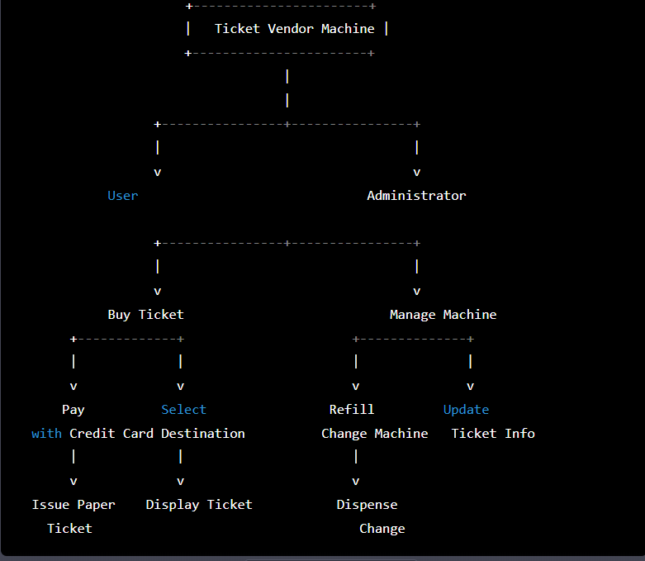

1. The passenger presses the "Start" button on the ticket vending machine.
2. The machine displays a menu of potential destinations.
3. The passenger selects their desired destination from the menu.
4. The machine prompts the passenger to input their credit card details.
5. The passenger inputs their credit card information.
6. The machine validates the credit card information.
7. If the credit card information is invalid, the process ends and the machine displays an error message.
8. If the credit card information is valid, the machine charges the passenger's credit card account.
9. The machine issues a paper ticket with a bar code.
10. The process ends.

**Require 4:**

Activity diagram for Ticket Vendor Machine:

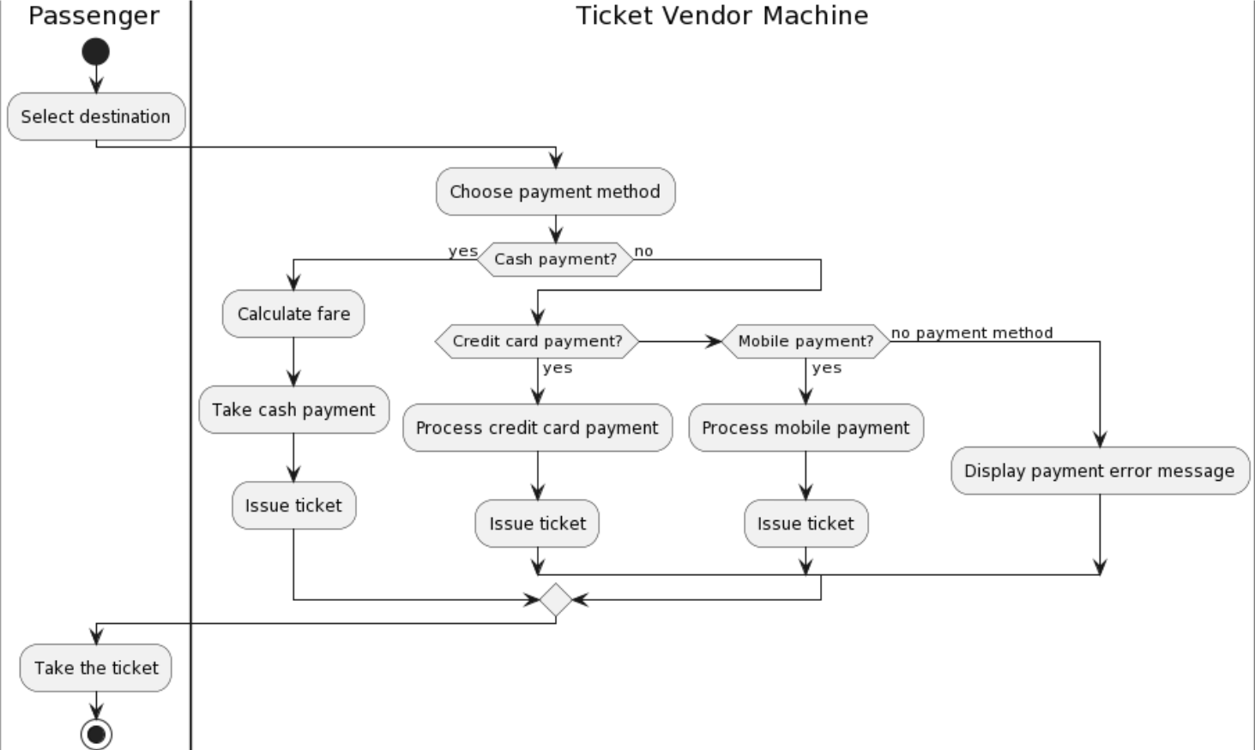

Here is the activity diagram for the communication among systems if the ticket vendor machine is integrated with other systems like Momo, VNPay, and ZaloPay:

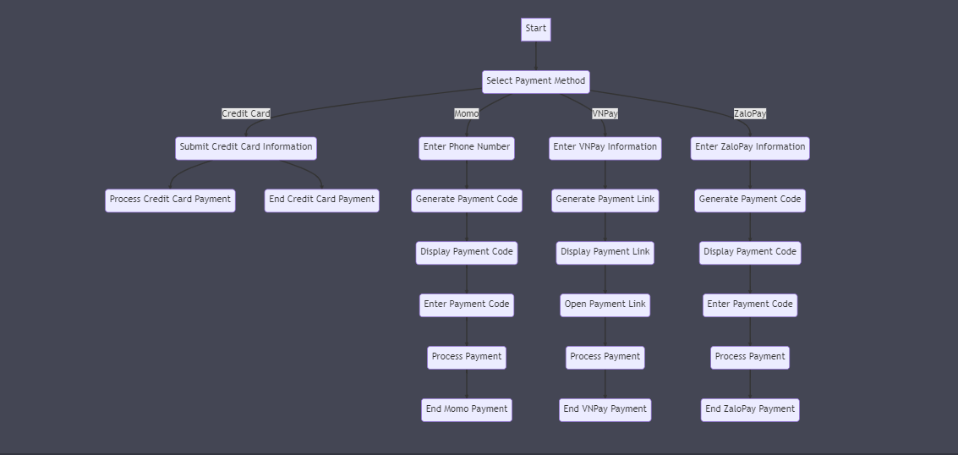

**Require 5:**

Sequence Diagram:

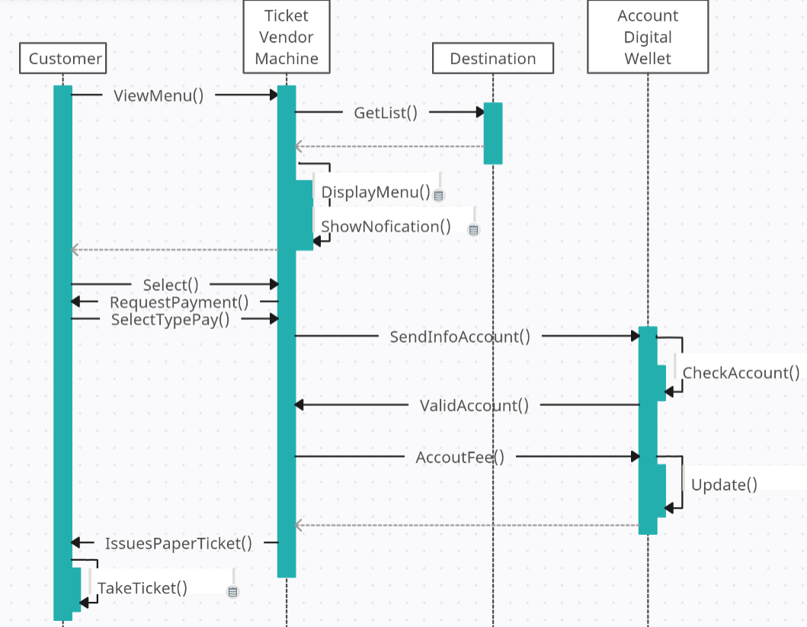

State Chart Diagram:

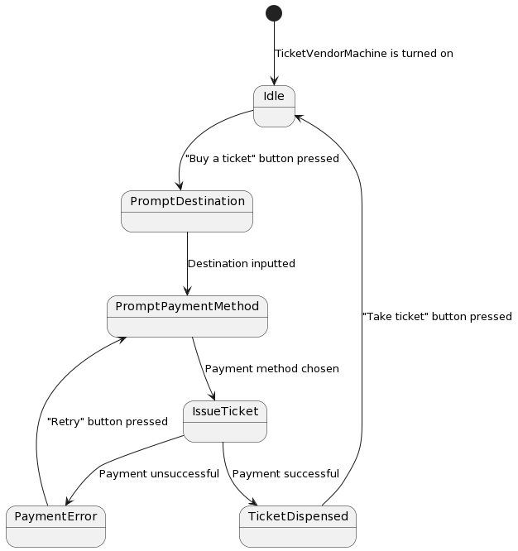

Class Diagram:

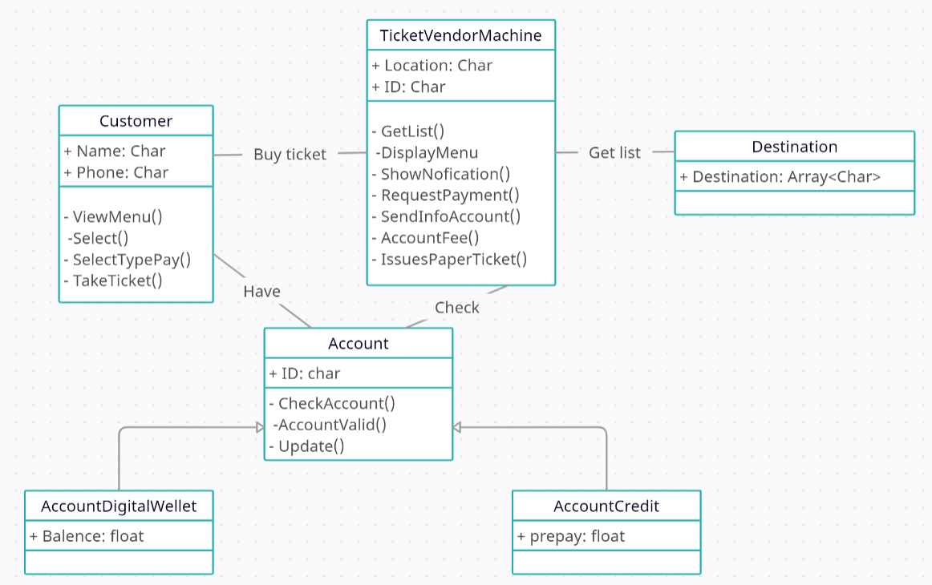

**Require 7:**

MVC model:

