CellockAI
Installation & Setup Guide
Your AI-powered coding companion for VS Code
Version 0.17.1 • July 2026

Table of Contents
Prerequisites 3
1. Install the Extension 3
Option A: Install from VSIX (Recommended) 3
Option B: Install from VS Code Marketplace 3
Verify Installation 3
2. Configure Model Profiles 3
Switching Profiles 4
3. Codebase Memory & Graph 4
Step 1: Configure MCP Server 4
Step 2: Open Settings → Codebase Index 5
Step 3: Install Binary 5
Step 4: Index Current Project 5
Step 5: Browse the Graph 6
Step 6: Query via Agent 6
4. Document Indexing & Search 6
Step 1: Start the Indexer Server 6
Step 2: Configure MCP Server 7
Step 3: Connect 7
Step 4: Index Documents 7
Step 5: Search 7
Step 6: Available Agent Tools 7
5. Database (PostgreSQL) Connection 8
6. Real-World Scenarios 8
7. File Reference 11
8. Troubleshooting 12

Prerequisites
Before installing CellockAI, ensure you have the following:

VS Code 1.85+ or a compatible editor (Cursor, Windsurf, etc.)
Node.js 18+ required for MCP servers and the extension runtime

1. Install the Extension

Option A: Install from VSIX (Recommended)
Run the following command in your terminal:
code --install-extension apps/vscode/cellock-ai-0.17.1.vsix

Alternatively, use the VS Code UI: Extensions → … (ellipsis) → Install from VSIX… → select the .vsix file.
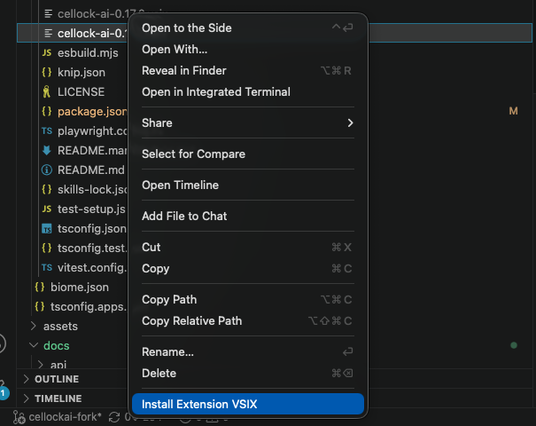

Verify Installation
Open VS Code, press Cmd+Shift+P (Mac) or Ctrl+Shift+P (Windows/Linux), type CellockAI: Open. The CellockAI chat panel should appear in the sidebar.

2. Configure Model Profiles
CellockAI uses model profiles stored in <workspace>/.cellockai/profiles.json to switch between different LLM backends. Create this file in your workspace root:

{
"activeProfileId": "180ddee5-9778-4b0f-afd5-3c2f38fe412d",
"profiles": [
{
"id": "f3205c96-f7f5-4d44-9a4b-be7bb9467cd9",
"name": "haiku",
"baseUrl": "http://10.60.70.4:20128/v1",
"modelId": "haiku",
"apiKey": "sk-6db89dd1d6ea53a4-3jz4jf-801430d0"
},
{
"id": "180ddee5-9778-4b0f-afd5-3c2f38fe412d",
"name": "opus",
"baseUrl": "http://10.60.70.4:20128/v1",
"modelId": "opus",
"apiKey": "sk-6db89dd1d6ea53a4-3jz4jf-801430d0"
}
]
}

Field | Description
activeProfileId | The profile used by default when the workspace opens
profiles[].id | Unique UUID for each profile
profiles[].name | Display name shown in the profile selector
profiles[].baseUrl | OpenAI-compatible API endpoint
profiles[].modelId | Model identifier passed to the API
profiles[].apiKey | API key for authentication

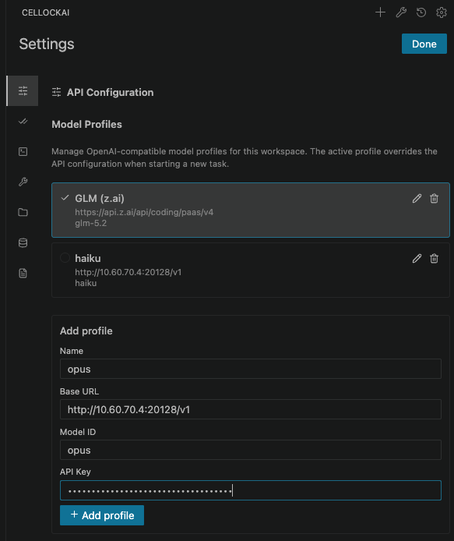

Switching Profiles
Open Settings → API Configuration and select your active profile from the dropdown, or edit activeProfileId directly in the JSON file.

3. Codebase Memory & Graph
The Codebase Memory & Graph tab indexes your codebase into a knowledge graph so the AI agent can search functions, trace call paths, and understand architecture.
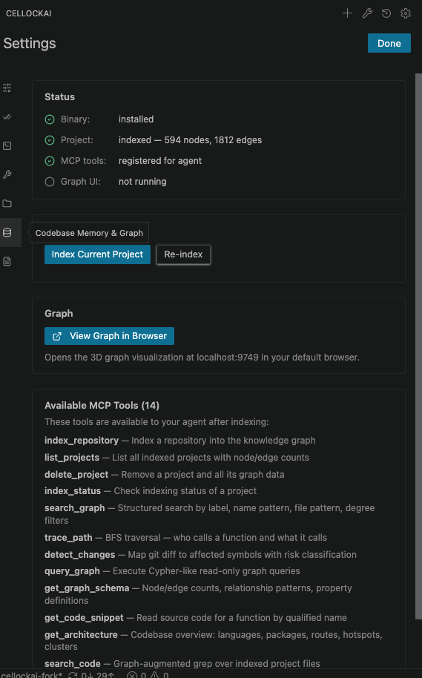

Step 1: Open Settings → Codebase Index
Navigate to Settings → Codebase Index (gear icon → "Codebase Memory & Graph" tab).

Step 2: Install Binary
If the binary is not installed, click Install in the Status card. The extension downloads the codebase-memory-mcp binary to <extension-globalStorage>/cellockai.cellock-ai/codebase-memory-mcp/.

After installation, the status shows:
Check | Status
Binary | installed (v0.x.y)
Project | not indexed
MCP tools | registered for agent
Graph UI | not running

Step 4: Index Current Project
Click Index Current Project in the Indexing card. A log panel shows progress. Indexing extracts:
Functions and classes — signatures, parameters, and docstrings
Call graphs — who calls whom, data flow between functions
Routes and APIs — HTTP endpoints, async channel subscriptions
Imports and dependencies — cross-file relationships

Step 5: Browse the Graph
Click View Graph in Browser to open the 3D knowledge graph at localhost:9749.

Step 6: Query via Agent
After indexing, your agent has these MCP tools available:

Tool | Description
search_graph | Find functions, classes, routes by name or natural-language query
trace_path | Follow call chains (callers/callees) up/downstream
get_code_snippet | Read source code for any indexed function or class
query_graph | Run Cypher queries for complex structural patterns
get_architecture | Get high-level architecture overview with package clusters

Example agent prompt:
"Find all functions that call sendMessage and trace the data flow into it."

4. Document Indexing & Search
The Document Indexing & Search tab connects to a Document Indexer server for full-text and semantic search across documents, specs, and notes.

Step 1: Configure MCP Server
Navigate to Settings → Document Index. Enter the server URL: http://10.60.70.4:8080 (default http://localhost:8080) and click Connect. The green indicator confirms connection.
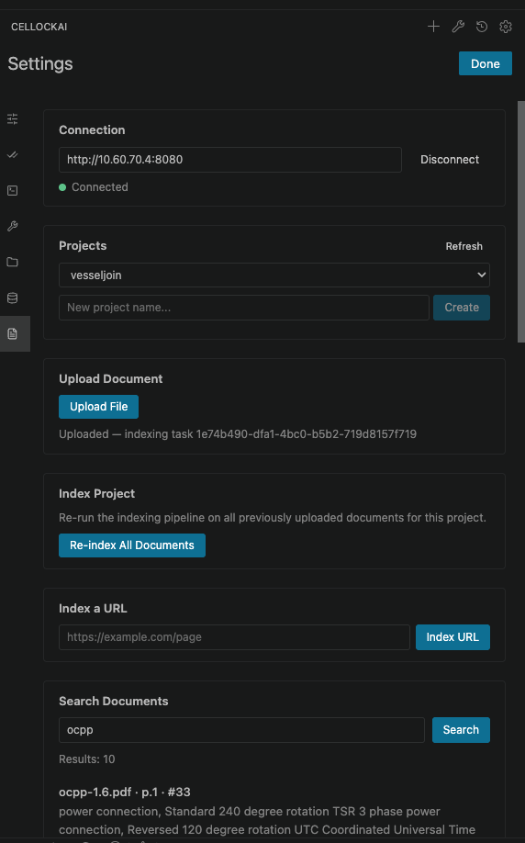
It will pre-select the project based on current working dir, if your project is not showed in the list, feel free to enter new project name to create it

Step 2: Configure MCP Server
.cellockai/mcp_settings.json should contain the vessel-indexer entry:

{
"mcpServers": {
"vessel-indexer": {
"type": "streamableHttp",
"url": "http://localhost:8080/mcp",
"disabled": false
}
}
}

Step 4: Index Documents
The tab provides several indexing options:
Upload — Upload files (PDF, markdown, text) directly
Index Batch — Batch-index a directory of documents
Index — Index from a URL or by crawling a documentation site
Upload a document to start indexing, when finish uploading it, there will be a task id to cehck with task inspector to see when it finish
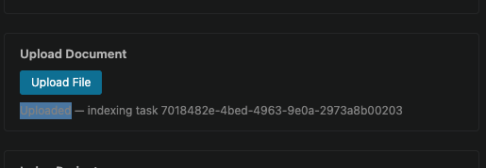
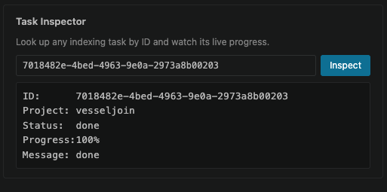

Step 5: Search
Use the Search card to query indexed documents. Results return relevant chunks with source context.
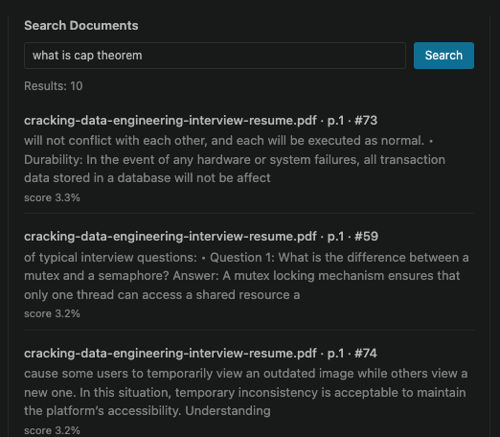
In the extension
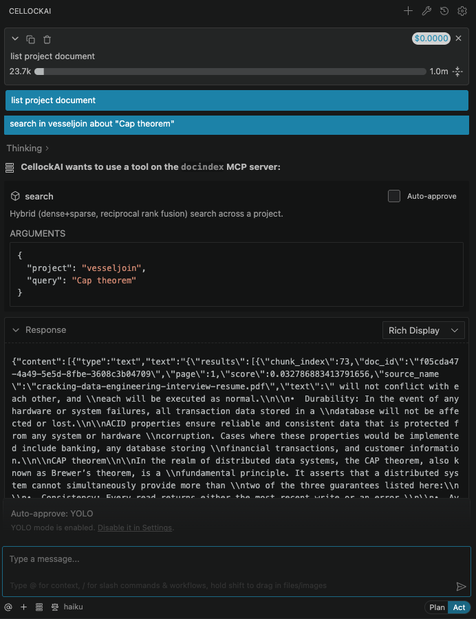

Step 6: Available Agent Tools

Tool | Description
search | Hybrid dense+sparse retrieval; ranked chunks with source context
index_document | Index a local document file
index_url | Index a document at a URL
get_task | Check the status of an indexing task
create_project | Create a new vessel-indexer project
list_projects | List existing vessel-indexer projects
delete_document | Delete an indexed document

5. Database (PostgreSQL) Connection
The Database tab connects a live PostgreSQL database as an MCP server so the agent can query current schema and data. In Settings → Database (or MCP → Add Database), enter a name (default toolbox-postgres), host, port, database, user, and password. On Add Server, the extension writes a stdio entry to .cellockai/mcp_settings.json that runs the upstream @toolbox-sdk/server via `npx -y @toolbox-sdk/server --prebuilt=postgres --stdio`.
Tools (defined by the npm package, not the extension): list_tables, execute_sql.
Safety: provision a READ-ONLY database role for this MCP. execute_sql is read/write — never run INSERT/UPDATE/DELETE/DROP/ALTER/TRUNCATE/CREATE through the MCP; schema and data changes go through migrations/app code. The Cellock database requires a VPN. Always use GUID (never auto-increment IDs) and never expose auto-increment IDs in results.

6. Real-World Scenarios
Scenario A: Onboard onto a Large Codebase
Problem: New developer joins a team with a 500K+ line monorepo.

Setup:
1. Install CellockAI from VSIX
2. Index the monorepo via Codebase Index → Index Current Project (~5 min)
3. Open the graph to visualize module boundaries

Daily workflow:
• "Show me the architecture of the payments module" — agent calls get_architecture and returns a package-level summary with interdependencies
• "Who calls chargeCreditCard?" — agent traces 3 levels deep showing every caller, their modules, and argument shapes
• "What edge cases does the checkout handler handle?" — agent queries the graph for functions called by the checkout handler, returning docstrings and error paths
• "Where is the SQL query for user orders built?" — agent search_graph finds the exact function + file + line

Value: Days of code spelunking compressed into seconds of chat.
Scenario B: Multi-Model Workflow (Cost Optimization)
Problem: Use a cheap/fast model for simple tasks and a powerful model for complex reasoning.

Setup:
1. Create two profiles (haiku and opus) in .cellockai/profiles.json
2. Set haiku as default for quick queries

Daily workflow:
• "Refactor this variable name" → haiku handles it in <1s
• "Design the architecture for a new billing system" → switch to opus for deep reasoning
• "Explain this error message" → haiku is sufficient
• "Review this security-critical diff" → switch to opus for thorough analysis

Value: Cut API costs ~80% while keeping peak capability on tap.
Scenario C: Documentation-Driven Development
Problem: Internal documentation is spread across markdown files, Notion exports, and API specs.

Setup:
1. Start the Vessel Indexer server
2. Connect via Document Index → Connection card
3. Upload/batch-index all documentation directories
4. Index the codebase via Codebase Index

Daily workflow:
• "What's the API contract for the user service?" → agent queries docs-index and codebase graph in parallel, cross-references implementation against docs
• "Does the code match the spec for authentication?" → agent reads indexed spec + indexed code, compares, reports discrepancies
• "Find all places where we deviate from the coding standards doc" → agent searches the doc for rules and the code graph for violations

Value: One chat interface to ask "what does the spec say?" and "what does the code do?" — no more context-switching between docs and IDE.
Scenario D: Automated Code Review with Agent Tools
Problem: Catching subtle bugs needs deep understanding of downstream effects.

Setup:
1. Codebase indexed
2. Agent configured to use trace_path and search_graph autonomously

Daily workflow:
• Paste a diff into chat: "Review this change"
• Agent automatically calls trace_path on modified functions to find all callers
• Agent calls get_code_snippet on affected callers to understand impact
• Agent queries for test coverage of affected paths via search_graph
• Returns a review with downstream impact assessment, untested paths, and potential regressions

Value: Code review becomes impact-aware, catching regressions before they ship.
Scenario E: Cross-Project Architecture Discovery
Problem: Your codebase has multiple services (frontend, API, worker, shared libraries) in separate repos.

Setup:
1. Index each repo (open each in VS Code, run Index Current Project)
2. Use cross-repo intelligence: each index captures internal routes and channels

Daily workflow:
• Ask "What happens when the frontend calls /api/orders/create?"
• Agent traces: frontend route → API HTTP endpoint → worker async channel → email service
• Each hop is a different repo, but the graph connects them through route/channel matching
• Result: an end-to-end flow diagram across all services

Value: Service boundaries disappear — agents reason across your entire system.

7. File Reference
File | Purpose
.cellockai/profiles.json | Model profile definitions
.cellockai/mcp_settings.json | MCP server configurations
.cellockai/mcp.json | Project-level MCP merge source (optional)
.cellockai/skills/ | Local skills directory
.cellockai/rules/ | Project rules and instructions
.cellockai/rules/workflows/ | Workflow definitions
.cellockai/rules/hooks/ | Hook scripts
.cellockai/sessions/history.json | Session history

8. Troubleshooting
Symptom | Likely Fix
"Profile not found" | Verify activeProfileId matches a profile id in .cellockai/profiles.json
MCP server disconnected | Check .cellockai/mcp_settings.json syntax; re-open settings to trigger reload
Binary not installing | Check network access to the download URL; manual install via Settings UI
Document Index not connecting | Ensure Vessel Indexer server is running on the configured port
Indexing very slow | Use "fast" index mode for initial pass; full mode for targeted analysis
Agent not using MCP tools | Ensure mcpServerRegistered shows as registered in Codebase Index status card

