1. KPI
1.1. Total Revenue
select sum(total_price) Total_Revenue from pizza_sales;
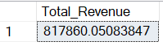
1.2. Average Order Value
select sum(total_price) / count(distinct order_id) Average_Order_Value from pizza_sales;
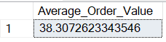
1.3. Total Pizza Sales
select sum(quantity) Total_Pizza_Sold from pizza_sales;
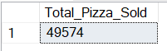
1.4. Total Orders
select count(distinct order_id) Total_Orders from pizza_sales;
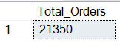
1.5. Average Pizza per Order
select cast(
cast(sum(quantity) as decimal(10,2)) /
cast(count(distinct order_id) as decimal(10,2)) as decimal(10,2))
Avg_Pizza_per_Order from pizza_sales;
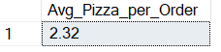

2. Daily Trend for Total Orders
select datename(DW, order_date) order_date,
count(distinct order_id) Total_Orders
from pizza_sales
group by datename(DW, order_date);
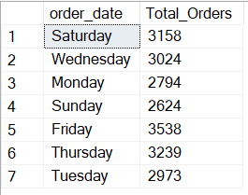

3. Monthly Trend for Total Orders
select datename(month, order_date) Month_Name,
count(distinct order_id) Total_Orders
from pizza_sales
group by datename(month, order_date)
order by Total_Orders desc;
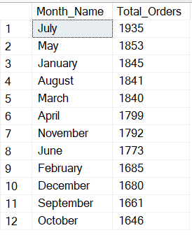

4. Percentage of Sales by Pizza Category
4.1. Percentage of Sales by Pizza Category per Month
create procedure calc_pct_sale
@month int
as
begin
select pizza_category,
cast(sum(total_price) as decimal(10,2)) Total_Sales,
cast(sum(total_price) * 100 / (select sum(total_price)
from pizza_sales
where MONTH(order_date) = @month)
as decimal(10,2)) Percentage_Sales
from pizza_sales
where MONTH(order_date) = @month
group by pizza_category;
end;

exec calc_pct_sale 12
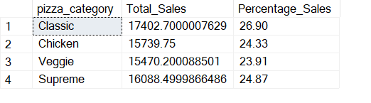
4.2. Percentage of Sales by Pizza Category over Year
select pizza_category,
cast(sum(total_price) as decimal(10,2)) Total_Sales,
cast(sum(total_price) * 100 / (select sum(total_price)
from pizza_sales )
as decimal(10,2)) Percentage_Sales
from pizza_sales
group by pizza_category;
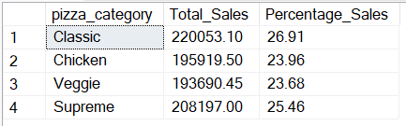

5. Percentage Sales by Pizza’s Size
5.1. Per Month
create procedure pct_sales_pizza_size_month
@month int
as
begin
select pizza_size,
cast(sum(total_price) as decimal(10,2)) Total_Sales,
cast(sum(total_price) * 100 / (select sum(total_price)
from pizza_sales
where MONTH(order_date) = @month)
as decimal(10,2)) Percentage_Sales
from pizza_sales
where MONTH(order_date) = @month
group by pizza_size;
end;

exec pct_sales_pizza_size_month 1
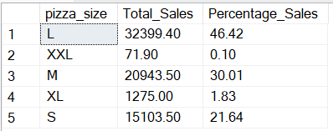

5.2. Per Quarter
create procedure pct_sale_pizza_quarter
@quarter int
as
begin
select pizza_category,
cast(sum(total_price) as decimal(10,2)) Total_Sales,
cast(sum(total_price) * 100 / (select sum(total_price)
from pizza_sales
where Datepart(quarter,order_date) = @quarter)
as decimal(10,2)) Percentage_Sales
from pizza_sales
where Datepart(quarter,order_date) = @quarter
group by pizza_category;
end;

exec pct_sale_pizza_quarter 2
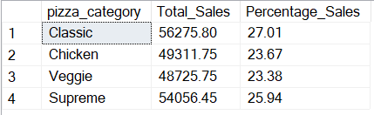
5.3. Over year
select pizza_size,
cast(sum(total_price) as decimal(10,2)) Total_Sales,
cast(sum(total_price) * 100 / (select sum(total_price)
from pizza_sales )
as decimal(10,2)) Percentage_Sales
from pizza_sales
group by pizza_size
order by Percentage_Sales DESC;
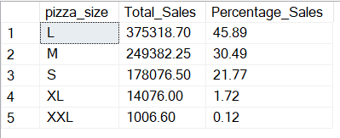

6. Total Pizza Sold by Category

select pizza_category,
cast(sum(total_price) as decimal(10,2)) Total_Revenue
from pizza_sales
group by pizza_category;
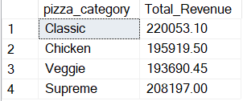

7. Top 5 Pizza by Revenue
select top 5 pizza_name,
cast(sum(total_price) as decimal(10,2)) Total_Revenue
from pizza_sales
group by pizza_name
order by Total_Revenue DESC;
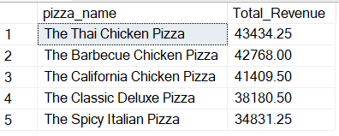

8. Bottom 5 Pizza by Revenue
select top 5 pizza_name,
cast(sum(total_price) as decimal(10,2)) Total_Revenue
from pizza_sales
group by pizza_name
order by Total_Revenue ASC;
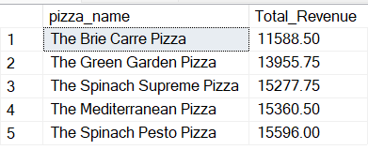
9. Top 5 Pizza by Quantity
select top 5 pizza_name,
sum(quantity) Quantity
from pizza_sales
group by pizza_name
order by Quantity DESC;
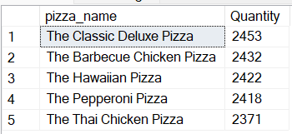

10. Bottom 5 Pizza by Quantity
select top 5 pizza_name,
sum(quantity) Quantity
from pizza_sales
group by pizza_name
order by Quantity ASC;
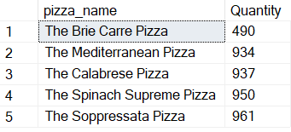

11. Top 5 Pizza by Total Order
select top 5 pizza_name,
count(distinct order_id) Total_Orders
from pizza_sales
group by pizza_name
order by Total_Orders DESC;
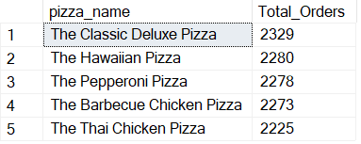

12. Bottom 5 Pizza by Total Order
select top 5 pizza_name,
count(distinct order_id) Total_Orders
from pizza_sales
group by pizza_name
order by Total_Orders ASC;
