**DATABASE SYSTEMS SS2021**

**ASSIGNMENT 1**

MEMBER LIST:

Nguyễn Duy Thanh – 1813967

Nguyễn Quang Tùng – 1814701

Nguyễn Ngọc Tân – 1813942

**I. BUSINESS DESCRIPTION**

ABC Bank has many branches. Each branch has a unique name, an address (including No., Street, District, City, and Region), phone numbers, fax numbers, email, and total number of employees working there. Each branch has many employees and an employee must work at a branch. There is always one employee assigned to manage that branch. The employee can only manage the office to which he or she is assigned. For each employee, we need to store a unique code, first name, last name, date of birth, phone numbers, email, and home address (including No., Street, District, and City).

The bank issues three different types of bank accounts for their customers. For Savings Accounts, the bank must keep track of the account’s balance, interest rate, and the date the account was opened. Checking Accounts pay no interest, so the bank keeps track of just the balance and date opened. The third type of account, Loans, requires tracking the date the loan was taken, the balance due, and the interest rate of the loan. Each customer may have any number of bank accounts, and all accounts have a unique account number. The bank save the following information of each customer: a unique code, first name, last name, home address, office address, phone numbers, email. Each customer is attended by an employee and an employee can serve many customers.

**II. REQUIREMENTS**

1. Design a fully labelled (E)ERD according to your business description. The diagram has to show appropriate entities (with key attributes underlined), relationships, cardinality ratios, and optional & mandatory membership classes.

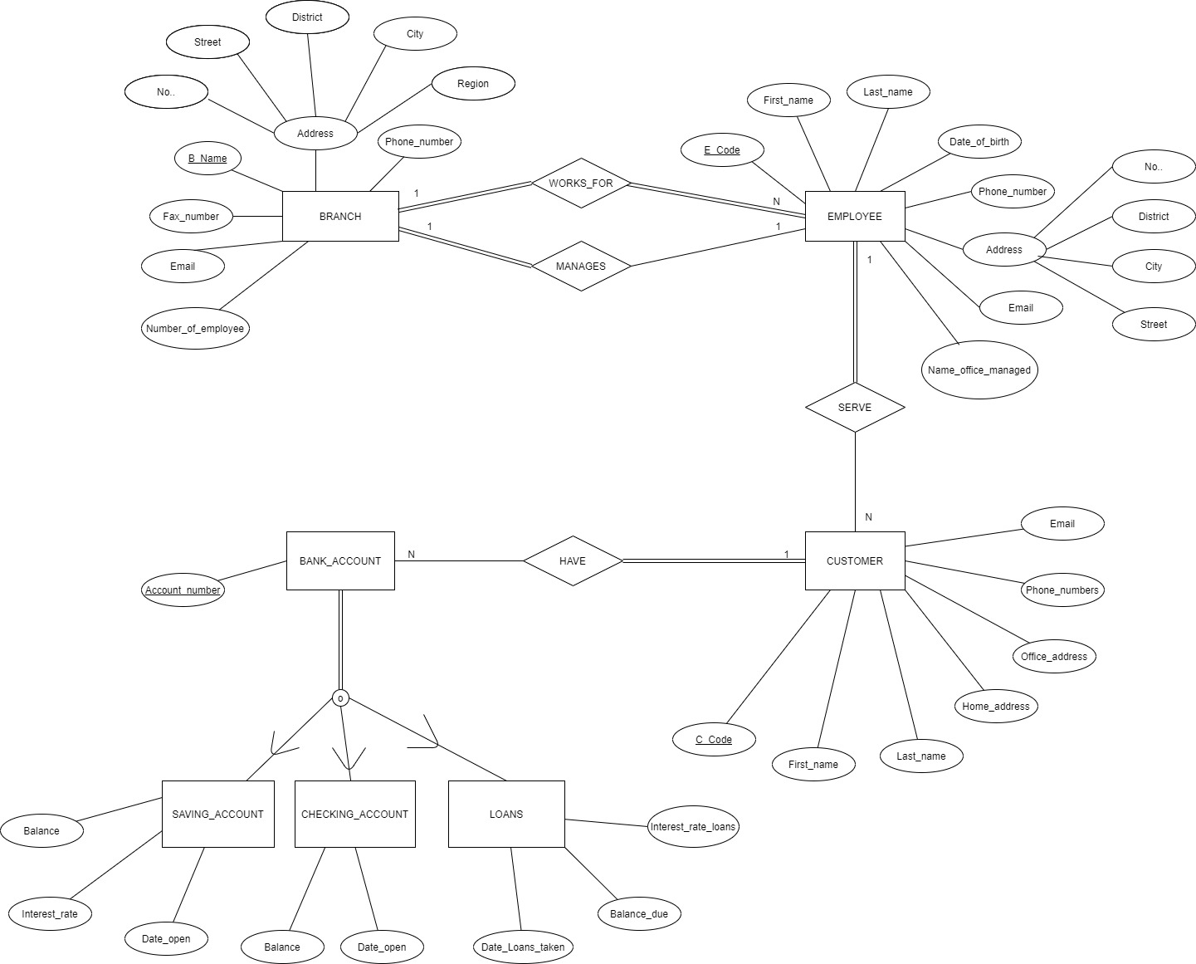

1. Mapping your (E)ER diagram above to a relational database schema.

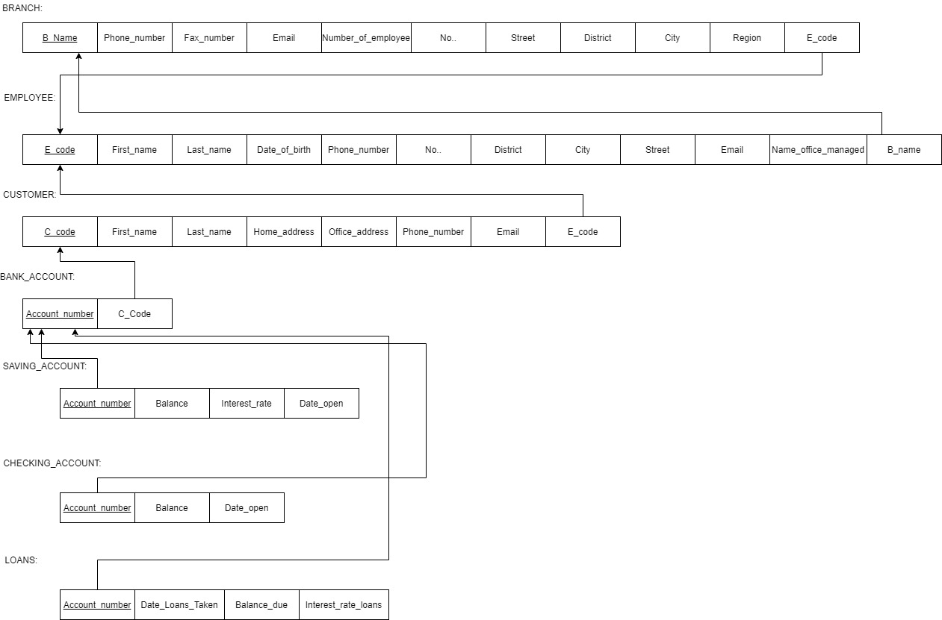

1. Identify all constraints not shown in your (E)ER diagram.

Ràng buộc thứ nhất không được thể hiện trong (E)ER diagram của tụi em là: phòng ban mà nhân viên quản lí có ở trong chi nhánh đó hay không chưa được thể hiện. Ở trên nhóm em chỉ để thành thuộc tính tên phòng ban mà nhân viên đó quản lí theo mô tả của bài “The employee can only manage the office to which he or she is assigned”.

Ràng buộc thứ 2 chính là: chưa thể hiện được tài khoản ngân hàng và chi nhanh có thể không cùng ngân hàng.

Khắc phục: giả sử mỗi phòng ban thuộc chi nhánh buộc có 1 nhân viên quản lí.

