Contents

Prerequisite 1

Create a job base image 1

Create Persistent Volume Claim 1

Create a schedule job to backup 2

Restore from a file 6

# Prerequisite

A site (with a database) was already set up (and running) in the same AWS Openshift project.

Go to the project you want to by the command line: **oc project <project name>**

(in this sample, **oc project dn-story-test**)

# Create a job base image

1. Create an image using build config via command line:

**oc apply -f <path to template folder>\base_container_job_dn-story-test.yaml**

Then build it in Openshift or from command line

**oc start-build dn-story-container –n dn-story-test**

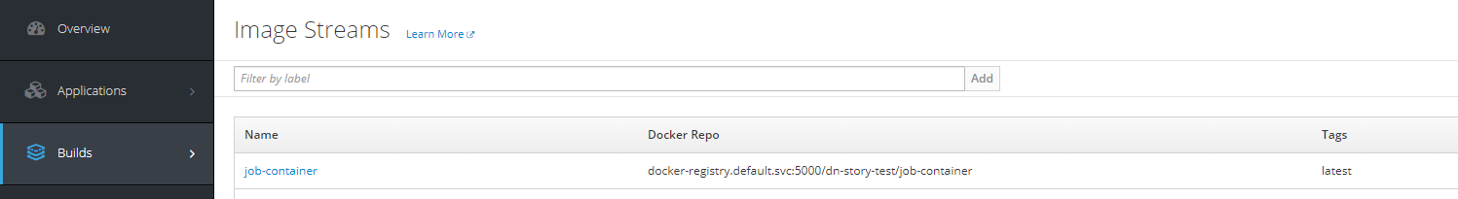

(Or hit the “Start Build” button on the UI of Openshift to build)

# Create Persistent Volume Claim

This PVC will store backup files of the scheduled job.

1. Create PVC using yaml via command line:

**oc apply -f <path to template folder>\pvc_creator.yaml**

It should then appear in the template resources list,

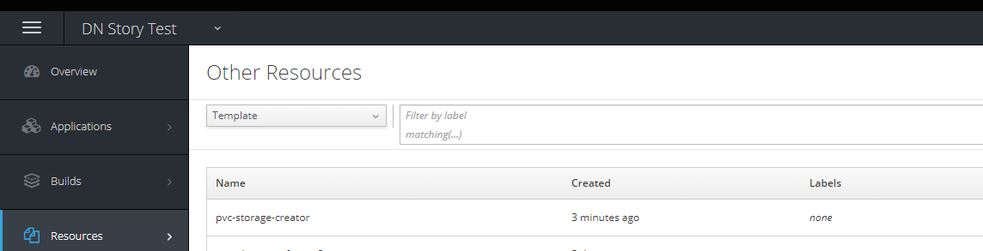

and in the catalog list

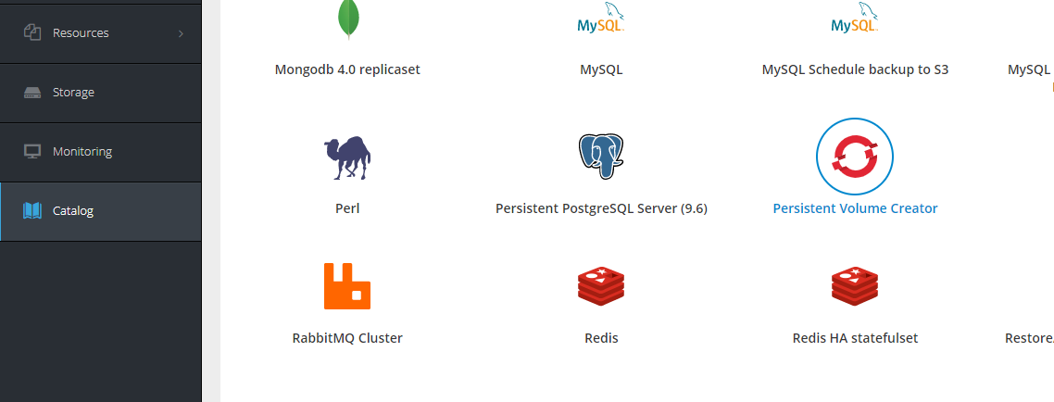

1. Click on the template in the Catalog, fill in the info and start experiencing

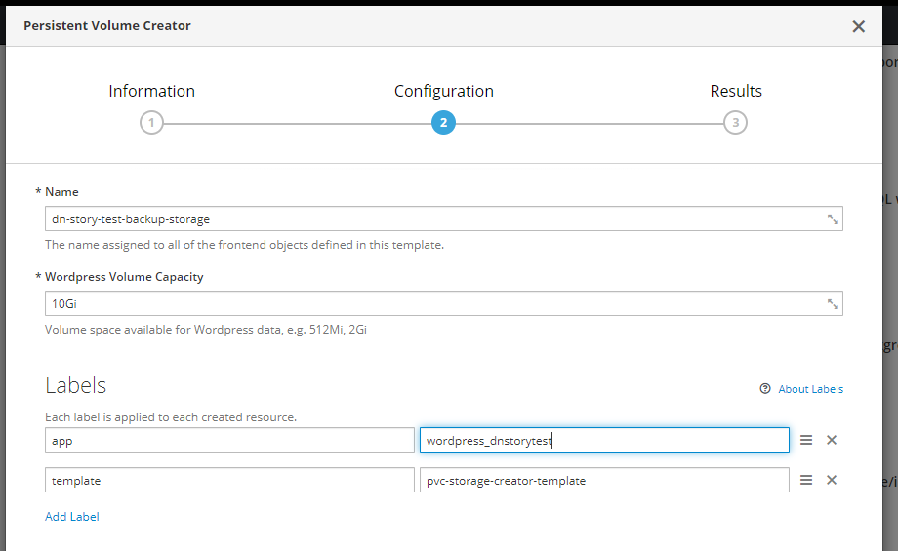

1. After created, we can see it in the Storage tab

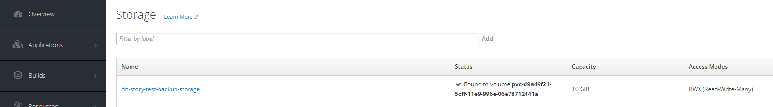

# Create a schedule job to backup

1. Create resources using template via command line:

**oc create -f <path to template folder>\mysql_cronjob_backup_s3_pvc.yaml**

It should then appear in the template resources list.

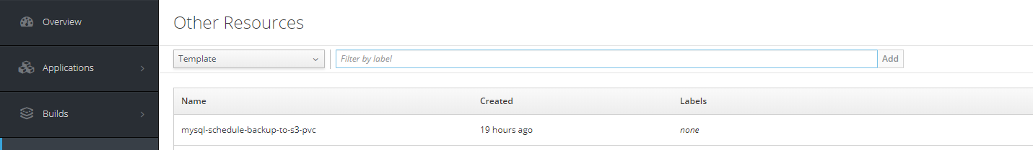

And catalog list

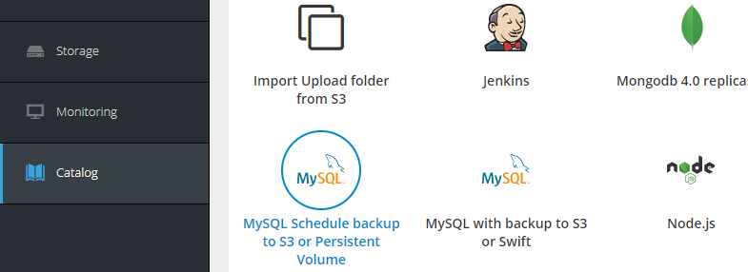

1. Click on the template in the Catalog, fill in the info and start experiencing

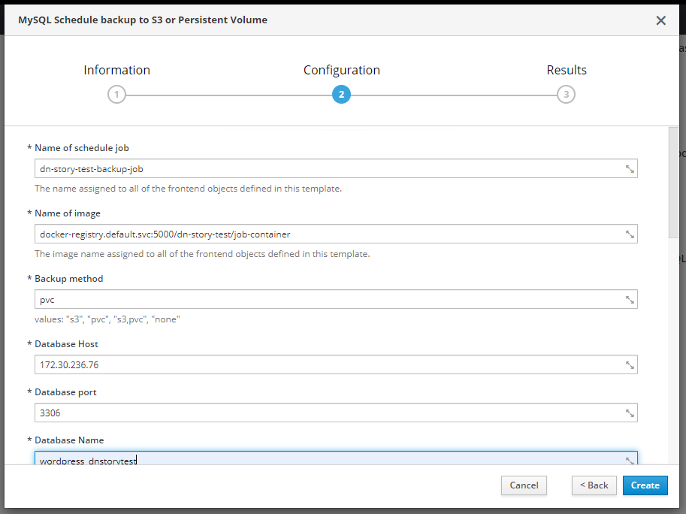

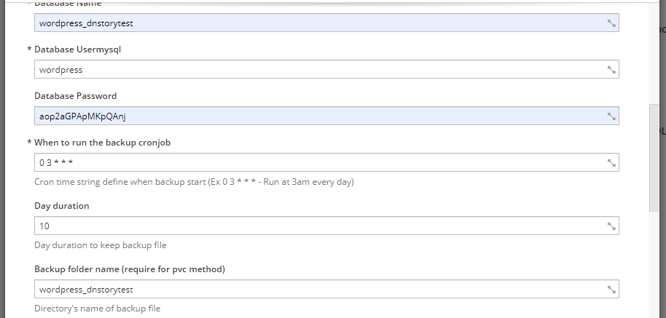

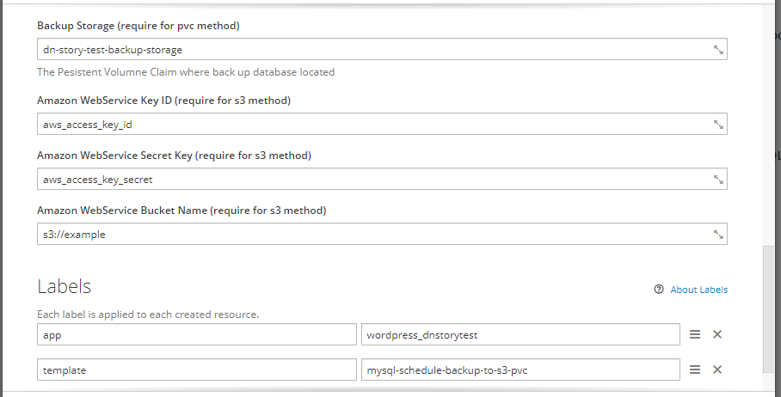

* ***Name of image***: This (image) has been built in the “Create job base image” section.
* ***Backup method***: This field will provide the method(s) we will use to store the SQL file.
  + S3: Store data in Amazon S3 Service
  + PVC: Store data in Persistent Volume Claim

We can fill more than one method for backup (see above screenshot).

* ***Database Host*** and ***Database port*** get from Service which created:

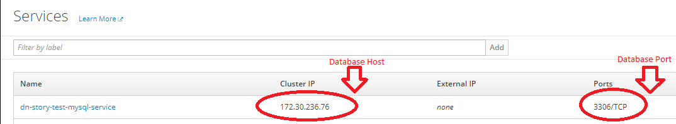

You can also take the Name of the database service to use as Host (instead of IP Address).

* ***Database Name***: You can get the value for this field from Deployments tab (Openshift UI)

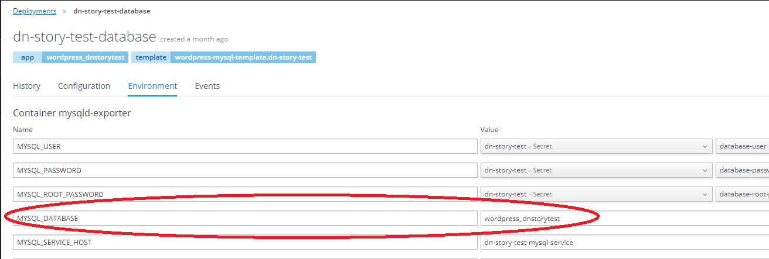

* ***Database Password***: You can get the value for this field from Secret tab (Openshift UI)

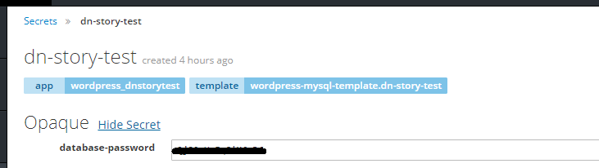

* ***Day duration***: if SQL files are older than this day, the script will remove them.
* ***Backup Storage***: **this field is only required when using PVC method**. This value is the name of storage which created from “Create Persistent Volume Claim” section
* ***Backup folder name***: this is a folder where SQL files are stored after backup. In PVC backup, the path to this folder will be: **“/data/backup/< Backup folder name >”**
* ***Amazon WebService Access Key ID & Amazon WebService Secret Key***: these fields are the values provided to access AWS S3 services. Reference:

<https://docs.aws.amazon.com/general/latest/gr/managing-aws-access-keys.html>

* ***Amazon WebService Bucket Name***: this path is the path of folder that will create backup folder and store SQL file into.

1. You will be able to see the job instances later on after it runs.

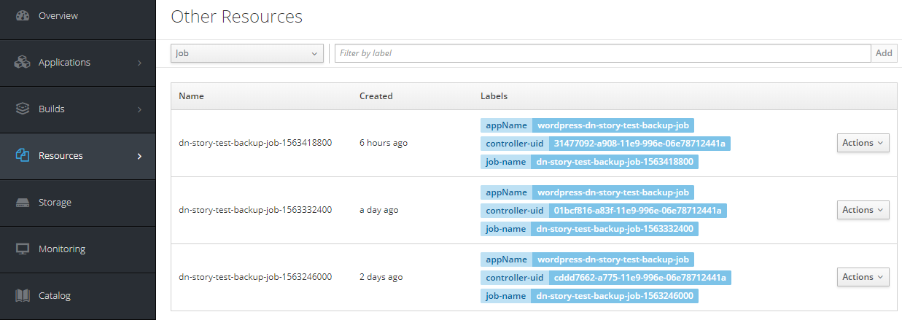

# Restore from a file

1. Create resources using template via command line:

**oc create -f <path to template folder>\mysql-restore-from-s3-pvc.yaml**

It should then appear in the template resources list.

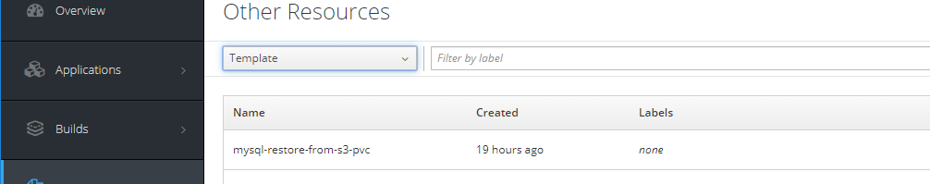

And catalog list

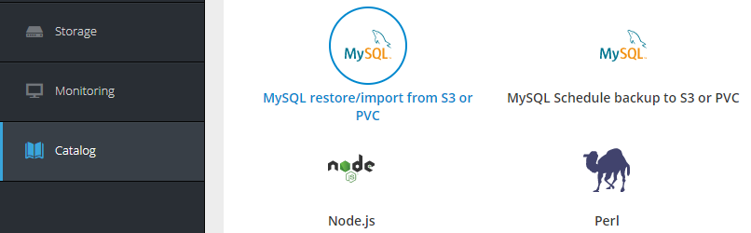

1. Click on the template in the Catalog, fill in the info and start experiencing

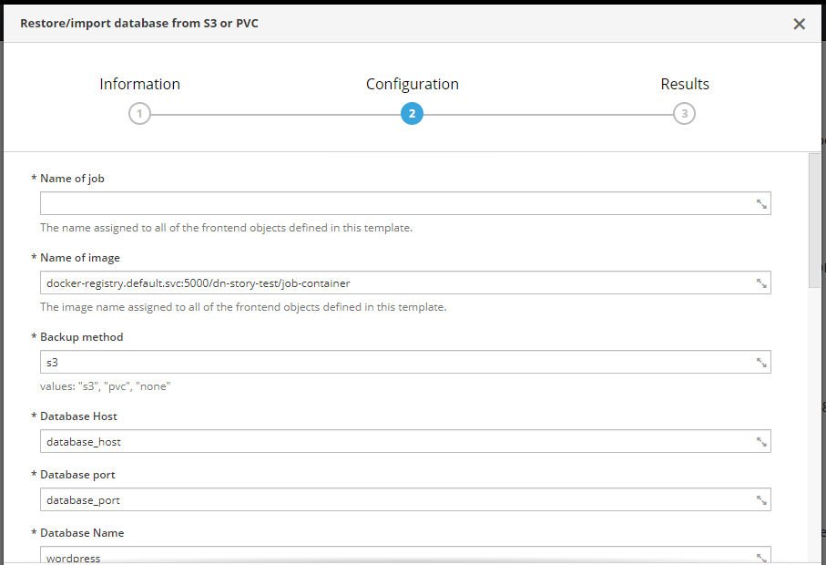

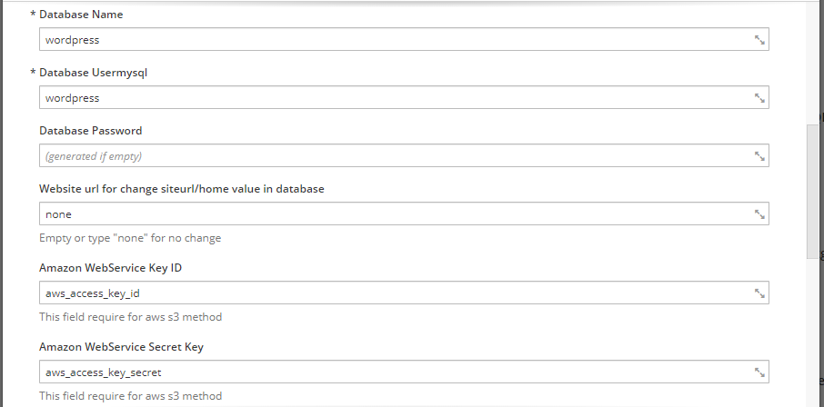

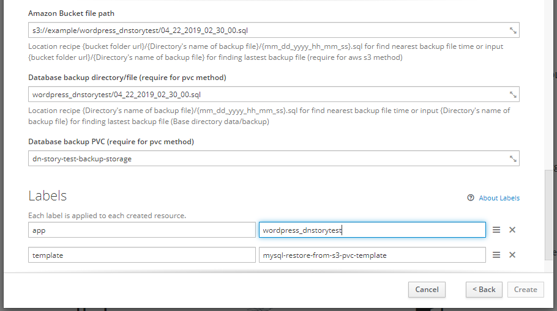

* ***Name of image***: This (image) has been built in the “Create job base image” section.
* ***Backup method***: This field will provide the method we will use to store the SQL file.
  + S3: Store data in Amazon S3 Service
  + PVC: Store data in Persistent Volume Claim

**This job only accepts one method per execution**

* ***Database backup PVC***: **this field only need when using PVC method**. This value is the name of storage which created from “Create Persistent Volume Claim” section

Optional Section:

* Restore with Amazon S3 method
  + Restore a specific file

***Amazon Bucket file path***: fill this field with the full path to SQL file.

If this file cannot be found, the script will analysis path and find another SQL file based on the correct format you enter. If your path is incorrect format, this job will not execute.

* + Restore the latest file

***Amazon Bucket file path***: fill this field to the folder contain SQL files. The script will access this folder and find the latest file in this folder

* Restore with Persistent Volume method
  + Restore with specific file location

***Database backup directory/file:*** fill this field with the full path of the SQL file.

If this file cannot be found, the script will separate the file name and the rest. The rest will add to “/data/backup/" and the script will find SQL file after analysis file name based on the correct format you enter. If your path is not the correct format, this job will not execute.

* + Restore the latest file

***Database backup directory/file:*** fill this field to the folder contain SQL files. The script will access “/data/backup/< dir backup provided >” and find the latest file in this directory.