**HANOI UNIVERSITY OF SCIENCE AND TECHNOLOGY**

**SCHOOL OF INFORMATION COMMUNICATION TECHNOLOGY**

**---o0o---**



**Scientific Computing Project**

**2D HEAT EQUATION PROBLEM**

**Group 3**

|  |  |
| --- | --- |
| **Dang Ngoc Huy** | **20200270** |
| **Vu Hong Quang** | **20205192** |
| **Bui Van Thanh** | **20200585** |
| **Ho Tran Anh Vu** | **20194885** |

*Under the assistance of:*

**Ph.D. Vu Van Thieu**

*Hanoi, 7/2022*

**Table of Contents**

0. TEAM MEMBERS: 4

1. PROBLEM DESCRIPTION. 5

2. NUMERICAL METHOD OF SOLVING THE PROBLEM OF HEAT EQUATIONS. 7

**2.1. THE SPATIAL DISCRETIZATION METHOD. 7**

**2.2. TIME INTEGRATION METHOD. 8**

**3. IMPLEMENTION. 10**

**3.1. INPUT PARAMETER. 10**

**3.2. SPATIAL DISCRETIZATION. 10**

**3.3. TIME INTEGRATION. 11**

**4. RESULT AND CONCLUSION. 12**

FINAL REPORT  
2D HEAT EQUATION PROBLEM

# TEAM MEMBERS:

|  |  |  |
| --- | --- | --- |
| **Member** | **Student ID** | **Tasks** |
| Đặng Ngọc Huy | 20200270 | * Demonstration video |
| Vũ Hồng Quang | 20205192 | * Code C |
| Bùi Văn Thành | 20200585 | * Code Matlab |
| Hồ Trần Anh Vũ | 20194885 | * Slides and report |

# 1. Problem dESCRIPTION.

A diffusion process, such as thermal diffusion in a solid or solute diffusion in a solution, can be modeled by a partial differential equation.

Consider a chemical compound that can be dissolved in a liquid. This chemical compound has a certain c (concentration) concentration (elements/m3). Assume that the compound moves in the solvent only through free diffusion (to eliminate the case of diffusion by solvent flow). We now go to find an equation that describes the concentration of c per small volume through Fick's law (which concerns a linear diffusion current with a concentration gradient).

Surface A

J

*Figure 1: Concentration gradient ∇c*

Let J be the flux or number of particles passing through a unit surface in a specified time (elements/m2s). Fick's law states that the flux J and the concentration gradient c are linearly dependent on each other according to the formula:

$J=-D.∇c$ [1]

Where D is the diffusion coefficient (m2/s).

dx

dz

dy

x

x + dx

Jx(x +dx)

x + dx

*Figure 2: Small volume dxdydz.*

Next, we consider a small volume block dV=dxdydz (Figure 2), and calculate the number of particles that diffuse into and out of this block. Do it by calculating in the three dimensions x, y, z independently, then add all the results obtained to get the total throughput. The number of elements passing through the block per unit time in the x dimension is given by the formula: (Jx(x)-Jx(x+dx))dydz, similarly we have the formulas for the y dimension and z dimension. Next, the total number of elements growing in the block must be equal to the number of elements that diffuse into the block. Therefore:

$$\frac{∂c}{∂t}dV= \left(J_{x}\left(x\right)-J_{x}\left(x+dx\right)\right)dydz$$

$+ \left(J_{y}\left(y\right)-J_{y}\left(y+dy\right)\right)dxdz+(J_{z}(z)-J_{z}(z+dz))dxdy$ [2]

Where t is the time. Dividing equation [2] by dV and assuming that dx, dy, dz → 0, we have:

$\frac{∂c}{∂t}= -\frac{∂J_{x}}{∂x}-\frac{∂J_{y}}{∂y}-\frac{∂J_{z}}{∂z}= -∇.J.$ [3]

$\frac{∂c}{∂t}= -\frac{∂J_{x}}{∂x}-\frac{∂J_{y}}{∂y}-\frac{∂J_{z}}{∂z}= -∇.J$ $\frac{∂c}{∂t}= -\frac{∂J_{x}}{∂x}-\frac{∂J_{y}}{∂y}-\frac{∂J_{z}}{∂z}= -∇.J$ Finally, combining [3] with the equation of Fick's Law [1] we get the diffusion equation:

$\frac{∂c}{∂t}= {D∇}^{2}c.$

# 2. Numerical method of solving the problem of Heat EQUATIONS.

We will solve Heat Equations [4] by numerical method, which includes two steps: spatial discretization and time integration.

## **2.1. The spatial discretization METHOD.**

Consider the problem of Heat Equations in a two-dimensional space of size MxM. In two-dimensional space, the Heat Equations takes the form:

$\frac{∂C}{∂t}=D(\frac{∂^{2}C}{{∂x}^{2}}+\frac{∂^{2}C}{{∂y}^{2}}$) [5]

To solve the above problem numerically, we first need to divide this MxM computational domain into a grid of points. Given the size of grid points in the x and y directions respectively dx and dy (dx=dy), we can determine the number of grid points in the x(m) and y(n) directions as follows:

m = M/dx,

n = M/dy.

Assume the grid points are addressed as (i,j), where :i = 0, 1, 2, …, m-1,

j = 0, 1, 2, …, n-1,

The position of the grid point (i, j) is determined as follows:

x = i * dx,

y = j * dy.

From here, the continuous points C(x,y) will be represented by C(i,j).

The way to divide the computational domain into a grid of points is described in Figure 3.

dx

dy

n

m

*Figure 3. Divides the computational domain into a grid of points*

After dividing the domain into a grid of points, we can calculate the right side of equation (5) using the Finite Difference Method.

Set :

$FD=\frac{∂^{2}C}{{∂x}^{2}}+\frac{∂^{2}C}{{∂y}^{2}}$ [6]

To calculate the second derivative of C with respect to x and y, we use the following formula:

$$\frac{∂^{2}C(i,j)}{{∂x}^{2}}=\frac{C\left(i+1,j\right)-2C\left(i,j\right)+C(i-1,j)}{{dx}^{2}}$$

$\frac{∂^{2}C(i,j)}{{∂y}^{2}}=\frac{C\left(i,j+1\right)-2C\left(i,j\right)+C(i,j-1)}{{dy}^{2}}$ [7]

From (6) and (7) we have:

$FD\left(i,j\right)= \frac{C\left(i+1,j\right)-2C\left(i,j\right)+C(i-1,j)}{dx^{2}}+ \frac{C\left(i,j+1\right)-2C\left(i,j\right)+C(i,j-1)}{{dy}^{2}}$ [8]

Equation (8) describes how to discretize Heat Equations over space.

## **2.2. time integration METHOD.**

After discretizing the system of Heat Equations according to space, we will obtain a system of ordinary differential equations (Ordinary Differential Equations) that depends on time t of the form:

$\frac{∂C(i,j)}{∂t}=FD(i,j)$ [9]

There are many methods to solve the ordinary differential equation (3.8), in this thesis we will use the forward Euler method.

The Euler method for solving differential equations usually has the following formula:

$C^{n+1}\left(i,j\right)= C^{n}\left(i,j\right)+{ht}^{*}FD^{n}(i,j)$ [10]

Where n is the nth computational step, ht is the time step length.

The forward Euler formula can be iteratively calculated as follows:

$$C^{1}\left(i,j\right)= C^{0}\left(i,j\right)+{ht}^{*}FD^{0}\left(i,j\right)$$

$$C^{2}\left(i,j\right)= C^{1}\left(i,j\right)+{ht}^{*}FD^{1}\left(i,j\right)$$

……. [11]

$$C^{n+1}\left(i,j\right)= C^{n}\left(i,j\right)+{ht}^{*}FD^{n}(i,j)$$

Where C­0 is the initial value.

# 3. ImPLEMENTION.

## **3.1.** **input parameter.**

## **3.2.** **Spatial Discretization.**

+) Matlab version:

+) C version:

## **3.3. TIME INTEGRATION.**

+) Matlab version:

+) C version:

# 4. RESULT AND CONCLUSION.

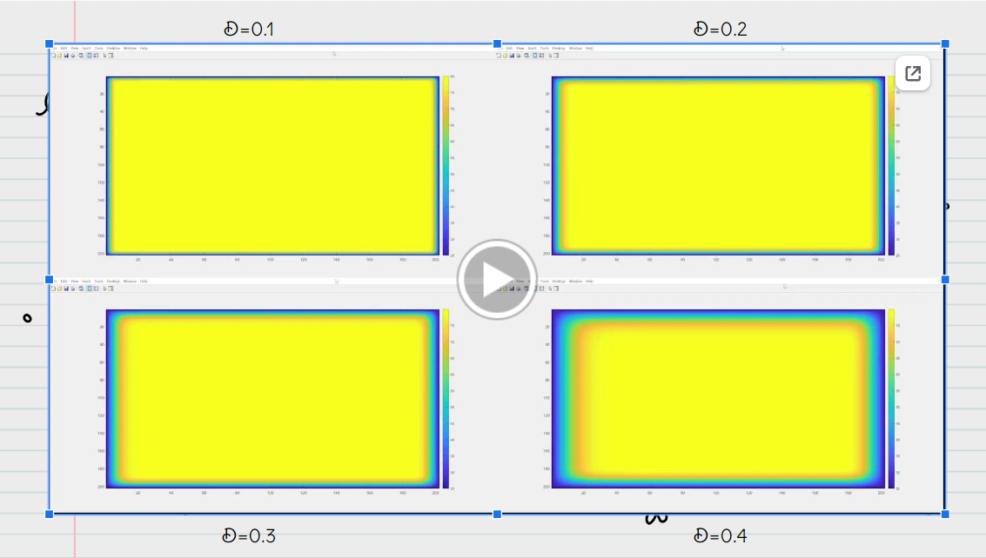

With different values of parameter D, we have different results, when D is smaller, we can see that the internal heat region is wider to the boundary.

Solving Heat Equation using Matlab is better than C in terms of speed and accuracy.