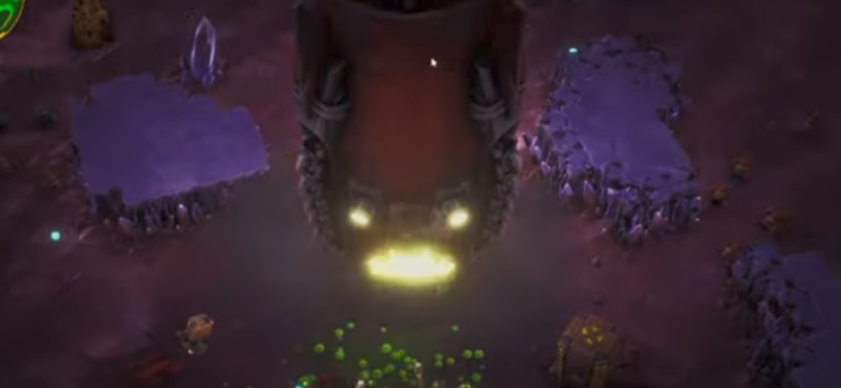

Procedurally generated map => Replayability => ease of access for level designer (example:Deep Rock)

Upgrade system=> Replayability(example:Hololive)

Gacha system=>Replayabilty(example:Hololive) this is not a priority.

Overcome challenge with superb optimization.

Good game feel=>the most important factor.

Stylized art=>easier to manage custom lighting.

Gameplay loop: Grind for resource=>buy upgrade=>grind more resource=>(buy character?)=>next map=>boss?=>next archetype map=>get more resource per playtime=repeat.

3 archetype map with different environments:

Lava map:

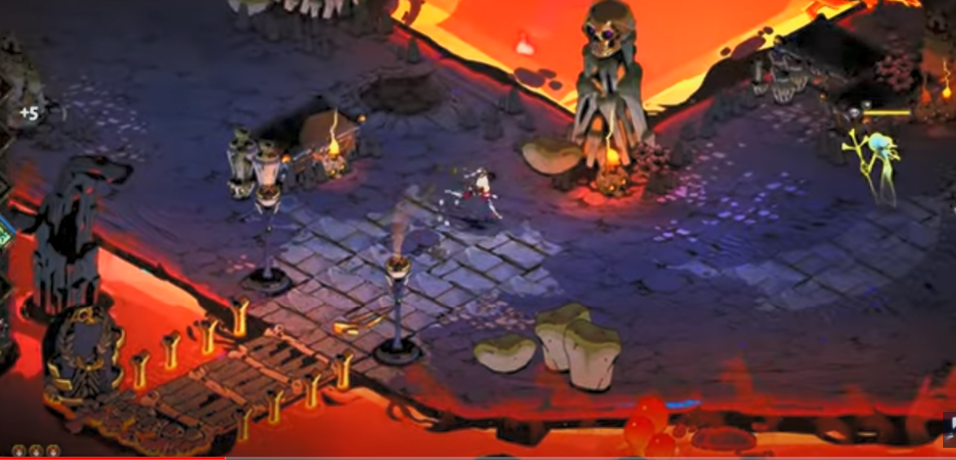

Snow map:

Interactive snow by using vertex shaders, can use enemy variant with similar concept.

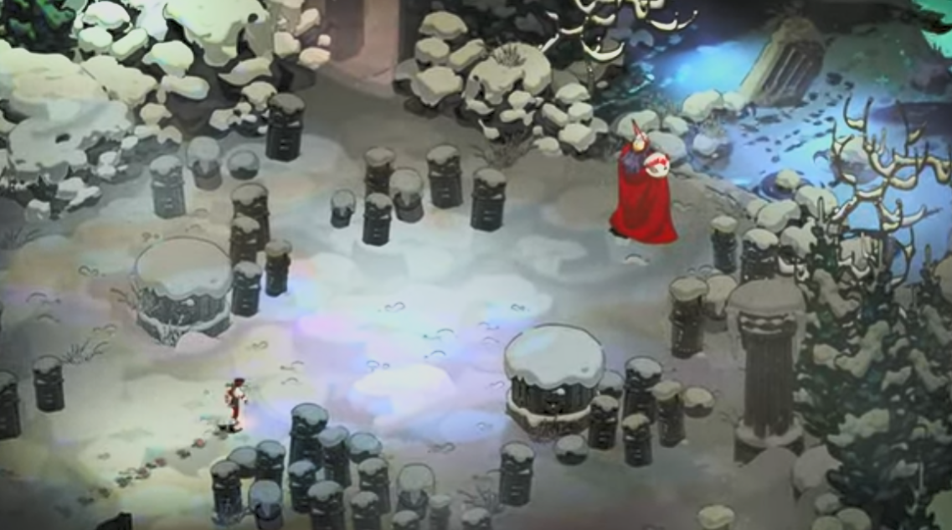

Jungle map:

Interactive foliage using vertex shaders

