B1: Đến trang <https://github.com/codegym-vn/wf-hello>

B2: Chọn Code => copy link

B3: mở Terminal gõ lệnh D: => enter => gõ cd Clone From Github => enter => gõ git clone (bỏ link đã copy) => enter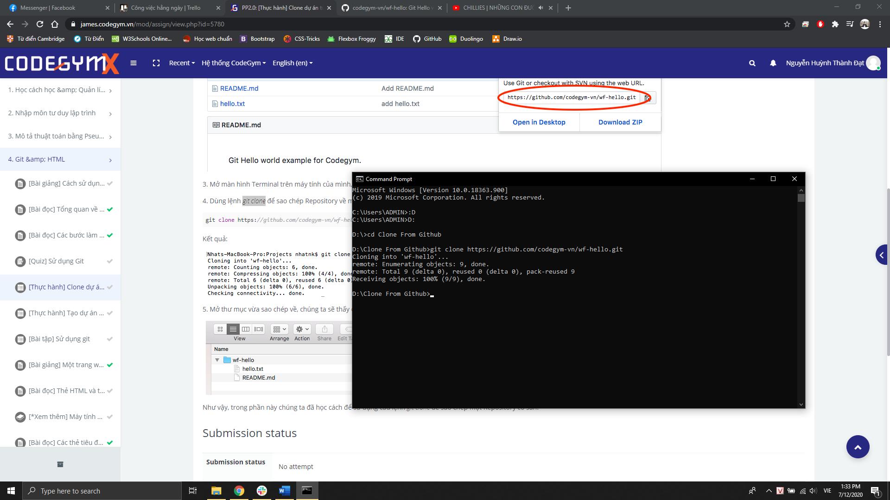

B4: mở file vừa Clone từ Github

