**Flowchart**

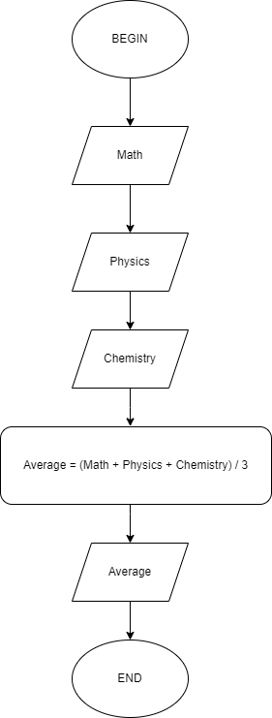

**Pseudo-code**

BEGIN

Input Math

Input Physics

Input Chemistry

Average = (Math + Physics + Chemistry) / 3

Display Average

END