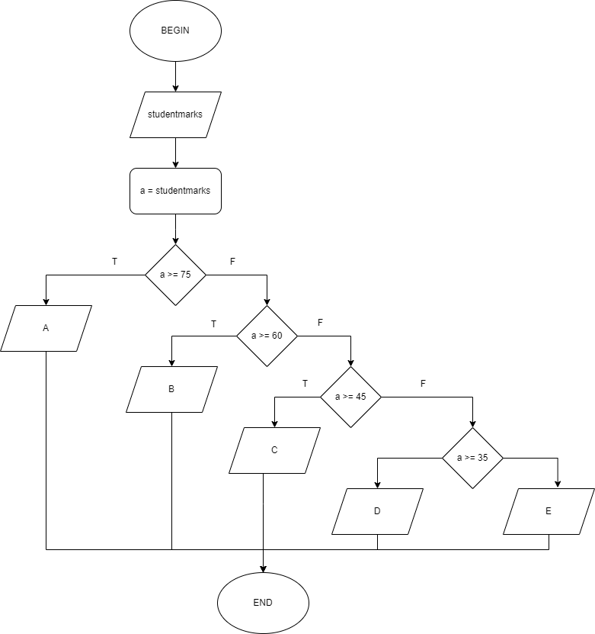**Flowchart**

**Pseudocode**

BEGIN  
 INPUT studentmarks  
 studentmarks = a  
 IF a >= 75  
 DISPLAY "A"  
 ELSE  
 IF a >= 60  
 DISPLAY "B"  
 ELSE  
 IF a >= 45  
 DISPLAY "C"  
 ELSE  
 IF a >= 35  
 DISPLAY "D"  
 ELSE  
 DISPLAY "E"  
 END IF  
 END IF  
 END IF  
 END IF  
END