DataExodus
Practical Assessment — Project Plan
Making cross-border tracking and hashed-identifier leakage visible,
then blocking it at the network edge

Field | Detail
Student | Thanh Dat Phan
Student ID | [Student ID]
Unit | [Unit code and name]
Assessor | [Unit Teacher / Course Coordinator]
Submission | Week 8 — Moodle, 5:00 pm AEST
Repository | github.com/thanhdat23102005/DataExo

1. Project Background
Open the developer tools on almost any Australian news or government site and the page contacts a dozen companies the visitor has never heard of. The Australian Competition and Consumer Commission's Digital Platforms Inquiry found that consumers have little practical visibility of this, and the Privacy Act's Australian Privacy Principle 8 places obligations on organisations that disclose personal information overseas. Neither the visibility nor the accountability is easy for an individual to check for themselves.
The specific claim this project tests is that hashing an identifier makes it anonymous. It does not. Because the same email address always produces the same hash, that hash is a stable name for a person that can be matched across unrelated websites, even though the raw address never crosses the wire. The United States Federal Trade Commission issued guidance in 2024 making the same point. A system that hashes a user's own identifier locally and then watches for those hashes in outbound traffic can demonstrate the weakness directly, rather than describing it.
The project was initiated by the student as an individual undertaking for this unit. There is no external sponsor or client; the assessor acts as the approving stakeholder. It fits the unit's project criteria because it is a complex technology project rather than a single artefact: it combines applied research, software built across two platforms, a measurement study with stated hypotheses, and a deployment that has to work on real hardware in a real home network.
The deliverables are deliberately two things a person can install. A Chrome extension makes the problem visible on one machine. A Raspberry Pi 5 application collects what the extension observes, adds attribution the browser cannot perform, and blocks tracker domains by DNS for every device on the network, including phones and televisions no browser extension can reach.
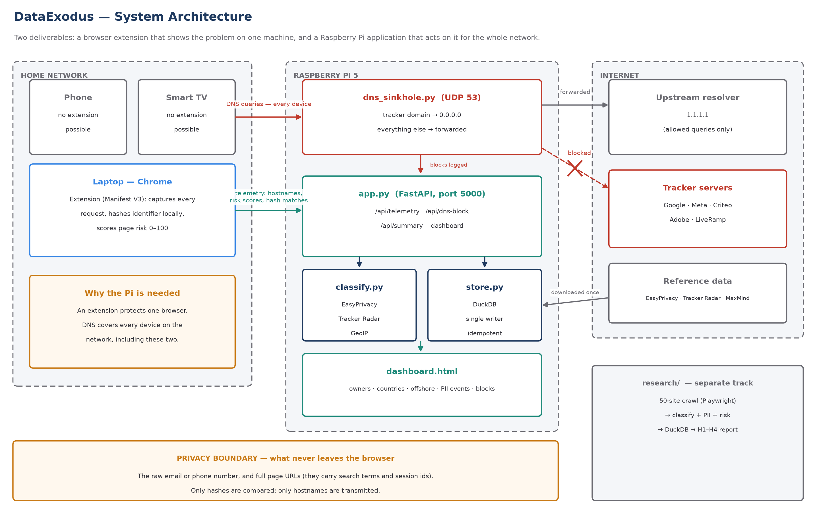
Figure 1 — System architecture block diagram: components, data flows, and the privacy boundary that raw identifiers and page URLs never cross.

2. Detailed Analysis of Requirements
Requirements were derived from three sources: the research question itself, the legal context of APP 8, and the practical constraints of the platforms involved. They are recorded here, carry stable identifiers, and are traced through to verification in Table 4 so that nothing is claimed without a way to check it.

2.1 High-level requirements — what needs to be done
ID | Requirement | Rationale
HR-1 | Identify who receives data from a visited page, and which company owns them | Attribution is the basis of every other finding
HR-2 | Determine the destination country and flag transfers outside comparable regimes | Directly addresses APP 8 cross-border disclosure
HR-3 | Detect the user's own identifier leaving as a hash, not only in plain text | The project's central claim about anonymisation
HR-4 | Distinguish covert disclosure to third parties from intentional first-party use | Without this, ordinary use of a search box reads as a breach
HR-5 | Block tracker domains for every device on the network, not only one browser | Phones, televisions and apps cannot run an extension
HR-6 | Present findings so a non-specialist can act on them | A finding nobody understands changes nothing
HR-7 | Measure tracking across a defined sample of Australian sites | Supports the research hypotheses H1–H4

2.2 Low-level requirements — how it will be done
ID | Requirement | Implementation approach
LR-1 | Capture every outbound request in the browser | Chrome Manifest V3 service worker, webRequest observer
LR-2 | Hash the identifier locally across every plausible normalisation | WebCrypto SHA-1/256/512 plus a local MD5; digits-only, +61, 61, Gmail dot and +tag forms
LR-3 | Never transmit the raw identifier or full page URLs | Only hostnames, risk scores and hash-match events are sent
LR-4 | Resolve destination hostnames to a country | MaxMind GeoLite2 lookup on the Pi, where the database can be held in memory
LR-5 | Store observations idempotently | DuckDB upsert keyed on (tab, destination); retried deliveries must not double-count
LR-6 | Answer tracker DNS queries with 0.0.0.0 and forward everything else | Threaded UDP server using dnslib, upstream 1.1.1.1
LR-7 | Keep blocking decisions separate from labelling decisions | Hosts-format list for DNS; EasyPrivacy whole-domain rules for labelling
LR-8 | Provide a dashboard and an in-browser popup | FastAPI-served dashboard polling a summary endpoint; extension popup
LR-9 | Crawl the study sample reproducibly | Playwright headless crawler over a site list frozen in week 1

3. Definition of Project Goals
Each goal is specific, measurable, achievable, results-oriented and time-bound, and together they cover every requirement listed above.
Goal | SMART statement | Covers
G1 | By week 10, correctly attribute owner and country for at least 90% of third-party destinations observed on the study sample, verified by manual spot-check against Tracker Radar. | HR-1, HR-2
G2 | By week 10, demonstrate a hashed identifier being matched in live traffic across at least four hash algorithms and four normalisation forms, evidenced by a reproducible test. | HR-3
G3 | By week 11, classify every identifier match as covert or intentional with zero misclassification across the manual test set. | HR-4
G4 | By week 11, block at least 75,000 tracker domains network-wide with zero false positives across a defined set of twelve common Australian and global sites. | HR-5
G5 | By week 12, present results through a browser popup and a Pi dashboard that a non-specialist can read without explanation, validated by one informal usability walk-through. | HR-6
G6 | By week 13, complete the 50-site crawl and report on hypotheses H1–H4 with stated statistical methods. | HR-7

4. Methodology and Standards

4.1 Development methodology and why
The project uses incremental delivery in vertical layers: each layer is a complete, working system on its own, and later layers add capability without the earlier ones becoming worthless. Layer one is the extension alone. Layer two adds the Pi collector. Layer three adds network-wide DNS blocking. Layer four is the measurement study.
This was chosen over a waterfall sequence because the riskiest unknowns are technical and sit early: whether Manifest V3 permits the necessary observation, and whether a DNS blocklist can be applied without breaking ordinary websites. A waterfall plan would surface those in an integration phase with no time left to respond. It was chosen over formal Scrum because ceremonies designed to coordinate a team add overhead without benefit for a single student; the useful parts of agile practice — short increments, working software at each step, revising the plan against evidence — are retained without the meeting structure.
The approach has already justified itself. A DNS blocklist parser written during layer three classified wikipedia.org and github.com as trackers, because rules that block a single path were read as blocking an entire domain. At the DNS layer that error removes a site from the network for every device, not for one browser. It was found by testing the layer in isolation before it was connected to anything, which a later integration phase would not have permitted.

4.2 Tools and why each was selected
Tool | Used for | Justification
Chrome Manifest V3 | Browser observation | The only extension platform Chrome now accepts; forces an honest design because blocking webRequest is unavailable
Python 3 + FastAPI | Pi application | Async HTTP with typed request handling; runs comfortably on a Pi 5 and is the language the analysis code already uses
DuckDB | Storage and analysis | Columnar analytical queries in a single file with no server to administer; suits aggregate questions such as 'which owner receives the most requests'
dnslib | DNS sinkhole | Pure Python, no system DNS server to configure, and the blocking logic stays readable and testable rather than hidden in dnsmasq configuration
Playwright | Study crawler | Drives a real browser, so JavaScript-inserted trackers are captured as a real visitor would trigger them
MaxMind GeoLite2 | Country attribution | Free, offline, and widely cited in academic measurement work
EasyPrivacy and DuckDuckGo Tracker Radar | Tracker and owner identification | Public and independently checkable, so any classification in this report can be audited

4.3 Standards applied
- Privacy Act 1988 (Cth), Australian Privacy Principle 8 — the definition of a cross-border disclosure used throughout; country adequacy is applied as a documented simplification, not as legal advice.
- Chrome Extensions Manifest V3 — required platform standard; the extension declares only the permissions it uses.
- Privacy by design — the raw identifier and full page URLs never leave the browser. Hashing is performed client-side and only hashes are ever compared.
- PEP 8 and type annotations for Python; ES modules for extension JavaScript.
- Semantic versioning on the extension manifest, so a demonstration can be tied to an exact build.
- Passive-observation research ethics, following published web-measurement practice such as Princeton's WebTAP: public pages only, no authentication, no attacks, no evasion, and only the student's own traffic and own identifier.

4.4 Rule-based classification, and no machine learning in the core
Every classification in the core system is rule-based and traceable to a public list. This is a deliberate constraint rather than a limitation of skill: it means each of the study's results can be checked by hand, which is why the sample is fixed at 50 sites — a number small enough to audit rather than one large enough to sound impressive and impossible to verify. A separate exploratory module asks whether a lightweight model can recognise a tracker from request shape alone without consulting a blocklist. It is trained on the rule-based labels, reported separately, and does not contribute to the study's figures.

5. Resources, Staffing and Costings
The project is staffed by one person. The roles below are distinct bodies of work rather than distinct people, and are listed separately because they carry different risks: an error in the classification role produces wrong findings, while an error in the deployment role takes a household off the internet.
Role | Responsibilities | Effort (est.)
Developer | Extension, Pi application, DNS sinkhole, crawler | ~70 h
Data analyst | Classification accuracy, hypothesis testing, reporting | ~25 h
Deployment / test | Pi setup, network configuration, false-positive testing | ~15 h
Technical writer | Charter, literature review, plan, presentations | ~20 h

Item | Cost (AUD) | Note
Raspberry Pi 5 (8 GB) | ~$145 | Already owned; listed at replacement cost
Power supply, 64 GB microSD, case | ~$65 | Already owned
Software — Python, FastAPI, DuckDB, Playwright, dnslib | $0 | Open source
EasyPrivacy, Tracker Radar, GeoLite2 | $0 | Free licences; GeoLite2 requires registration
Grafana and InfluxDB (optional monitoring) | $0 | Self-hosted open-source editions
Total cash outlay for the project | $0 | All hardware pre-owned, all software free
The absence of licence cost is itself a design decision. Every data source is public, so the work can be reproduced by an assessor or another student without purchasing anything, which would not be true of a commercial threat-intelligence feed.

6. Timeline and Milestones
Week | Milestone | Status
1–3 | Topic definition, site list frozen, project charter | Complete
4–5 | Literature review; crawler and classification pipeline | Complete
6–7 | Extension: capture, risk scoring, local hashing, malware blocking | Complete
8 | Pi application, DNS sinkhole, project plan, early-stage presentation | This submission
9–10 | Full 50-site crawl; owner and country attribution measured against G1, G2 | Planned
11 | Network deployment and false-positive testing against G3, G4 | Planned
12 | Dashboard refinement and usability walk-through (G5) | Planned
13 | Hypothesis testing and written report (G6) | Planned
14 | Final presentation and submission | Planned

7. Implementation Details
Work to date is not a prototype sketch. The following is implemented and has been executed end to end, which is the evidence behind the status column above.
Component | State | Evidence
Extension (Manifest V3) | Built, v3.3 | Captures requests, hashes locally, scores risk, blocks malware domains
Local MD5 implementation | Verified | Matches a reference implementation on 12 test vectors including UTF-8 input and the 55/56/57/64-byte padding boundaries
Identifier normalisation | Verified | An identifier typed as '0412 345 678' is matched when a tracker hashes '61412345678'; the single-form approach it replaced did not match
Pi telemetry API | Built and tested | A retried delivery produces no duplicate rows and no double-counted requests
DNS sinkhole | Built and tested | Blocked domains answer 0.0.0.0 and :: ; unrelated domains are forwarded; zero false positives across the twelve-site test set
Pi dashboard | Built | Owners, countries, offshore flags, identifier events, DNS blocks
Study crawler and pipeline | Built, sample run | 10 government sites crawled; 543 requests classified into the database

Two items are known to be outstanding and are scheduled rather than hidden. Three unit-test files in the research track fail at import because they were written against an earlier module interface, and the remaining forty sites have not yet been crawled. Both are addressed in weeks 9 and 10.

8. How the Project Will Be Evaluated
Evaluation is against the goals in section 3, using evidence that can be reproduced by someone else rather than asserted.
Goal | Method of evaluation | Pass condition
G1 | Manual spot-check of attribution against Tracker Radar for a random sample of 30 destinations | ≥ 90% agreement
G2 | Scripted test hashing a known identifier in four forms and four algorithms, then matching against synthetic traffic | All forms matched
G3 | Manual test set of first-party and third-party identifier transmissions | Zero misclassification
G4 | Automated block/allow test over twelve named sites plus normal browsing for one week | Zero false positives; ≥ 75,000 domains loaded
G5 | Usability walk-through with one non-technical participant, structured think-aloud | Participant states correctly who collected their data and where it went
G6 | Kruskal–Wallis for H1, H2 and H4 across sectors; proportion with confidence interval for H3 | Result reported with method and effect size, significant or not

A negative result is still a result. If tracking density does not differ by sector, that is reported as found; the project is not designed to confirm a preferred conclusion.

9. Risks and Mitigation
Risk | Impact | Mitigation
A blocklist false positive removes a site for the whole household | High | Blocking and labelling use separate sources; a defined allow-test runs before deployment; documented rollback of router DNS
The Pi becomes a single point of DNS failure | High | Documented revert procedure; secondary DNS deliberately left blank is a stated trade-off, not an oversight
Chrome DNS-over-HTTPS bypasses the sinkhole | Medium | Documented as a limitation; the extension still observes these requests, which is why both deliverables exist
Sites change during the study period | Medium | Site list frozen in week 1; crawl dates recorded with results
Crawling from a single network biases attribution | Medium | Stated as a limitation; GeoIP reports where a server is, not where data is ultimately stored
Scope growth beyond available time | Medium | Layered delivery: each layer is independently demonstrable, so later layers can be cut without invalidating earlier ones

10. References
- Australian Competition and Consumer Commission 2019, Digital Platforms Inquiry — Final Report, ACCC, Canberra.
- Attorney-General's Department 2022, Privacy Act Review — Report, Commonwealth of Australia.
- Federal Trade Commission 2024, 'Hashing is not anonymization', FTC Technology Blog.
- Englehardt, S & Narayanan, A 2016, 'Online tracking: a 1-million-site measurement and analysis', Proceedings of the ACM SIGSAC Conference on Computer and Communications Security.
- Office of the Australian Information Commissioner, Australian Privacy Principles Guidelines, Chapter 8.
- DuckDuckGo 2024, Tracker Radar dataset; EasyList project, EasyPrivacy filter list.

