DataExodus
Where Does My Data Go?
Measuring Third-Party Data Flows on Australian Websites
Practical Project Plan
Thanh Dat Phan
TAFE NSW Higher Education — Cybersecurity, Individual Project
Assessment A3 — 18/09/2026 (Week 8)

This plan builds on the Project Charter (A1) and sets out how the rest of DataExodus gets delivered — scope, work breakdown, schedule, budget, and risk — all matching the figures already committed in the Charter.

1. Project Scope Statement
DataExodus looks at what 50 Australian websites actually do with a visitor's data: where third-party requests go, who receives them, which country they land in, and whether they carry personal information, raw or hashed. The core claim being tested is that hashing is not anonymisation — the same email always hashes to the same string, so a hashed identifier still lets a tracker follow one person across every site that gets it.
In scope: A browser extension with a live traffic-light indicator, an automated crawler for all 50 sites, a classification pipeline (tracker identity, owner, destination country), a personal-data detector for raw and hashed identifiers, a 0-100 risk score, a local database with a self-hosted Grafana dashboard, statistical testing of four hypotheses (H1-H4), and a written report.
Out of scope: No security testing, scanning, or exploitation. No logging into anyone's accounts but my own test accounts. No collecting anyone else's traffic. No bypassing security controls. No public deployment.
Done means: All 50 sites crawled and every classification checked by hand; H1-H4 tested with results written up; the dashboard and extension demonstrable on request; a final report with reproducible code and a passing test suite.

2. Work Breakdown Structure
The project splits into nine phases (Figure 1), each broken down into smaller tasks (Table 1). Task numbers follow standard WBS notation (Phase.Task), and each one lists what has to finish before it can start — that dependency chain is what the schedule in Section 3 is built from.
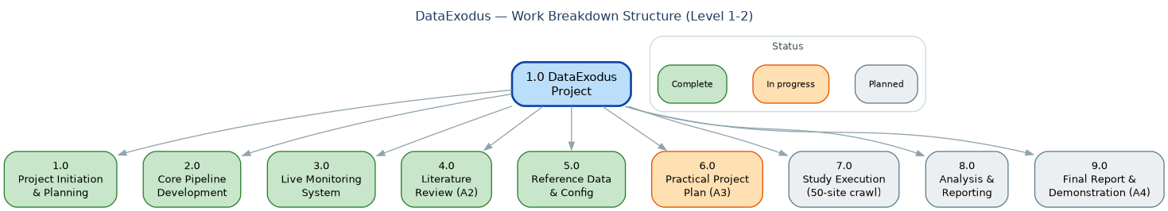
Figure 1 — Work Breakdown Structure, Level 1-2, coloured by status as of Week 8.
WBS ID | Task | Phase | Predecessor | Status
1.1 | Topic selection & scoping | 1.0 Project Initiation & Planning | - | Done
1.2 | Project Charter (A1) | 1.0 Project Initiation & Planning | 1.1 | Done
1.3 | Environment setup (RHEL VM, venv, dependencies) | 1.0 Project Initiation & Planning | 1.1 | Done
2.1 | Site list & sector configuration (data/sites.yaml) | 2.0 Core Pipeline Development | 1.3 | Done
2.2 | Web crawler (Playwright, fingerprint-API hooks) | 2.0 Core Pipeline Development | 2.1 | Done
2.3 | Classification engine (tracker / owner / country) | 2.0 Core Pipeline Development | 2.2 | Done
2.4 | PII detector (raw + hashed identifiers) | 2.0 Core Pipeline Development | 2.3 | Done
2.5 | Risk scoring engine (0-100) | 2.0 Core Pipeline Development | 2.4 | Done
2.6 | Automated test suite | 2.0 Core Pipeline Development | 2.2 | Done
3.1 | Chrome extension (Manifest V3) | 3.0 Live Monitoring System | 2.3 | Done
3.2 | FastAPI local agent | 3.0 Live Monitoring System | 3.1 | Done
3.3 | InfluxDB + Grafana dashboard | 3.0 Live Monitoring System | 3.2 | Done
4.1 | Source research & synthesis | 4.0 Literature Review (A2) | 1.2 | Done
4.2 | Literature Review submission (A2) | 4.0 Literature Review (A2) | 4.1 | Done
5.1 | Tracker/blocklist reference data (Tracker Radar, EasyPrivacy) | 5.0 Reference Data & Config | 2.3 | Done
5.2 | MaxMind GeoLite2 integration (offshore/country attribution) | 5.0 Reference Data & Config | 5.1 | Done
5.3 | Personal identity index configuration (hash-matching) | 5.0 Reference Data & Config | 5.2 | Done
6.1 | WBS / schedule / cost / risk documentation | 6.0 Practical Project Plan (A3) | 5.3 | In progress
6.2 | Practical Project Plan submission & demo (A3) | 6.0 Practical Project Plan (A3) | 6.1 | In progress
7.1 | Full 50-site crawl | 7.0 Study Execution | 6.2 | Planned
7.2 | Manual verification of every classification | 7.0 Study Execution | 7.1 | Planned
8.1 | Hypothesis testing (H1-H4) | 8.0 Analysis & Reporting | 7.2 | Planned
8.2 | Charts & visualisations | 8.0 Analysis & Reporting | 8.1 | Planned
8.3 | Optional ML tracker-classifier extension | 8.0 Analysis & Reporting | 8.1 | Planned (optional)
9.1 | Draft & refine final report | 9.0 Final Report & Demonstration (A4) | 8.2 | Planned
9.2 | Rehearse live demonstration | 9.0 Final Report & Demonstration (A4) | 9.1 | Planned
9.3 | Final submission & demonstration (A4) | 9.0 Final Report & Demonstration (A4) | 9.2 | Planned
Table 1 — Work Breakdown Structure (Level 2 detail).

3. Project Schedule (Time)
Twelve weeks, built around the unit's four assessment events (Weeks 3, 6, 8, 12). Build work runs alongside writing rather than after it, so implementation doesn't get crammed into the last few weeks. As of this submission (Week 8), Figure 2 shows Phases 1-5 done, Phase 6 (this plan) in progress, and Phases 7-9 — the full 50-site study — scheduled for Weeks 9-12.
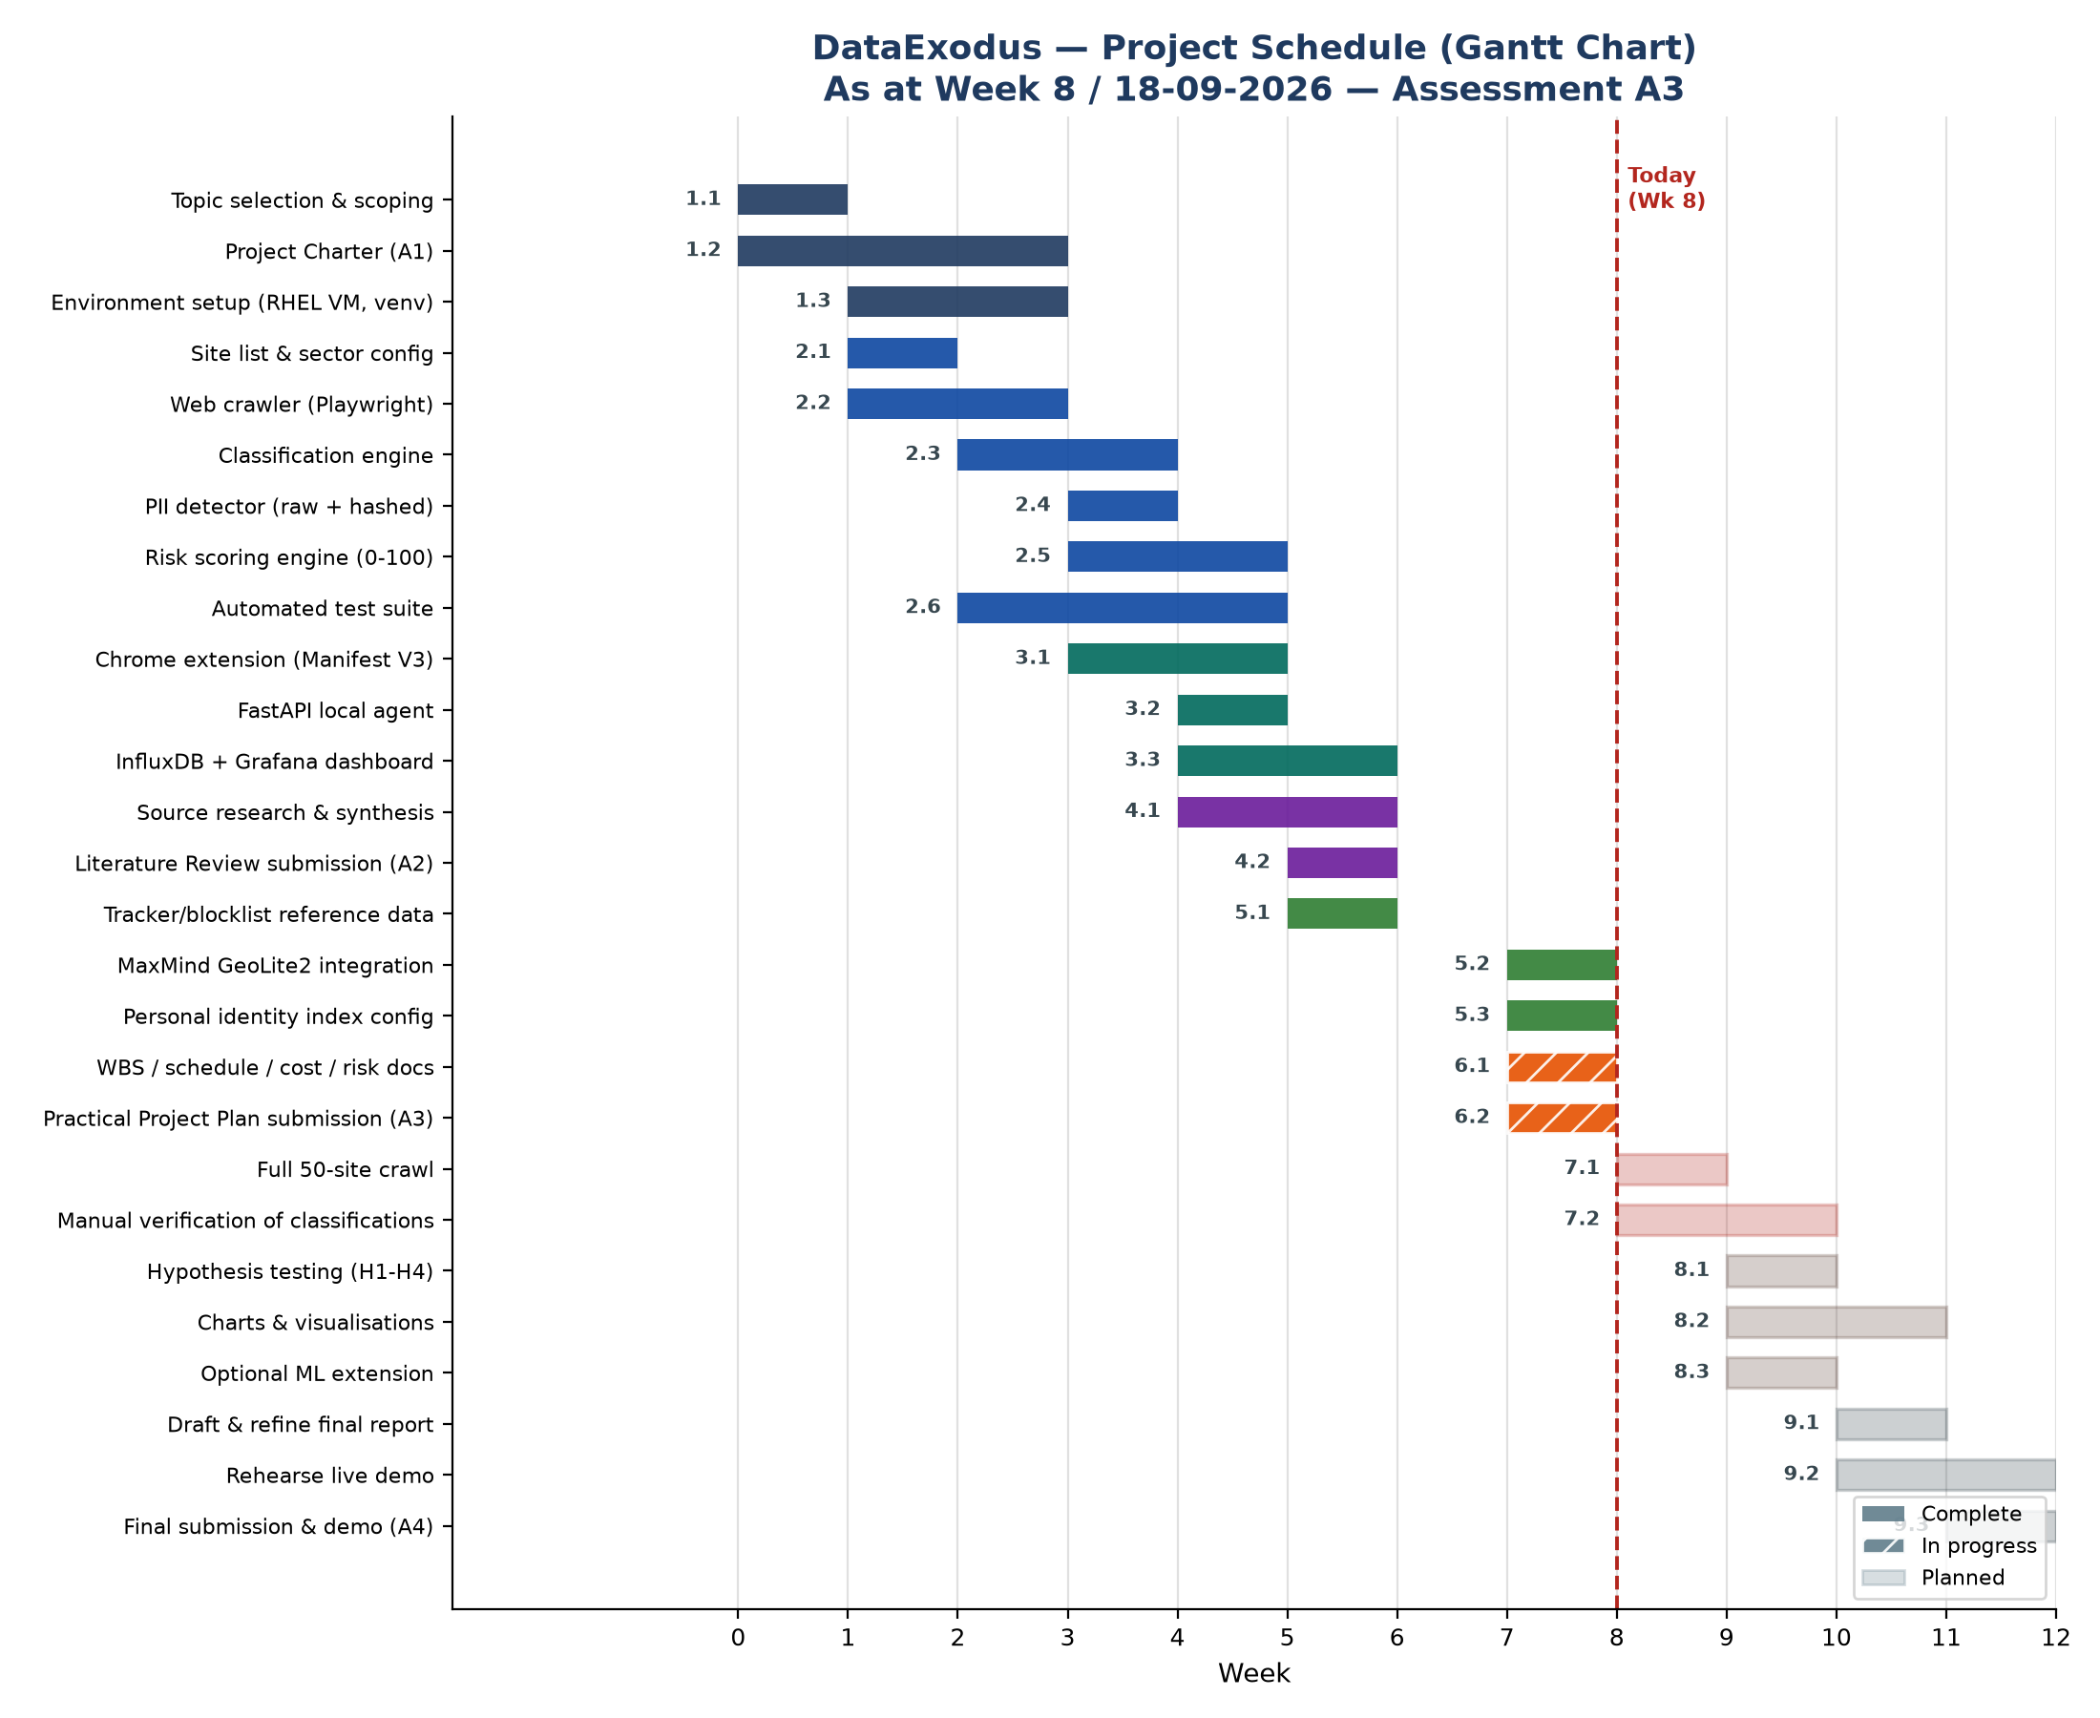
Figure 2 — Gantt chart, all 26 Level-2 tasks, as at Week 8.
WBS ID | Task | Start | Duration | Status
1.1 | Topic selection & scoping | Wk 1 | 1 wk | Done
1.2 | Project Charter (A1) | Wk 1 | 3 wks | Done
1.3 | Environment setup | Wk 2 | 2 wks | Done
2.1 | Site list & sector config | Wk 2 | 1 wk | Done
2.2 | Web crawler | Wk 2 | 2 wks | Done
2.3 | Classification engine | Wk 3 | 2 wks | Done
2.4 | PII detector | Wk 4 | 1 wk | Done
2.5 | Risk scoring engine | Wk 4 | 2 wks | Done
2.6 | Automated test suite | Wk 3 | 3 wks | Done
3.1 | Chrome extension | Wk 4 | 2 wks | Done
3.2 | FastAPI local agent | Wk 5 | 1 wk | Done
3.3 | InfluxDB + Grafana | Wk 5 | 2 wks | Done
4.1 | Source research & synthesis | Wk 5 | 2 wks | Done
4.2 | Literature Review (A2) | Wk 6 | 1 wk | Done
5.1 | Tracker/blocklist data | Wk 6 | 1 wk | Done
5.2 | MaxMind GeoLite2 integration | Wk 8 | 1 wk | Done
5.3 | Identity index config | Wk 8 | 1 wk | Done
6.1-6.2 | Practical Project Plan (A3) | Wk 8 | 1 wk | In progress
7.1 | Full 50-site crawl | Wk 9 | 1 wk | Planned
7.2 | Manual verification | Wk 9 | 2 wks | Planned
8.1 | Hypothesis testing (H1-H4) | Wk 10 | 1 wk | Planned
8.2 | Charts & visualisations | Wk 10 | 2 wks | Planned
8.3 | Optional ML extension | Wk 10 | 1 wk | Planned (optional)
9.1 | Draft & refine final report | Wk 11 | 1 wk | Planned
9.2 | Rehearse live demo | Wk 11 | 2 wks | Planned
9.3 | Final submission & demo (A4) | Wk 12 | 1 wk | Planned
Table 2 — Schedule detail (start week and duration per task).

4. Project Cost
Total cash spend: $0. The laptop is mine, every tool is free and open-source, and every reference dataset (GeoIP, tracker lists) is free to use. Nothing here depends on a purchase or institutional budget, so cost isn't what could delay this project.
Category | Item | Cost (AUD) | Notes
Hardware | Personal laptop | $0 | Student-owned
Hardware | Raspberry Pi 5 (optional always-on collection phase) | $0 | Student-owned / optional tier
Software | Python, Playwright, DuckDB, FastAPI, InfluxDB OSS, Grafana OSS | $0 | Free and open-source
Reference data | MaxMind GeoLite2, DuckDuckGo Tracker Radar, EasyPrivacy | $0 | Free tier / open licence
Hosting / infrastructure | Self-hosted on student hardware | $0 | No cloud spend
Contingency | — | $0 | No paid dependency identified
Table 3 — Cash budget by category.
Table 4 turns the same WBS into an hours-based estimate, using a rough junior-analyst rate ($50/hr) just to show the estimating method. It's a notional number for the exercise — no one gets paid, and it doesn't touch the actual $0 budget above.
WBS Phase | Est. Effort (hrs) | Indicative Rate | Indicative Value | Status
1.0 Project Initiation & Planning | 12 | $50 | $600 | Done
2.0 Core Pipeline Development | 30 | $50 | $1,500 | Done
3.0 Live Monitoring System | 18 | $50 | $900 | Done
4.0 Literature Review (A2) | 12 | $50 | $600 | Done
5.0 Reference Data & Config | 8 | $50 | $400 | Done
6.0 Practical Project Plan (A3) | 10 | $50 | $500 | In progress
7.0 Study Execution | 14 | $50 | $700 | Planned
8.0 Analysis & Reporting | 16 | $50 | $800 | Planned
9.0 Final Report & Demonstration (A4) | 12 | $50 | $600 | Planned
Total | 132 | — | $6,600 | —
Table 4 — Notional effort-cost estimate (indicative only; actual cash cost is $0).

5. Risk Management
The risk register carries over from the Charter unchanged (R1-R7); Figure 3 just plots it so the highest-priority items are easy to spot. R1 (scope creep) is still the biggest open risk, kept in check by freezing the site list early and gating optional work behind the core phases in the WBS.
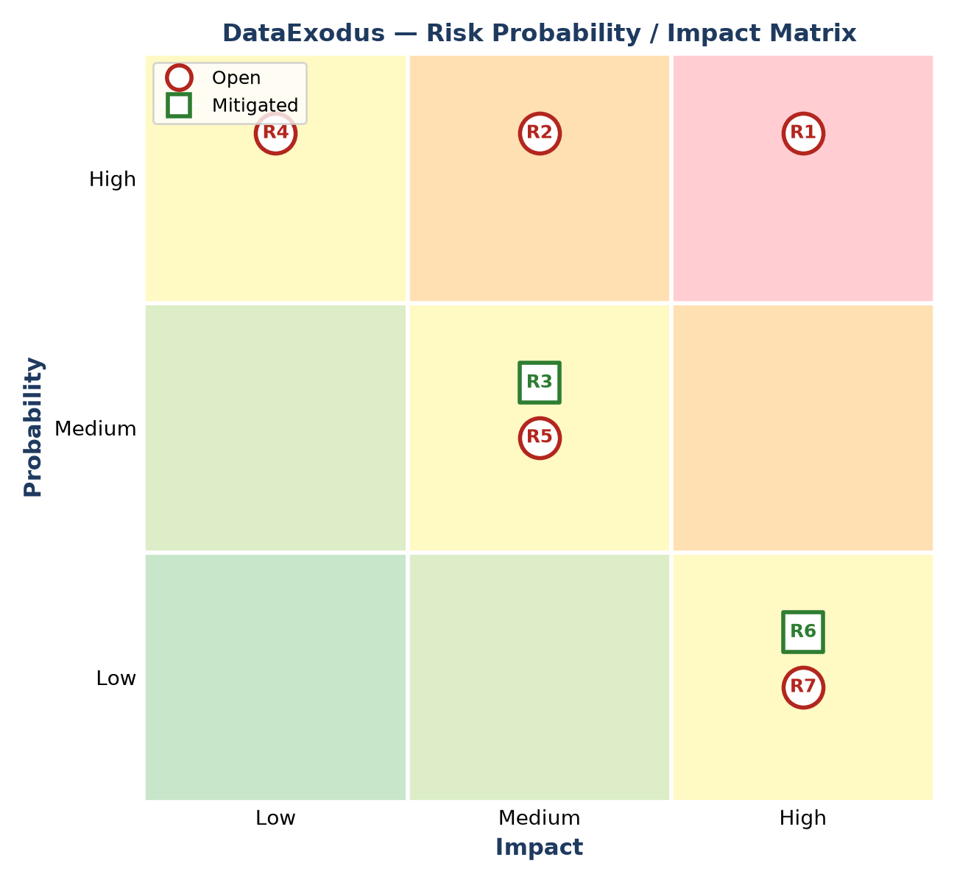
Figure 3 — Risk probability/impact matrix (R1-R7, from the Project Charter).
Risk Id | Risk Statement | Probability | Impact | Score | Status | Response
R1 | Scope creep across optional phases | High | High | 9 | Open | Site list frozen in Week 1; optional work gated on core completion
R2 | Too much time spent on UI/dashboard polish | High | Medium | 6 | Open | Hard cap of one week on interface work
R3 | Browser extension API limitations | Medium | Medium | 4 | Mitigated | Extension built on the Manifest V3 webRequest API and verified working end-to-end
R4 | Certificate pinning blocks mobile app inspection | High | Low | 3 | Open | Recorded as a finding; no bypass attempted
R5 | Crawler blocked by target websites | Medium | Medium | 4 | Open | Conservative request rate, honest user agent, robots.txt respected
R6 | Poor data quality / logic errors found late | Low | High | 3 | Mitigated | Unit tests caught a real third-party classification bug, fixed before the full crawl; Week 3 decision gate required real data and a first chart
R7 | Data loss | Low | High | 3 | Open | Git version control plus weekly backup
Table 5 — Risk register (Score = Probability × Impact, Low=1, Medium=2, High=3).

6. Milestones
Milestone | Due | Status
M0 — Project Charter approved (A1) | Week 3 | Done
M1 — Core pipeline built & verified (crawler, classifier, PII, risk, tests) | Week 5 | Done
M2 — Live monitoring stack verified end-to-end (extension, agent, dashboard) | Week 6 | Done
M2a — Literature Review submitted (A2) | Week 6 | Done
M3 — Reference data complete (GeoIP, blocklists, identity index) | Week 8 | Done
M4 — Practical Project Plan submitted & demonstrated (A3) | Week 8 | In progress
M5 — Full 50-site crawl complete | Week 9 | Planned
M6 — All classifications manually verified | Week 9 | Planned
M7 — Hypotheses H1-H4 tested with documented results | Week 10 | Planned
M8 — Final report drafted | Week 11 | Planned
M9 — Final submission & demonstration (A4) | Week 12 | Planned
Table 6 — Milestones. M0, M2a, M4 and M9 are the four formal assessment events; the rest are internal checkpoints I use to self-review progress.

Approval
Any scope change beyond what's frozen in Section 1 needs sign-off from the unit teacher first, same as the Charter.
Project Manager Signature | Sponsor or Originator Signature
Thanh Dat Phan | [Unit Teacher Name]
18/09/2026 | [Date]

