DataExodus
Where Does My Data Go?
Measuring Third-Party Data Flows on Australian Websites
Project Charter
Thanh Dat Phan
TAFE NSW Higher Education — Cybersecurity, Individual Project
Assessment A1 — 13/08/2026

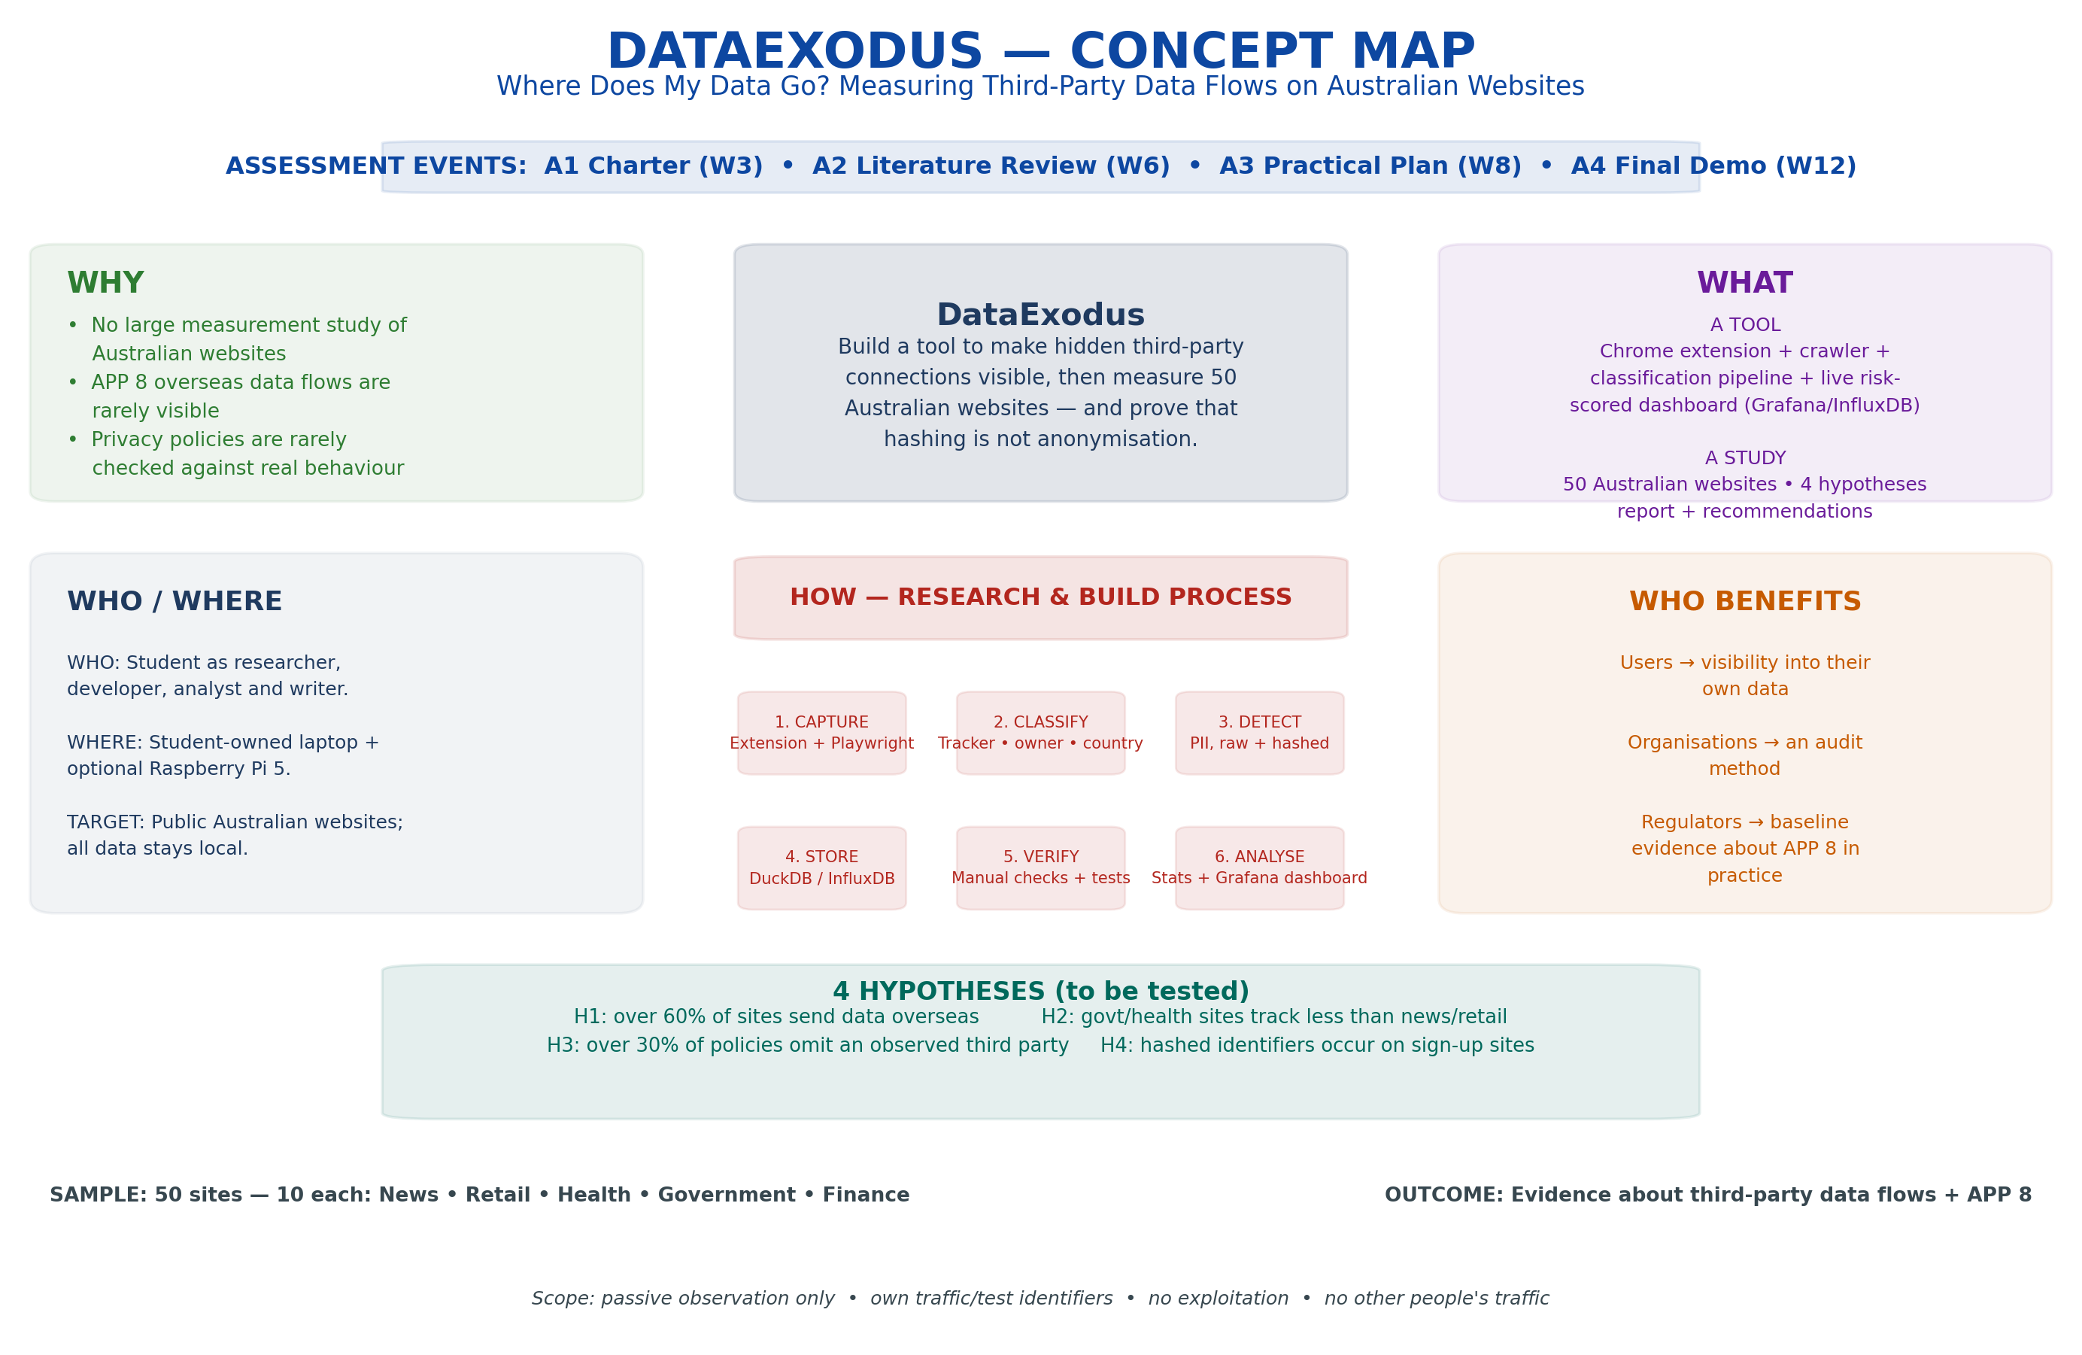
Figure 1 — DataExodus concept map: why, what, who, where and how the project delivers its goal.

As adapted from Stackpole (2013), following the unit's Project Charter template.

PROJECT CHARTER
Project Title: DataExodus — Where Does My Data Go? Measuring Third-Party Data Flows on Australian Websites
Project Sponsor: [Unit Teacher / Course Coordinator Name], TAFE NSW
Date Prepared: 13/08/2026 (v3 — consolidated, reflects the system as built)
Project Manager: Thanh Dat Phan
Project Customer: [Unit Teacher Name], TAFE NSW Higher Education — Cybersecurity (assessing this project as the individual project unit)

Executive Summary
When a browser visits an Australian website, it quietly contacts dozens of other companies. DataExodus is a tool that makes those hidden connections visible, and a study that uses it to measure what 50 Australian websites actually do — where data goes, what personal information it carries (including in hashed form), and whether it matches what their privacy policies promise. The central technical claim under test is that hashing is not anonymisation: the same email always produces the same hash, so a hashed identifier still lets a tracker follow a person across every site that receives it. The core pipeline, a live monitoring agent, and a self-hosted Grafana dashboard are already built and verified; the full 50-site study follows the schedule under Project Deliverables.

Project Purpose or Justification
Australians are told their data is handled responsibly, but nobody has measured what actually leaves the browser. This project addresses three gaps:
- Nobody has measured Australia: large tracking-measurement studies exist for the US and Europe; none exist for Australian websites.
- The law is untested in practice: Australian Privacy Principle (APP) 8 governs sending personal information overseas. Every third-party request carrying an identifier abroad is potentially an APP 8 event, but these flows are invisible to users and rarely documented.
- Policies are unverified: privacy policies state things like "we may share data with selected partners." Nobody checks whether the stated partners match the real ones.

Project Description
The project delivers two things, sharing one classification/personal-data/risk-scoring core:
- A tool: a Chrome browser extension (Manifest V3) that captures outbound requests and shows a green/amber/red traffic-light badge; a Playwright crawler for the 50-site study; a Python classification pipeline (tracker identity, owner, destination country, personal-data content, raw or hashed); a 0–100 risk score shared by both modes; and a self-hosted dashboard (Grafana, backed by InfluxDB) that visualises where data goes in real time.
- A study: 50 Australian websites (10 each across news/media, retail, health, government, and finance) crawled with an automated browser, every classification manually verified, and four hypotheses tested about tracking prevalence, offshore data flows, and privacy-policy accuracy.
Two pipelines share the same core (Figure 2): Study mode — the crawler writes raw captures to disk, pipeline/process.py classifies and scores every request into a DuckDB dataset, and analysis/report.py and analysis/export_sheet.py turn that into a report, CSV, and an Excel workbook with a chart. Live mode — the extension streams the student's own browsing to a local FastAPI agent (pipeline/agent.py), which classifies and scores each request in real time, drives the extension's badge, and writes every point to InfluxDB for the Grafana dashboard. Both modes are built and verified end-to-end: an automated test suite (23/23 passing) covers the classifier, PII detector, and risk scorer, and a real test crawl (10 government-sector sites, 614 requests) has already produced classified data.
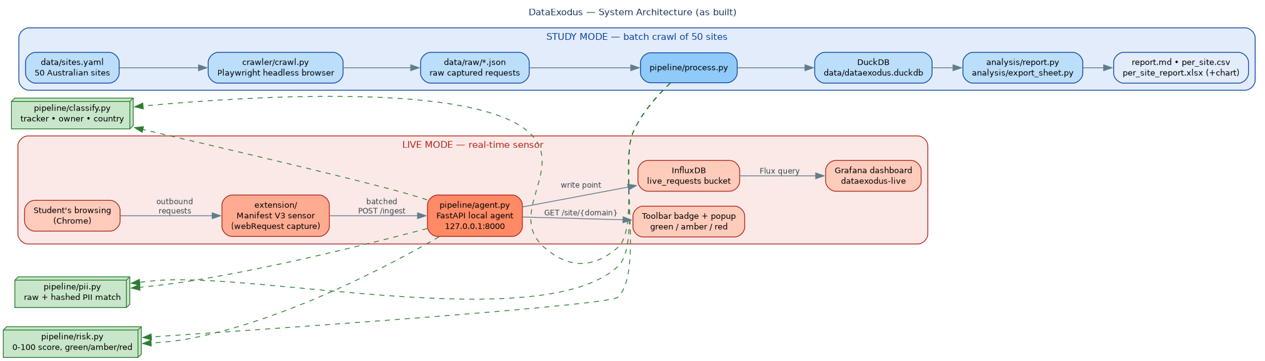
Figure 2 — System architecture as built: Study mode (top) and Live mode (bottom) share the same classify/PII/risk-scoring core (left).

Machine Learning
The rule-based pipeline (pipeline/classify.py) stays the source of truth for the study — every label it produces can be checked by hand against DuckDuckGo Tracker Radar and EasyPrivacy, which is the whole point of keeping the sample at 50 sites. Machine learning is a separate, clearly-scoped experiment on top of that, not a replacement for it: can a lightweight supervised model learn to recognise a tracker from request-level features alone (host shape, resource type, keyword counts), without consulting a blocklist at all? That matters because blocklists lag — a classifier that generalises could flag trackers a static list misses.
Method: Implemented in pipeline/ml_classifier.py. Ten features are engineered per request (host length, subdomain count, digit count, hyphen presence, path length, query-parameter count, a tracker-keyword hit count, resource type, and whether the request is third-party/insecure — derived from the initiating page and the URL scheme, since the pipeline doesn't store either directly), with the existing rule-based is_tracker label used as ground truth. Two models are trained and compared against a naive baseline ("predict tracker whenever the request is third-party") on a 75/25 stratified split.
Model | Accuracy | Precision (tracker) | Recall (tracker)
Baseline (third-party only) | 89.7% | — | —
Logistic Regression (selected) | 99.3% | 0.96 | 1.00
Random Forest | 99.3% | 0.96 | 1.00
Result: Trained and evaluated on the current 543-request dataset (10 government-sector sites, deduplicated, 19.2% positive class). Logistic Regression was selected and saved to data/ml_tracker_model.joblib. The baseline already gets most requests right because, by construction of the rule-based classifier, a request can only be a tracker if it is third-party — so this experiment mainly tests whether ML can resolve the residual cases the baseline gets wrong. On the held-out 136 requests, the baseline misclassified 14 (all false positives, 0 false negatives); both models cut that to 1 false positive with 0 false negatives. It is not evidence that ML could replace the rule-based classifier outright on a small, single-sector, imbalanced sample. Retraining on the full 50-site dataset (Week 6) is the natural next step, and is tracked as an Optional-tier extension so it never gates core delivery.
Verification: 5 unit tests (tests/test_ml_classifier.py, all passing) cover feature extraction — including deriving third-party/insecure from the initiating page and handling missing values — and confirm the scikit-learn pipeline trains and predicts on synthetic data, independent of the real crawl dataset.

Automation
Everything downstream of "pick a site" runs unattended:
- Crawling: crawler/crawl.py drives a headless Playwright browser across the site list and, on every page, automatically hooks the Canvas/WebGL/AudioContext/Font APIs to detect fingerprinting attempts — no manual interaction with any site.
- Classification: pipeline/process.py runs the classifier, PII detector, and risk scorer over every captured request unattended and writes straight to DuckDB.
- Live monitoring: the browser extension automatically captures the student's own traffic in the background and streams it over WebSocket to a local FastAPI agent (pipeline/agent.py), which classifies and broadcasts scored events in real time — nothing to trigger by hand once the agent is running.
- Infrastructure: monitoring/setup_monitoring.sh downloads, configures, and starts InfluxDB and Grafana unattended and is idempotent (safe to re-run); the dashboard and datasource are provisioned from committed config files rather than clicked together by hand.
- Reporting: analysis/report.py turns the DuckDB dataset into hypothesis-test results (H1–H4) and four charts (Sankey data-flow diagram, sector comparison, destination-country map, top owners) without manual steps. analysis/export_sheet.py (CSV/Excel export) predates the pipeline's schema change and is known stale — flagged here rather than left silently broken; not required for the Week 6 milestone.
- Testing: pytest exercises the classification, PII, risk, and ML modules on every run — 18/18 passing after this week's fixes (entity resolution no longer skipped for non-tracker domains; Tracker Radar download corrected; pipeline.process no longer duplicates rows on re-run). Three older test files predating the pipeline rewrite (test_classify.py, test_pii.py, test_risk.py) still import a since-renamed API and are excluded until updated — tracked as routine follow-up, not a project risk.

Initial Risks
Risk Id | Risk Statement | Probability | Impact | Score | Status | Response
R1 | Scope creep across optional phases | High | High | 9 | Open | Site list frozen in Week 1; optional work gated on core completion
R2 | Too much time spent on UI/dashboard polish | High | Medium | 6 | Open | Hard cap of one week on interface work
R3 | Browser extension API limitations | Medium | Medium | 4 | Mitigated | Extension built on the Manifest V3 webRequest API and verified working end-to-end
R4 | Certificate pinning blocks mobile app inspection | High | Low | 3 | Open | Recorded as a finding; no bypass attempted
R5 | Crawler blocked by target websites | Medium | Medium | 4 | Open | Conservative request rate, honest user agent, robots.txt respected
R6 | Poor data quality / logic errors found late | Low | High | 3 | Mitigated | Unit tests caught a real third-party classification bug, fixed before the full crawl; Week 3 decision gate requires real data and a first chart
R7 | Data loss | Low | High | 3 | Open | Git version control plus weekly backup
Score = Probability × Impact (Low=1, Medium=2, High=3).

Initial Stakeholders
Name | Interest | Impact | Strategies
Thanh Dat Phan (student) | Sole researcher, developer, analyst, and writer; personally assessed on the outcome | High | Weekly self-review against the schedule below; decision gate in Week 3
[Unit Teacher Name] (sponsor / assessor) | Approves scope, supervises progress, grades each assessment event | High | Progress reported at each of the four assessment milestones
The 50 measured organisations | Not directly involved; observed passively via public pages only | Low | No authentication, no scanning; any vulnerability found by accident is disclosed privately and withheld from the report until resolved
Australian website users (indirect) | Beneficiaries of increased transparency about their own data | Low | Benefit passively through the published findings and recommendations
Regulators, e.g. OAIC (indirect) | Potential audience for baseline evidence on APP 8 in practice | Low | No direct engagement; findings framed as exploratory evidence only

Project Deliverables
Summary Milestones | Due Date
Project Proposal (Charter) — this document, a working prototype (extension, live agent, Grafana dashboard already verified), and first captured data | Week 3
Literature Review — measurement studies and Australian privacy law, research gap identified | Week 6
Practical Project Plan & Demo — architecture, methodology, evaluation plan, live demonstration | Week 8
Implementation & Final Demo — complete tool, verified 50-site dataset, tested hypotheses, final report, demonstration | Week 12

Summary Budget and Feasibility
Total cost: $0. All hardware is student-owned (personal laptop; Raspberry Pi 5 for an optional always-on collection phase). All software is free and open-source (Python, Playwright, DuckDB, FastAPI, InfluxDB OSS, Grafana OSS). Reference data is drawn from free open sources (MaxMind GeoLite2, DuckDuckGo Tracker Radar, EasyPrivacy, Tranco rankings). No institutional resources, cloud spend, or purchases are required, so the project has no budget dependency that could delay delivery. Feasibility is no longer purely theoretical: the extension, live agent, classification/PII/risk pipeline, and self-hosted dashboard are already built and verified, which de-risks the remaining work (the full 50-site crawl and written analysis) considerably.

Project Objectives and Success Criteria
Scope: In scope: browser extension with traffic-light indicator, automated 50-site crawler, classification pipeline, personal-data (raw + hashed) detector, 0–100 risk scoring, local database and self-hosted dashboard, statistical analysis of four hypotheses, written report. Out of scope: no security testing, scanning, or exploitation; no logging into accounts other than the student's own test accounts; no collection of anyone else's traffic; no attempt to bypass security controls; no public deployment.
Time: 12 weeks, structured around the four assessment events, with core build work (Weeks 1–8) running in parallel with writing so implementation is not compressed into the final block.
Cost: $0 — see Summary Budget above.
Quality: Classification accuracy checked against DuckDuckGo Tracker Radar; personal-data detection tested with deliberately planted known identifiers; reproducibility checked by re-crawling all 50 sites after one week; code quality maintained through an automated test suite (23/23 passing).
Other: All observation is passive and limited to the student's own traffic and public pages, with robots.txt respected and conservative request pacing.

Acceptance Criteria
The project is accepted as complete when:
- all 50 sites have been crawled and every classification manually verified;
- the four hypotheses (H1–H4) have been tested with documented results;
- the live dashboard (Grafana) and browser-extension traffic-light indicator are demonstrable on request;
- the final report is submitted with reproducible code, setup instructions, and a passing automated test suite.

Project Approval and Manager
Project Approval Requirements: Scope changes beyond the frozen core (see Project Objectives and Success Criteria — Scope) require sign-off from the unit teacher before implementation begins.
Project Manager: Thanh Dat Phan is responsible for delivery of all four assessment events against this charter.

Approvals
Project Manager Signature | Sponsor or Originator Signature
Thanh Dat Phan | [Unit Teacher Name]
[Date] | [Date]

