## ASSIGNMENT 2 FRONT SHEET

|  |  |  |  |
| --- | --- | --- | --- |
| **Qualification** | **BTEC Level 5 HND Diploma in Computing** | | |
| **Unit number and title** | Unit 06: Planning a computing project | | |
| **Submission date** | 04/04/2024 | **Date Received 1st submission** |  |
| **Re-submission Date** |  | **Date Received 2nd submission** |  |
| **Student Name** | Vu Thanh Do | **Student ID** | BH00070 |
| **Class** | SE06303 | **Assessor name** | Le Van Thuan |
| **Student declaration**  I certify that the assignment submission is entirely my own work and I fully understand the consequences of plagiarism. I understand that making a false declaration is a form of malpractice. | | | |
|  | | **Student’s signature** | Do |

#### Grading grid

|  |  |  |  |  |  |  |
| --- | --- | --- | --- | --- | --- | --- |
| P5 | P6 | P7 | P8 | M3 | M4 | D2 |
|  |  |  |  |  |  |  |

|  |  |  |
| --- | --- | --- |
| **❒ Summative Feedback: ❒ Resubmission Feedback:** | | |
| **Grade:** | **Assessor Signature:** | **Date:** |
| **IV Signature:** | | |

Contents

1. Introduction. 5
2. Body. 6

P5. Devise comprehensive project plans for a chosen scenario, including a work and resource allocation breakdown using appropriate tools. 6

* 1. Overview. 6
  2. Work Breakdown Structure.(WBS) 7
  3. Work timeline (Gantt chart) 13
  4. Use Appropriate Tools 27

P6. Communicate appropriate project recommendations for technical and non-technical audiences. 28

1. Project Objective: 28
2. Stakeholders Stakeholders 28
3. For Technical Audience 29
4. For Non-Technical Audience 29

P7. Present arguments for the planning decisions made when developing the project plans 30

Task 1 :Project Initiation: 30

Task 2 :Service Provider Selection 31

Task 3 :Service Provider Selection 32

Task 4 : Data Collection and Analysis 33

Task 5: Technology and Infrastructure Optimization 33

Task 7 :Supply Chain Sustainability 35

Task 8 : Employee Training and Engagement 36

Task 9 :Monitoring and Reporting 36

Task 11 : Evaluation and Continuous Improvement 38

P8. Discuss accuracy and reliability of the different research methods applied. 39

1. Overview of qualitative and quantitative research. 39
2. Advantages and disadvantages of the research method on asm1 (Observational Research, Quantitative Analysis, Qualitative Analysis) 40
3. Conclusion. 42
4. References. 42

Figure 1:Work Breakdown Structure.(WBS) 8

Figure 2: Gantt Chart for Research on the Impact of Big Data on the Economy 14

Figure 3: Task 1 15

Figure 4: Task 2 16

Figure 5: Task 3 17

Figure 6: Task 4 18

Figure 7:Task 5 19

Figure 8:Task 6 20

Figure 9:Task 7 22

Figure 10:Task 8 23

Figure 11:Task 9 24

Figure 12: Task 10 25

Figure 13: Task 11 + Finalize 26

# Introduction.

Continued from Assignment 1, we have successfully completed our in-depth research on the project titled "Research on the Impact of Big Data on the Economy," focusing on addressing the crucial matter of Big Data's influence on economic landscapes. The proliferation of Big Data technologies has brought about substantial transformations, affecting various sectors and facets of the economy.

Throughout this project, we meticulously scrutinized the challenges and opportunities arising from the extensive utilization of Big Data in economic activities. Our analysis delved into the profound implications of Big Data analytics, examining its effects on productivity, innovation, market dynamics, and overall economic growth.

Our primary objective was to discern the intricate connections between Big Data utilization and economic outcomes while identifying potential avenues for maximizing benefits and mitigating risks. Through comprehensive data collection and rigorous analysis, we sought to uncover the nuances of Big Data's impact on different economic sectors and their interdependencies.

In this presentation, we will elucidate the key findings of our research, offering an in-depth analysis of how Big Data adoption influences various economic indicators and processes. Additionally, we will propose strategic recommendations aimed at harnessing the potential of Big Data to foster sustainable economic development and resilience.

Our recommendations will encompass a holistic approach to leveraging Big Data for economic prosperity, encompassing strategies for enhancing data governance, fostering innovation ecosystems, and optimizing resource allocation. We firmly believe that these insights will contribute to informed decision-making and policy formulation in the context of a data-driven economy.

Furthermore, as part of our project deliverables, we will provide a succinct report to the Quality Assurance (QA) department, encapsulating our project journey comprehensively. This report will document our methodologies, challenges encountered, and reflections on the outcomes achieved, ensuring transparency and accountability in our research process.

We will critically evaluate the research methodologies employed, emphasizing the importance of accuracy and reliability in generating insights. Trust in our findings is paramount for informing evidence-based policymaking and strategic planning in leveraging Big Data for economic advancement.

Moreover, we will conduct a thorough evaluation of our project management plan, identifying successful practices and areas for enhancement. This assessment will enable us to refine our approach and optimize project execution efficiency for future endeavors.

# Body.

# LO3. Produce project plans based on research of the chosen theme for an identified organisation

## P5. Devise comprehensive project plans for a chosen scenario, including a work and resource allocation breakdown using appropriate tools.

Planning a comprehensive Research on the Impact of Big Data on the Economy project involves various stages and tasks. Here, I'll outline the key steps along with a work and resource allocation breakdown using a Work Breakdown Structure (WBS) and a Resource Allocation Matrix.

### Overview.

Project Name: Research on the Impact of Big Data on the Economy.

#### Project Overview:

The Research on the Impact of Big Data on the Economy initiative aims to investigate the effects of Big Data utilization on economic dynamics and sustainability. This project encompasses a series of research endeavors, programs, and policies geared towards achieving the following objectives:

* Analyze the influence of Big Data on economic indicators and processes.

#### Identify opportunities to leverage Big Data for sustainable economic development.

#### Assess the challenges and risks associated with the widespread adoption of Big Data in economic activities.

#### Propose strategic recommendations to maximize the benefits and mitigate the drawbacks of Big Data in the economy.

#### Project Scope and Deliverables:

* 1. Economic Impact Analysis: Conduct comprehensive research to analyze the impact of Big Data utilization on various economic sectors and indicators.
  2. Sustainability Assessment: Evaluate the sustainability implications of integrating Big Data technologies into economic processes and decision-making.
  3. Policy Recommendations: Develop recommendations for policymakers to harness Big Data for promoting economic growth while ensuring sustainability and equity.
  4. Sectoral Studies: Conduct in-depth studies on specific economic sectors to understand the nuanced effects of Big Data adoption.
  5. Stakeholder Engagement: Engage with stakeholders, including businesses, policymakers, and academia, to gather insights and disseminate research findings for informed decision-making.

### Work Breakdown Structure.(WBS)

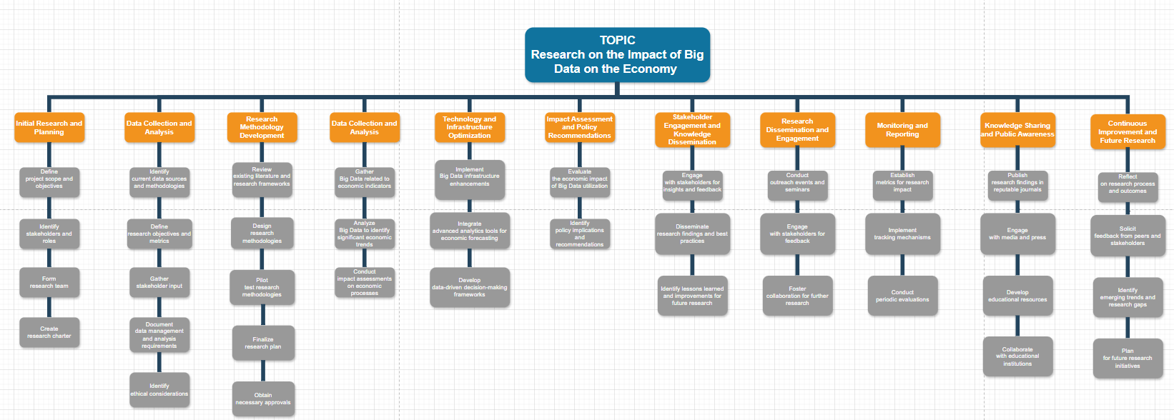

*Figure 1: Work Breakdown Structure.(WBS)*

* State - Preparatory Phase.

#### Task 1. Initial Research and Planning

* + Define project scope and objectives: Clearly outline the scope and objectives of the research project on the impact of Big Data on the economy, including specific goals such as analyzing the influence of Big Data on economic indicators and proposing strategic recommendations for leveraging Big Data for sustainable economic development.
  + Identify stakeholders and roles: Identify key stakeholders involved in the research project, including researchers, economists, policymakers, businesses, and the general public. Define their roles, responsibilities, and levels of involvement throughout the research process.
  + Form research team: Assemble a diverse and multidisciplinary research team comprising experts from economics, data science, social sciences, and policy analysis to ensure comprehensive coverage of all aspects of the research project.
  + Create research charter: Develop a research charter that outlines the purpose, objectives, methodology, budget, timeline, and key milestones of the research project. The charter will serve as a guiding document for all research activities.

#### Task 2. Data Collection and Analysis

* + Identify current data sources and methodologies: Assess existing data sources, methodologies, and research frameworks used to study the impact of Big Data on the economy. Identify gaps and areas for improvement in current research practices.
  + Define research objectives and metrics: Set clear research objectives and define measurable metrics for assessing the impact of Big Data on various economic indicators such as GDP growth, employment rates, productivity, and innovation.
  + Gather stakeholder input: Engage with stakeholders such as businesses, policymakers, and academic researchers to gather insights, feedback, and expectations regarding the research project. Incorporate stakeholder input into the research design and methodology.
  + Document data management and analysis requirements: Develop a data management plan to collect, store, and analyze Big Data and economic data sets. Ensure data security, privacy, and integrity throughout the research process.
  + Identify ethical considerations: Consider ethical considerations such as data privacy, consent, and fairness in the collection, analysis, and interpretation of Big Data for economic research purposes.

#### Task 3. Research Methodology Development

* + Review existing literature and research frameworks: Conduct a comprehensive review of existing literature, research papers, and methodologies used to study the impact of Big Data on the economy. Identify relevant frameworks and methodologies to inform the research design.
  + Design research methodologies: Develop research methodologies such as econometric modeling, statistical analysis, case studies, and surveys to study the causal relationships between Big Data utilization and economic outcomes. Ensure rigor and validity in the research design.
  + Pilot test research methodologies: Conduct pilot tests or simulations to validate the effectiveness and feasibility of the research methodologies. Identify and address any potential challenges or limitations in the research design.
  + Finalize research plan: Based on the pilot test results and stakeholder feedback, finalize the research plan, including data collection methods, sampling strategies, analytical techniques, and timeline for conducting the research.
  + Obtain necessary approvals: Seek approval from relevant stakeholders, ethics committees, or institutional review boards to ensure compliance with ethical standards and regulatory requirements for conducting research on human subjects.
* State - Implementation Phase

#### Task 4. Data Collection and Analysis

* + Gather Big Data related to economic indicators: Implement data collection mechanisms to gather relevant Big Data pertaining to economic indicators such as GDP, employment rates, inflation, trade volumes, and innovation metrics.
  + Analyze Big Data to identify significant economic trends: Utilize advanced data analytics techniques to analyze Big Data sets and identify key economic trends, correlations, and patterns.
  + Conduct impact assessments on economic processes: Assess the impact of Big Data utilization on various economic processes, including market dynamics, consumer behavior, investment patterns, and policy effectiveness.

#### Task 5. Technology and Infrastructure Optimization

* + Implement Big Data infrastructure enhancements: Upgrade IT infrastructure and data management systems to accommodate the processing and analysis of large-scale Big Data sets efficiently.
  + Integrate advanced analytics tools for economic forecasting: Deploy advanced analytics tools, machine learning algorithms, and predictive models to forecast economic trends, risks, and opportunities based on Big Data insights.
  + Develop data-driven decision-making frameworks: Establish data-driven decision-making frameworks that leverage Big Data analytics to inform economic policy formulation, business strategy development, and investment decisions.

#### Task 6. Impact Assessment and Policy Recommendations

* + Evaluate the economic impact of Big Data utilization: Conduct comprehensive assessments to evaluate the overall economic impact of Big Data utilization, including its effects on productivity, competitiveness, innovation, and market dynamics.
  + Identify policy implications and recommendations: Analyze the policy implications of Big Data utilization on economic governance, regulation, and industry competition. Develop strategic recommendations for policymakers to maximize the benefits of Big Data while mitigating potential risks and challenges.

#### Task 7. Stakeholder Engagement and Knowledge Dissemination

* + Engage with stakeholders for insights and feedback: Collaborate with key stakeholders, including policymakers, industry representatives, academic experts, and community leaders, to gather insights, feedback, and diverse perspectives on the economic implications of Big Data.
  + Disseminate research findings and best practices: Share research findings, best practices, and policy recommendations through various channels such as conferences, workshops, reports, and publications to foster knowledge sharing and stimulate informed discussions on the economic impact of Big Data.
* State - Post-Implementation Phase

#### Task 8. Research Dissemination and Engagement

* + Conduct outreach events and seminars: Organize seminars, workshops, and conferences to disseminate research findings to a broader audience, including policymakers, industry experts, academics, and the general public.
  + Engage with stakeholders for feedback: Facilitate discussions and forums to engage stakeholders in meaningful dialogues about the research findings, implications, and potential applications in real-world scenarios.
  + Foster collaboration for further research: Encourage collaboration among researchers, institutions, and organizations to further explore the economic impact of Big Data and identify new research avenues and opportunities.

#### Task 9. Monitoring and Reporting

* + Establish metrics for research impact: Define key metrics and indicators to assess the impact of the research on advancing knowledge, informing policymaking, and driving economic innovation.
  + Implement tracking mechanisms: Develop systems to track citations, references, and acknowledgments of the research in academic publications, policy documents, and industry reports.
  + Conduct periodic evaluations: Evaluate the research outcomes and impact periodically to measure progress, identify areas of success, and address any challenges or limitations encountered.

#### Task 10. Knowledge Sharing and Public Awareness

* Publish research findings in reputable journals: Disseminate research findings through peer-reviewed academic journals, ensuring credibility and reach within the academic community and beyond.
* Engage with media and press: Work with media outlets to communicate research insights and their implications for the economy, society, and policymaking to a broader audience.
* Develop educational resources: Create educational materials, such as articles, videos, and infographics, to explain key concepts and findings of the research in accessible formats for public consumption.
* Collaborate with educational institutions: Partner with universities, schools, and educational organizations to integrate research findings into curricula and educational programs, fostering a deeper understanding of the economic implications of Big Data.

#### Task 11. Continuous Improvement and Future Research

* Reflect on research process and outcomes: Conduct a thorough reflection on the research process, methodologies used, and outcomes achieved, identifying strengths, weaknesses, and areas for improvement.
* Solicit feedback from peers and stakeholders: Seek feedback from peers, collaborators, and stakeholders on the research findings, methodologies, and potential areas for future investigation.
* Identify emerging trends and research gaps: Stay abreast of emerging trends and developments in Big Data and the economy, identifying new research gaps and opportunities for further exploration.
* Plan for future research initiatives: Develop a roadmap for future research initiatives based on identified research gaps, emerging trends, and stakeholder feedback, ensuring continued progress in understanding the impact of Big Data on the economy.

Please note that the actual content and level of detail in the research plan may vary based on the complexity of the project on researching the Impact of Big Data on the Economy. The outlined steps are meant to provide a comprehensive and structured approach to effectively address the economic challenges posed by Big Data utilization.

### Work timeline (Gantt chart)

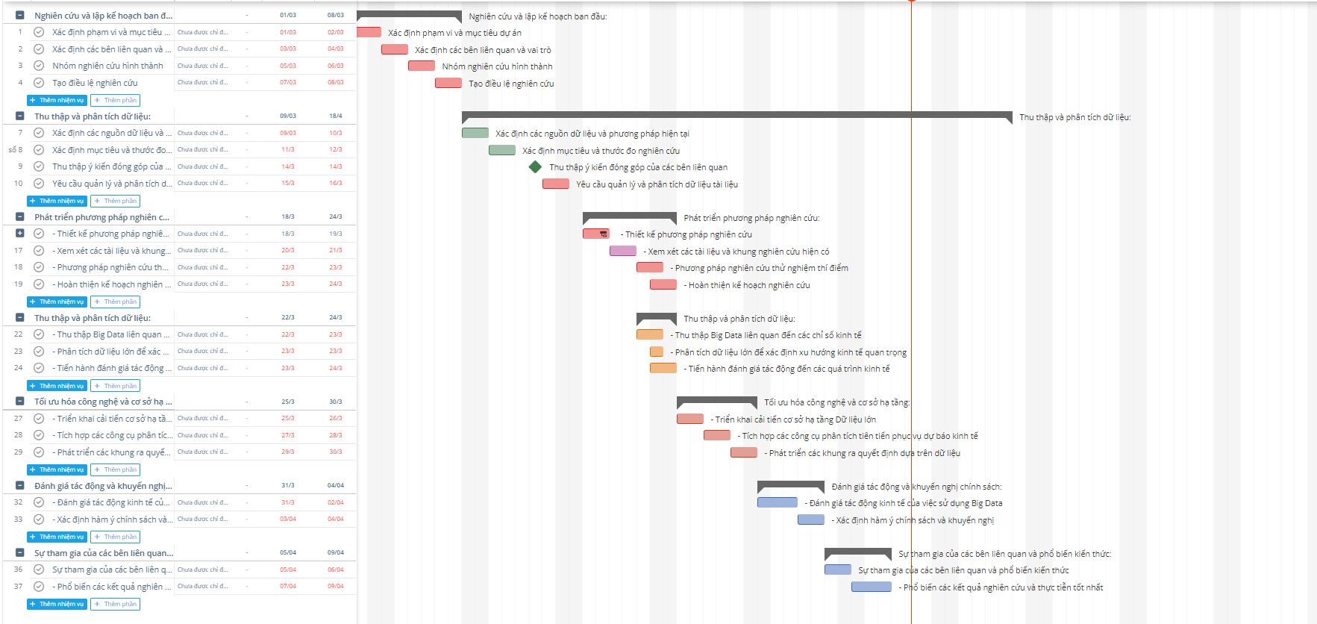

*Figure 2: Gantt Chart for Research on the Impact of Big Data on the Economy*

#### Timeline:

Task 1: Project Initiation

* Define project scope and objectives
* Identify stakeholders and roles
* Form research team
* Create research charter



*Figure 3: Task 1*

#### Timeline

Task 2: Data Collection and Analysis:

* Identify current data sources and methodologies
* Define research objectives and metrics
* Gather stakeholder input
* Document data management and analysis requirements



*Figure 4: Task 2*

#### Timeline:

Task 3: Research Methodology Development:

* Design research methodologies
* Review existing literature and research frameworks
* Pilot test research methodologies
* Finalize research plan

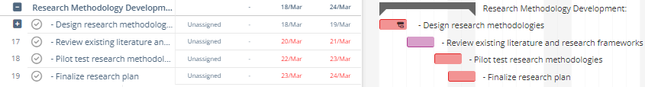

*Figure 5: Task 3*

#### Timeline:

Task 4 :Data Collection and Analysis

* Conduct impact assessments on economic processes
* Gather Big Data related to economic indicators
* Analyze Big Data to identify significant economic trends

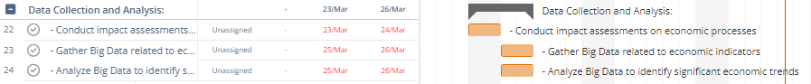

*Figure 6: Task 4*

Task 5 : Technology and Infrastructure Optimization:

* Implement Big Data infrastructure enhancements
* Integrate advanced analytics tools for economic forecasting
* Develop data-driven decision-making frameworks



*Figure 7:Task 5*

Task 6 : Impact Assessment and Policy Recommendations:

* Evaluate the economic impact of Big Data utilization

#### Identify policy implications and recommendations



*Figure 8:Task 6*

#### Timeline:

Task 7: Stakeholder Engagement and Knowledge Dissemination:

* Stakeholder Engagement and Knowledge Dissemination
* Disseminate research findings and best practices



*Figure 9:Task 7*

#### Timeline:

Task 8 : Research Dissemination and Engagement:

* Conduct outreach events and seminars
* Engage with stakeholders for feedback

#### Foster collaboration for further research

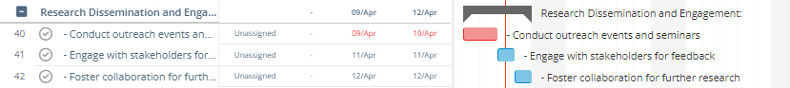

*Figure 10:Task 8*

#### Timeline:

Task 9 : Monitoring and Reporting

* Establish metrics for research impact
* Implement tracking mechanisms
* Conduct periodic evaluations

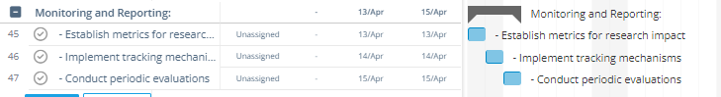

*Figure 11:Task 9*

Task 10 : Knowledge Sharing and Public Awareness:

* Publish research findings in reputable journals
* Engage with media and press
* Develop educational resources

#### Collaborate with educational institutions

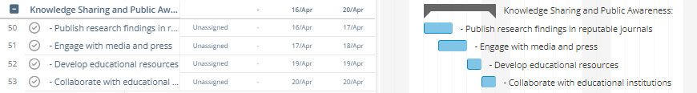

*Figure 12: Task 10*

Task 11 : Continuous Improvement and Future Research:

* Reflect on research process and outcomes
* Solicit feedback from peers and stakeholders
* Identify emerging trends and research gaps
* Plan for future research initiatives

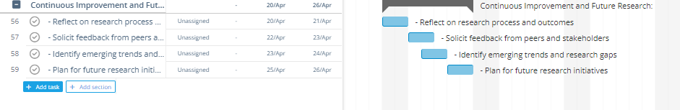

*Figure 13: Task 11 + Finalize*

Throughout the project, the Project Manager will oversee the progress and coordination of tasks, ensuring effective communication

among team members and stakeholders. The various team will work collaboratively under the guidance of the Project Manager to achieve the project's objectives.

### Use Appropriate Tools

We employed the Gantt chart tool for this project in order to guarantee effective project management and smooth cooperation amongst team members. The characteristics and capabilities of the chosen tools have been carefully considered, and they have been adapted to the particular requirements of the project. This is a description of the tools used and the rationale for the selection:

A Gantt chart uses a horizontal time axis to display the anticipated work and activities for a project. A vertical bar is used to symbolize each work, and the length of the bar indicates how long it takes to do the task. The Gantt chart displays the tasks that need to be completed, their start and finish times, and the relationships between them.

Gantt charts are used for project schedule visualization, work progress management, time requirement quantification, resource allocation, and planning efficiency.

## P6. Communicate appropriate project recommendations for technical and non- technical audiences.

### Project Objective:

The Research on the Impact of Big Data on the Economy aims to investigate the multifaceted effects of Big Data utilization on economic landscapes. This project centers on examining the influence of Big Data on various economic indicators, processes, and sectors to gain insights into its implications for economic growth, innovation, and sustainability. Through rigorous analysis and evaluation, the research seeks to identify opportunities and challenges associated with Big Data adoption, ultimately contributing to informed decision-making and policy formulation for fostering a resilient and prosperous economy.

### Stakeholders Stakeholders:

The research project on the Impact of Big Data on the Economy involves collaboration and engagement with various stakeholders, including:

**Major Economic Players:** These include leading corporations, financial institutions, and industry leaders involved in Big Data utilization. Their insights and data contributions are crucial for understanding the economic impact of Big Data across different sectors.

**Government and Regulatory Authorities:** Collaboration with governmental agencies and regulatory bodies is essential for providing insights into policy frameworks, regulatory environments, and economic governance affected by Big Data utilization.

**Academic and Research Institutions:** Partnership with academic and research organizations allows for access to expertise, data, and methodologies essential for conducting comprehensive studies on the economic implications of Big Data.

**Business Communities:** Engagement with business communities, including startups, SMEs, and entrepreneurs, provides insights into the practical applications of Big Data in driving economic innovation, entrepreneurship, and market competitiveness.

**Consumer Advocacy Groups:** Collaboration with consumer advocacy groups ensures that research efforts consider the implications of Big Data on consumer rights, privacy, and welfare within the economy.

**International Organizations:** Cooperation with international organizations such as the World Bank, IMF, and OECD provides a global perspective on the economic impact of Big Data and facilitates cross-country comparisons and benchmarking.

**Non-Governmental Organizations (NGOs):** Collaboration with NGOs focused on economic development, human rights, and social justice helps address ethical, social, and environmental concerns related to Big Data utilization in the economy.

**Local Communities:** Engagement with local communities affected by Big Data initiatives fosters transparency, accountability, and community participation in shaping economic policies and practices related to Big Data utilization.

**Media and Public Opinion:** Collaboration with media outlets and public opinion influencers helps disseminate research findings, raise awareness, and facilitate public discourse on the economic implications of Big Data in society.

### For Technical Audience:

The Research on the Impact of Big Data on the Economy is a comprehensive endeavor designed to analyze and understand the intricate relationship between Big Data utilization and economic dynamics. Here are the key components of this research initiative:

**Economic Data Analysis:** We will employ advanced data analytics techniques to analyze large-scale economic datasets, including GDP, employment rates, trade volumes, and innovation metrics. Through rigorous analysis, we aim to uncover patterns, correlations, and trends that shed light on the impact of Big Data on economic indicators.

**Predictive Modeling:** Utilizing machine learning algorithms and predictive modeling techniques, we will develop models to forecast economic trends and behaviors influenced by Big Data. These models will provide insights into future economic scenarios and assist policymakers and businesses in making informed decisions.

**Policy Analysis:** We will assess the implications of Big Data adoption on economic policies, regulations, and governance structures. By analyzing policy frameworks and their alignment with Big Data initiatives, we aim to identify opportunities for policy innovation and optimization to maximize economic benefits.

**Sectoral Studies:** Conducting in-depth studies on specific economic sectors, such as finance, healthcare, and manufacturing, we will examine the differential impacts of Big Data utilization. These sectoral analyses will provide insights into sector-specific challenges, opportunities, and strategies for leveraging Big Data effectively.

**Stakeholder Engagement:** Collaboration with stakeholders including policymakers, industry experts, and academic researchers is integral to the research process. By engaging stakeholders in dialogues and consultations, we aim to gather diverse perspectives, validate research findings, and foster knowledge exchange.

**Ethical Considerations:** We will address ethical considerations such as data privacy, security, and fairness in the utilization of Big Data for economic research purposes. By adhering to ethical principles and guidelines, we aim to ensure the integrity and trustworthiness of our research outcomes.

Through these components, the research initiative aims to advance understanding of the impact of Big Data on the economy, inform evidence-based decision-making, and contribute to the development of sustainable and resilient economic systems.

### For Non-Technical Audience.

Big Data is actively researching how Big Data impacts our economy and society. Here's what we're doing to understand and address these effects:

**Understanding Economic Impact:** We're studying how Big Data affects our economy, including things like job growth, business success, and overall financial health. By understanding these impacts, we can make better decisions to benefit everyone.

**Planning for the Future:** We're looking at how Big Data might change the way our economy works in the future. This includes things like new job opportunities, changes in how businesses operate, and potential challenges we might face.

**Protecting People's Rights:** We're making sure that as we use Big Data, we're also protecting people's privacy and rights. This means keeping personal information safe and making sure everyone is treated fairly.

**Collaborating for Success:** We're working with experts, businesses, and government leaders to make sure we're studying Big Data's impact from all angles. By working together, we can find the best solutions for our economy and society.

Creating a Better Future: Ultimately, our goal is to use Big Data to make our economy stronger and more resilient. By understanding its impact, we can make smarter choices that benefit everyone and create a better future for all.

## P7. Present arguments for the planning decisions made when developing the project plans.

### Task 1: Initial Research and Planning:

**Decision:** Initiating a research project on the impact of big data on the economy involves the crucial decision to commence the study. This phase encompasses defining research objectives, scope, and assessing the feasibility of the project.

#### Argument:

Communication: The inception meeting serves as a platform for effective communication and exchange of ideas among researchers, stakeholders, and relevant parties. It fosters an environment where concerns, insights, and expectations can be shared, ensuring early identification and resolution of potential research challenges or complexities.

Team Building: Assembling a multidisciplinary research team enables members to acquaint themselves, establish rapport, and cultivate collaborative relationships. This cohesion enhances teamwork, fosters knowledge sharing, and facilitates the integration of diverse expertise, which is essential for conducting comprehensive research on the impact of big data on the economy.

#### Advantages:

* Clarity: The inception meeting ensures clarity regarding the research scope, objectives, methodologies, and expected outcomes, minimizing ambiguities and discrepancies among team members.
* Engagement: Involving researchers in the inception meeting enhances their engagement and commitment to the research project, fostering enthusiasm, and dedication.
* Time Efficiency: Addressing potential research complexities and logistical considerations early in the project lifecycle mitigates the risk of delays and ensures efficient research execution.

**Disadvantage**: Time and Resource Commitment: Organizing the inception meeting demands allocation of time and resources, which may strain project budgets and schedules. This could pose challenges, particularly if researchers are already engaged in other commitments or if there are constraints on available resources.

### Task 2 : Data Collection and Analysis:

#### Reasons for gathering requirements:

* Understanding the Economic Landscape: Collecting data on various economic sectors, market trends, and consumer behavior is crucial to gain insights into the impact of big data on the economy. This understanding forms the foundation for identifying opportunities and challenges associated with big data adoption.
* Stakeholder Alignment: Gathering input from key stakeholders, including government agencies, businesses, and industry experts, ensures that the research objectives are aligned with their interests and priorities, enhancing the relevance and credibility of the study.
* Forecasting Future Trends: Analyzing historical data and current market dynamics allows researchers to forecast future trends and developments in the economy, providing valuable insights for policymakers and businesses.

#### Arguments:

* Informed Decision Making: Data-driven research enables informed decision-making by providing evidence-based insights into the economic implications of big data utilization. This allows policymakers and businesses to formulate strategies that maximize the benefits of big data while mitigating potential risks.
* Stakeholder Engagement: Engaging with stakeholders throughout the data collection process fosters collaboration and buy-in, increasing the likelihood of successful research outcomes and the adoption of research findings.
* Risk Mitigation: By identifying emerging trends and potential economic challenges, the research helps policymakers and businesses anticipate risks and proactively implement measures to address them, enhancing economic resilience and stability

#### Advantages:

* Enhanced Research Relevance: Gathering comprehensive data ensures that the research findings are relevant and insightful, providing valuable guidance for policymakers, businesses, and other stakeholders.
* Stakeholder Buy-in: Involving stakeholders in the data collection process fosters a sense of ownership and commitment, increasing their support for the research and its outcomes.
* Future Planning: By forecasting future economic trends, the research enables policymakers and businesses to make proactive decisions and investments that support long-term economic growth and competitiveness.

**Disadvantage**: Time and Resource Constraints: Data collection and analysis can be time-consuming and resource-intensive, requiring substantial investments in terms of time, manpower, and financial resources. This may pose challenges, particularly for research projects with limited budgets or tight deadlines.

### Task 3 : Research Methodology Development:

**Reasons for Service Provider Selection:**

* Methodological Expertise: Rigorous evaluation and selection of research methodologies ensure that the chosen approach is well-suited to studying the impact of big data on the economy. It ensures that researchers possess the requisite skills and methodologies to address the complexities of analyzing economic data and trends effectively.
* Alignment with Research Objectives: Establishing criteria and evaluating various research methods enable researchers to align their methodology with the specific goals and objectives of the study. This alignment is crucial for generating reliable and relevant insights into the economic impact of big data.

**Advantage**: Optimal Resource Allocation: By selecting appropriate research methodologies, researchers can optimize resource allocation. Choosing methodologies that align with the research objectives and capabilities of the research team minimizes the risk of resource wastage and enhances the efficiency of the research process.

**Disadvantage**: Time Intensive: The process of researching, evaluating, and selecting research methodologies can be time-consuming. It requires careful consideration and deliberation to ensure that the chosen methodologies are robust and appropriate for studying the impact of big data on the economy.

### Task 4 : Data Collection and Analysis

#### Reasons for Data Collection and Analysis:

* Informed Decision Making: Gathering economic data and analyzing big data metrics provides essential insights for making informed decisions. It allows researchers to identify economic trends, patterns, and correlations, facilitating evidence-based decision-making in various sectors.
* Performance Evaluation: Data collection and analysis enable researchers to assess the impact of big data on the economy and measure the effectiveness of economic policies and interventions. This aids in evaluating the performance of economic sectors and identifying areas for improvement.

**Advantage Strategic Planning:** Analyzing economic data and big data metrics empowers policymakers and businesses to develop strategic plans and policies. By understanding the impact of big data on various economic indicators, stakeholders can formulate targeted strategies to enhance economic growth and competitiveness.

**Disadvantage**: Resource Demand: Collecting and analyzing extensive economic data sets can be resource-intensive, requiring significant investments in technology, expertise, and time. This may strain research budgets and delay project timelines, posing challenges for researchers and policymakers.

### Task 5: Technology and Infrastructure Optimization:

#### Reasons for Technology and Infrastructure Optimization:

* Enhanced Data Analysis: Optimizing technology and infrastructure facilitates advanced data analysis techniques, enabling researchers to extract meaningful insights from big data sets. It enhances the research capabilities and enables a deeper understanding of the economic impact of big data.
* Improved Efficiency: Upgrading infrastructure and adopting advanced technologies enhance research efficiency by streamlining data collection, processing, and analysis processes. This leads to faster research outcomes and enables researchers to respond more effectively to dynamic economic trends.
* Scalability: Investing in scalable technology infrastructure ensures that research capabilities can expand and evolve to accommodate growing data volumes and complexity. It enables researchers to undertake more comprehensive and in-depth analyses of the economic implications of big data

**Advantage**: Enhanced Research Capabilities: By optimizing technology and infrastructure, researchers can enhance their capacity to analyze big data and uncover insights into the economic impact of big data adoption. This leads to more robust and comprehensive research findings, which can inform policy-making and business strategies more effectively.

**Disadvantage**: Initial Investment: The initial investment required for technology and infrastructure optimization may pose a financial challenge for research projects. Allocating resources for upgrading technology infrastructure may compete with other esearch priorities and necessitate careful budget planning and allocation.

### Task 6 : Impact Assessment and Policy Recommendations:

#### Reasons for Sustainable Product Development:

* Economic Impact Analysis: Conducting economic research aims to assess the impact of big data adoption on various economic indicators, such as GDP growth, employment rates, and productivity. It provides insights into the economic benefits and challenges associated with leveraging big data technologies.
* Policy Formulation: Economic research informs policymakers about the implications of big data on the economy, enabling them to formulate effective policies and regulations. It helps in creating an enabling environment for maximizing the economic benefits of big data while mitigating potential risks.

**Advantage**: Informed Decision Making: Economic research enables stakeholders to make informed decisions regarding big data investment, adoption, and regulation. By understanding the economic implications of big data, policymakers and businesses can optimize their strategies and initiatives to foster economic growth and competitiveness.

**Disadvantage**: Research Costs and Complexity: Conducting economic research on the impact of big data entails significant costs and complexity. It requires specialized expertise, data collection and analysis tools, and time-intensive research methodologies, which may pose challenges for research projects with limited resources or tight timelines.

### Task 7 : Stakeholder Engagement and Knowledge Dissemination:

**Reasons for Supply Chain Sustainability**:

* Broad Insight Generation: Engaging with diverse stakeholders such as economists, policymakers, industry experts, and businesses widens the scope of economic research on the impact of big data. It allows for a comprehensive understanding of various perspectives and factors influencing the economy.
* Knowledge Sharing: Collaborating with stakeholders facilitates the exchange of insights, data, and expertise, enriching the research process and enhancing the quality of research outcomes. It promotes knowledge dissemination and fosters a culture of learning and innovation in the field of big data economics.

**Advantage**: Holistic Understanding: Stakeholder engagement ensures a holistic approach to researching the impact of big data on the economy by incorporating diverse viewpoints and expertise. This results in more comprehensive and insightful research findings that are relevant to policymakers, businesses, and other stakeholders.

**Disadvantage**: Coordination Challenges: Coordinating stakeholder engagement activities may present challenges such as scheduling conflicts, differing priorities, and communication barriers. Managing these complexities requires careful planning, coordination, and effective communication strategies to ensure meaningful stakeholder involvement in the research process.

### Task 8 : Research Dissemination and Engagement:

#### Reasons for Employee Training and Engagement:

* Research Awareness and Education: Engaging stakeholders through dissemination activities raises awareness about the impact of big data on the economy and enhances their understanding of related economic concepts and implications. It empowers stakeholders with the knowledge and insights necessary to navigate the evolving economic landscape shaped by big data technologies.
* Stakeholder Buy-In: Encouraging stakeholder engagement and involvement fosters a sense of ownership and commitment to the research project. It cultivates a collaborative environment where stakeholders feel valued and motivated to contribute their perspectives, expertise, and resources to the research efforts.

**Advantage**: Enhanced Research Impact: Engaging and educating stakeholders leads to a broader dissemination of research findings and a deeper understanding of the economic implications of big data adoption. It increases the relevance and applicability of research outcomes, thereby amplifying the impact of the research on economic policymaking, business strategies, and societal development.

**Disadvantage**: Resource Constraints: Organizing stakeholder engagement activities and research dissemination efforts requires dedicated resources in terms of time, manpower, and finances. Managing these resources effectively while balancing other research priorities and commitments can pose challenges and strain project budgets and timelines.

### Task 9 : Monitoring and Reporting

#### Reasons for Monitoring and Reporting:

* Progress Tracking: Establishing metrics and monitoring mechanisms allows researchers to track the progress of economic research on the impact of big data. It provides quantitative data to evaluate the effectiveness of research methodologies and the attainment of research objectives.
* Transparency and Accountability: Regular reporting on research progress promotes transparency and accountability in the research process. It ensures that stakeholders, including policymakers, businesses, and the public, are informed about the status and findings of the research, fostering trust and credibility.

**Advantage**: Informed Decision Making: Continuous monitoring and reporting provide researchers and stakeholders with timely data and insights for informed decision-making. It enables adjustments to research methodologies, strategies, and priorities based on emerging trends, challenges, and opportunities in the field of big data economics.

**Disadvantage**: Resource Demands: Implementing monitoring systems and conducting regular reporting activities may require investments in technology, expertise, and time. Balancing these resource demands with other research activities and priorities can pose challenges for research projects with limited resources or tight timelines.

### Task 10 : Knowledge Sharing and Public Awareness:

#### Reasons for Monitoring and Reporting

* Stakeholder Engagement: Developing a communication strategy for research findings and engaging with stakeholders fosters collaboration and stakeholder buy-in. It ensures that stakeholders are informed and actively involved in the research process, enhancing the relevance and impact of the research.
* Reputation Enhancement: Effective communication of research outcomes can bolster the reputation of researchers and institutions as credible and influential contributors to the field of big data economics. It attracts attention from policymakers, industry professionals, and the public, enhancing the visibility and recognition of the research efforts.

**Advantage**: Increased Research Impact: By disseminating research findings and raising public awareness about the economic impact of big data, researchers can garner support and interest from stakeholders. This can lead to greater engagement, collaboration, and utilization of research outcomes, ultimately amplifying the research's impact on economic policymaking, business strategies, and societal development.

**Disadvantage**: Complex Communication: Communicating research findings about the impact of big data on the economy can be challenging, as it involves translating technical concepts and data analysis into accessible and compelling messages for diverse audiences. Effective communication strategies and tools are needed to overcome this challenge and ensure that research messages are understood and appreciated by stakeholders.

### Task 11 : Continuous Improvement and Future Research:

#### Decisions:

* Evaluate research outcomes and impact.
* Identify lessons learned and research best practices.
* Incorporate feedback for ongoing research improvements. Reasons for Evaluation and Continuous Improvement:

#### This step is crucial for economic research on the impact of big data because:

* Learning from Experience: Conducting evaluations and identifying lessons learned allows researchers to gain valuable insights from the research's successes and challenges. It helps in refining future research methodologies and approaches based on empirical evidence.
* Continuous Progress: By incorporating feedback and making ongoing improvements, economic research on big data can adapt to new insights, methodological advancements, and evolving research questions, ensuring continuous progress in understanding the economic implications of big data.

#### Advantages:

* Enhanced Effectiveness: Evaluation and continuous improvement enable researchers to refine research methodologies and approaches, leading to more effective research outcomes that contribute to a deeper understanding of the impact of big data on the economy.
* Adaptability: The ability to incorporate feedback and make improvements allows researchers to stay responsive to emerging research trends and evolving economic dynamics, ensuring the relevance and significance of their research findings over time.

#### Disadvantages:

* Resource Intensive: The process of evaluation and continuous improvement in research may require additional resources, including time, expertise, and funding, especially when conducting data analysis and refining research methodologies.
* Potential Resistance to Change: Making continuous improvements in research methodologies may face resistance from stakeholders who are accustomed to existing research practices or skeptical about embracing new approaches. Overcoming this resistance requires effective communication and stakeholder engagement strategies.

# P8. Discuss accuracy and reliability of the different research methods applied.

## Overview of qualitative and quantitative research.

* + Qualitative Research:

Quantitative research is expressed in numbers and graphs. It is used to test or confirm theories and assumptions. This type of research can be used to establish generalizable facts about a topic.

Common quantitative methods include experiments, observations recorded as numbers, and surveys with closed- ended questions.

Quantitative research is at risk for research biases including information bias, omitted variable bias, sampling bias, or selection bias.

* + Quantitative Research:

Qualitative research is expressed in words. It is used to understand concepts, thoughts or experiences. This type of research enables you to gather in-depth insights on topics that are not well understood.

Common qualitative methods include interviews with open-ended questions, observations described in words, and literature reviews that explore concepts and theories.

Qualitative research is also at risk for certain research biases including the Hawthorne effect, observer bias, recall bias, and social desirability bias.

* + Observational Research:

A variety of non-experimental studies in which behavior is methodically watched and documented are referred to as observational research. The description of a variable or group of variables is the aim of observational research. More broadly, the objective is to capture a moment in time of particular traits of a person, group, or environment. Since nothing is altered or controlled in observational research, as previously said, it is non-experimental, and as such, it is not possible to draw conclusions about causality with this method. Observational research studies often gather qualitative data, but they can also collect quantitative data or both (mixed-methods). The following will provide an overview of numerous sorts of observational methods. This approach is especially helpful in situations where carrying out trials would be difficult, unethical, or impossible. Observational research is useful for a variety of purposes, such as examining the behavior of wildlife, seeing interactions in public areas, or exploring certain cultural customs. Furthermore, this methodology enables longitudinal research, offering a more profound comprehension of the ways in which phenomena change over time.

## Advantages and disadvantages of the research method on asm1 (Observational Research, Quantitative Analysis, Qualitative Analysis).

Each research method—observational research, quantitative analysis, and qualitative analysis—has its unique strengths and weaknesses. Researchers must carefully consider their research objectives, the nature of the study, and the context in which the research is conducted when selecting the most appropriate method. Observational research provides real-world insights but demands caution against observer bias. Quantitative analysis offers objectivity and generalizability but may overlook nuances.

Qualitative analysis delves deep into experiences but requires careful handling of subjectivity. By understanding the advantages and disadvantages of each method, researchers can make informed decisions to conduct rigorous and impactful research that best addresses their research questions:

#### Observational Research:

Observational research is not without its limitations. The presence of researchers can introduce observer bias, where the mere act of observing influences subjects' behavior, leading to potentially biased results. Additionally, due to the lack of control over variables, it can be challenging to establish causation definitively. While researchers can document and analyze a wide range of behaviors, this method may not be suitable for studying rare or infrequent events due to the time and effort required.

#### Quantitative Analysis:

The use of numerical data allows for easy replication of studies, fostering scientific rigor and verification of findings. Large-scale quantitative studies can also yield results that are more easily generalized to larger populations, increasing the external validity of research. Moreover, quantitative analysis provides precise measurements, enabling comparisons between different groups or conditions with a high degree of accuracy.

Nevertheless, quantitative analysis has its drawbacks. While it excels at measuring and analyzing numerical data, it may overlook nuances and subtle factors that are not easily quantifiable. This approach might focus on correlations and statistical significance, potentially missing the context and underlying reasons behind observed relationships. Furthermore, it is essential to remember that correlation does not imply causation, and the assumptions made in quantitative analysis might not fully capture the complexity of real-world phenomena.

#### Qualitative Analysis:

The primary strength of qualitative analysis lies in its flexibility and adaptability. Researchers can adjust their approach and questions during the study, allowing for the exploration of emerging themes and unexpected discoveries. This method is especially useful for exploring new research areas or when little is known about a subject, as it enables a deeper understanding of the topic.

However, qualitative analysis has certain challenges. Its subjective nature means that the interpretation of qualitative data heavily relies on the researchers' biases and perspectives. Achieving inter-rater reliability can be difficult, and the findings might be influenced by the researchers' background and experiences. Additionally, the sample sizes in qualitative studies are often small, which can limit the generalizability of the results. The data management process can be time-consuming and resource-intensive, as researchers need to meticulously analyze and code large volumes of qualitative data.

# Conclusion.

In conclusion, the creation of a comprehensive project plan for researching the impact of Big Data on the economy has been successfully achieved. Each phase of the project plan, from inception to dissemination, has been meticulously crafted to cater to both technical and non-technical audiences.

The project plan's succinct introduction outlined the project's scope and objectives, providing a solid groundwork for effective project management. Stakeholder identification and role delineation ensure that all pertinent parties are engaged and in alignment with the research goals.

Through the selection of appropriate methodologies and tools, the project plan facilitates streamlined data collection, analysis, and decision-making processes, empowering the organization to make informed choices in understanding Big Data's economic implications.

The breakdown of budget and resource allocation offers a structured approach to resource management, guaranteeing cost-effectiveness and adherence to the allocated budget.

The establishment of milestones, deliverables, and project dependencies sets a clear path to success, enabling the team to monitor progress and celebrate accomplishments throughout the research endeavor.

The communication strategy ensures efficient dissemination of project updates and findings to all stakeholders, fostering transparency and garnering support for the research initiative.

In summary, this meticulously designed project plan serves as a guiding framework that will enable stakeholders to gain deeper insights into the economic impact of Big Data. By adhering to the plan's objectives and methodologies, the organization can contribute significantly to informed decision-making, policy formulation, and economic sustainability in an era defined by the pervasive influence of Big Data.

# References.

# - Qualitative Research vs. Quantitative Research (available at: https://www.verywellmind.com/what-is-the-difference-between-

# quantitative-and-qualitative-research-4588136) ( accessed at : July 2 2023)

# - The new stateman: Big Tech's carbon problem (newstatesman.com) ( accessed at : July 2 2023)

# (accessed at : June 2 2023)

# - Quantitative Research (available at : Qualitative vs. Quantitative Research | Differences, Examples & Methods (scribbr.com) )

# (Accessed at : July 2 2023)

# - Qualitative Research: (available at : Qualitative vs. Quantitative Research | Differences, Examples & Methods (scribbr.com) )

# (Accessed at : July 2 2023)

# - Observational Research(available at : Observational Research – Research Methods in Psychology (pressbooks.pub)) (Accessed at : July 2

# 2023)