BEGIN

INPUT point

IF (point >= 75 ) DISPLAY “Loai A”

ELSE

IF (point >= 60) DISPLAY "Loai B"

ELSE

IF (point >= 45 ) DISPLAY "Loai C"

ELSE

IF(point >=35) DISPLAY "Loai D"

ELSE DISPLAY ”Loai E”

END IF

END IF

END IF

END IF

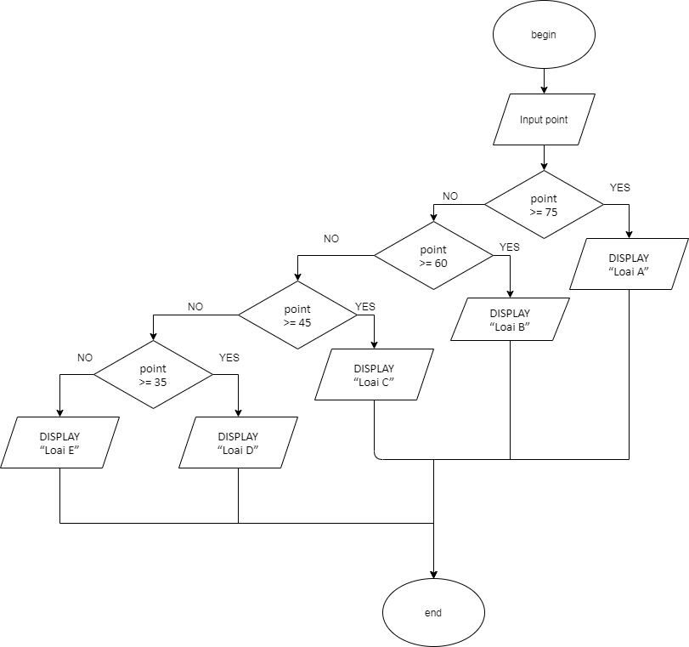END