INTELLIGENT SYSTEM DEVELOPMENT

ASSIGNMENT 01
Vietnam House Price Prediction Intelligent System
From Data Representation to a First Intelligent System

Student | ........................................................
Student ID | ........................................................
Class | ........................................................
Dataset | House Price Prediction Dataset Vietnam - 2024

Technical Report
Workflow adapted from Chapter 12 - Deploying Machine Learning Models

1. Introduction
This project develops a small intelligent system that predicts Vietnamese house prices from structured real-estate information. The implementation follows the course framework Understand -> Represent -> Learn -> Experiment -> Apply and adapts the workflow of Chapter 12 of Python Machine Learning: load data, clean data, inspect relationships, evaluate algorithms, select the best model, train with fit(), save/load the model, make predictions, and deploy an application.
The teacher additionally requires three distribution charts, five machine-learning models, five evaluation metrics, selection of the best model, and a simple free mobile-phone deployment. The report also follows Assignment 01 requirements for baseline, controlled experiments, system demonstration, reflection, and reproducibility.

2. Intelligent System Definition
The system receives house attributes from a dataset or user interface, transforms them into a computational feature representation, applies the same preprocessing used during training, and produces a predicted price in billion VND. The result is intended as a reference estimate for buyers, sellers, or analysts rather than a professional appraisal.
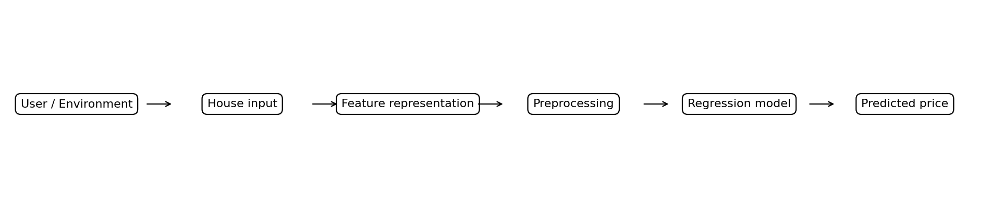
Figure 1. Complete intelligent-system path from input to predicted price (generated by notebook code).

3. Problem Definition
Formal problem statement: Given the selected feature vector representing a Vietnamese house, predict its numerical Price for a previously unseen property.
- Learning type: supervised learning.
- Task type: regression because Price is numerical.
- Input: numerical and categorical house attributes plus location derived from Address.
- Target: Price in billion VND.
- Output: one predicted price for a new house.

4. Dataset
The project uses the provided gia_nha.csv from the House Price Prediction Dataset Vietnam - 2024. The file contains 30,229 observations and 12 original columns. One observation corresponds to one property listing.
Original feature | Type | Meaning
Address | Categorical/text | Property address; transformed into Province and District
Area | Numerical | House area in square metres
Frontage | Numerical | Frontage width
Access Road | Numerical | Road/access width
House direction | Categorical | House direction
Balcony direction | Categorical | Balcony direction
Floors | Numerical | Number of floors
Bedrooms | Numerical | Number of bedrooms
Bathrooms | Numerical | Number of bathrooms
Legal status | Categorical | Legal status
Furniture state | Categorical | Furniture status
Price | Numerical target | House price in billion VND

5. Data Representation
Traditional machine learning operates on a computational representation rather than the complete real-world object. Full Address has very high cardinality, so the notebook extracts Province and District from the last two comma-separated address components. This preserves coarse location information while keeping the feature vector compact.
Feature group | Type | Encoded representation | Preprocessing
Area, Frontage, Access Road, Floors, Bedrooms, Bathrooms | Numerical | Real-valued features | Median imputation + StandardScaler
House direction, Balcony direction, Legal status, Furniture state | Categorical | Ordinal category codes | Most-frequent imputation + OrdinalEncoder
Province, District | Categorical location | Ordinal category codes | Extracted from Address, then encoded; unseen category = -1
Raw feature, encoded feature, and final model input are therefore distinct. The encoder is fit only on training data and then reused for validation, test, and application inputs.

6. Exploratory Data Analysis
The three required distribution charts are generated directly from gia_nha.csv by the notebook when Run All is executed.
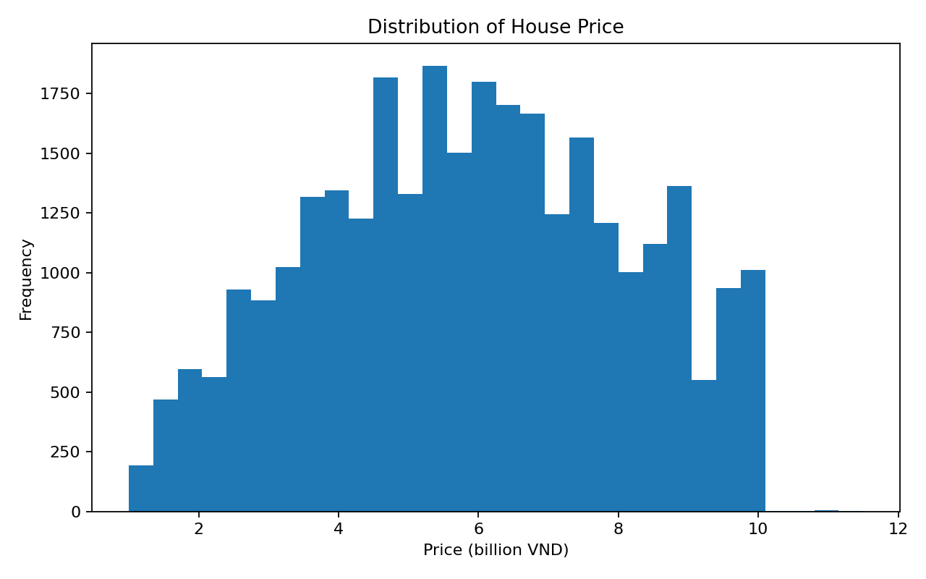
Figure 2. Distribution of Price generated from the dataset.
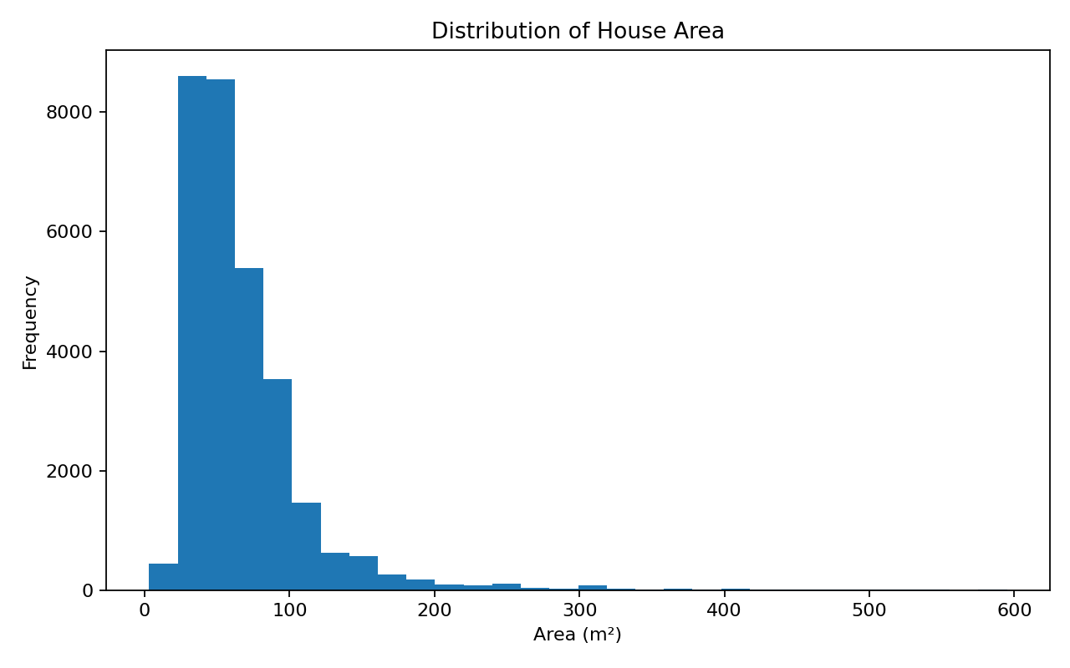
Figure 3. Distribution of Area generated from the dataset.
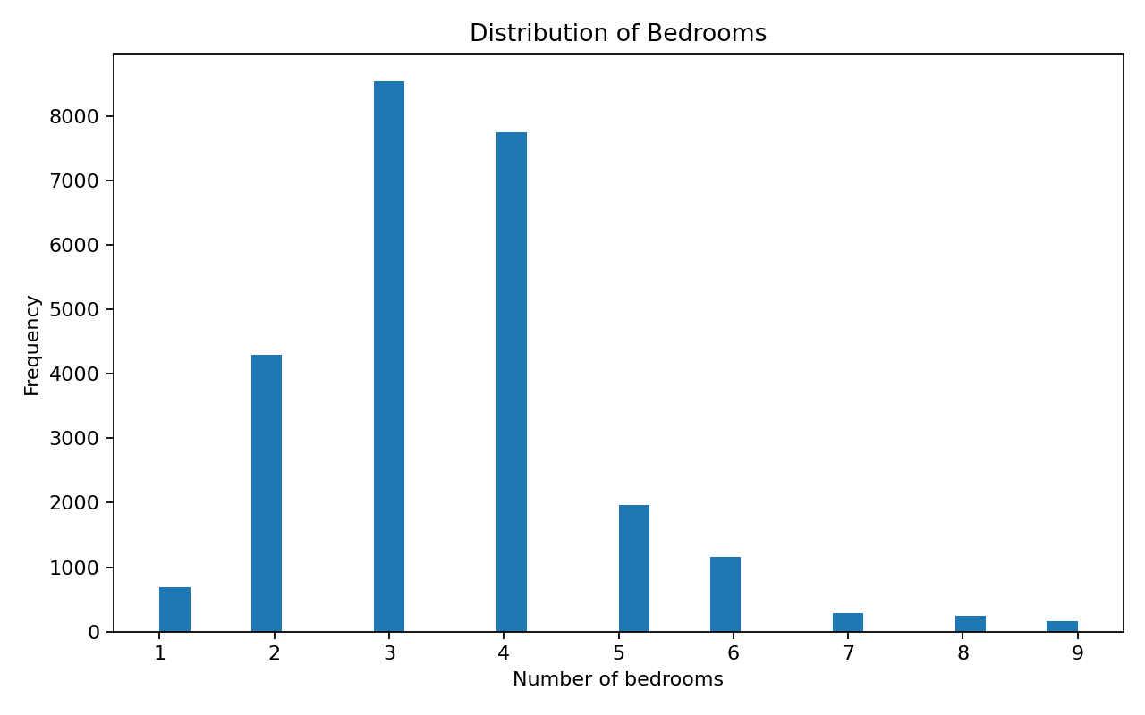
Figure 4. Distribution of Bedrooms generated from the dataset.

6.1 Correlation between numerical features
Following the Chapter 12 pattern, the notebook calls corr() and plots the numerical correlation matrix before model training. Correlation is informative for numerical variables but is not used to discard categorical location variables; their usefulness is tested separately in the representation experiment.
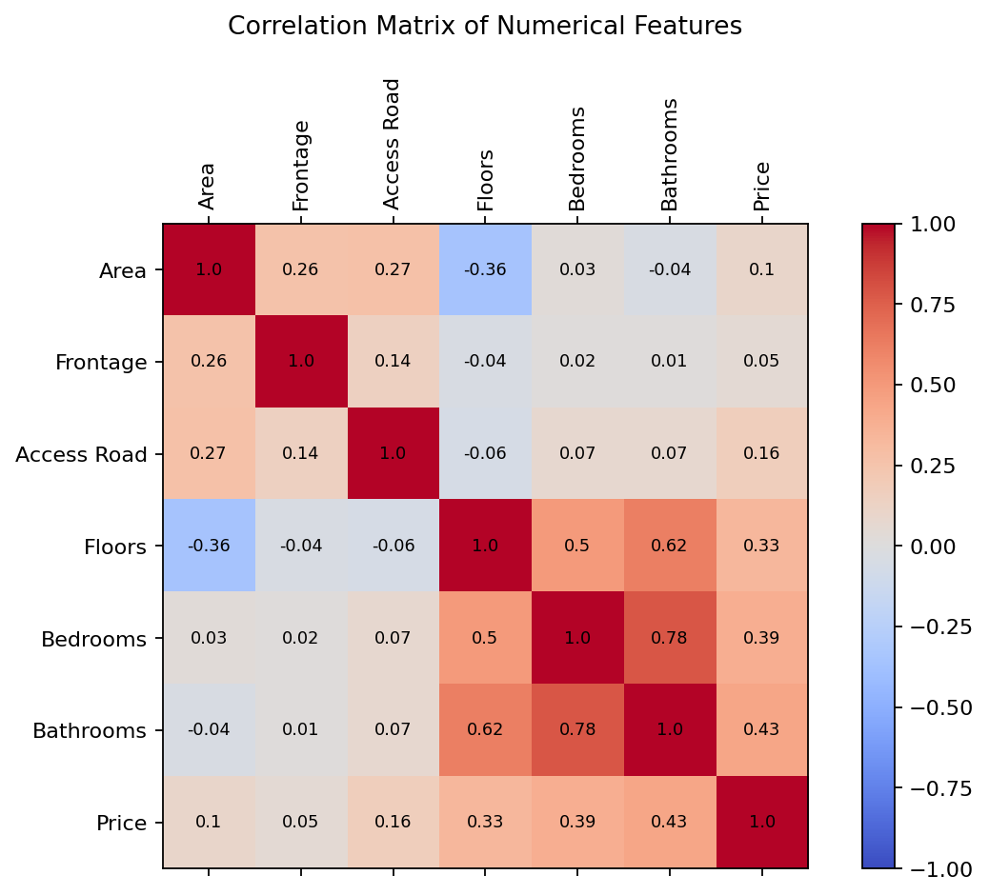
Figure 5. Correlation matrix generated directly from the current dataset.

7. Experimental Design

7.1 Train / validation / final test separation
The data is first split into 80% training portion and 20% untouched final test data. The 80% training portion is then split into training and validation sets, giving approximately 64% training, 16% validation, and 20% final test. Model comparison and controlled experiments use only training and validation data. The final test set is used after all choices are fixed.

7.2 Baseline
A DummyRegressor using the mean training price is fit as the first reference point. Its validation MAE is 1.8344 and R² is approximately -0.0000. A learned model should meaningfully improve over this simple strategy.

7.3 Five evaluation metrics
- MAE: average absolute prediction error; lower is better.
- MSE: average squared error; penalizes large errors; lower is better.
- RMSE: square root of MSE and has the same price unit; lower is better.
- R²: proportion of target variance explained; higher is better.
- MAPE: average absolute percentage error; lower is better.

8. Traditional Machine-Learning Models
Every model receives the same encoded training matrix and is trained by an explicit model.fit(X_train_ready, y_train) call in the notebook.

8.1 Linear Regression
Input representation: Encoded numerical feature matrix.
Relationship learned: Linear additive relationship between features and price.
Learned parameters: Feature coefficients and intercept.
Learning criterion: Minimization of squared prediction error.
Assumptions: Effects are approximately linear and additive.
Strengths: Fast, simple, and interpretable.
Weaknesses: Limited ability to model complex non-linear interactions.

8.2 Ridge Regression
Input representation: Same encoded numerical feature matrix.
Relationship learned: Regularized linear relationship.
Learned parameters: Coefficients and intercept.
Learning criterion: Squared error with an L2 penalty on coefficients.
Assumptions: Mainly linear and additive effects.
Strengths: More stable than ordinary linear regression when features are correlated.
Weaknesses: Still limited for strong non-linear relationships.

8.3 Decision Tree Regressor
Input representation: Same encoded numerical feature matrix.
Relationship learned: Recursive feature-space partitions.
Learned structure: Tree nodes, thresholds, branches, and leaf predictions.
Learning criterion: Squared-error reduction at splits.
Assumptions: Few distributional assumptions.
Strengths: Captures non-linearity and interactions.
Weaknesses: A single tree can overfit and be unstable.

8.4 Random Forest Regressor
Input representation: Same encoded numerical feature matrix.
Relationship learned: An ensemble of randomized decision trees.
Learned structure: Many trees and their split rules.
Learning criterion: Squared-error reduction inside each tree; tree outputs are averaged.
Assumptions: Few distributional assumptions.
Strengths: Strong non-linear performance and lower variance than a single tree.
Weaknesses: Larger and less interpretable than linear models.

8.5 Extra Trees Regressor
Input representation: Same encoded numerical feature matrix.
Relationship learned: An ensemble of highly randomized decision trees.
Learned structure: Many trees with randomized split candidates.
Learning criterion: Squared-error reduction in each tree; ensemble predictions are averaged.
Assumptions: Few distributional assumptions.
Strengths: Captures non-linearity and often trains quickly.
Weaknesses: Less interpretable and can still require many trees.

9. Results and Model Comparison
The following table is read directly from results/model_comparison.csv, which is written by the executed notebook. The values are not manually typed into the report-generation code.
Model | MAE | MSE | RMSE | R² | MAPE (%)
Random Forest | 1.0478 | 1.9416 | 1.3934 | 0.5978 | 21.99
Extra Trees | 1.1558 | 2.2102 | 1.4867 | 0.5421 | 24.58
Decision Tree | 1.2148 | 2.6841 | 1.6383 | 0.4440 | 25.19
Linear Regression | 1.5747 | 3.7158 | 1.9276 | 0.2303 | 35.84
Ridge Regression | 1.5759 | 3.7205 | 1.9289 | 0.2293 | 35.88
Baseline Mean | 1.8344 | 4.8273 | 2.1971 | -0.0000 | 43.73
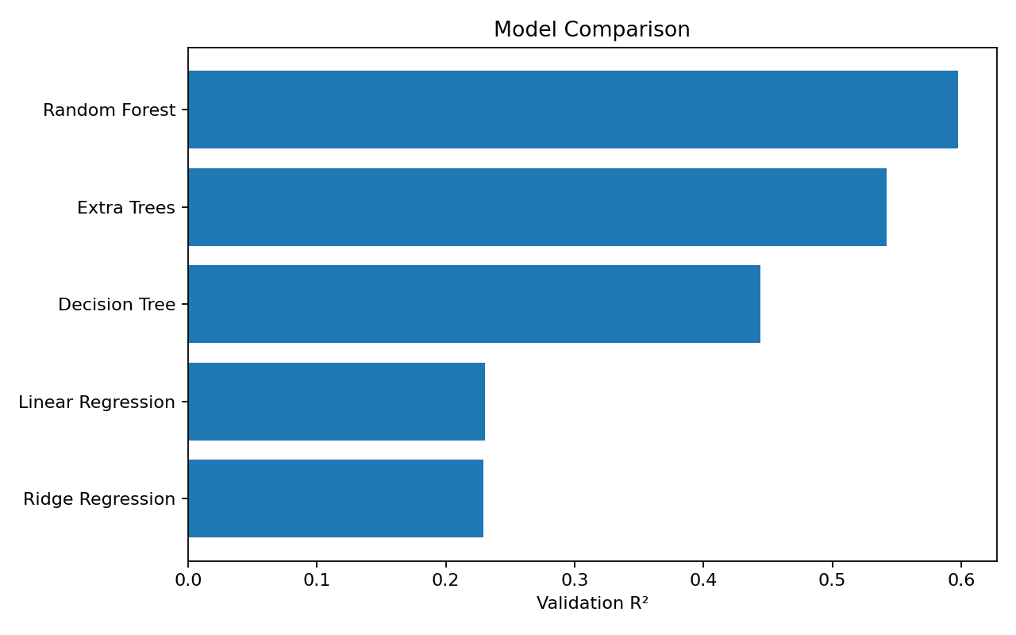
Figure 6. Validation R² comparison generated from the computed comparison DataFrame.
Random Forest is selected because it has the highest validation R² (0.5978) and also the lowest validation MAE (1.0478) among the five learned models. This supports the conclusion with several metrics rather than one score only.

10. Controlled Experiments

10.1 Experiment 1 - Model comparison
Question: Under the same representation and validation protocol, which of the five models predicts price most accurately? Result: Random Forest is best on validation data. The likely reason is that house price contains non-linear interactions among area, rooms, road/frontage, categorical status, and location that are difficult for linear models to capture.

10.2 Experiment 2 - Hyperparameter investigation
Question: How does the Random Forest n_estimators parameter affect validation performance when other settings are fixed? Each candidate is trained with an explicit fit() call.
Trees | MAE | MSE | RMSE | R² | MAPE (%)
10 | 1.0827 | 2.0684 | 1.4382 | 0.5715 | 22.71
30 | 1.0534 | 1.9634 | 1.4012 | 0.5933 | 22.08
50 | 1.0478 | 1.9416 | 1.3934 | 0.5978 | 21.99
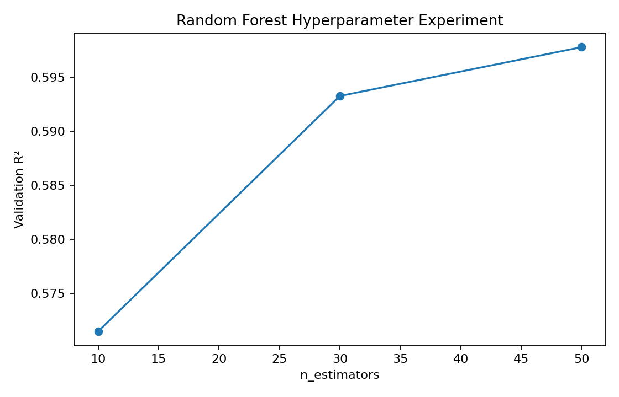
Figure 7. Hyperparameter experiment generated from actual fit/predict results.
Among the tested values, 50 trees gives the highest validation R² (0.5978). The improvement becomes smaller as more trees are added, so this value is a reasonable classroom/demo trade-off.

10.3 Experiment 3 - Representation / feature investigation
Question: Does explicitly representing location using Province and District improve performance? The same Random Forest configuration is fit twice; only the representation changes.
Representation | MAE | MSE | RMSE | R² | MAPE (%)
Without Province + District | 1.3963 | 3.1229 | 1.7672 | 0.3531 | 31.14
With Province + District | 1.0478 | 1.9416 | 1.3934 | 0.5978 | 21.99
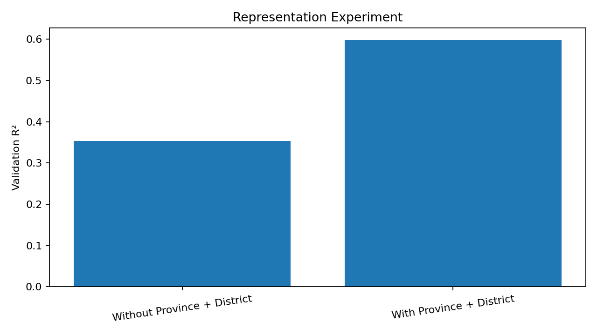
Figure 8. Representation experiment generated from actual model results.
Adding Province and District increases validation R² from 0.3531 to 0.5978 and reduces MAPE from 31.14% to 21.99%. This is strong evidence that representation directly affects what the model can learn.

11. Final Model and Unseen Test Evaluation
After model and parameter choices are fixed, the preprocessing object is fit on the complete 80% training portion and the final Random Forest is fit again using final_model.fit(...). Only then is the untouched 20% test set transformed and predicted.
MAE | MSE | RMSE | R² | MAPE (%)
1.0551 | 1.9942 | 1.4122 | 0.5910 | 22.36
The final unseen test result is MAE 1.0551 billion VND, RMSE 1.4122 billion VND, R² 0.5910, and MAPE 22.36%. The model performs substantially better than the baseline, although prediction error remains significant because listing prices depend on information not fully represented in the dataset.

12. Training, Saving, Loading, and Prediction
Following Chapter 12, after selection the final model is explicitly trained with fit(), saved to disk, loaded again, and used for predictions. This project saves a Python pickle bundle containing both the fitted preprocessing object and the fitted Random Forest. Preserving preprocessing is necessary because new application inputs must be transformed exactly like the training data.
Saved artifact: house_price_model.pkl

12.1 Three system-demonstration cases
Case | Area | Floors | Bedrooms | Province | District | Predicted price
1 | 50 | 4 | 4 | Hồ Chí Minh | Bình Tân | 5.727 billion VND
2 | 80 | 5 | 5 | Hà Nội | Cầu Giấy | 8.426 billion VND
3 | 120 | 3 | 4 | Đà Nẵng | Ngũ Hành Sơn | 6.853 billion VND
These predictions are read directly from results/demo_predictions.csv, which is produced after loading the saved model in the notebook.

13. Intelligent Application and Mobile Deployment
A trained model alone is not the complete intelligent system. The project therefore includes app.py, which loads house_price_model.pkl, accepts user input, creates the same feature representation, applies the saved preprocessing, calls model.predict(), and returns the predicted price.
The simplest free mobile deployment is a responsive Flask web application. The laptop runs the Python server and the phone acts as the front-end client over the same Wi-Fi network. The user runs python app.py, checks the laptop IPv4 address using ipconfig, and opens http://<laptop-ip>:5000 on the phone. This follows the REST/client architecture described in Chapter 12 while avoiding paid cloud hosting or Android Studio.
Complete application path: User / Environment -> Input -> Feature Representation -> Preprocessing -> Trained Random Forest -> Predicted Price -> Mobile/Web Output.

14. Reflection
What information does the system receive? Physical house attributes, direction/status categories, and location derived from Address.
What is the internal representation? Standardized numerical values and ordinal-encoded categorical values after missing-value imputation.
What does the model learn? Statistical relationships between the feature vector and observed house prices.
What prediction does it make? A numerical price estimate in billion VND.
Why can it handle unseen input? The same fitted preprocessing is applied to new inputs and the trained model generalizes from observed examples.
What can reasonably be called intelligent? The system learns a predictive mapping from examples instead of using manually written price rules.
What prevents it from being more capable? No exact coordinates, limited temporal/market information, simplified address parsing, missing attributes, and noisy listing prices.

14.1 Reflection on representation
The current feature vector preserves important structural and coarse location information but loses fine-grained spatial relationships. The same problem could be represented by exact geospatial coordinates, neighborhood graphs, text sequences/embeddings from full addresses and descriptions, or images. A different representation would make different learning methods possible and could improve generalization.

15. Limitations
- Listing price is not necessarily final transaction price.
- Province/District extraction is a simple rule and does not fully model geography.
- Ordinal category codes are compact and easy to deploy, but arbitrary numeric codes are not ideal for linear models.
- Important variables such as exact coordinates, property age, nearby amenities, time of listing, and market conditions are absent.
- The model should not be treated as a professional valuation service.

16. Conclusion
The project satisfies Assignment 01 as a small intelligent system rather than a collection of unrelated Scikit-learn examples. It defines the problem, represents raw information as features, generates three distribution charts, creates a baseline, trains five traditional machine-learning models using explicit fit() calls, evaluates them using five regression metrics, performs three controlled experiments, selects and evaluates a final model on unseen data, saves/loads the trained system, demonstrates three inputs, and deploys the prediction pipeline through a mobile-friendly Flask application.

References
- Dinh Que Tran. Intelligent System Development - Assignment 01: From Data Representation to a First Intelligent System.
- Dinh Que Tran. Intelligent System Development - Lecture 01: From Intelligence to Intelligent Systems.
- Wei-Meng Lee. Python Machine Learning. Wiley, 2019. Chapter 12: Deploying Machine Learning Models.
- Nguyen Tien Nhan. House Price Prediction Dataset Vietnam - 2024, Kaggle.

