LAB 1: Java Programming

Exercise 1 (3 mks)

Construct a website form for users registering and log in/out with Java code using JSP + Servlet + JDBC + Mysql + DAO. Refer [1] and the attached document at the end.

Exercise 2 (3 mks)

Construct a Java web application that manages a collection of books with the basic feature: list, insert, update, delete (or CRUD operations - Create, Read, Update and Delete). Refer [2]

Exercise 3 (4 mks)

Given a set of classes of a bookstore online: Customer, Address, Account, Book, OrderList (a list of books a customer orders), Order.

Construct a class diagram

Add attributes

Using DAO

Construct MySQL database for managing books, customers, accounts, orders

Making use of Exercise 1,2 to build a website for customer with the following functionalities

Register

Login/out

Search (books) for selecting books

Create Order

References

[1] JSP Servlet JDBC MySQL CRUD. Available at:

https://www.javaguides.net/2019/03/jsp-servlet-jdbc-mysql-crud-example-tutorial.html
https://www.javaguides.net/2019/03/registration-form-using-jsp-servlet-jdbc-mysql-example.html
https://www.javaguides.net/2019/03/login-form-using-jsp-servlet-jdbc-mysql-example.html

[2] https://www.codejava.net/coding/jsp-servlet-jdbc-mysql-create-read-update-delete-crud-example

References

JSP-Servlet-mySQL pg. 2

DAO Design pattern pg. 22

JSP Servlet JDBC MySQL CRUD
By Ramesh Fadatare
https://www.javaguides.net/2019/03/jsp-servlet-jdbc-mysql-crud-example-tutorial.html
In this tutorial, we are building a simple User Management web application that manages a collection of users with the basic feature:
list, insert, update, delete (or CURD operations - Create, Update, Read and Delete).
You can download the source code of this tutorial from my GitHub repository and the link is given at the end of this tutorial.
Top JSP, Servlet and JDBC Tutorials:
- Servlet Tutorial
- JSP Tutorial
- JDBC 4.2 Tutorial
Check out Build Todo App using JSP, Servlet, JDBC, and MySQL.
We will develop below simple basic features in our User Management web application:
- Create a User
- Update a User
- Delete a User
- Retrieve a User
- List of all Users
The application looks something like this:
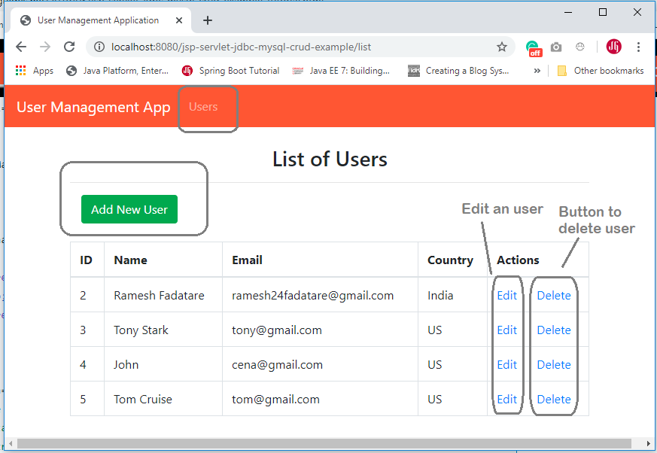

Tools and technologies used
- JSP - 2.2 +
- IDE - STS/Eclipse Neon.3
- JDK - 1.8 or later
- Apache Tomcat - 8.5
- JSTL - 1.2.1
- Servlet API - 2.5
- MySQL - mysql-connector-java-8.0.13.jar

Development Steps
- Create an Eclipse Dynamic Web Project
- Add Dependencies
- Project Structure
- MySQL Database Setup
- Create a JavaBean - User.java
- Create a UserDAO.java
- Create a UserServlet.java
- Creating User Listing JSP Page - user-list.jsp
- Create a User Form JSP Page - user-form.jsp
- Creating Error JSP page
- Deploying and Testing the Application Demo

Class Diagram
Here is the class diagram of the User Management web application that we are going to develop in this tutorial:
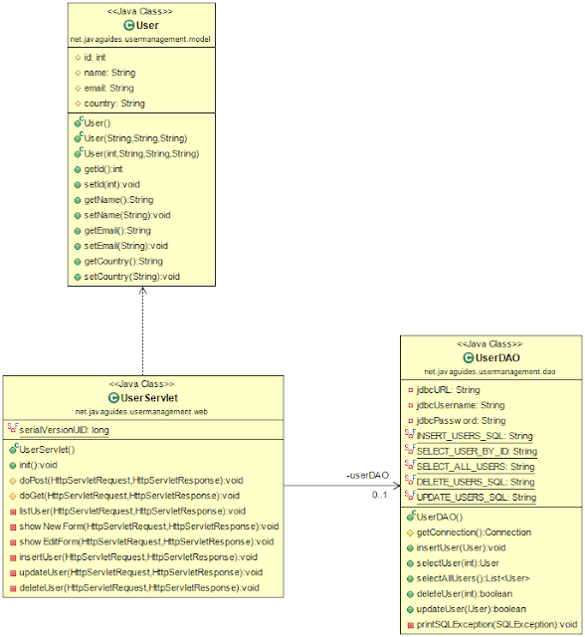

1. Create an Eclipse Dynamic Web Project
To create a new dynamic Web project in Eclipse:
1. On the main menu select File > New > Project....
2. In the upcoming wizard choose Web > Dynamic Web Project.
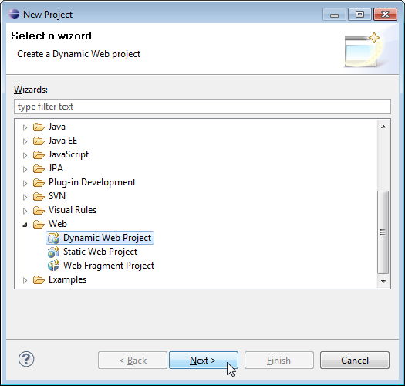
3. Click Next.
4. Enter project name as "jsp-servlet-jdbc-mysql-example";
5. Make sure that the target runtime is set to Apache Tomcat with the currently supported version.

2. Add Dependencies
Add the latest release of below jar files to the lib folder.
- jsp-api.2.3.1.jar
- servlet-api.2.3.jar
- mysql-connector-java-8.0.13.jar
- jstl-1.2.jar

3. Project Structure
Standard project structure for your reference -
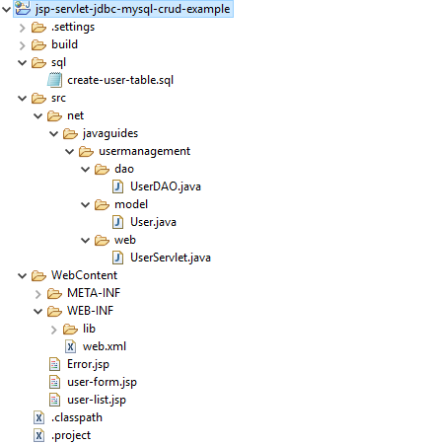

4. MySQL Database Setup
Let's create a database named "demo" in MySQL. Now, create a users table using below DDL script:
CREATE DATABASE 'demo';
USE demo;

create table users (
id int(3) NOT NULL AUTO_INCREMENT,
name varchar(120) NOT NULL,
email varchar(220) NOT NULL,
country varchar(120),
PRIMARY KEY (id)
);
You can use either MySQL Command Line Client or MySQL Workbench tool to create the database. The above a users table looks like:
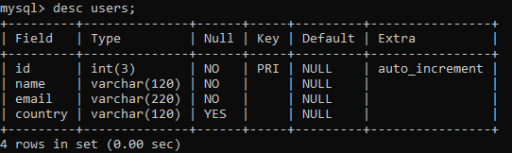

5. Create a JavaBean - User.java
Let's create a User java class to model a user entity in the database with the following code:
package net.javaguides.usermanagement.model;

/**
* User.java
* This is a model class represents a User entity
* @author Ramesh Fadatare
*
*/
public class User {
protected int id;
protected String name;
protected String email;
protected String country;

public User() {}

public User(String name, String email, String country) {
super();
this.name = name;
this.email = email;
this.country = country;
}

public User(int id, String name, String email, String country) {
super();
this.id = id;
this.name = name;
this.email = email;
this.country = country;
}

public int getId() {
return id;
}
public void setId(int id) {
this.id = id;
}
public String getName() {
return name;
}
public void setName(String name) {
this.name = name;
}
public String getEmail() {
return email;
}
public void setEmail(String email) {
this.email = email;
}
public String getCountry() {
return country;
}
public void setCountry(String country) {
this.country = country;
}
}

6. Create a UserDAO.java
Let's create a UserDAO class which is a Data Access Layer (DAO) class that provides CRUD (Create, Read, Update, Delete) operations for the table users in a database. Here’s the full source code of the UserDAO:
package net.javaguides.usermanagement.dao;

import java.sql.Connection;
import java.sql.DriverManager;
import java.sql.PreparedStatement;
import java.sql.ResultSet;
import java.sql.SQLException;
import java.util.ArrayList;
import java.util.List;

import net.javaguides.usermanagement.model.User;

/**
* AbstractDAO.java This DAO class provides CRUD database operations for the
* table users in the database.
*
* @author Ramesh Fadatare
*
*/
public class UserDAO {
private String jdbcURL = "jdbc:mysql://localhost:3306/demo?useSSL=false";
private String jdbcUsername = "root";
private String jdbcPassword = "root";

private static final String INSERT_USERS_SQL = "INSERT INTO users" + " (name, email, country) VALUES " +
" (?, ?, ?);";

private static final String SELECT_USER_BY_ID = "select id,name,email,country from users where id =?";
private static final String SELECT_ALL_USERS = "select * from users";
private static final String DELETE_USERS_SQL = "delete from users where id = ?;";
private static final String UPDATE_USERS_SQL = "update users set name = ?,email= ?, country =? where id = ?;";

public UserDAO() {}

protected Connection getConnection() {
Connection connection = null;
try {
Class.forName("com.mysql.jdbc.Driver");
connection = DriverManager.getConnection(jdbcURL, jdbcUsername, jdbcPassword);
} catch (SQLException e) {
// TODO Auto-generated catch block
e.printStackTrace();
} catch (ClassNotFoundException e) {
// TODO Auto-generated catch block
e.printStackTrace();
}
return connection;
}

public void insertUser(User user) throws SQLException {
System.out.println(INSERT_USERS_SQL);
// try-with-resource statement will auto close the connection.
try (Connection connection = getConnection(); PreparedStatement preparedStatement = connection.prepareStatement(INSERT_USERS_SQL)) {
preparedStatement.setString(1, user.getName());
preparedStatement.setString(2, user.getEmail());
preparedStatement.setString(3, user.getCountry());
System.out.println(preparedStatement);
preparedStatement.executeUpdate();
} catch (SQLException e) {
printSQLException(e);
}
}

public User selectUser(int id) {
User user = null;
// Step 1: Establishing a Connection
try (Connection connection = getConnection();
// Step 2:Create a statement using connection object
PreparedStatement preparedStatement = connection.prepareStatement(SELECT_USER_BY_ID);) {
preparedStatement.setInt(1, id);
System.out.println(preparedStatement);
// Step 3: Execute the query or update query
ResultSet rs = preparedStatement.executeQuery();

// Step 4: Process the ResultSet object.
while (rs.next()) {
String name = rs.getString("name");
String email = rs.getString("email");
String country = rs.getString("country");
user = new User(id, name, email, country);
}
} catch (SQLException e) {
printSQLException(e);
}
return user;
}

public List < User > selectAllUsers() {

// using try-with-resources to avoid closing resources (boiler plate code)
List < User > users = new ArrayList < > ();
// Step 1: Establishing a Connection
try (Connection connection = getConnection();

// Step 2:Create a statement using connection object
PreparedStatement preparedStatement = connection.prepareStatement(SELECT_ALL_USERS);) {
System.out.println(preparedStatement);
// Step 3: Execute the query or update query
ResultSet rs = preparedStatement.executeQuery();

// Step 4: Process the ResultSet object.
while (rs.next()) {
int id = rs.getInt("id");
String name = rs.getString("name");
String email = rs.getString("email");
String country = rs.getString("country");
users.add(new User(id, name, email, country));
}
} catch (SQLException e) {
printSQLException(e);
}
return users;
}

public boolean deleteUser(int id) throws SQLException {
boolean rowDeleted;
try (Connection connection = getConnection(); PreparedStatement statement = connection.prepareStatement(DELETE_USERS_SQL);) {
statement.setInt(1, id);
rowDeleted = statement.executeUpdate() > 0;
}
return rowDeleted;
}

public boolean updateUser(User user) throws SQLException {
boolean rowUpdated;
try (Connection connection = getConnection(); PreparedStatement statement = connection.prepareStatement(UPDATE_USERS_SQL);) {
statement.setString(1, user.getName());
statement.setString(2, user.getEmail());
statement.setString(3, user.getCountry());
statement.setInt(4, user.getId());

rowUpdated = statement.executeUpdate() > 0;
}
return rowUpdated;
}

private void printSQLException(SQLException ex) {
for (Throwable e: ex) {
if (e instanceof SQLException) {
e.printStackTrace(System.err);
System.err.println("SQLState: " + ((SQLException) e).getSQLState());
System.err.println("Error Code: " + ((SQLException) e).getErrorCode());
System.err.println("Message: " + e.getMessage());
Throwable t = ex.getCause();
while (t != null) {
System.out.println("Cause: " + t);
t = t.getCause();
}
}
}
}
}

7. Create a UserServlet.java
Now, let's create UserServlet that acts as a page controller to handle all requests from the client. Let’s look at the code first:
package net.javaguides.usermanagement.web;

import java.io.IOException;
import java.sql.SQLException;
import java.util.List;

import javax.servlet.RequestDispatcher;
import javax.servlet.ServletException;
import javax.servlet.annotation.WebServlet;
import javax.servlet.http.HttpServlet;
import javax.servlet.http.HttpServletRequest;
import javax.servlet.http.HttpServletResponse;

import net.javaguides.usermanagement.dao.UserDAO;
import net.javaguides.usermanagement.model.User;

/**
* ControllerServlet.java
* This servlet acts as a page controller for the application, handling all
* requests from the user.
* @email Ramesh Fadatare
*/

@WebServlet("/")
public class UserServlet extends HttpServlet {
private static final long serialVersionUID = 1 L;
private UserDAO userDAO;

public void init() {
userDAO = new UserDAO();
}

protected void doPost(HttpServletRequest request, HttpServletResponse response)
throws ServletException, IOException {
doGet(request, response);
}

protected void doGet(HttpServletRequest request, HttpServletResponse response)
throws ServletException, IOException {
String action = request.getServletPath();

try {
switch (action) {
case "/new":
showNewForm(request, response);
break;
case "/insert":
insertUser(request, response);
break;
case "/delete":
deleteUser(request, response);
break;
case "/edit":
showEditForm(request, response);
break;
case "/update":
updateUser(request, response);
break;
default:
listUser(request, response);
break;
}
} catch (SQLException ex) {
throw new ServletException(ex);
}
}

private void listUser(HttpServletRequest request, HttpServletResponse response)
throws SQLException, IOException, ServletException {
List < User > listUser = userDAO.selectAllUsers();
request.setAttribute("listUser", listUser);
RequestDispatcher dispatcher = request.getRequestDispatcher("user-list.jsp");
dispatcher.forward(request, response);
}

private void showNewForm(HttpServletRequest request, HttpServletResponse response)
throws ServletException, IOException {
RequestDispatcher dispatcher = request.getRequestDispatcher("user-form.jsp");
dispatcher.forward(request, response);
}

private void showEditForm(HttpServletRequest request, HttpServletResponse response)
throws SQLException, ServletException, IOException {
int id = Integer.parseInt(request.getParameter("id"));
User existingUser = userDAO.selectUser(id);
RequestDispatcher dispatcher = request.getRequestDispatcher("user-form.jsp");
request.setAttribute("user", existingUser);
dispatcher.forward(request, response);

}

private void insertUser(HttpServletRequest request, HttpServletResponse response)
throws SQLException, IOException {
String name = request.getParameter("name");
String email = request.getParameter("email");
String country = request.getParameter("country");
User newUser = new User(name, email, country);
userDAO.insertUser(newUser);
response.sendRedirect("list");
}

private void updateUser(HttpServletRequest request, HttpServletResponse response)
throws SQLException, IOException {
int id = Integer.parseInt(request.getParameter("id"));
String name = request.getParameter("name");
String email = request.getParameter("email");
String country = request.getParameter("country");

User book = new User(id, name, email, country);
userDAO.updateUser(book);
response.sendRedirect("list");
}

private void deleteUser(HttpServletRequest request, HttpServletResponse response)
throws SQLException, IOException {
int id = Integer.parseInt(request.getParameter("id"));
userDAO.deleteUser(id);
response.sendRedirect("list");

}
}

8. Creating User Listing JSP Page - user-list.jsp
Next, create a JSP page for displaying all users from the database. Let's create a list-user.jsp page under the WebContent directory in the project with the following code:
<%@ page language="java" contentType="text/html; charset=UTF-8"
pageEncoding="UTF-8"%>
<%@ taglib uri="http://java.sun.com/jsp/jstl/core" prefix="c"%>
<html>

<head>
<title>User Management Application</title>
<link rel="stylesheet" href="https://stackpath.bootstrapcdn.com/bootstrap/4.3.1/css/bootstrap.min.css" integrity="sha384-ggOyR0iXCbMQv3Xipma34MD+dH/1fQ784/j6cY/iJTQUOhcWr7x9JvoRxT2MZw1T" crossorigin="anonymous">
</head>

<body>

<header>
<nav class="navbar navbar-expand-md navbar-dark" style="background-color: tomato">
<div>
<a href="https://www.javaguides.net" class="navbar-brand"> User
Management App </a>
</div>

<ul class="navbar-nav">
<li><a href="<%=request.getContextPath()%>/list" class="nav-link">Users</a></li>
</ul>
</nav>
</header>
<br>

<div class="row">
<!-- <div class="alert alert-success" *ngIf='message'>{{message}}</div> -->

<div class="container">
<h3 class="text-center">List of Users</h3>
<hr>
<div class="container text-left">

<a href="<%=request.getContextPath()%>/new" class="btn btn-success">Add
New User</a>
</div>
<br>
<table class="table table-bordered">
<thead>
<tr>
<th>ID</th>
<th>Name</th>
<th>Email</th>
<th>Country</th>
<th>Actions</th>
</tr>
</thead>
<tbody>
<!-- for (Todo todo: todos) { -->
<c:forEach var="user" items="${listUser}">

<tr>
<td>
<c:out value="${user.id}" />
</td>
<td>
<c:out value="${user.name}" />
</td>
<td>
<c:out value="${user.email}" />
</td>
<td>
<c:out value="${user.country}" />
</td>
<td><a href="edit?id=<c:out value='${user.id}' />">Edit</a> &nbsp;&nbsp;&nbsp;&nbsp; <a href="delete?id=<c:out value='${user.id}' />">Delete</a></td>
</tr>
</c:forEach>
<!-- } -->
</tbody>

</table>
</div>
</div>
</body>

</html>
Once you will deploy above JSP page in tomcat and open in the browser looks something like this:

9. Create a User Form JSP Page - user-form.jsp
Next, we create a JSP page for creating a new User called user-form.jsp. Here’s its full source code:
<%@ page language="java" contentType="text/html; charset=UTF-8"
pageEncoding="UTF-8"%>
<%@ taglib uri="http://java.sun.com/jsp/jstl/core" prefix="c"%>
<html>

<head>
<title>User Management Application</title>
<link rel="stylesheet" href="https://stackpath.bootstrapcdn.com/bootstrap/4.3.1/css/bootstrap.min.css" integrity="sha384-ggOyR0iXCbMQv3Xipma34MD+dH/1fQ784/j6cY/iJTQUOhcWr7x9JvoRxT2MZw1T" crossorigin="anonymous">
</head>

<body>

<header>
<nav class="navbar navbar-expand-md navbar-dark" style="background-color: tomato">
<div>
<a href="https://www.javaguides.net" class="navbar-brand"> User Management App </a>
</div>

<ul class="navbar-nav">
<li><a href="<%=request.getContextPath()%>/list" class="nav-link">Users</a></li>
</ul>
</nav>
</header>
<br>
<div class="container col-md-5">
<div class="card">
<div class="card-body">
<c:if test="${user != null}">
<form action="update" method="post">
</c:if>
<c:if test="${user == null}">
<form action="insert" method="post">
</c:if>

<caption>
<h2>
<c:if test="${user != null}">
Edit User
</c:if>
<c:if test="${user == null}">
Add New User
</c:if>
</h2>
</caption>

<c:if test="${user != null}">
<input type="hidden" name="id" value="<c:out value='${user.id}' />" />
</c:if>

<fieldset class="form-group">
<label>User Name</label> <input type="text" value="<c:out value='${user.name}' />" class="form-control" name="name" required="required">
</fieldset>

<fieldset class="form-group">
<label>User Email</label> <input type="text" value="<c:out value='${user.email}' />" class="form-control" name="email">
</fieldset>

<fieldset class="form-group">
<label>User Country</label> <input type="text" value="<c:out value='${user.country}' />" class="form-control" name="country">
</fieldset>

<button type="submit" class="btn btn-success">Save</button>
</form>
</div>
</div>
</div>
</body>

</html>
Once you will deploy above JSP page in tomcat and open in the browser looks something like this:
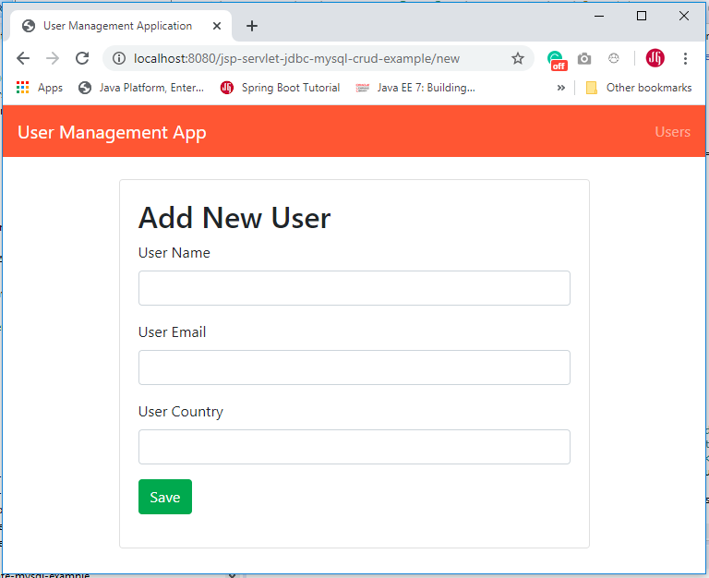
The above page acts for both functionalities to create a new User and Edit the same user. The edit page looks like:
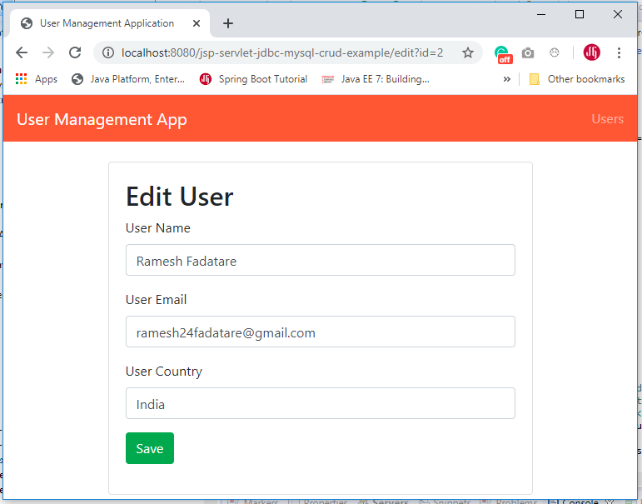

10. Creating Error JSP page
Here’s the code of the Error.jsp page which simply shows the exception message:
<%@ page language="java" contentType="text/html; charset=UTF-8"
pageEncoding="UTF-8" isErrorPage="true" %>
<!DOCTYPE html PUBLIC "-//W3C//DTD HTML 4.01 Transitional//EN"
"http://www.w3.org/TR/html4/loose.dtd">
<html>
<head>
<title>Error</title>
</head>
<body>
<center>
<h1>Error</h1>
<h2><%=exception.getMessage() %><br/> </h2>
</center>
</body>
</html>

11. Deploying and Testing the Application
It's time to see a demo of the above User Management web application. Deploy this web application in tomcat server.
Type the following URL in your web browser to access the User Management application: http://localhost:8080/jsp-servlet-jdbc-mysql-crud-example/

Create a new User

Edit a User

List of all Users

GitHub Repository
The source code this tutorial (User Management) is available on my GitHub repository at https://github.com/RameshMF/jsp-servlet-jdbc-mysql-crud-tutorial.
Check out Build Todo App using JSP, Servlet, JDBC, and MySQL.

Servlet + JSP + JDBC + MySQL Examples
- Servlet + JSP + JDBC + MySQL Example
- Registration Form using JSP + Servlet + JDBC + Mysql Example
- Login Form using JSP + Servlet + JDBC + MySQL Example

DAO Design Pattern
https://www.journaldev.com/16813/dao-design-pattern
DAO stands for Data Access Object. DAO Design Pattern is used to separate the data persistence logic in a separate layer. This way, the service remains completely in dark about how the low-level operations to access the database is done. This is known as the principle of Separation of Logic.
With DAO design pattern, we have following components on which our design depends:
- The model which is transferred from one layer to the other.
- The interfaces which provides a flexible design.
- The interface implementation which is a concrete implementation of the persistence logic.
Implementing DAO pattern
With above mentioned components, let’s try to implement the DAO pattern. We will use 3 components here:
- The Book model which is transferred from one layer to the other.
- The BookDao interface that provides a flexible design and API to implement.
- BookDaoImpl concrete class that is an implementation of the BookDao interface.
Let us put this logic into a diagram:
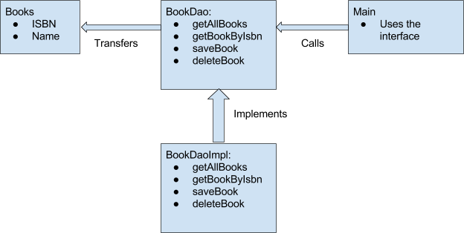

DAO Pattern model Class
Now, let’s put up our model object.
package com.journaldev.model;

public class Books {

private int isbn;
private String bookName;

public Books() {
}

public Books(int isbn, String bookName) {
this.isbn = isbn;
this.bookName = bookName;
}

// getter setter methods
}
It is a simple object with just 2 properties to keep things simple.

DAO Pattern Interface
Let’s define the interface to access the data associated with it at persistence level.

package com.journaldev.dao;

import com.journaldev.model.Books;

import java.util.List;

public interface BookDao {

List<Books> getAllBooks();
Books getBookByIsbn(int isbn);
void saveBook(Books book);
void deleteBook(Books book);
}

DAO Pattern Implementation
Next, we create a concrete class implementing the above interface.

package com.journaldev.daoimpl;

import com.journaldev.dao.BookDao;
import com.journaldev.model.Books;

import java.util.ArrayList;
import java.util.List;

public class BookDaoImpl implements BookDao {

//list is working as a database
private List<Books> books;

public BookDaoImpl() {
books = new ArrayList<>();
books.add(new Books(1, "Java"));
books.add(new Books(2, "Python"));
books.add(new Books(3, "Android"));
}

@Override
public List<Books> getAllBooks() {
return books;
}

@Override
public Books getBookByIsbn(int isbn) {
return books.get(isbn);
}

@Override
public void saveBook(Books book) {
books.add(book);
}

@Override
public void deleteBook(Books book) {
books.remove(book);
}
}

Using DAO Pattern
Finally, we put this implementation to use in our main() method:

package com.journaldev;

import com.journaldev.dao.BookDao;
import com.journaldev.daoimpl.BookDaoImpl;
import com.journaldev.model.Books;

public class AccessBook {

public static void main(String[] args) {

BookDao bookDao = new BookDaoImpl();

for (Books book : bookDao.getAllBooks()) {
System.out.println("Book ISBN : " + book.getIsbn());
}

//update student
Books book = bookDao.getAllBooks().get(1);
book.setBookName("Algorithms");
bookDao.saveBook(book);
}
}

Advantages of DAO pattern
There are many advantages for using DAO pattern. Let’s state some of them here:
- While changing a persistence mechanism, service layer doesn’t even have to know where the data comes from. For example, if you’re thinking of shifting from using MySQL to MongoDB, all changes are needed to be done in the DAO layer only.
- DAO pattern emphasis on the low coupling between different components of an application. So, the View layer have no dependency on DAO layer and only Service layer depends on it, even that with the interfaces and not from concrete implementation.
- As the persistence logic is completely separate, it is much easier to write Unit tests for individual components. For example, if you’re using JUnit and Mockito for testing frameworks, it will be easy to mock the individual components of your application.
- As we work with interfaces in DAO pattern, it also emphasizes the style of “work with interfaces instead of implementation” which is an excellent OOPs style of programming.
EXAMPLE 2
public class Student {
private String name;
private int rollNo;

Student(String name, int rollNo){
this.name = name;
this.rollNo = rollNo;
}

public String getName() {
return name;
}

public void setName(String name) {
this.name = name;
}

public int getRollNo() {
return rollNo;
}

public void setRollNo(int rollNo) {
this.rollNo = rollNo;
}
}

Step 2
import java.util.List;

public interface StudentDao {
public List<Student> getAllStudents();
public Student getStudent(int rollNo);
public void updateStudent(Student student);
public void deleteStudent(Student student);
}
import java.util.ArrayList;
import java.util.List;

public class StudentDaoImpl implements StudentDao {

//list is working as a database
List<Student> students;

public StudentDaoImpl(){
students = new ArrayList<Student>();
Student student1 = new Student("Robert",0);
Student student2 = new Student("John",1);
students.add(student1);
students.add(student2);
}
@Override
public void deleteStudent(Student student) {
students.remove(student.getRollNo());
System.out.println("Student: Roll No " + student.getRollNo() + ", deleted from database");
}

//retrive list of students from the database
@Override
public List<Student> getAllStudents() {
return students;
}

@Override
public Student getStudent(int rollNo) {
return students.get(rollNo);
}

@Override
public void updateStudent(Student student) {
students.get(student.getRollNo()).setName(student.getName());
System.out.println("Student: Roll No " + student.getRollNo() + ", updated in the database");
}
}

public class DaoPatternDemo {
public static void main(String[] args) {
StudentDao studentDao = new StudentDaoImpl();

//print all students
for (Student student : studentDao.getAllStudents()) {
System.out.println("Student: [RollNo : " + student.getRollNo() + ", Name : " + student.getName() + " ]");
}

//update student
Student student =studentDao.getAllStudents().get(0);
student.setName("Michael");
studentDao.updateStudent(student);

//get the student
studentDao.getStudent(0);
System.out.println("Student: [RollNo : " + student.getRollNo() + ", Name : " + student.getName() + " ]");
}
}

