* **Tutorial Laravel**

[**https://appdividend.com/category/laravel/**](https://appdividend.com/category/laravel/)

* **Start command prompt in folder**

in folder

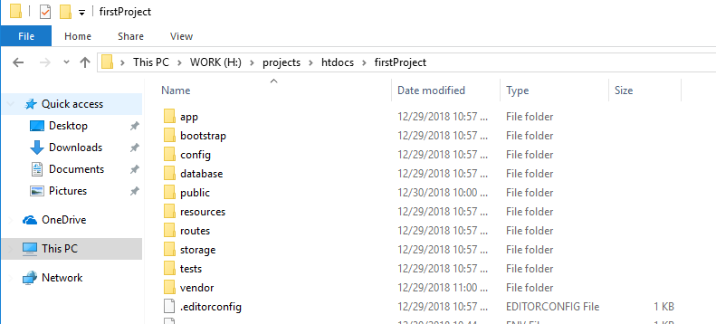

enter

* **Start port (mac dinh) laravel**

php artisan serve

* **Set port 8080**

php artisan serve --port=8080

php artisan serve --port=9000

* **Reset cache**

php artisan config:cache

php artisan config:clear

* **Create database by migrate**

php artisan migrate

* **Tao Controller**

php artisan make:controller ImageController

* **Include file**

@include('layouts.adminLayout.admin_header')

* **Include content**

@yield('content')

* **Cap nhat thu vien intervention/image**

php composer.phar require intervention/image

composer require intervention/image (chay cmd trong thu muc project laravel)

<https://appdividend.com/2018/04/13/laravel-image-intervention-tutorial-with-example/>

* **Sua loi Laravel 5.4: Specified key was too long error**

app/providers/AppServiceProvider.php

use Illuminate\Support\Facades\Schema;

public function boot()

{

Schema::defaultStringLength(191);

}

<https://laravel-news.com/laravel-5-4-key-too-long-error>

* Sua loi clone project and run

<https://bobcares.com/blog/laravel-something-went-wrong/>

* Stop run Laravel in command prompt

Ctr + c

* Exception handling

<https://laraveldaily.com/how-to-catch-handle-create-laravel-exceptions/>

<https://laracasts.com/discuss/channels/eloquent/handling-sql-based-exceptions>

public function search(Request $request)

{

try {

$user = User::findOrFail($request->input('user_id'));

} catch (ModelNotFoundException $exception) {

return back()->withError($exception->getMessage())->withInput();

}

return view('users.search', compact('user'));

}

<h3 class="page-title text-center">Search for user by ID</h3>

@if (session('error'))

<div class="alert alert-danger">{{ session('error') }}</div>

@endif

<form action="{{ route('users.search') }}" method="POST">...</form>

return back()->withError('User not found by ID ' . $request->input('user_id'))->withInput();