**SUPERMARKET SHOPPING APPLICATION**

MPP COURSE PROJECT

Duy Thanh Vo – 986033

Huynh Huong Duong Truong – 986043

September 2017

# **Problem Statement:**

We have been asked to develop and an Supermarket Shopping Application (SSA) for a local supermarket. This application will enable customers to buy products, as well as proceed checkout their shopping card toward make payment for their order. Also, they can track their order history if they have registered an user account in application. Moreover, they can update their profile, as well as update the payment information which includes credit/debit card information and shipping address.

When a customer first open SSA, he/she views products from home screen. Products are organized follow category list. He/she adds products to their shopping cart and continue shopping or they proceed checking out. Also, SSA will verify the product from stock whether these products are available.

For customers who have logged in to application which the shipping information and payment information supplied, he/she has more “Buy 1-Click” feature on a specified product. Also, they can enable or disable this feature from their settings.

Once the customer has completed choosing products, customers can proceed checking out their shopping cart. The SSA also will look up the promotion information whether there are any discounts applying to products in this shopping cart. After that, customer can go to payment screen to complete their order by supplying the bank card information, as well as the shipping information.

Especially, customer will belong to different types Standard, Silver and Gold. When customer first register to the SSA, their type are Standard. They can be promoted to another type depend on total amount of their order values in the history. He/she also will receive a discount percentage on next their orders in future.

# **Technology**

The main technologies used for the development of this application are as follows:

* Front-End Development: JavaFX
* Back-End Development: Java
* Database: SQLite

# **Architecture**

Project used the typical three layer architecture:

**DbConnection:** This class is mainly used to do the database activity like Select, Update and Delete query to database. It also checks if the database connection is open or not. If database connection is not open, then it opens the connection and performs the database query.

**Database Access Layer (DAO):** builds the query based on received parameters from the Business Logic Layer and passes it the DbConnection class for execution. And simple return results from the DbConnection class to Business Logic Layer.

**Data Object (DO):** is nothing more but a class with the contents GET and SET methods. It’s mainly used to pass data between Data Access Layer and Business Logic Layer.

**Business Logic Layer (BUS):** works as a bridge between Presentation Layer and DAO. All the user values received from the Presentation Layer are being passed to BUS.

**Domain Object:** it’s mainly used to pass data between Business Logic Layer and Presentation Layer.

**Presentation Layer:** is mainly used for getting user data and then passing it to Business Logic Layer for further procedure, and when data is received in Domain Object then it’s responsible to represent value object in the appropriate form which user can understand.

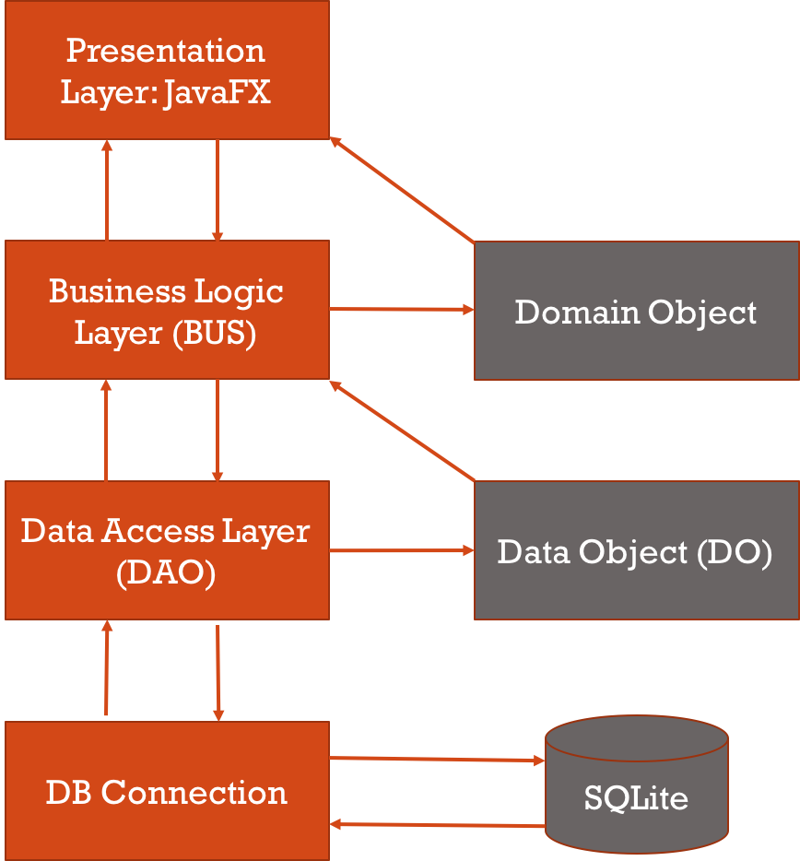

# **Use Case Diagram:**

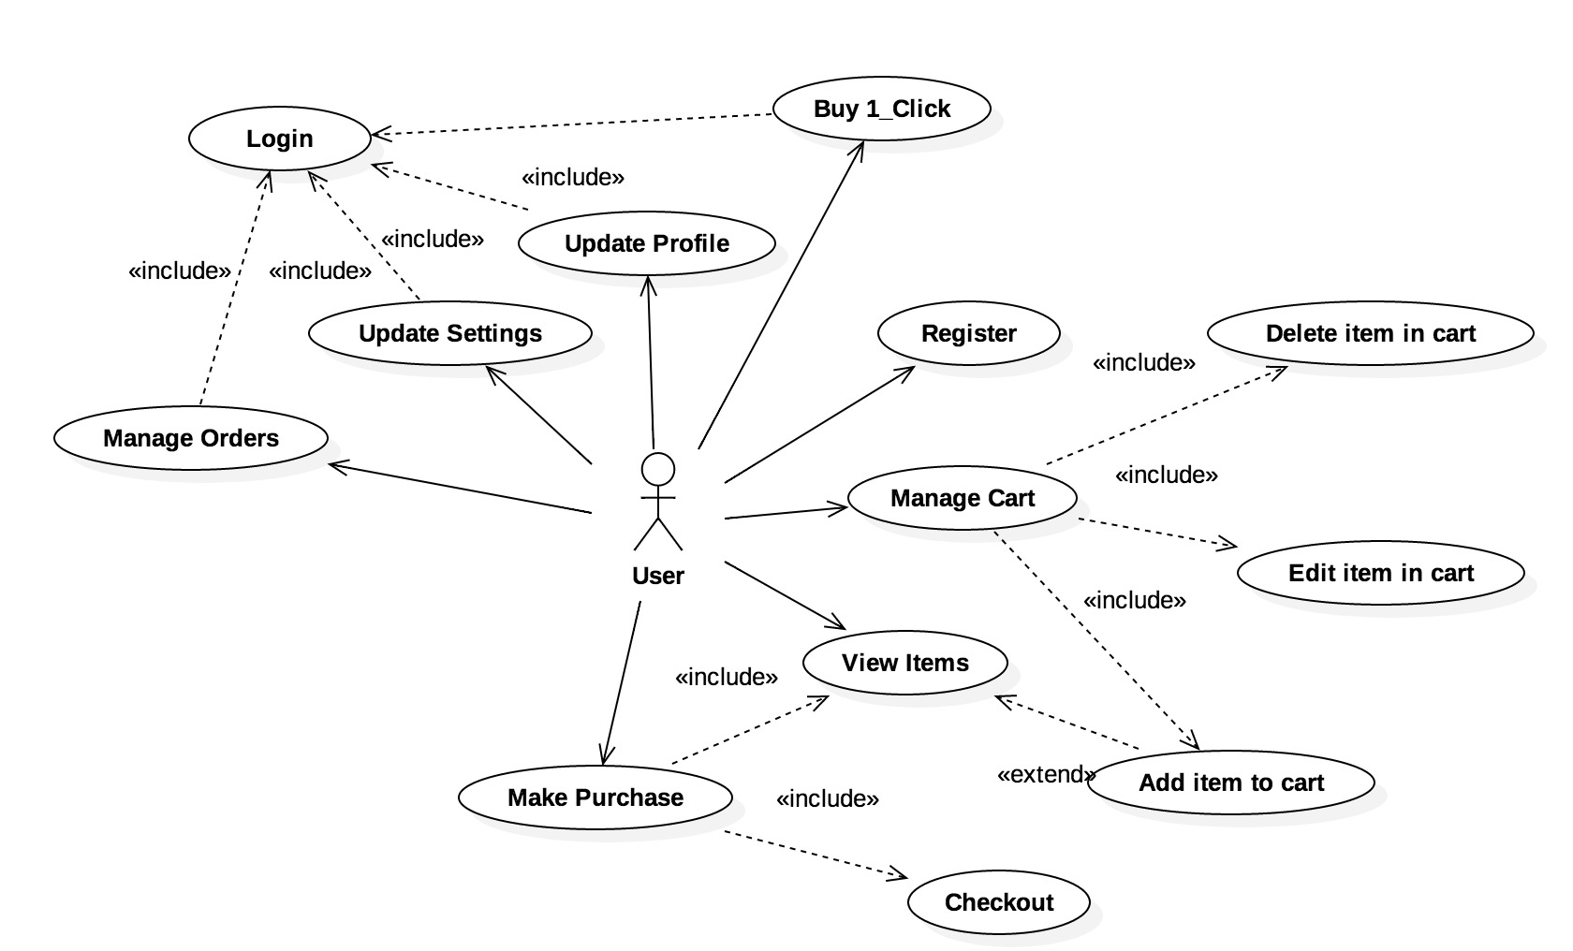

# **Identified Classes:**

* User
* User Type
* User Setting
* Customer
* Shopping Cart
* Order
* Line Item
* Product
* Product Category
* Promotion

# **Class Diagrams:**

* **Domain:**

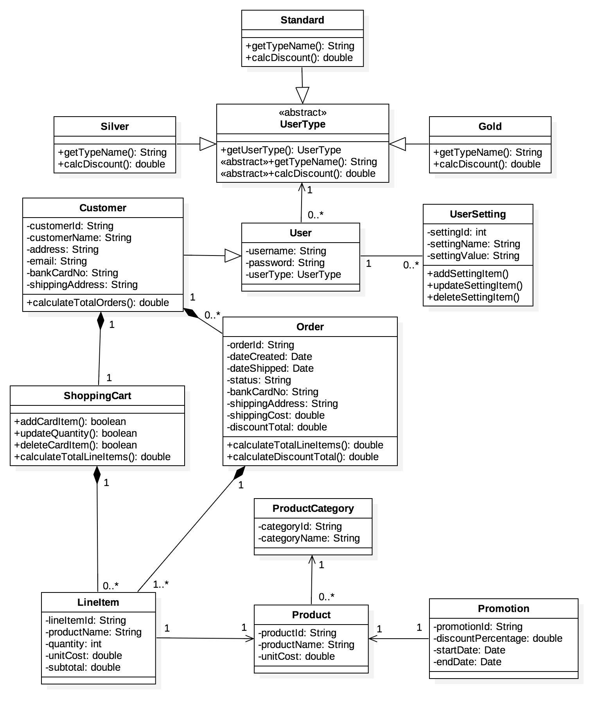

* **Business Logic Layer (BUS):**

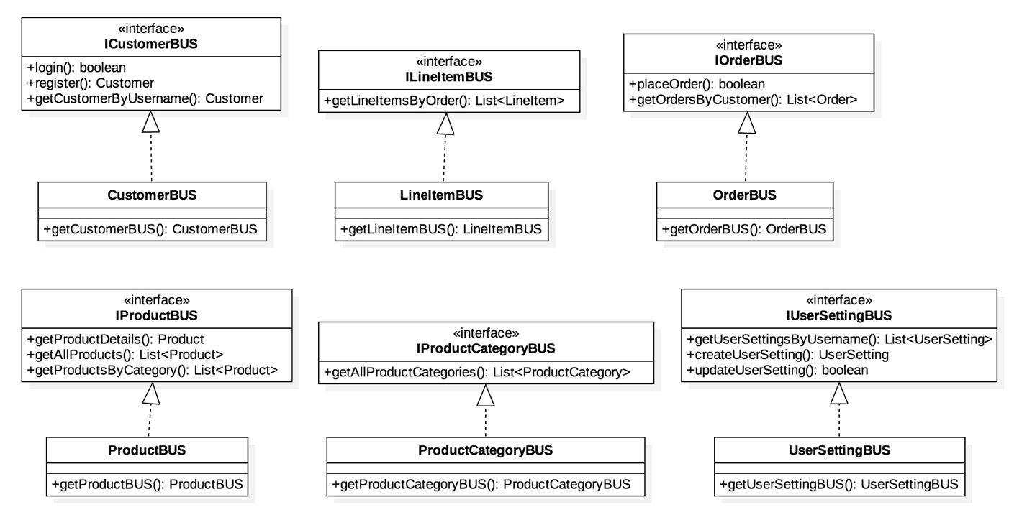

* **Data Access Layer (DAO):**

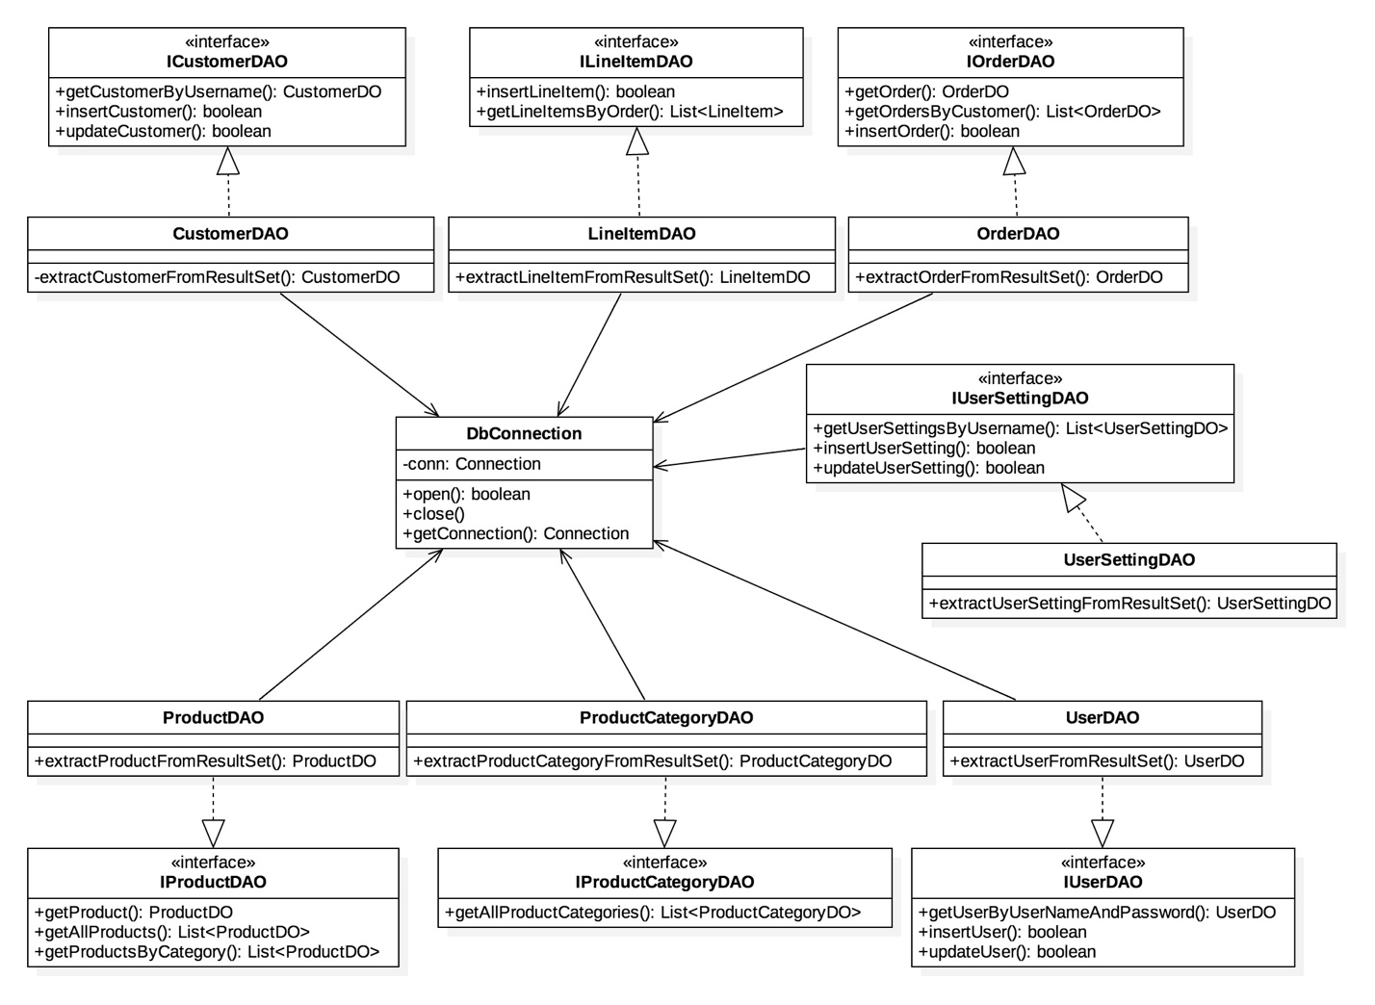

# **Sequence Diagrams:**

* **Login:**

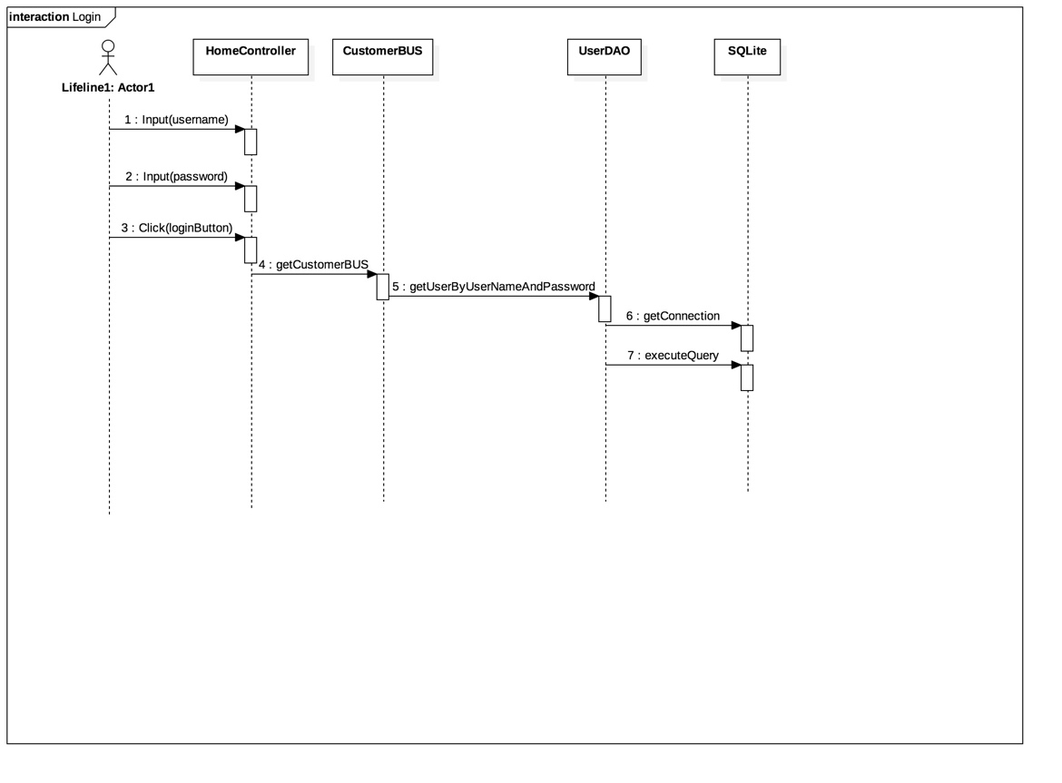

* **Sign Up:**

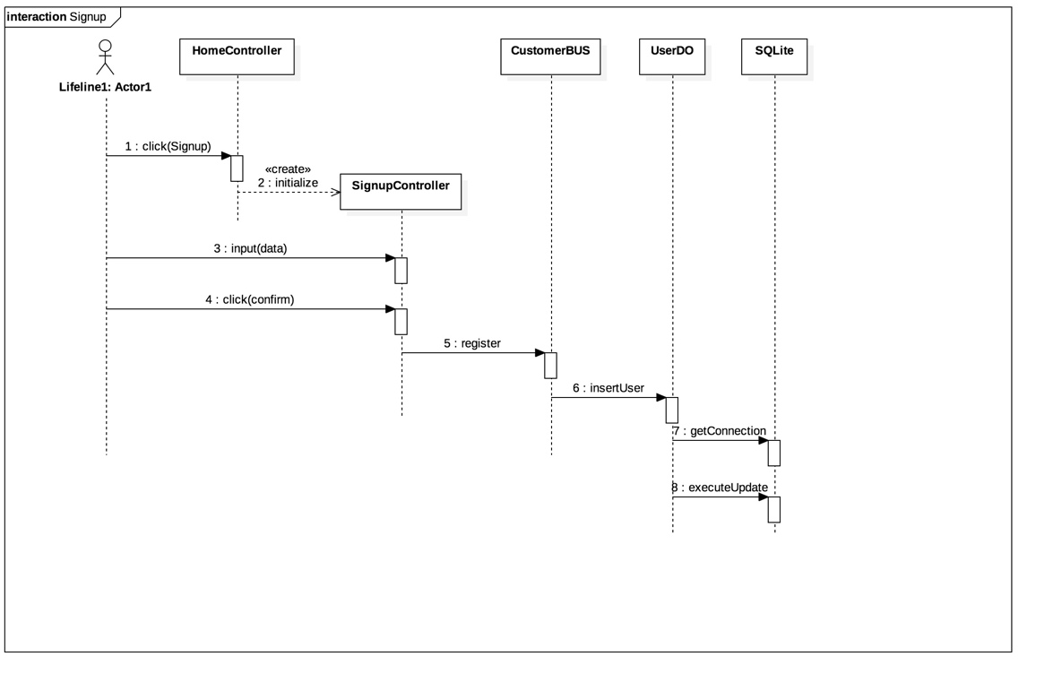

* **View Order:**

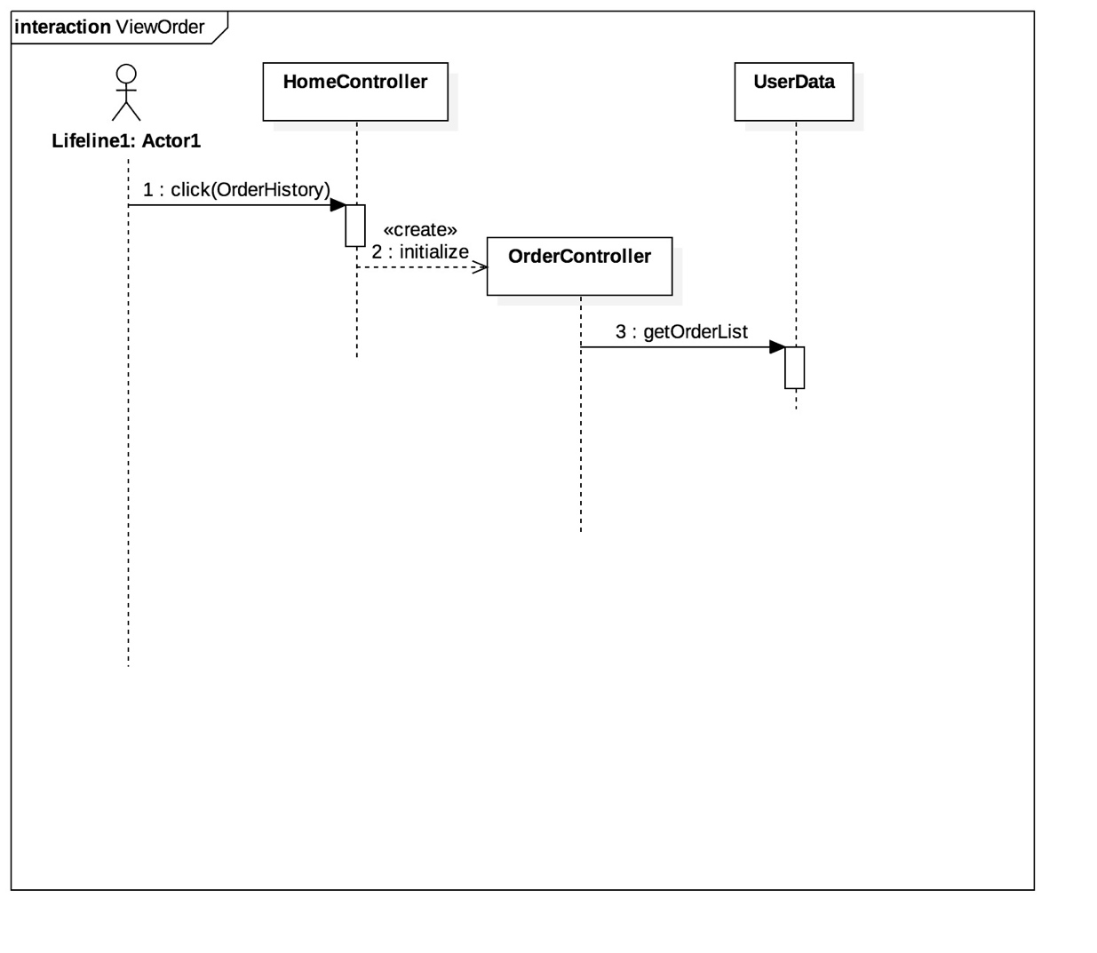

* **Add Shopping Cart:**

