**Quick User Manual**

**Compatibility**

This plugin was made to any QGIS Desktop version from 3.4.0-Madeira (python 3.7) to 3.44.x-Solothurn (python 3.12). It was tested with Windows 64bit environment but might be incompatible with Mac or Linux.

This plugin heavily depends on the 3rd party packages, such as s2cloudless, numpy, cv2, pystac_client those are python-version-based compatibility. These required dependencies will be installed upon the first use.

This plugin was developed with Qt5 and supports Qt6.

This plugin requires an active CDSE account to download Sentinel-2 images from. You can register free of charge (as of July 2025) here: [Copernicus Data Space Ecosystem | Europe's eyes on Earth](https://dataspace.copernicus.eu/)

**Installation**

Users will have some ways to install this plugin into your QGIS Desktop.

**Default QGIS plugins installation via QGIS plugin repository**

Just install this plugin like any others. (Plugins ==> Manage and Install plugins… ==> Search for Cloud Mask Sentinel-2 ==> Install plugin button)

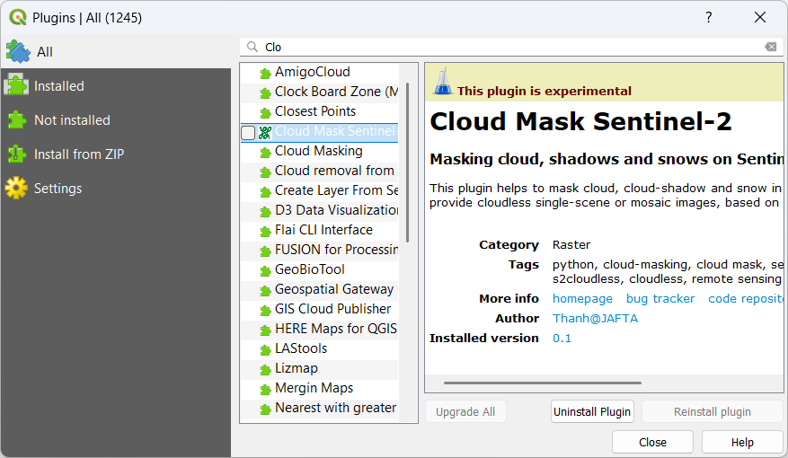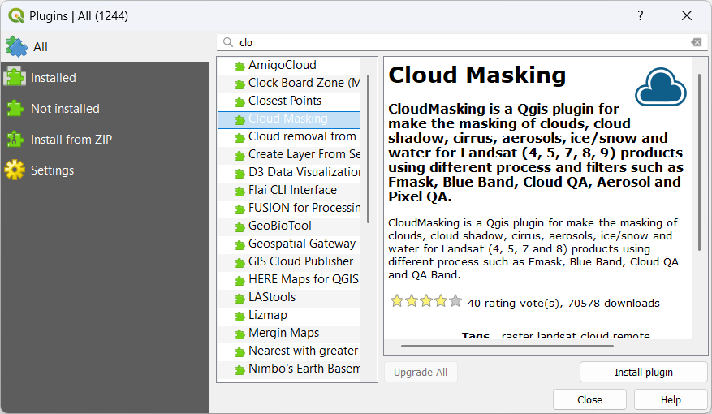

**Installation using zipped package**

* Download this zipped plugin [from GitHub](https://github.com/thanhgis/s2cloudmask/archive/refs/heads/master.zip)
* Plugins ==> Manage and Install Plugins… ==> Install from ZIP ==> Browse the downloaded ‘s2cloudmask-master.zip’ file ==> Install Plugin
* Make sure to rename the installed folder to ‘s2cloudmask’ (delete ‘-master’ at the end of the installed folder name).

**Custom (advanced) installation**

* Download this zipped plugin [from GitHub](https://github.com/thanhgis/s2cloudmask/archive/refs/heads/master.zip) then unzip it.
* Copy the unzipped folder to the QGIS’s core plugins directory at [QGIS Desktop Installed Folder]\apps\[**qgis**]\python\plugins

**Dependencies installation**

All required dependencies (around 360 MB or more) will be installed the first time you use this plugin, just follow-up the steps show on QGIS interface. Restart the QGIS once installation is completed to take effect.

**Use**

For the first time use, you need to input your CDSE credentials. Once it worked for the first time, this credential will be stored in your PC.

In case that wrong or inactivated CDSE credentials were used, the plugin will not be able to connect to the CDSE server and below warning will be shown. You then need to delete the ‘_creds.json’ file in the plugin folder then try again with your correct CDSE credentials.

Before starting the plugin, make sure that you have opened your working area (area of interest), scale your QGIS map canvas to 1:25000 or lower (just to search for Sentinel-2 scene covering your AOI). At the masking step, you can play with other AOI or scale which you can choose depending on the preview image.

If you select by calendar monthly view, then dates with image will be highlighted for the whole view:

If you custom select with two mouse clicks on the date range, the dates with image will be highlighted for the selected range only.

