DANANG SOFTWARE CORPORATION
SOFTECH-APTECH



❖ Group name : Group 1
❖ Class : Batch 120
❖ Instructor : Vu Thi Thanh Huyen
❖ Group Members :
- Ly Thanh Hai
- Nguyen Khanh

- Acknowlegement
We have taken efforts in this project. However, it would not have been possible without the kindly support and help of many individuals and organizations. We would like to extend our sincerely thankful to all of them.
We want to express our deep gratitude to the Softech-Aptech for their guidance and constant supervision as well as providing necessary information regarding the project, especially thanks to Mrs. Vu Thi Thanh Huyen who teach us many things during this project as well as helped us develop the analysis proceeding from it and debugged code.



- Introduction
'EMP Transfer Management' is a software belong to HK Coporation, which help the leader of company can manage the transfer of employee between projects. It offers various function such as create/update/remove employee, create/request/approve transfers. It also have ability to generate report of transfer in particular need.
- Problem definition
Currently the transfer records are maintained in the computer but there is no fixed format for it. Also the information needs to be shared by releasing circulars to the respective managers and employees and other related staff members (if any).
The information though maintained on computers, entire information can not be found at single place. If higher management wants some details about the transfers, they have to get it from the respective department heads. This becomes time consuming.
Proposed Solution
The management has decided to have a system for managing the transfers which will access a central database. This system can be installed on all the machines and the employees will have restricted access levels.
The system will have logins for employees and system administrator. And searching transfer records, making new transfers, genera report etc will be taken care of.
- Requirement Attributes
  - Functional Requirements
    - Login function
User need to have an user account in database in order to login to application.
Password provided in login will be encrypted and compare to the encrypted password in database.

Application function by role:

      - Human resource manager
HR can login to:
        - Add new employee, update employee, delete employee.
        - Search for employee, search for transfer records.
        - Create new transfer, approve transfer requests.
        - Generate reports.

      - Project manager
PM can login to:
        - Add new project, update project, delete project.
        - Search for employee, search for transfer records.
        - Create new transfer.
        - Generate reports.

      - President
The president can login to:
        - Add new user
        - Search for employee, search for transfer records.
        - Generate reports.

    - Management function
      - Manage Employees
        - Admin can add new employee, update existing employee or delete an employee
        - The employee who has been deleted will be mark as 'isDeleted = 1' in database, not actual delete from database.
      - Manage projects
        - Admin can add new project, update existing project or delete a project.
        - The project who has been deleted will be mark as 'isDeleted = 1' in database, not actual delete from database.

    - Search function
      - Search employees
Show that employees's profile, is available or not and current work.
This function provide:
        - Search by ID
        - Search by Name
        - Search by Project ID
        - Search by Free on particular date
      - Search Transfer records
Show the list of record has been made.
This function provide:
        - Search by ID
        - Search by From Project
        - Search by To Project
        - Search by from date
        - Search by to date

    - Request for transfer
When the Project Manager see that the project need more employees, he/she can search for the employee match the need, then make new request transfers.
    - HR approves transfer
After a request transfer is created, the noftification send to HR, then HR login to system and decide to approve or decline the request.
    - HR create a new transfer directly.
If needed, the HR can create a new transfer without mark it as request.
    - Generate reports
After every week or month, all the admin can generate reports, which showing infomations about all the transfers:
        - Make report of all transfer in a particular month.
        - Make report of all transfer in a date range 'from date' and 'to date'.
        - Make report of all transfer in a particular project like “from project A to project B” or “from project A” or “to project B”.
    - Logout
When user click logout button, the program come back to its start state.

  - Hardware and software requirement
  - Hardware
    - Processor 166 Mhz or higher
    - Ram more than 128
    - Disk space lager than 500Mb
  - Software
    - Windows XP or higher, Linux, MacOsX
    - Java 6 or higher
    - Microsoft SQL Server 2008 or higher

- System Analysis

  - Usecase Diagram

  - Data Flow Diagram Level 0

  - Data Flow Diagram Level 1

  - Database
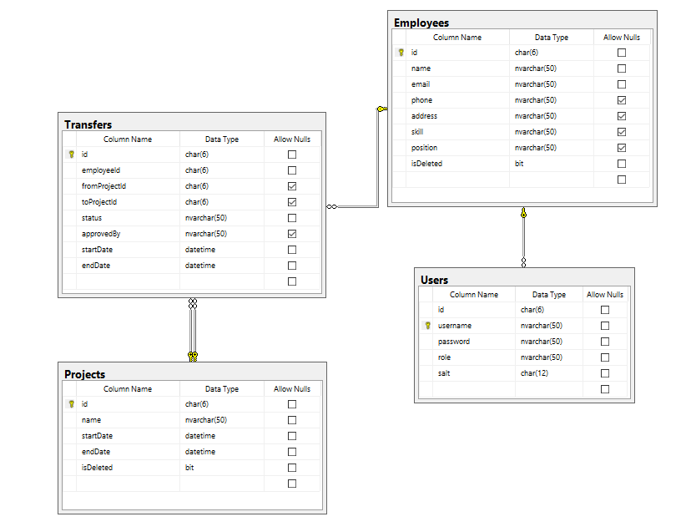

- Design
  - Main form

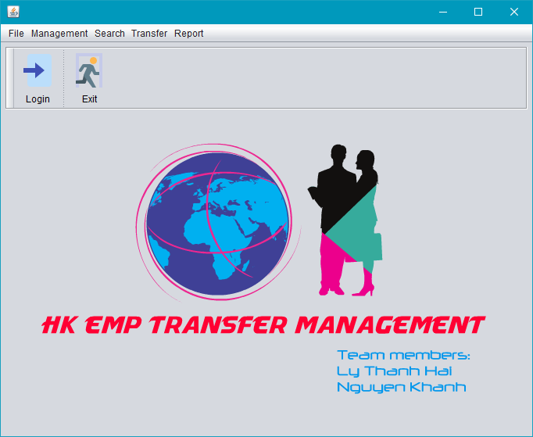

  - Login form

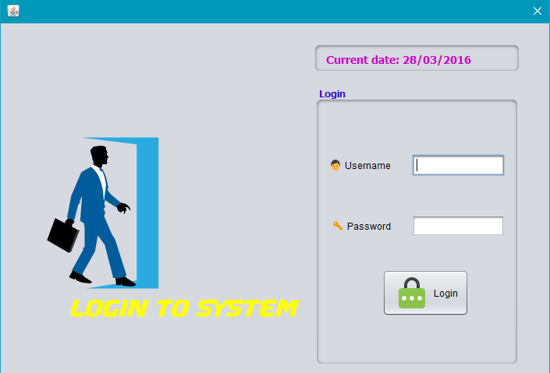

  - Add User form

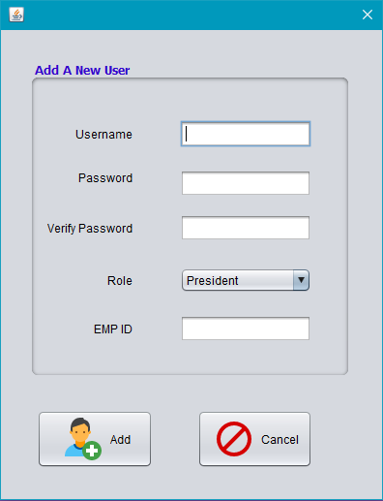
  - Manage Employee form

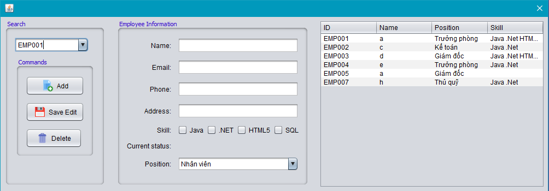

  - Manage Project form

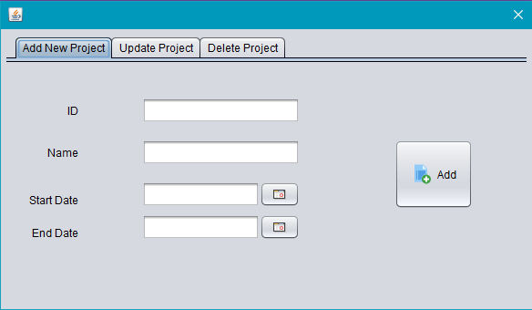

  - Search Employee form

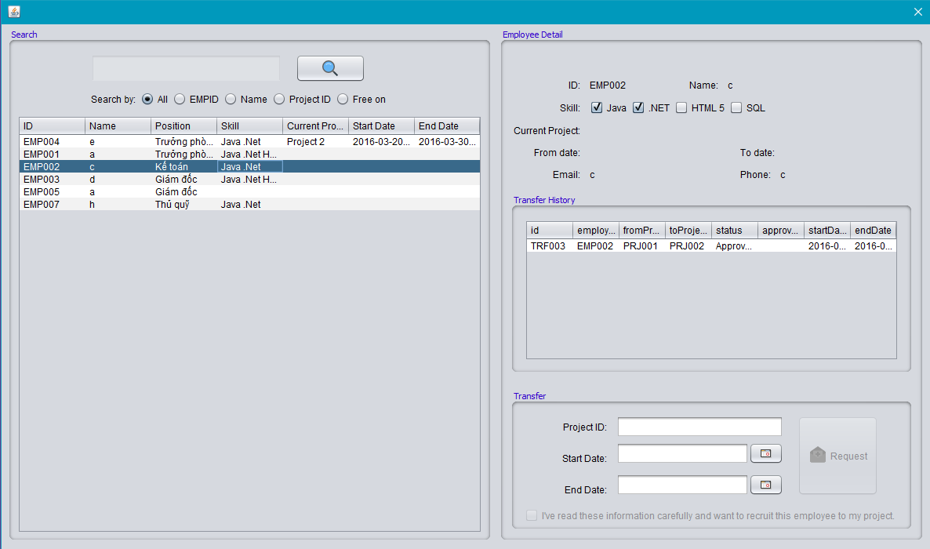

  - Search Records form

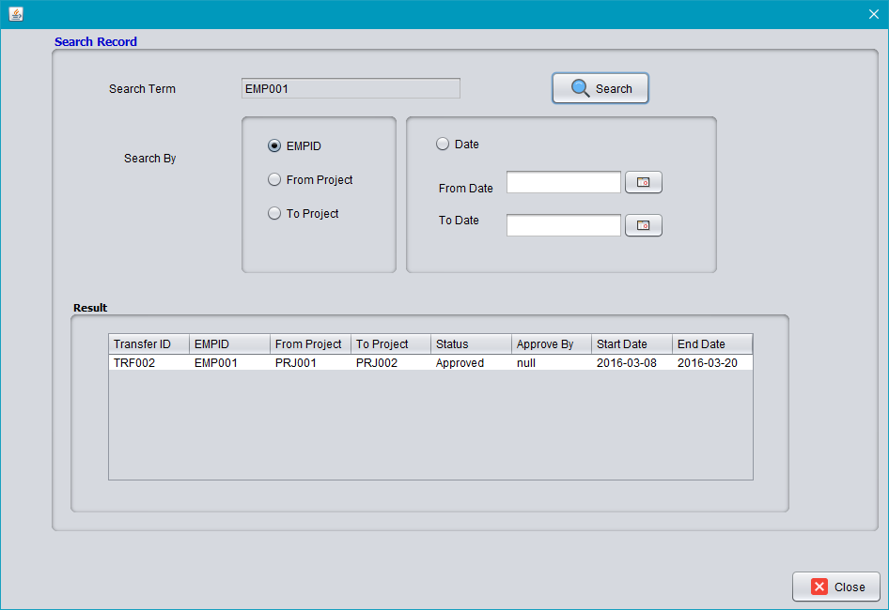

  - Create A New Transfer form

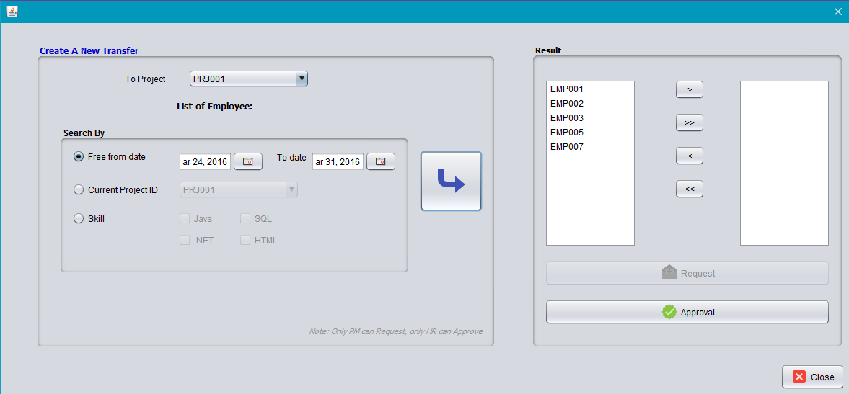

  - Approval Transfer form

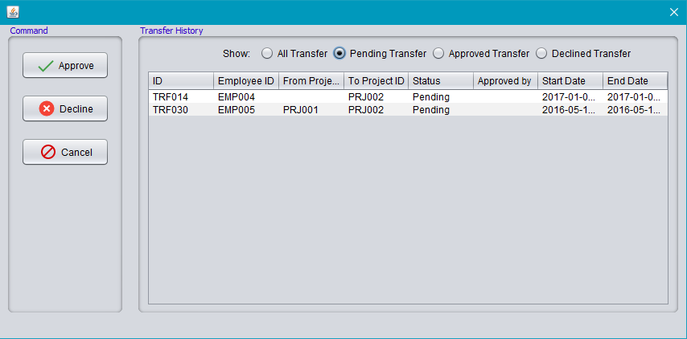

  - Generate Report form

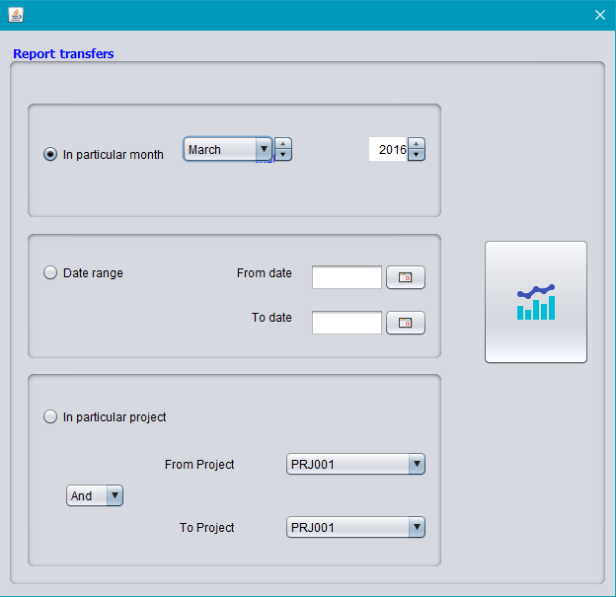

- Task Sheet
No. | Name | From Date | To Date | Status | Assigned
First stage: Research and design system
1 | Design functions/role |  |  |  | Ly Thanh Hai
2 | Draw diagrams |  |  |  | Ly Thanh Hai
3 | Design mockup |  |  |  | Nguyen Khanh
4 | Design database |  |  |  | Nguyen Khanh
Second stage: Coding
1 | Main form |  |  |  | Ly Thanh Hai + Nguyen Khanh
2 | Login/logout |  |  |  | Ly Thanh Hai
3 | Add user |  |  |  | Ly Thanh Hai
4 | Manage project |  |  |  | Ly Thanh Hai
5 | Search for transfer records |  |  |  | Ly Thanh Hai
6 | Create a new transfer |  |  |  | Ly Thanh Hai
7 | Generate report |  |  |  | Ly Thanh Hai
8 | Manage employee |  |  |  | Nguyen Khanh
9 | Search for employee and request transfer |  |  |  | Nguyen Khanh
10 | Approval transfer |  |  |  | Nguyen Khanh

