Luu Do ( flow-char): 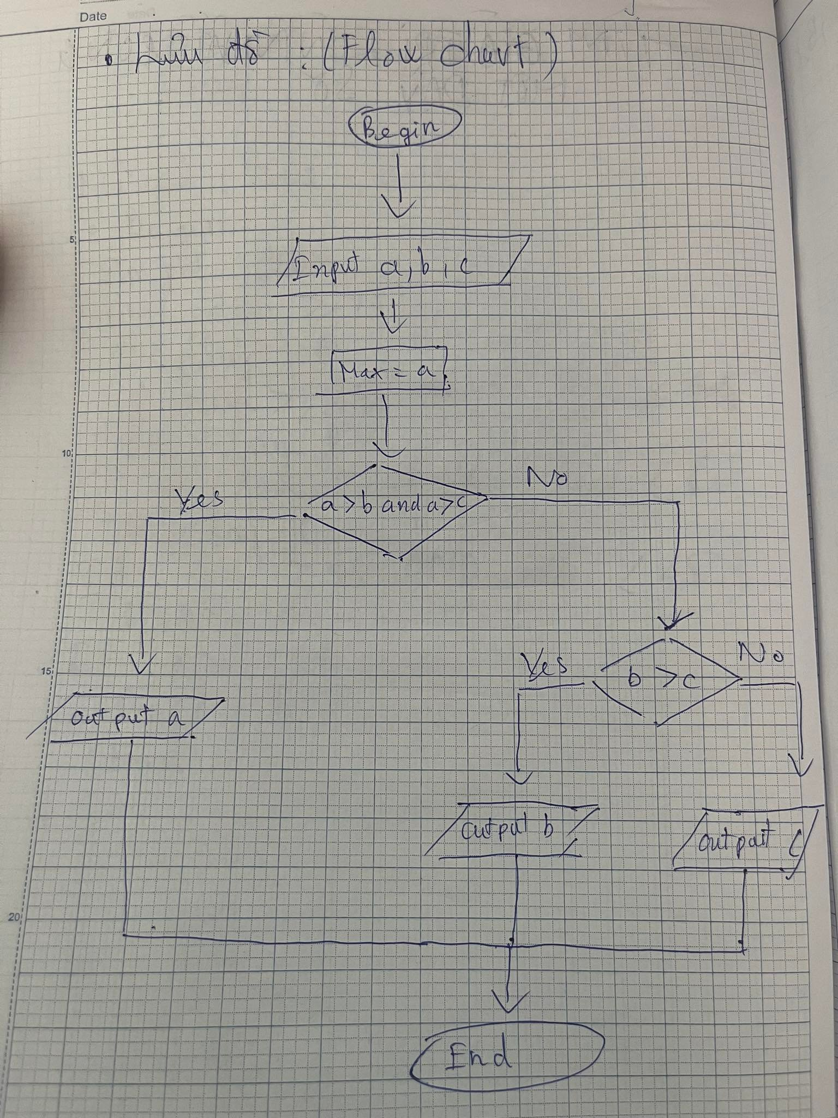

Ma Gia (pseudo-code)

Begin

input a,b,c

Max = a

if a > b and a > c

display max = a

if a < b or a < c

if b > c

display max = b

else

display max = c

end