RTL_EXERCISE_1 BOUND FLASHER
Author
Date | 2017/03/28
Version | 1.1

Contents
1. Interface 2
2. Functional implementation. 3
3. Internal implementation. 5
3.1. Overall. 5
3.2. State Machine 6
4. History 7

1. Interface

module_name
aaa
16
ddd
ccc
bbb
Figure 1: the figure of Bound Flasher System

Signal | Width | In/Out | Description
clk | 1 | In | System clock. State transitions occur on the positive edge.
rst_n | 1 | In | Asynchronous active-low reset. When LOW (0), system returns to IDLE state with all lamps OFF.
flick | 1 | In | Control signal. In IDLE state, HIGH (1) starts the flasher sequence. At kickback points (lamp[5] in step 3, lamp[10] in step 5), HIGH triggers the kickback sequence.
lamp | 16 | Out | 16-bit cumulative lamp output. lamp[i]=1 means lamp[i] is ON. Lamps are always ON contiguously from lamp[0] upward. Example: when level=6, lamp[15:0] = 16'h003F (lamp[0] to lamp[5] all ON).
Table 1: Description of signals in Bound Flasher

2. Functional implementation.
- Implement a 16-bits LEDs system
- System’s Operation base on three input signal
  - Reset
  - Clock
  - Flick
- The system specification
- Clock (clk): positive-edge triggered. All state transitions occur on the rising edge of clk.
- Reset signal (rst_n): asynchronous, active-low.
- rst_n = 0 (LOW-ACTIVE): System is reset to IDLE state immediately (asynchronous). All lamps OFF.
- rst_n = 1 (de-asserted): System operates normally according to flick input.
- Flick signal (flick): controls start and kickback behaviour as described below.
- At the initial state, all lamps are OFF. If flick signal is ACTIVE (HIGH = 1), the flasher starts operating. All lamps turn ON/OFF in a cumulative bar pattern: when N lamps are active, lamp[0] through lamp[N-1] are all ON simultaneously.
- Step 1: The lamps are turned ON gradually from lamp[0] to lamp[5]. (Level rises from 0 to 6; at peak, lamp[0] to lamp[5] are all ON.)
- Step 2: The lamps are turned OFF gradually from lamp[5] (max) to lamp[0] (min). (Level falls from 6 to 0; at valley, all lamps are OFF.)
- Step 3: The lamps are turned ON gradually from lamp[0] to lamp[10]. (Level rises from 0 to 11; at peak, lamp[0] to lamp[10] are all ON.) [Kickback point at lamp[5] -- see Additional condition.]
- Step 4: The lamps are turned OFF gradually from lamp[10] (max) to lamp[5] (min). (Level falls from 11 to 6; at valley, lamp[0] to lamp[5] remain ON.)
- Step 5: The lamps are turned ON gradually from lamp[5] to lamp[15]. (Level rises from 6 to 16; at peak, ALL 16 lamps are ON.) [Kickback point at lamp[10] -- see Additional condition.]
- Step 6: Finally, the lamps are turned OFF gradually from lamp[15] (max) to lamp[0] (min). (Level falls from 16 to 0; all lamps OFF.) System returns to initial state.
- Additional condition (Kickback): At each kickback point, if flick signal is ACTIVE (HIGH), the lamps will turn OFF gradually again to the minimum lamp of the previous state, then continue the ON operation as described above. Kickback is only checked when lamps are being turned ON gradually, and is NOT checked during the first ON phase (Step 1). Kickback points: lamp[5] during Step 3 (previous state min = all OFF = level 0), and lamp[10] during Step 5 (previous state min = lamp[5] = level 6).

- Some insulations:
- When flick = 0 at kickback points: no kickback triggered, lamps continue ON to destination.
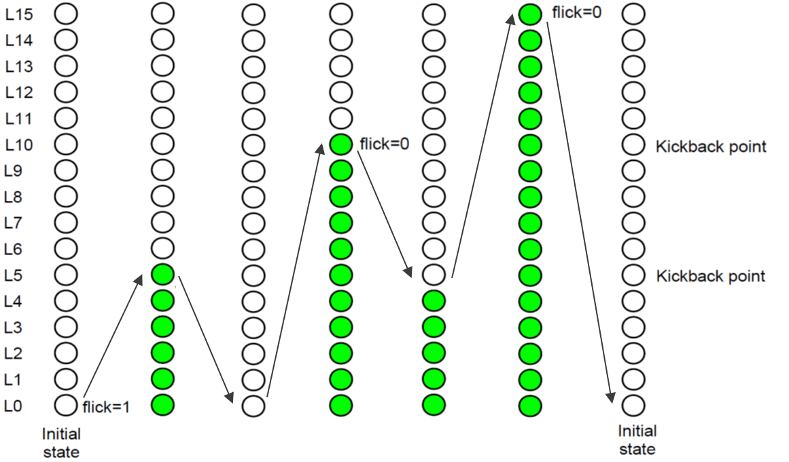
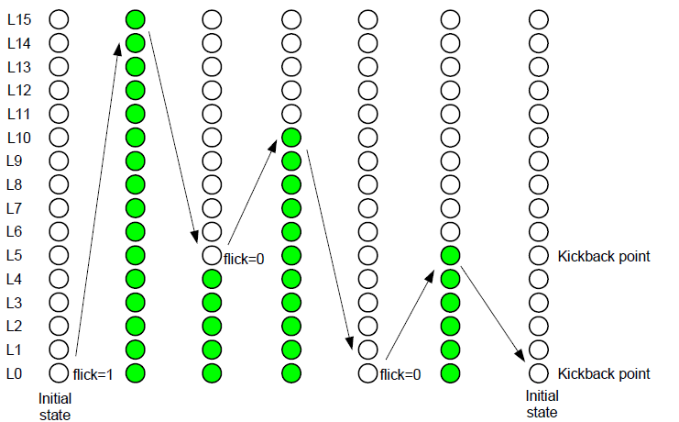

- When flick = 1 at kickback point (lamp[10] during Step 5): lamps turn OFF from lamp[10] back to lamp[5], then resume ON to lamp[15].
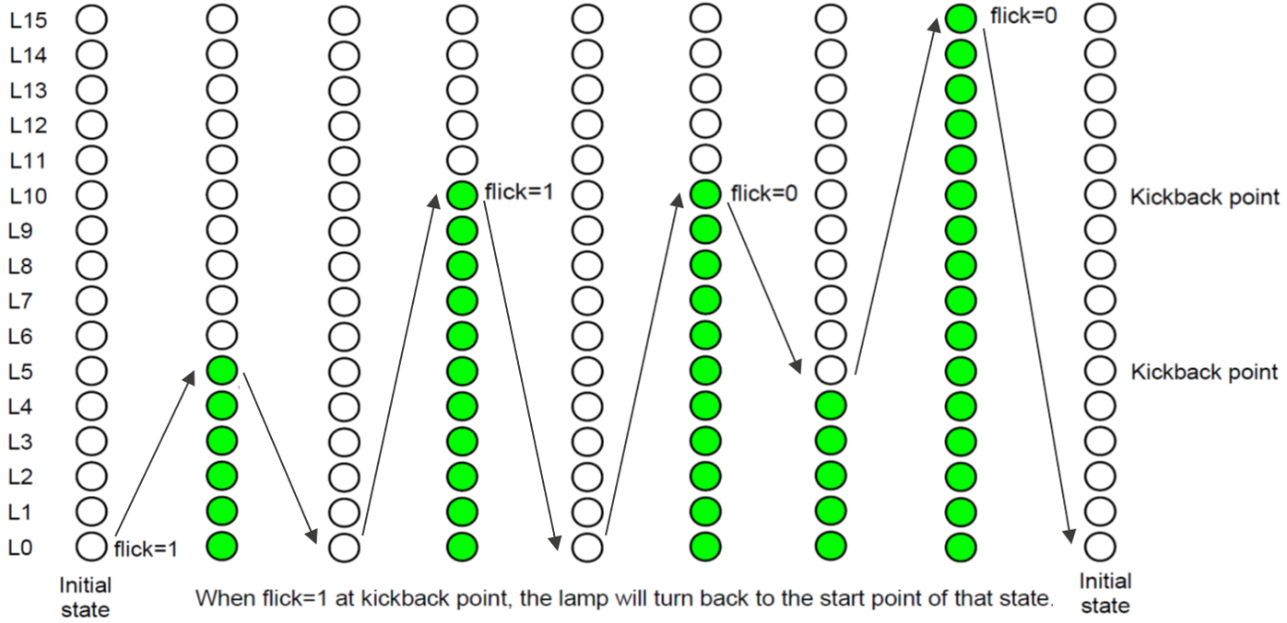
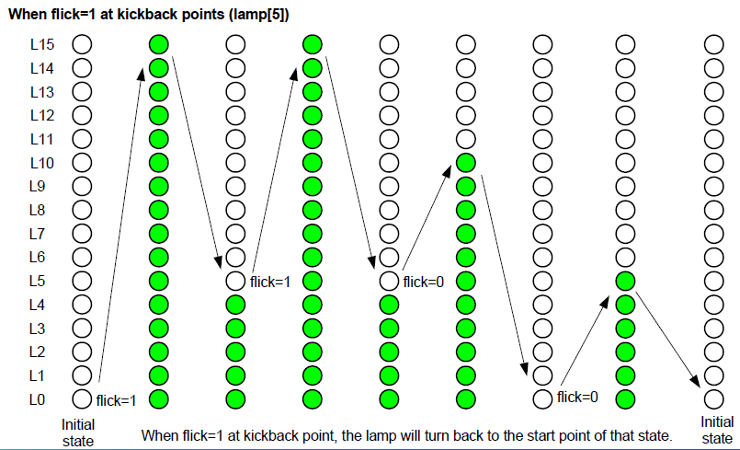

3. Internal implementation.

3.1. Overall.

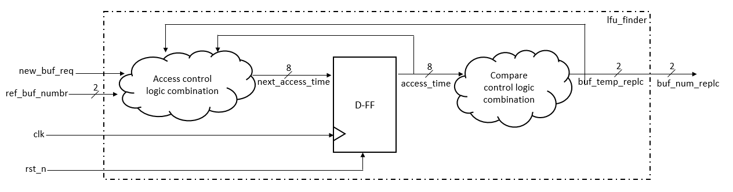

Figure 3.1: Block diagram of Bound Flasher
Table 3.1: Block diagram of Bound Flasher Description
Port / Block | Description
clk | Input clock (positive-edge)
rst_n | Asynchronous active-low reset input
flick | Start / kickback control input
lamp[15:0] | 16-bit cumulative bar lamp output (all ON from lamp[0] to lamp[level-1])

3.2. State Machine

Figure 3.2: State Machine of Bound Flasher

Table 3.2: variable name of State machine
Variable | Type | Description
state | reg [3:0] | Current FSM state register (FF). Holds the active state encoding.
level | reg [4:0] | Current lamp count register (FF). Range 0-16. level=N means lamp[0] to lamp[N-1] are ON.
next_state | reg [3:0] | Next FSM state (combinational). Output of next-state logic.
next_level | reg [4:0] | Next lamp count (combinational). Output of level transition logic.

Table 3.3: state name of State machine
State | Code | Level range | Description
IDLE | 4'd0 | 0 | All lamps OFF. Waits for flick=1 to start Step 1.
ON_0_5 | 4'd1 | 1 -> 6 | Step 1: lamps accumulate from lamp[0] to lamp[5]. First state, no kickback.
OFF_5_0 | 4'd2 | 5 -> 0 | Step 2: lamps clear from lamp[5] down to all OFF.
ON_0_10 | 4'd3 | 1 -> 11 | Step 3: lamps accumulate from lamp[0] to lamp[10]. Kickback checked when level=6 (lamp[5]).
KB1_OFF | 4'd4 | 5 -> 0 | Kickback1 OFF: lamps clear from lamp[5] to all OFF.
KB1_ON | 4'd5 | 1 -> 11 | Kickback1 resume: lamps re-accumulate from lamp[0] to lamp[10]. No kickback check.
OFF_10_5 | 4'd6 | 10 -> 6 | Step 4: lamps clear from lamp[10] down to lamp[5] (lamp[0]-lamp[5] remain ON).
ON_5_15 | 4'd7 | 7 -> 16 | Step 5: lamps accumulate from lamp[6] to lamp[15]. Kickback checked when level=11 (lamp[10]).
KB2_OFF | 4'd8 | 10 -> 6 | Kickback2 OFF: lamps clear from lamp[10] to lamp[5] (lamp[0]-lamp[5] remain ON).
KB2_ON | 4'd9 | 7 -> 16 | Kickback2 resume: lamps re-accumulate from lamp[6] to lamp[15]. No kickback check.
OFF_15_0 | 4'd10 | 15 -> 0 | Step 6: all lamps clear from lamp[15] to all OFF. Returns to IDLE.

4. History

Date | Author | Modified part | Description
2017/03/28 | Original Author | All | New creation
2026/03/25 | Thanh | All | Updated specification for RTL Exercise 1 submission: corrected functional description, added timing diagrams, added state/variable tables.

