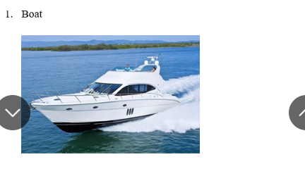
this picture may be taken at the sea,
in the foreground of the picture, we can see the man and the girl, It seems that they are a couple .they are on a beautiful white yacht. It looks very modern and expensive.
The man is driving the yacht in joy and happiness with his lover.
The background of the picture is a high mountain peak, hiding in the fog and a green forest
I think they are so happy with each other and I also feel relax and cute when I look at this picture
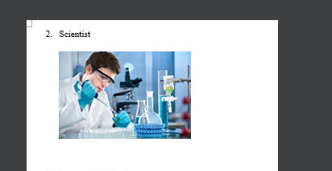

I'm not sure but I think this is a picture of a scientist.
According to the picture, This is a scientist doing an experiment in a laboratory. he is wearing a hospital uniform, clear glasses, and blue gloves. he has the beauty of a European man, he looks very attentive to his work.
On the right side of the picture, on the lab table, there are the laboratory instruments or something like that.
when I look at the picture, I wanna be a Scientist like him

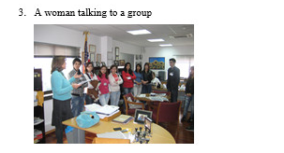

this picture may be taken in the classroom
According to the picture, We can see many people some of them are standing in line. the woman in the blue Shirt is talking to her students. they look so attentive to listen clearly to what the woman says.
In the foreground of the picture. on the table, there are many documents or something like that
I think they are all delighted with learning work. I also feel
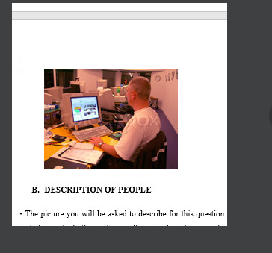
useful when I look at this picture
this picture may be taken in the workroom
According to the picture, we can see a man in a white T-shirt is sitting down in the chair. He is looking at the screen and typing on the keyboard to make a project, It seems that he is a programmer
In the foreground of the picture. on the table, there are a computer and a white keyboard and many documents of his work
I think he is delighted with his work. I also feel
useful when I look at this picture

