**DA NANG UNIVERSITY**

**UNIVERSITY OF INFORMATION & COMMUNICATION TECHNOLOGY**

**VIETNAM KOREA**

**Faculty of Computer Science**



**REPORT**

**BASE PROJECT 2**

**TOPIC: HEALTHCARE MANAGEMENT SYSTEM**

Performed by students: **TRUONG CONG HOANG THANH – 22IT270**

**HO VAN NHAT TRUONG – 22IT320**

Instructor: **Assoc. Prof., Dr. NGUYEN THANH BINH**

Grade : **22GIT1**

Da Nang, Dec 2023

**DA NANG UNIVERSITY**

**UNIVERSITY OF INFORMATION & COMMUNICATION TECHNOLOGY**

**VIETNAM KOREA**

**Faculty of Computer Science**



**REPORT**

**BASE PROJECT 2**

**TOPIC: HEALTHCARE MANAGEMENT SYSTEM**

Performed by students: **TRUONG CONG HOANG THANH – 22IT270**

**HO VAN NHAT TRUONG – 22IT320**

Instructor: **Assoc. Prof., Dr. NGUYEN THANH BINH**

Grade : **22GIT1**

Da Nang, Dec 2023

Thank you

To create this website, our team received a lot of support and help from the instructor - Ms. Nguyen Thu Huong.

With deep and sincere feelings, allow me to express my gratitude to you and all of you who have helped and researched together throughout the process of implementing the topic. With limited time and experience, this report cannot avoid shortcomings. We look forward to receiving the teachers' guidance and architectural comments, from which we can supplement and improve our experience and better serve the following projects.

Our team would like to sincerely thank you!

*Student*

Truong Cong Hoang Thanh

Ho Van Nhat Truong

# INTRODUCTION

Currently, people's demand for medical examination and treatment is increasing. However, Vietnam's public healthcare system still has many limitations, leading to overload, long waiting times, and the quality of medical examination and treatment is not guaranteed.

Deploying a medical examination scheduling website is an effective solution to solve the above problems. The website helps people book medical examination appointments online, proactively choose the appropriate examination time, and avoid long waiting times. This helps improve the quality of medical examination and treatment services, bringing satisfaction to people.

Specifically, the medical examination scheduling website helps solve the following problems:

Improve the quality of medical examination and treatment services: The website helps people proactively choose appropriate examination times, avoid long waiting times, thereby helping to reduce overload at the hospital. This contributes to improving the quality of medical examination and treatment, bringing satisfaction to people.

Increase people's satisfaction: Website helps people save time and effort when scheduling medical examinations. This contributes to increasing people's satisfaction with the quality of medical examination and treatment services.

Improve hospital management efficiency: Website helps hospitals manage medical examination schedules more scientifically and effectively. This helps avoid overload and duplicate examination schedules, thereby contributing to improving the quality of medical examination and treatment.

Thus, implementing a medical examination scheduling website plays an important role in improving the quality of medical examination and treatment services, increasing people's satisfaction and improving hospital management efficiency. This is a project that needs to be implemented soon to meet the increasing needs of the people.

To clarify the above issues, the report needs to provide specific figures and data to demonstrate. For example, the report can provide data on overcrowding at public hospitals, data on people's satisfaction with the quality of medical examination and treatment services, etc. In addition, the report The report also needs to analyze in detail the benefits of medical appointment scheduling websites for people, hospitals and society.

INSTRUCTOR REVIEWS

**TABLE OF CONTENTS**

**INTRODUCTION**

**LIST OF FIGURES**  **6**

**CHAPTER 1: OVERVIEW OF THE TOPIC**  **7**

1. Introduction 7

2. Specification of problem requirements  7

2.1 Introduction 7

2.2 User Object  7

2.3 Functional requirements  7

2.3.1 Requirements for people  7

2.3.2 Requirements for hospitals  8

2.4 Non-functional requirements  8

2.5 Other requirements  8

**CHAPTER 2:** **SYSTEM ANALYSIS AND DESIGN**

I. USE CASE DIAGRAM  9

1. System Actors 9

2. System Use Cases 10

3. Diagram 11

3.1 Main Use Case Diagram  11

3.2 Use Case Diagram for Patient  12

3.3 Use Case Diagram for Register/Login 12

3.4 Use case diagram for scheduling a medical appointment 14

II. CLASS DIAGRAM  15

III. ACTIVITY DIAGRAM  16

1. Specification of activity diagram requesting appointment 16

2. Specification of activity diagram create doctor 19

3. Specification of activity diagram change appointment schedule 21

IV. STATE DIAGRAM  22

1. State diagram for the patient appointment system 22

2. State diagram for patient appointment scheduling 24

V. INTERACTION DIAGRAM  26

**CHAPTER 4: DESIGNING WEBISITE INTERFACES**

1. Analysis of website design requirements 31

2. Results  32

2.1 Customer Website 32

2.2 Dashboard Website  38

2.3 Mobile Version  43

**CHAPTER 5: CONCLUSION**

5. 1 . Conclusion  47

# LIST OF PICTURES

Figure 3.1 Main use case diagram 14

Figure 3.2 Use case Diagram for patient 15

Figure 3.3 Register/Login Diagram (Use case diagram) 15

Figure 3.4 Use case diagram for scheduling a medical appointment.  17

Figure 4: Class Diagram . 18

Figure 5: Activity diagram for request appointment 19

Figure 6: Activity diagram for request appointment 22

Figure 7: Activity diagram for change appointment schedule .............................................24

Figure 8: State diagram for the patient appointment system 25

Figure 9: State diagram for patient appointment scheduling 27

Figure 10: Sequence diagram: Retrieving a patient’ s detail 29

Figure 11: Home Page: Introduction 32

Figure 12: Home page: Popular specialities and Prominent Healcare Facilities 33

Figure 13: Home page: Outstanding Doctor of week and about VKU Healcare introduction 34

Figure 14: Login page 35

Figure 15: Register page. 35

Figure 16: Specialty page 36

Figure 17: Doctor profile page 37

Figure 18: Manage user page: View all users 38

Figure 19: Manage user page: Add a new users 39

Figure 20: Manage user page: Add a new doctor 40

Figure 21: Manage doctor’s schedule page: Add new schedules 41

Figure 22: Manage clinic page: Add new clinic. 42

Figure 23: Manage Specialty page: Add new specialty 43

Figure 24: Home page: Banner Introduction 43

Figure 25: Mobile Home page: Popular specialities 44

Figure 26: Mobile Home page: Outstanding Doctor of week and about VKU Healcare introduction 44

Figure 27: Mobile Login page 45

Figure 28: Mobile Sign up page 45

Figure 29: Mobile Specialty page 46

Figure 30: Mobile Profile Doctor page 46

# CHAPTER 1: OVERVIEW OF THE TOPIC

1. **Introduction**

The healthcare system stands as a cornerstone of societal well-being, embodying the collective effort to safeguard and enhance the health of individuals and communities. In its essence, a healthcare system is a multifaceted network of institutions, professionals, and services intricately woven together to deliver medical care, promote public health, and address the diverse health needs of a population.

The imperative nature of healthcare is underscored by its pivotal role in preserving life, alleviating suffering, and contributing to the overall welfare of society. From primary care centers offering preventive services to advanced hospitals providing specialized treatments, the healthcare system is a dynamic and evolving entity that adapts to the changing landscape of health challenges.

At its core, a robust healthcare system aspires to achieve several fundamental goals: ensuring equitable access to care, maintaining high standards of quality, managing costs effectively, and advancing medical knowledge through research and innovation. It is a collective commitment to promoting health equity, where every individual, regardless of background or circumstance, has the opportunity to attain optimal health and well-being.

As we navigate the complexities of modern healthcare, the importance of a well-functioning and inclusive healthcare system becomes increasingly apparent. This introductory exploration serves as a doorway into the intricate world of healthcare, setting the stage for a deeper understanding of its components, challenges, and the ongoing efforts to create healthier and more resilient communities.

1. **Specification of problem requirements**

**2.1 Introduction**

The medical scheduling website is a software system built to help people book medical examinations online, proactively choose appropriate treatment times, and avoid long waits.

**2.2 User object**

Users of the website to schedule medical appointments include:

- People: People need medical examinations and treatment at the hospital.

- Hospital: The hospital needs to manage people's medical examination schedules.

**2.3 Functional requirements**

**2.3.1 Requirements for people**

- People can register an account on the website.

- People can log in to the website using their registered account.

- People can search for information about hospitals and clinics.

- People can choose the hospital, clinic and specialty they need to be examined.

- People can choose a suitable examination time.

- People can schedule medical examinations.

- People can check the scheduled examination schedule.

**2.3.2 Requirements for hospitals**

- Hospitals can register for an account on the website.

- Hospitals can log in to the website using their registered account.

- Hospitals can manage people's medical examination schedules.

- The hospital can view the list of people who have scheduled examinations.

- The hospital can view each resident's medical examination schedule.

- The hospital can confirm people's medical examination schedule.

- Hospitals can cancel people's medical appointments.

**2.4. Non-functional requirements**

- Security requirements: Website must be designed and implemented to secure information of people and hospitals.

- Scalability requirements: The website must be designed and deployed to be callable to meet future development needs.

- Performance requirements: Website must have good performance, meeting the needs of people and hospitals.

***2.5. Other requirements***

- Website must be designed to be user-friendly.

- Websites must be designed to meet the needs of users on different devices, including computers, smartphones, and tablets.

1. **Technology used**
   1. **Hyper Text Markup Languages (HTML)**

HTML (Hyper Text Markup Languages) is also known as "Hypertext Markup Language". It is used to create web pages through bookmarks. So HTML is not a programming language, it's just a markup language. The extension of the HTML file is usually html or htm. Browsers will read HTML files and display them as web pages. The HTML tags will be hidden, only displaying text content and other objects such as images, media, etc. With different browsers, they display an HTML file with a certain result. HTML pages are sent over the internet using the HTTP protocol.

HTML not only allows embedding more image and sound objects, but also allows embedding scripts in it (for example scripting languages like JavaScript) to animate the web page. For more effective web page presentation, HTML is allowed to be used in conjunction with CSS. HTML has officially been the W3C standard since January 1997 with HTML 3.2 version. Previously, HTML was published according to RFC standards.

HTML is compatible with all operating systems and its browsers. Ease of learning and writing is an advantage of HTML. Not only that, editing HTML does not have too complicated requirements, usually just using Notepad is enough. HTML continues to be developed. The current version of HTML is HTML5 – an upgraded version of XHTML. HTML5 is much improved, especially strongly supports multimedia elements without plugins. HTML5 in general is much more powerful not only in terms of speed and adaptability but also in its ability to support API (Application Programming Interface) and DOM (Document Object Model). or tree of data structures).

* 1. **Cascading Style Sheet(CSS)**

CSS – Cascading Style Sheet is used to present documents written in HTML or XHTML. In addition, the layered styling language can also be used for XML, SVG, XUL, etc. The CSS specification is maintained by the W3C organization.

CSS has a simple structure and uses English words to name properties. CSS when used can be written directly into the HTML code or referenced from a separate css file. Currently CSS is usually written as a single file with the extension *.css. We can use that one CSS file for many websites, saving a lot of time and effort. An important feature is the inheritance of CSS, reducing the number of lines of code and still achieving the requirements.

However, for CSS, browsers understand it in its own style. Therefore, the presentation of the same content on different browsers is not uniform .

* 1. **Bootstrap**

Bootstrap is a Framework that contains HTML, CSS, and JavaScript. Framework in Vietnamese means "framework" to help save time and effort, moreover, building two teamplates for Desktop and Mobile interfaces is outdated instead of Responsive. Responsive will help your website display compatible with all screen sizes so you can customize the display more on different types of screens.

* 1. **React.js**

React.js is an open-source JavaScript library, crafted with precision by Facebook, that aims to simplify the intricate process of building interactive user interfaces. Imagine a user interface built with React as a collection of components, each responsible for outputting a small, reusable piece of HTML code.

* 1. **Javascript**

JavaScript often abbreviated as JS, is a programming language that is one of the core technologies of the World Wide Web, alongside HTML and CSS. As of 2023, 98.7% of websites use JavaScript on the client side for webpage behavior,[10] often incorporating third-party libraries. All major web browsers have a dedicated JavaScript engine to execute the code on users' devices.

JavaScript is a high-level, often just-in-time compiled language that conforms to the ECMAScript standard

* 1. **Node.js**

Node.js is a popular server-side programming platform for building web applications. It is based on Google's V8 JavaScript engine and uses event-driven, non-blocking I/O, which makes it fast and efficient. Node.js is designed for scalability and can handle a large number of concurrent connections. It is also widely used for creating real-time, data-intensive applications such as chat servers and game client servers. Node.js has a large and active community, and there are many libraries and framework

**CHAPTER 2: SYSTEM ANALYSIS AND DESIGN**

1. **USE CASE DIAGRAM**
2. **System Actors**

|  |  |  |
| --- | --- | --- |
| **No** | **Actor** | **Role, Responsibilities** |
| 1. | Admin | **Role**: The admin plays a crucial role in managing the overall system and ensuring its smooth operation.  **Responsibilities**:  - Creating, modifying, and deleting user accounts for doctors, nurses, receptionists, and other staff members.  - Assigning appropriate roles and permissions to each user based on their responsibilities.  - Monitoring system activities and addressing any security concerns.  - Managing system configurations and settings. |
| 2. | Doctor | **Role**: Doctors are primary healthcare providers responsible for diagnosing and treating patients.  **Responsibilities**:  - Viewing and updating patient information to stay informed about medical history, test results, and current conditions.  - Prescribing medications with accurate dosage and instructions for the nursing staff to administer.  - Collaborating with other healthcare professionals for comprehensive patient care.  - Utilizing the system to make informed decisions and improve treatment outcomes. |
| 3. | Patient | **Role**: Patients are the recipients of healthcare services, actively involved in managing their health information.  **Responsibilities**:  - Viewing personal health records to stay informed about diagnoses, treatments, and upcoming appointments.  - Requesting appointments with specific healthcare providers based on their healthcare needs.  - Providing accurate and up-to-date medical history during visits.  - Collaborating with healthcare professionals to actively participate in their care. |

1. **System Use cases**

|  |  |  |
| --- | --- | --- |
| **No** | **Use case** | **Description** |
| 1. | Register/Login | Users need to pass this step to go inside the system, where every single role will be separate for each user. |
| 2. | Manage User Accounts | The admin can create, modify, or delete user accounts within the hospital system. This includes assigning roles and permissions to different users. |
| 3. | View Patient Information | Doctors can access and review detailed information about a patient, including medical history, test results, and current conditions. |
| 4. | Update Patient Records | Doctors can edit and update patient records to reflect changes in their health status, treatments, and other relevant information. |
| 5. | Prescribe Medication | Doctors can prescribe medications for patients, specifying dosage, frequency, and any additional instructions. The prescription details are then recorded in the patient's medical records. |
| 6. | Schedule Appointments | Doctors can schedule appointments for patients with doctors or other healthcare professionals, considering availability and urgency. |
| 7. | View Personal Health Records | Patients can securely access and view their personal health records, including diagnoses, treatments, and upcoming appointments. |
| 8. | Request Appointments | Patients can request appointments with specific healthcare providers or departments, indicating their preferred date and time. |

1. **Diagram**
   1. **Main Use case Diagram**

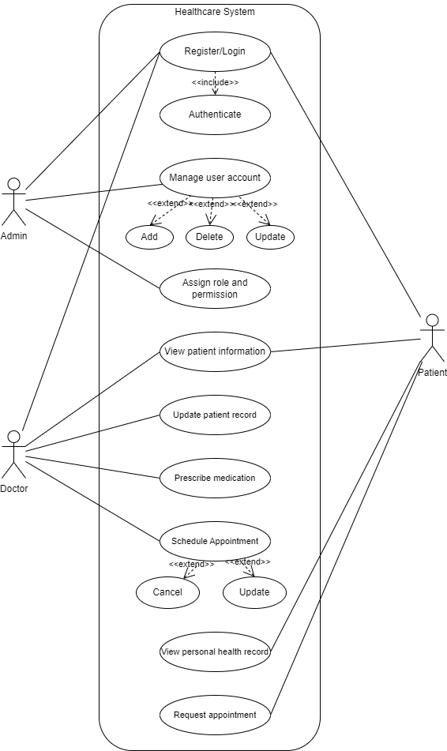

*Figure 3.1 Main use case diagram*

**3.2Use case Diagram for Patient**

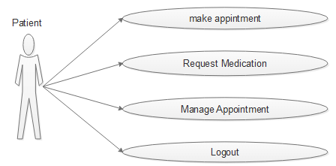

*Figure 3.2 Use case Diagram for patient*

**3.3 Use case Diagram for Register/Login**

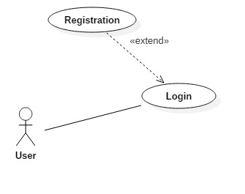

*Figure 3.3 Register/Login Diagram (Use case diagram)*

**Use case: Login**

*Description:*

- User enter Username and Password.

- The system authenticates the login name and password.

- If username and password are valid, the system allows access for users.

- If username and password are invalid, the system displays an error message.

*Status:*

- Begin: User cannot Login.

- End: User can Login.

*Progress:*

- User enter Username and Password.

- The system authenticates the login name and password.

- If username and password are valid, the system performs the following steps:

+ Update the user's status to "Logged in".

+ Save user login information to the system.

+ Display the website's home page to users.

- If username and password are invalid,  the system performs the following steps:

+ Display an error message to the user.

**Use case: Register**

*Description:*

- The user provides registration information to the system.

- The system checks the validity of registration information.

- If the registration information is valid, the system creates an account for the user.

- If not, the system displays an error message.

*Status:*

- Begin: User does not have an account.

- End: User has an account.

*Progress*:

- The user provides registration information to the system.

- The system checks the validity of registration information.

- If the registration information is valid, the system performs the following steps:

+ Create accounts for users.

+ Send a confirmation email to the user.

- If the registration information is invalid, the system performs the following steps:

+ Display an error message to the user.

*Registration information:*

- Username: Username must be unique and cannot contain special characters.

- Password: Password must be at least 8 characters and include uppercase letters, lowercase letters, and numbers.

- Full name: Full name must be the user's first and last name.

- Date of birth: Date of birth must be the user's actual date of birth.

- Gender: Gender must be male or female.

- Phone number: Phone number must be a valid mobile phone number.

- Email: Email must be a valid email address.

*Error message:*

- Invalid username or password.

- name error.

- Invalid date of birth.

- Invalid gender.

- Invalid phone number.

- Invalid email.

**3.4 Use case diagram for scheduling a medical appointment**

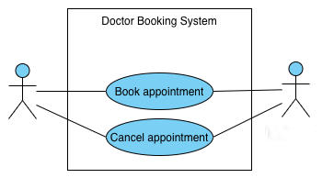

*Figure 3.4 Use case diagram for scheduling a medical appointment*

1. **CLASS DIAGRAM**

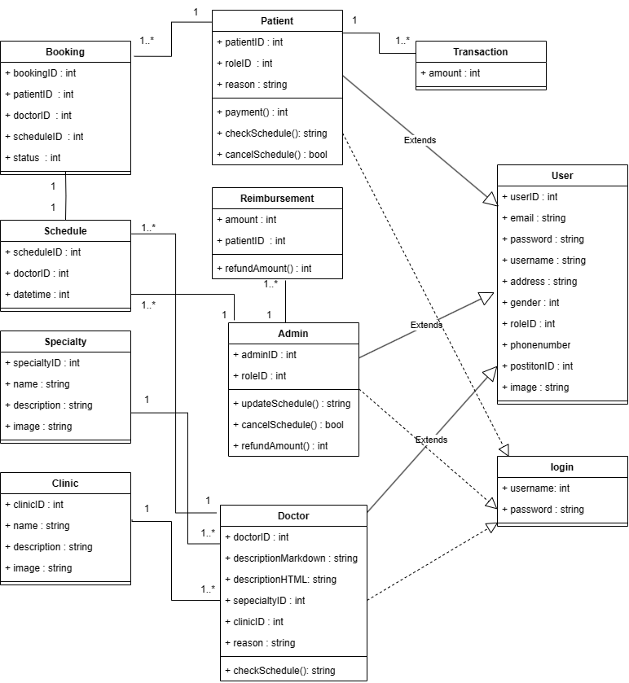

*Figure 4: Class Diagram*

1. **ACTIVITY DIAGRAM**
2. **Specification of activity diagram requesting appointment**

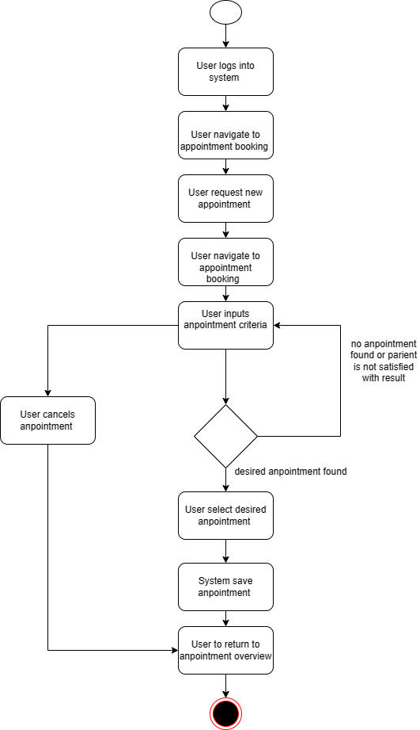

*Figure 5: Activity diagram for request appointment*

***Activity Flow****:*

*1. User accesses website:*

- The user opens a web browser and navigates to the website of the healthcare provider or clinic.

- The user clicks on the "Schedule Appointment" button or link

.

*2. User selects appointment type:*

- The user is presented with a list of available appointment types, such as general checkups, specialist appointments, or follow-up appointments.

- The user selects the desired appointment type from the list.

*3. User enters personal information:*

- The user is presented with a form to enter their personal information, such as name, date of birth, contact information, and insurance details.

- The user fills out the form and submits their information.

*4. Website validates user information:*

- The website validates the user's personal information to ensure it is complete and accurate.

- If any information is missing or invalid, the website prompts the user to correct it.

*5. Website checks appointment availability:*

- The website checks the availability of appointments for the selected appointment type based on the user's preferred date and time.

- If available appointments are found, the website displays them to the user.

*6. User selects appointment time:*

- The user reviews the available appointments and selects their preferred date - and time from the list.

- The user confirms their selection and proceeds to the next step.

*7. Website reserves appointment:*

- The website reserves the selected appointment for the user and updates the appointment schedule.

- The website sends a confirmation email to the user with the appointment details.

*8. User receives appointment confirmation:*

- The user opens the confirmation email and reviews the appointment details.

- The user saves the confirmation email for future reference.

*Activity Flow:*

- If no available appointments are found for the selected date and time, the website informs the user and suggests alternative dates or times.

- If the user's personal information is incomplete or invalid, the website prompts the user to correct it before proceeding.

- If any technical errors occur during the appointment request process, the website displays an error message and prompts the user to contact the healthcare provider or clinic for assistance.

1. **Specification of activity diagram create doctor**

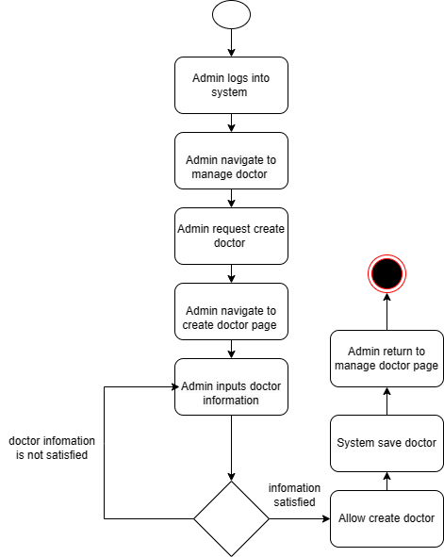

*Figure 6: Activity diagram for request appointment*

***Activity Flow****:*

- The admin enters the doctor's information, such as name, contact details, and professional qualifications. Once the admin is satisfied with the entered information, they click the "Allow Create Doctor" button.

- The system saves the doctor's information and returns the admin to the "Manage Doctors" page. The doctor's account has now been created, and the admin can manage their access privileges and assign them to a department or clinic.

- The activity diagram also shows a branch for handling cases where the admin is not satisfied with the entered information. In this case, the admin click the "Information Not Satisfied" button. The system will then display an error message and prompt the admin to correct the entered information.

**3. Specification of activity diagram change appointment schedule**

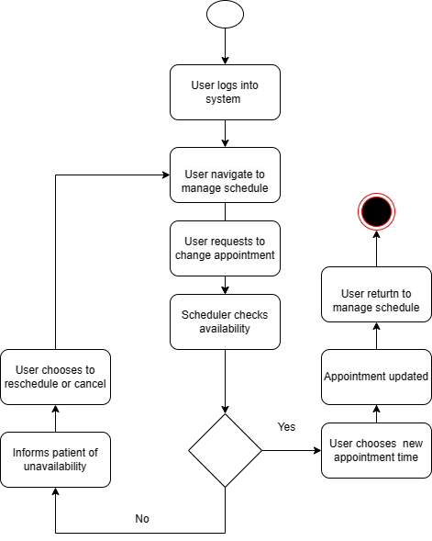

*Figure 7: Activity diagram for change appointment schedule*

***Activity Flow****:*

- The user starts by logging into the system and navigating to the manage schedule screen. They then request to change their appointment. The scheduler checks availability and informs the patient if their desired time is unavailable. If it is available, the user chooses a new appointment time and their appointment is updated.

*- Here is an example of how the activity diagram might be used:*

A patient needs to change their dentist appointment. They log into the dentist's website and navigate to the manage schedule screen. They click the "Change Appointment" button and select a new date and time. The dentist's system checks availability and confirms that the new appointment time is available. The patient clicks the "Confirm" button and their appointment is updated.

1. **STATE DIAGRAM**
2. **State diagram for the patient appointment system**

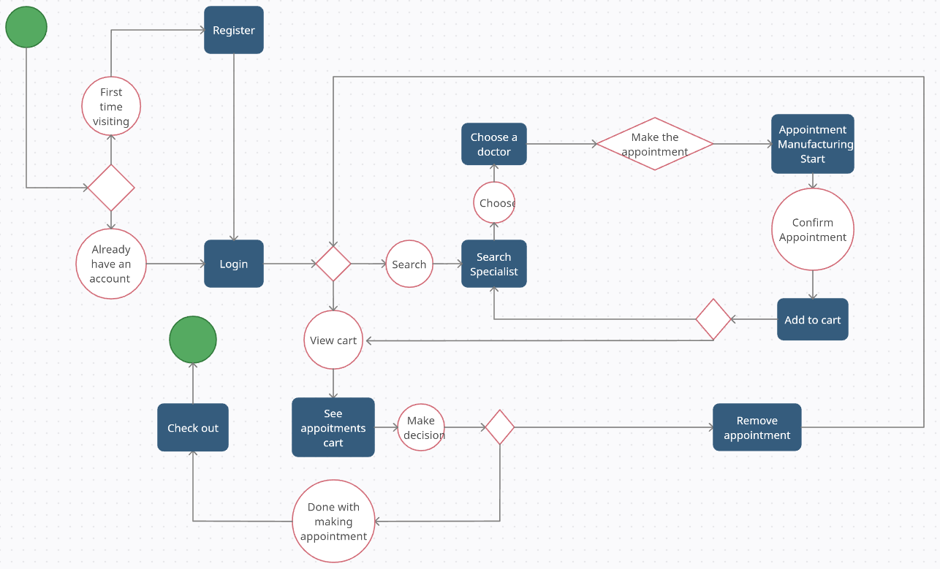

*Figure 8: State diagram for the patient appointment system*

1. ***Login/Register:***

*- Initial State:* NotloggedIn

*- States:* First Time visiting, Already have an account

*- Transitions:*

+Login: NotLoggedIn -> LoggedIn

+ Register: Register -> LoggedIn

1. ***Search Specialist***

*- Initial State:* NoSearch

*- States:* NoSearch, Searching

*- Transitions:*

+ Start Search: NoSearch -> Searching

+ Cancel Search: Searching -> NoSearch

1. ***Choose Doctor***

*- Initial State:* NoChoice

*- States:* NoChoice, Choosing

*- Transitions:*

+ Start Choosing: NoChoice -> Choosing

+ Cancel Choosing: Choosing -> NoChoice

1. ***Make Appointment***

*- Initial State:* NoAppointment

*- States:* NoAppointment, MakingAppointment

*- Transitions:*

+ Start Appointment: NoAppointment -> MakingAppointment

+ Cancel Appointment: MakingAppointment -> NoAppointment

+ Confirm Appointment: MakingAppointment -> NoAppointment

1. ***View Appointment***

*- Initial State:* NoView

*- States:* NoView, ViewingAppointments

*- Transitions:*

+ Start Viewing: NoView -> ViewingAppointments

+ Exit Viewing: ViewingAppointments -> NoView

1. ***Remove Appointment***

*- Initial State:* NoRemoval

*- States:* NoRemoval, RemovingAppointment

*- Transitions:*

+ Start Removal: NoRemoval -> RemovingAppointment

+ Cancel Removal: RemovingAppointment -> NoRemoval

+ Confirm Removal: RemovingAppointment -> NoRemoval

1. **State diagram for patient appointment scheduling**

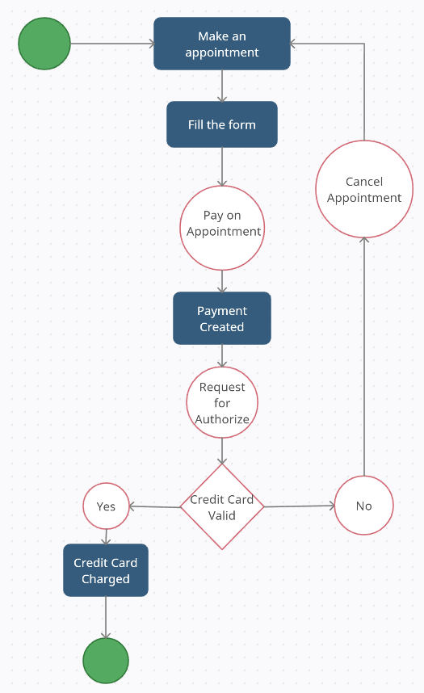

*Figure 9: State diagram for patient appointment scheduling*

1. ***Fill Appointment Form:***

*- Initial State:* FormEmpty

*- States:* FormEmpty, FormFilled

*- Transitions:*

+ Start Filling: FormEmpty -> FormFilled

+ Cancel Filling: FormFilled -> FormEmpty

1. ***Validate Information:***

*- Initial State:* NotValidated

*- States:* NotValidated, Valid, Invalid

*- Transitions:*

+ Start Validation: FormFilled -> NotValidated

+ Information Valid: NotValidated -> Valid

+ Information Invalid: NotValidated -> Invalid

1. ***Payment Processing:***

*- Initial State:* NoPayment

*- States:* NoPayment, PaymentCreated, PaymentFailed

*- Transitions:*

+ Create Payment (Credit Card Valid): Valid -> PaymentCreated

+ Create Payment (Credit Card Invalid): Invalid -> PaymentFailed

+ Cancel Payment: PaymentCreated -> NoPayment or PaymentFailed -> NoPayment

1. ***Credit Card Charged:***

*- Initial State:* NotCharged

*- States:* NotCharged, Charged

*- Transitions:*

+ Charge Credit Card: PaymentCreated -> NotCharged

+ Credit Card Charged: NotCharged -> Charged

1. ***Cancel Appointment (if credit card is invalid):***

*- Initial State:* NoCancellation

*- States:* NoCancellation, CancellationRequested, AppointmentCancelled

*- Transitions:*

+ Request Cancellation: PaymentFailed -> CancellationRequested

+ Confirm Cancellation: CancellationRequested -> AppointmentCancelled

+ Reject Cancellation: CancellationRequested -> NoCancellation

1. **INTERACTION DIAGRAM**

**Sequence diagram: Retrieving a patient’ s detail**

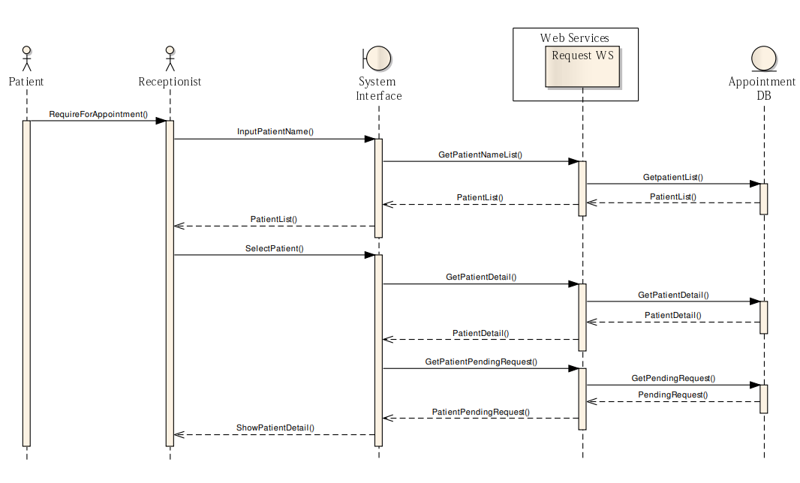

*Figure 10: Sequence diagram: Retrieving a patient’ s detail*

1. **Patient Initiates Request:**

The patient sends a message containing personal information and a request for an appointment to the receptionist.

1. **Receptionist Checks Patient's Record:**

- The receptionist checks if the patient's record exists in the appointment database.

- Receptionist enters the patient's name in the patient search engine on the system interface.

1. **System Interface Calls Web Service Method:**

The system interface calls the method GerPaimeiNameLisi() to request a web service to retrieve a list of patient names close to the input.

1. **Request Web Service Calls Database:**

The request web service calls a method to get the related patient from the appointment database based on the retrieved list.

1. **Receptionist Selects Patient:**

After browsing the patient's list, the receptionist selects the name of the patient who initiated the request.

1. **System Interface Calls Two Web Service Methods:**

The system interface calls two methods provided by the request web services:

- GetPatientDetail(): Retrieves detailed information about the selected patient from the database.

- GetPatientPendingRequest(): Retrieves the pending request for the selected patient from the database.

1. **Web Service Retrieves Data from Database:**

The request web service calls the corresponding methods to retrieve detailed information and pending requests from the appointment database.

1. **Receptionist Accesses Patient Information:**

The receptionist gains access to the detailed information and pending requests of the selected patient through the system interface.

## 1.3 Project structure

**Chapter 1: Introduction.** General introduction about the topic, its meaning and objectives.

**Chapter 2: Overview.** An overview of the system will

construction, the tasks that the system will perform, and the solutions involved.

**Chapter 3: Analysis and design of the system.** Includes required functions, steps to build a website.

**Chapter 4: Deploying construction.** Build the proposed pages with supporting tools

**Chapter 5: Conclusion and development direction.** Briefly present the results achieved and propose directions for future expansion and development.

# CHAPTER 4: DESIGNING WEBISITE INTERFACES

## Analysis of Website Design Requirements:

### Basic Requirements for an Healcare Website:

### Prioritize an intuitive and easy-to-navigate interface for seamless appointment scheduling. Ensure a visually appealing design to create a positive and professional impression on users.

### Online Support:

Implement live chat or messaging functionality for users to seek assistance during the appointment booking process. Integrate tools like WhatsApp, Messenger, or a dedicated chat system to enhance customer support.

### Mobile Version:

Optimize the website for mobile devices, ensuring a responsive design for convenient access from smartphones and tablets. Enable users to schedule appointments on-the-go, emphasizing accessibility and user convenience.

### SEO standard web design SEO-Friendly Design:

Implement SEO best practices to improve the website's visibility on search engines. Focus on local SEO, considering that users may search for medical services in specific locations.

## Expected Product Results:

## Users:

## Account Management:

## Provide a user registration and login system for individuals to create accounts.

## Allow users to manage their personal information and preferences.

## Appointment Booking:

## Enable users to view available time slots for appointments.

## Implement a shopping cart-like feature for selecting desired appointment slots.

## Collect necessary information for appointment confirmation and follow-up.

Administrators:

* Dashboard:
  + Develop a secure login system for administrators.
  + Create a dashboard for managing appointment schedules, user accounts, and overall website content.
* Content Management:
  + Enable administrators to update, delete, and edit information related to doctors, available time slots, and any relevant content.
  + Provide tools for managing user accounts and resolving issues.

## Results:

1. **Production Website**



*Figure 11: Home page: Banner introduction*

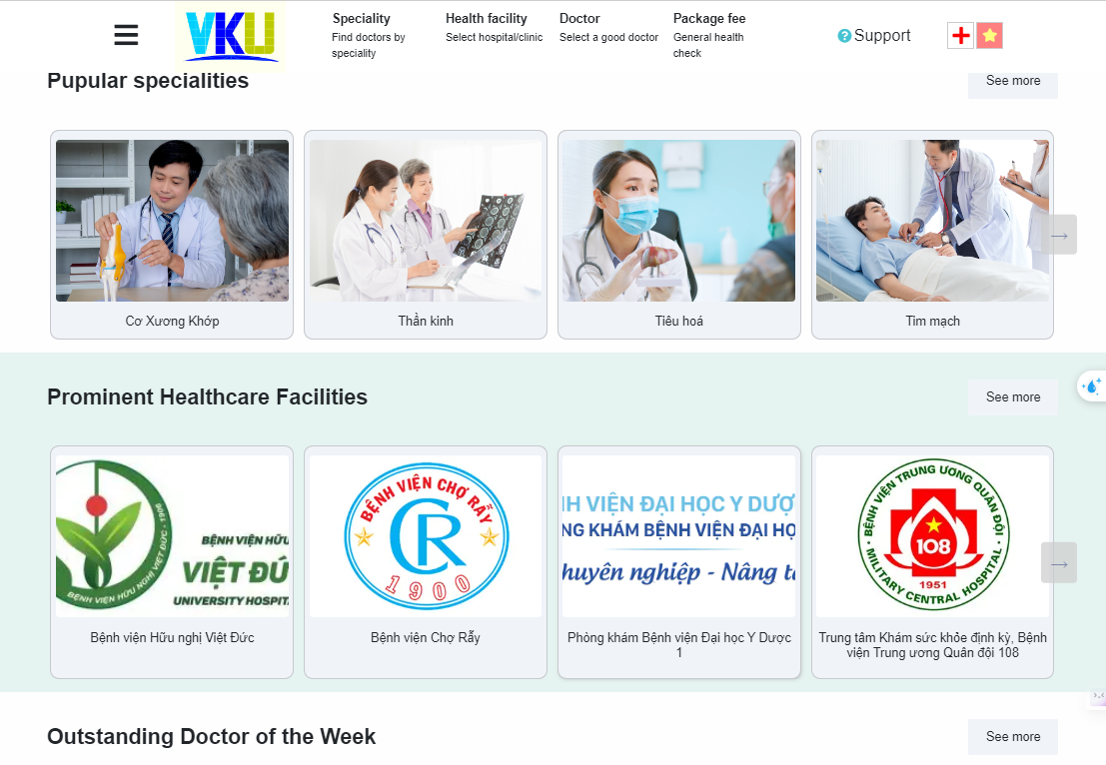

*Figure 12: Home page: Popular specialities and Prominent Healcare Facilities*

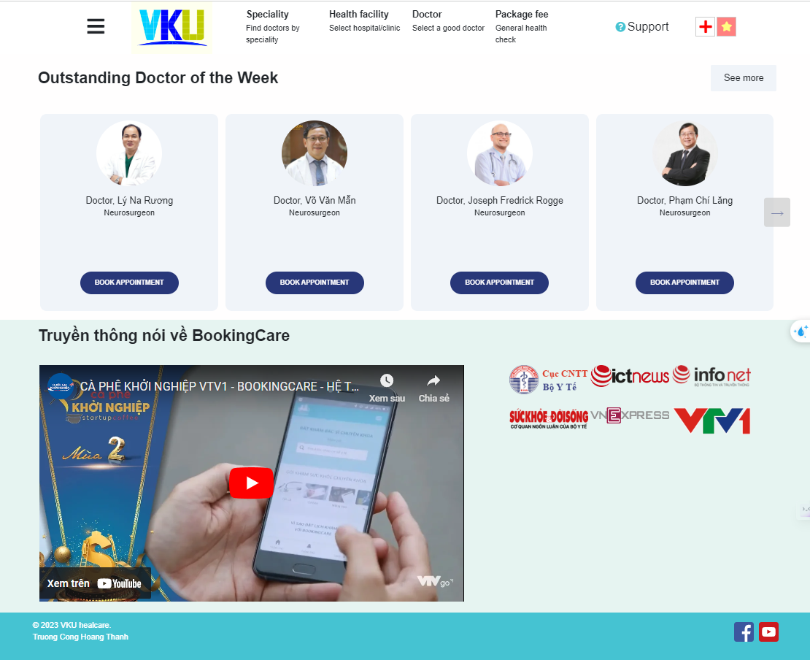

*Figure 13: Home page: Outstanding Doctor of week and about VKU Healcare introduction*

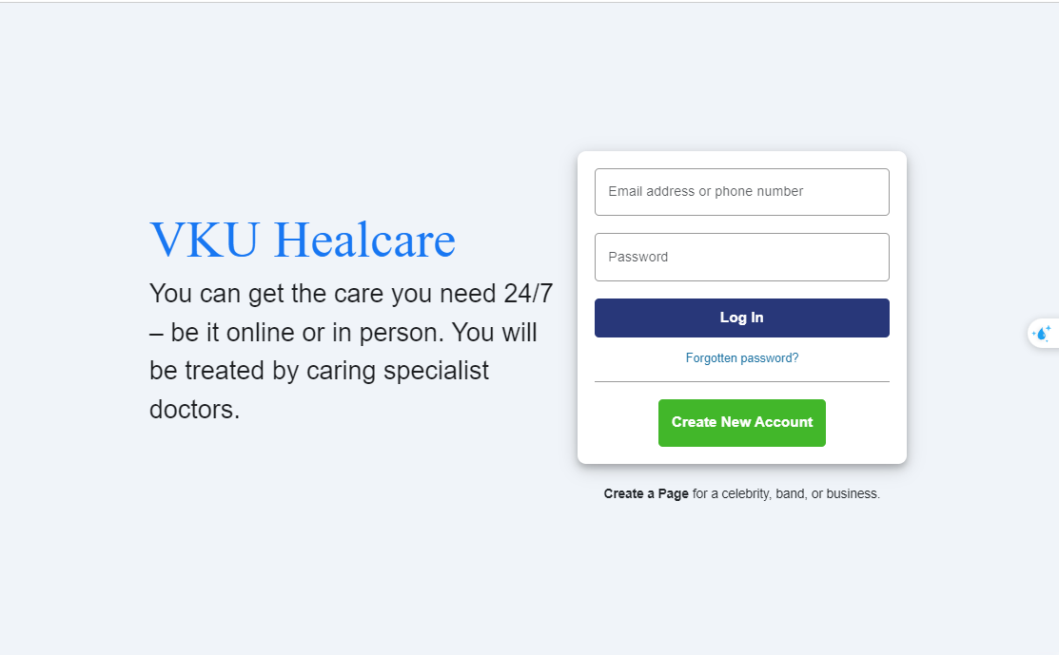

*Figure 14: Login page*

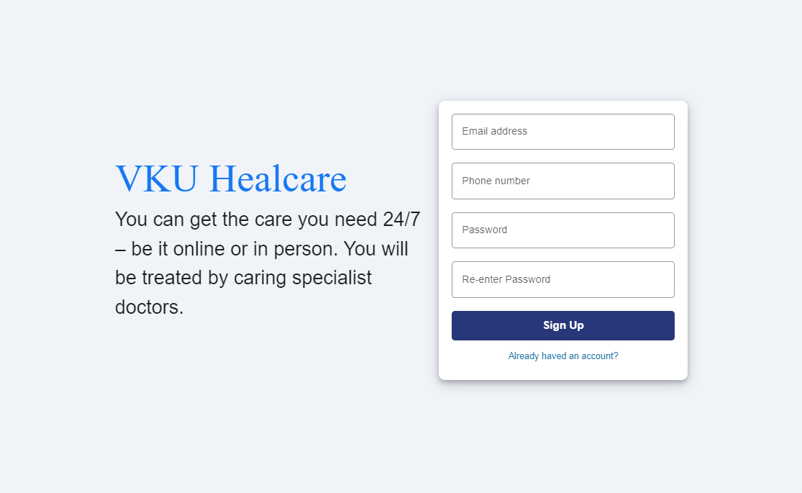

*Figure 15: Register page*

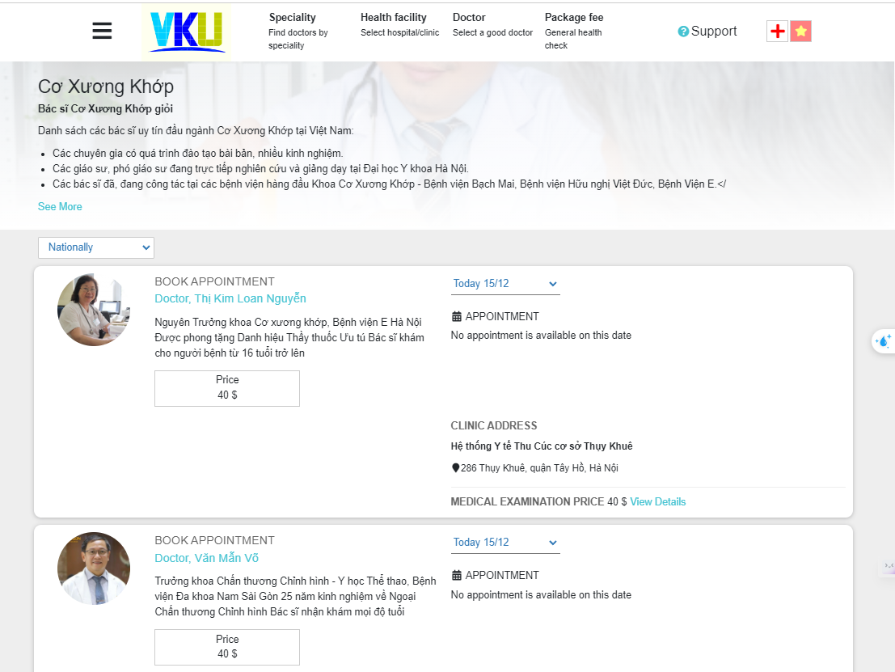

*Figure 16: Specialty page*

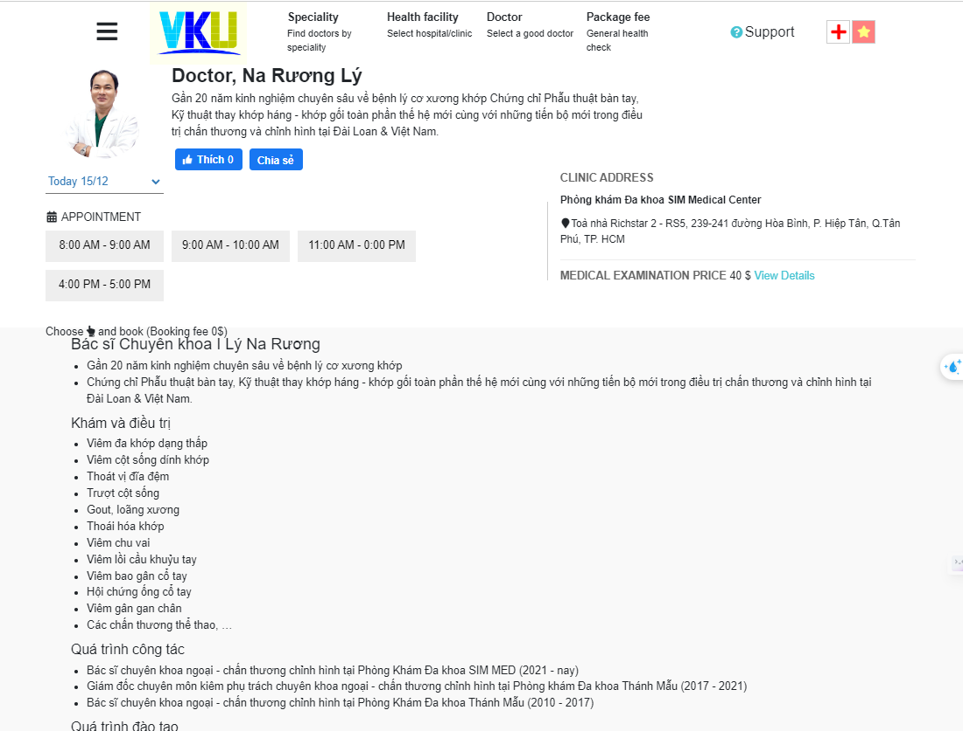

*Figure 17: Doctor profile page*

1. **Dashboard Website**

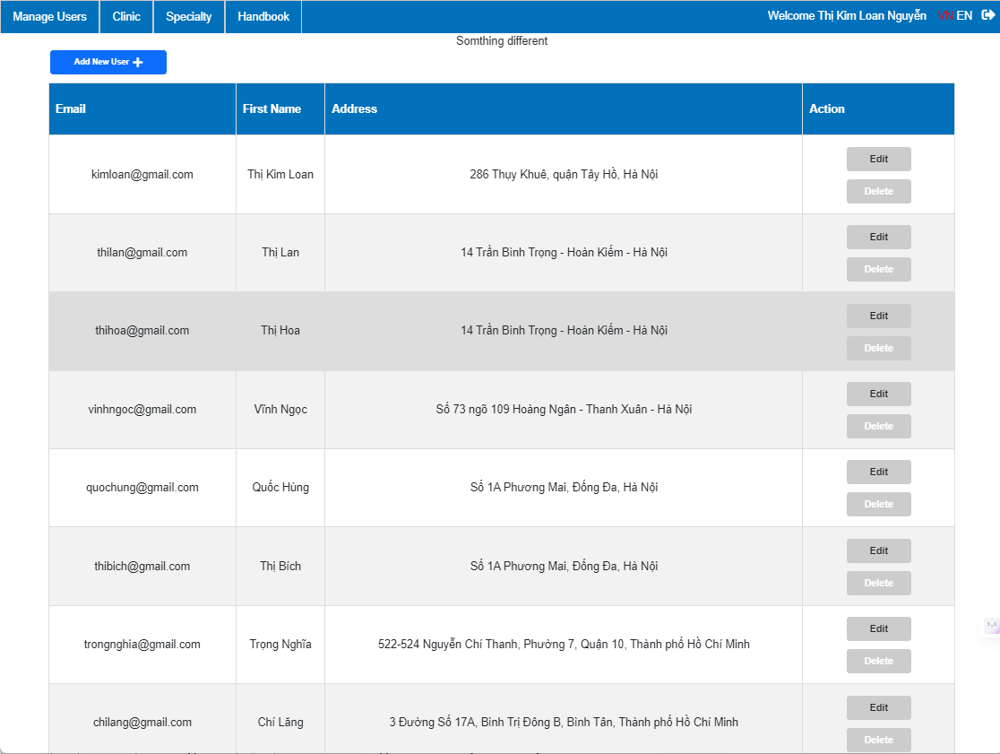

*Figure 18: Manage user page: View all users*

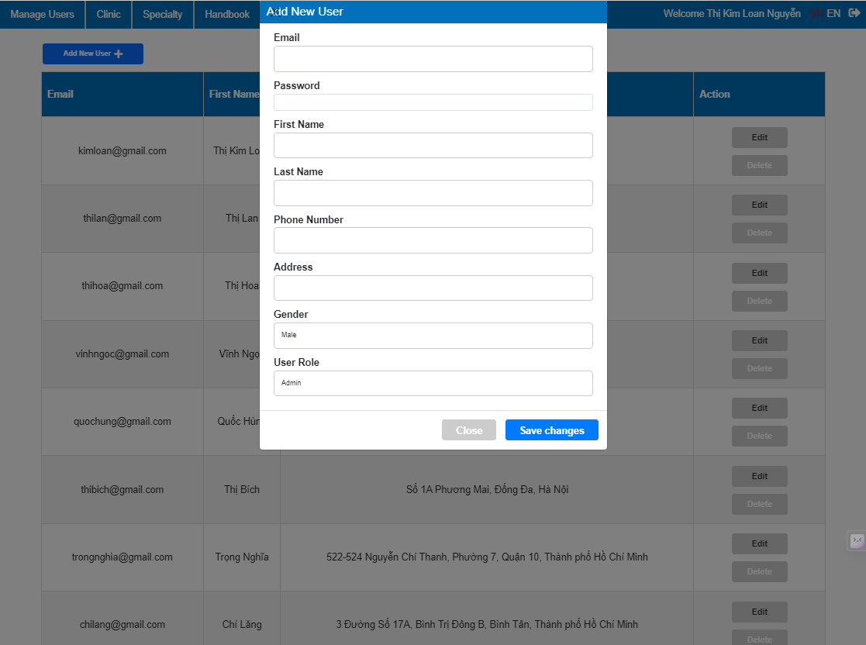

*Figure 19: Manage user page: Add a new user*

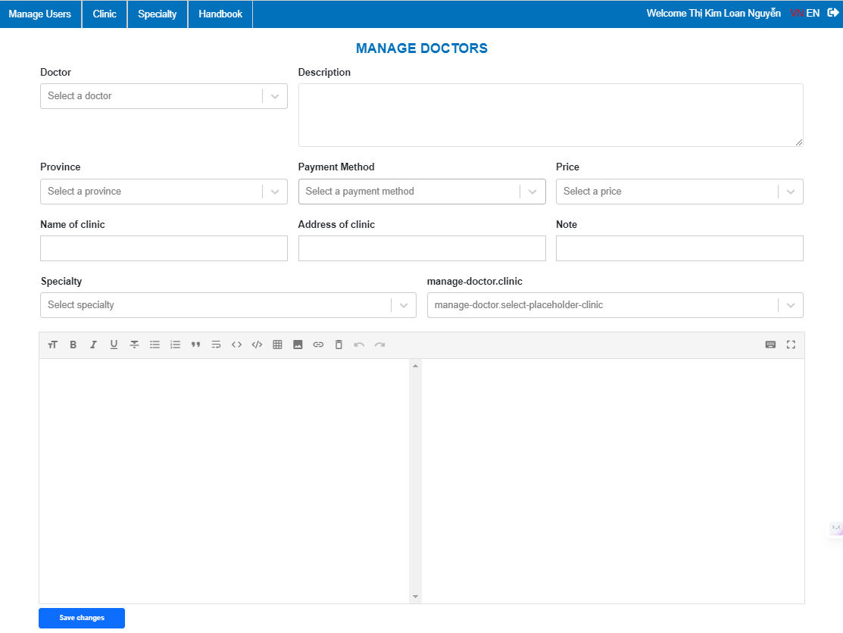

*Figure 20: Manage doctor page: Add a new doctor*

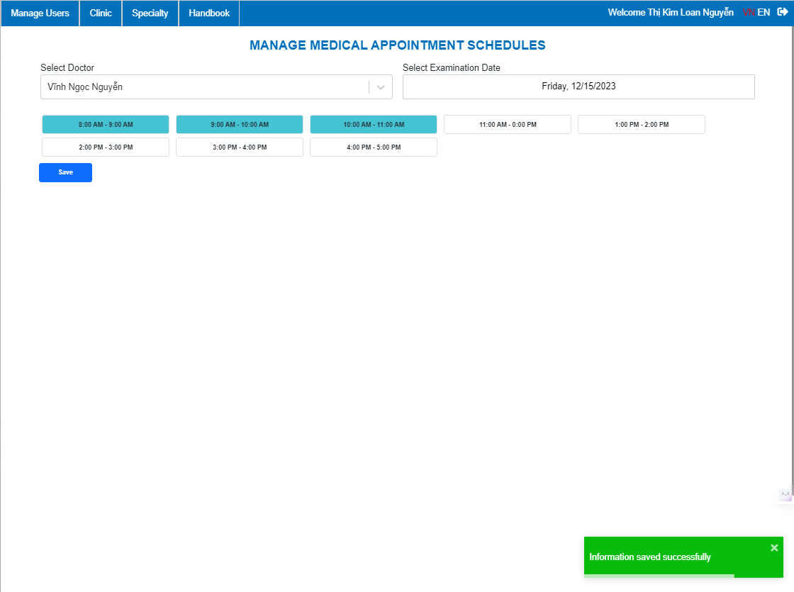

*Figure 21: Manage doctor’s schedule page: Add new schedules*

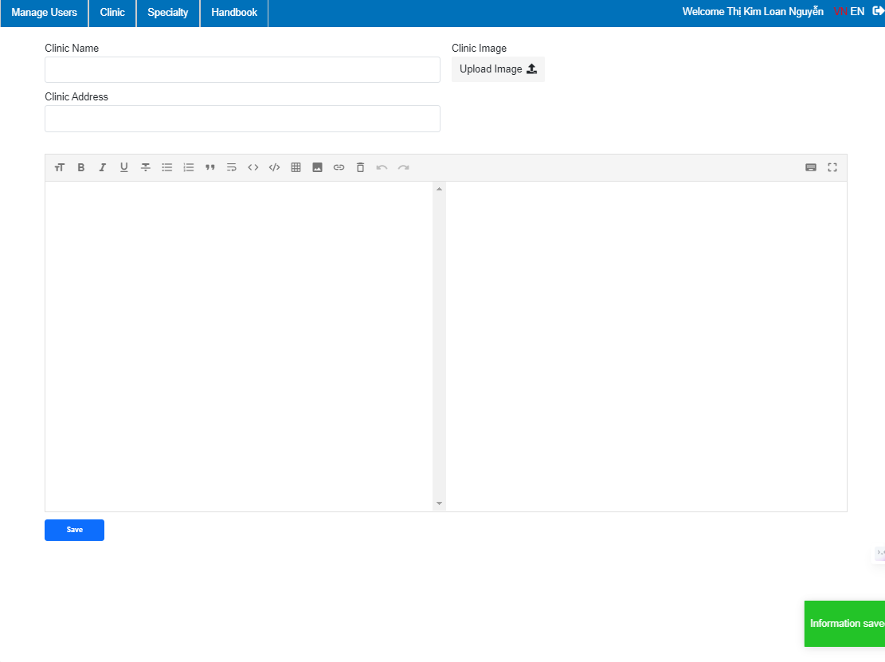

*Figure 22: Manage clinic page: Add new clinic*

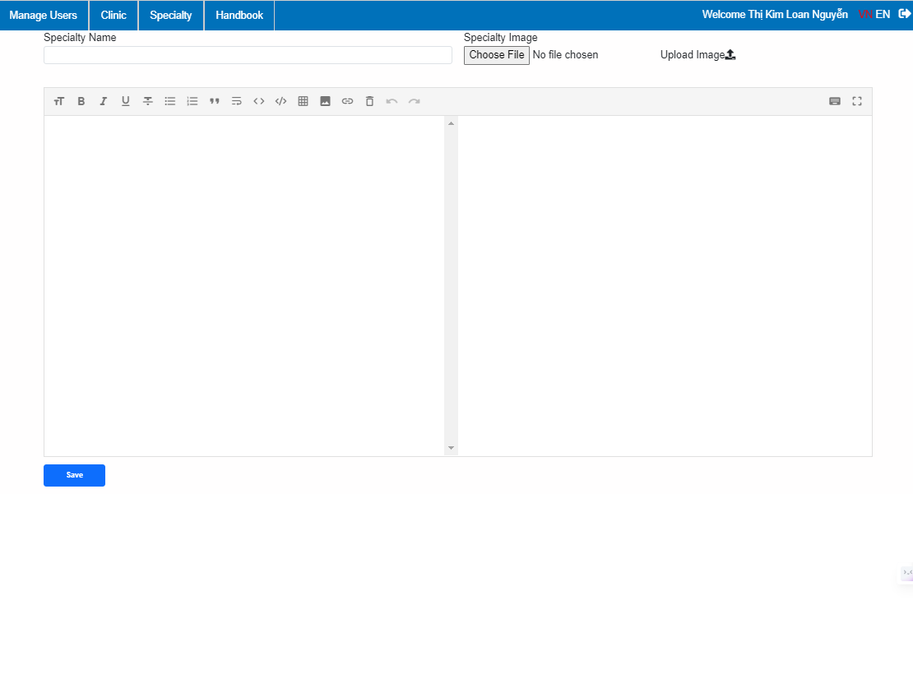

*Figure 23: Manage Specialty page: Add new specialty*

1. **Mobile version**

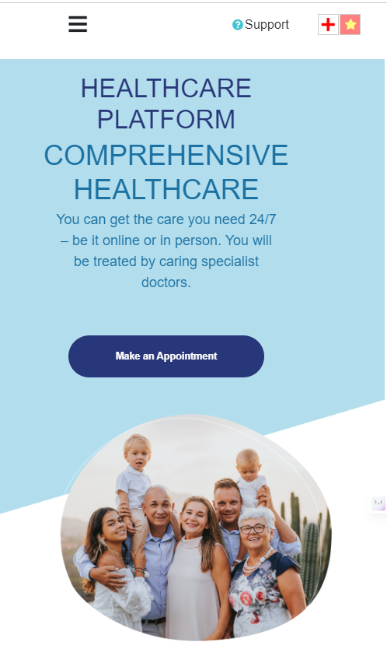

*Figure 24: Home page: Banner Introduction*

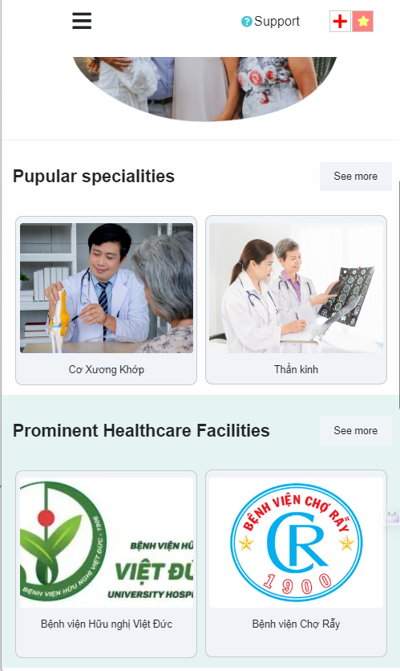

*Figure 25: Home page: Popular specialities*



*Figure 26: Home page: Outstanding Doctor of the week and About VKU Healcare*

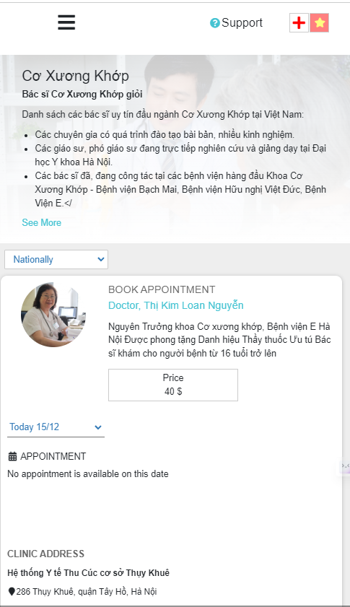

*Figure 27: Specialty page*

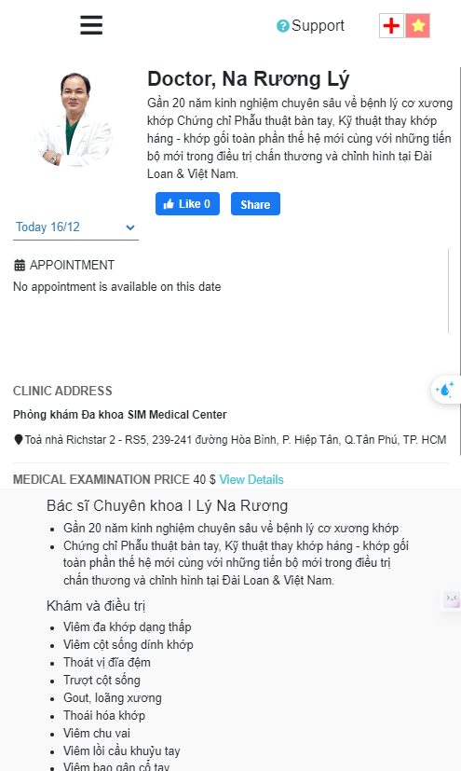

*Figure 28: Profile Doctor Page*

# CHAPTER 6: CONCLUSIONS

In conclusion, the healthcare system stands as a critical pillar in the edifice of societal prosperity, dedicated to the preservation and enhancement of human health. It is an intricate tapestry of institutions, professionals, and services woven together with the shared purpose of providing care, preventing illness, and promoting well-being. As we traverse the vast terrain of healthcare, we witness the system's capacity to adapt, innovate, and respond to the ever-changing landscape of health challenges.

The holistic nature of a healthcare system is not merely about diagnosing and treating ailments; it embodies a commitment to fostering health equity, where access to quality care is a right rather than a privilege. The system's resilience is evident in its continuous pursuit of balance—balancing accessibility with cost-effectiveness, quality with efficiency, and innovation with tradition.

As we peer into the future, the healthcare system becomes both a beacon of hope and a call to action. It beckons us to champion health for all, to eliminate disparities, and to embrace the potential of technological advancements and medical breakthroughs. The journey toward optimal health is a collective endeavor, demanding collaboration, compassion, and a sustained commitment to creating a world where every individual has the opportunity to lead a healthy and fulfilling life.

In essence, the conclusion of our exploration into the healthcare system invites reflection on the profound impact it has on our lives. It challenges us to envision a future where healthcare is not just a system but a continuum of care that empowers individuals, nurtures communities, and contributes to the vitality of our global society. In this collective pursuit, the healthcare system stands as both a testament to human resilience and a beacon of hope for a healthier and more equitable world.