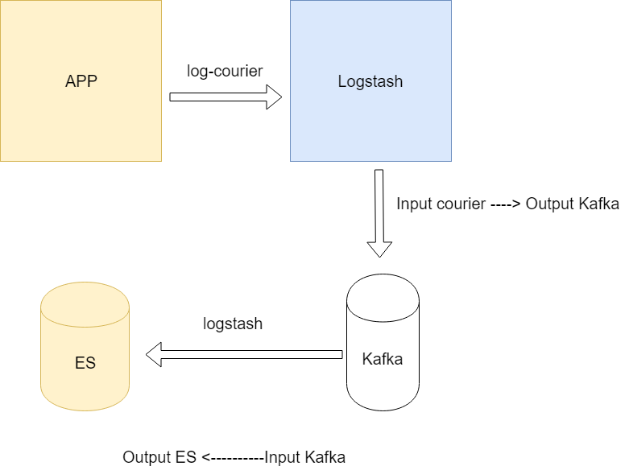

* Log-Courier ( ALL APP )
* vim /etc/log-courier/log-courier.yaml

*network:*

*servers:*

*- "log01.prod.hcm.fplay:5678"*

*- "log06.prod.hcm.fplay:5678"*

*transport: tls*

*ssl ca: /etc/log-courier/logstash.cer*

*method: loadbalance*

*files:*

*- paths:*

*- /var/log/nginx/json_access/*.json.log*

*fields:*

*type: nginx*

*general:*

*log stdout: true*

*log file: /var/log/log-courier.log*

*log level: info*

*spool size: 5120*

*spool timeout: 120*

* Logstash ( log01, log06 )
* vim /opt/logstash-6.3.2/config/logstash-courier.yml

*input {*

*courier {*

*port => 5678*

*ssl_certificate => "/opt/logstash-6.3.2/logstash.cer"*

*ssl_key => "/opt/logstash-6.3.2/logstash.key"*

*codec => json*

*}*

*}*

*output {*

*kafka {*

*codec => plain { format => "%{[message]}" }*

*topic_id => "logs_api"*

*bootstrap_servers => ["118.69.57.144:9092,118.69.57.143:9092,118.69.57.133:9092"]*

*}*

*}*

* vim /opt/logstash-6.3.2/config/logstash-es.ym

*input {*

*kafka {*

*id => "push_to_es"*

*consumer_threads => "9"*

*topics => "logs_api"*

*bootstrap_servers => ["118.69.57.144:9092,118.69.57.143:9092,118.69.57.133:9092"]*

*}*

*}*

*filter {*

*json {*

*source => "message"*

*remove_field => ["message"]*

*}*

*}*

*output {*

*elasticsearch {*

*id => "logstash_es"*

*hosts => ["log03.prod.hcm.fplay:9200"]*

*}*

*}*

* Supervisord: Config for Logstash (log01, log06)

vim /etc/supervisord.d/logstash-courier.ini

*[program:courier-logstash]*

*command=/opt/logstash-6.3.2/bin/logstash -f /opt/logstash-6.3.2/config/logstash-courier.yml --path.data /opt/logstash-6.3.2/custom-data/courier-logstash*

*autostart=true*

*autorestart=true*

*redirect_stderr=true*

*stdout_logfile=/var/log/logs-courier.log*

*stdout_logfile_backups=1*

vim /etc/supervisord.d/logstash-es.ini

*[program:logstash-es]*

*command=/opt/logstash-6.3.2/bin/logstash -f /opt/logstash-6.3.2/config/logstash-es.yml --path.data /opt/logstash-6.3.2/custom-data/logstash-es*

*autostart=true*

*autorestart=true*

*redirect_stderr=true*

*stdout_logfile=/var/log/logs-es.log*

*stdout_logfile_backups=1*

* *Kafka ( log04, log05, log06 )*
* Config file*: /opt/kafka_2.11-1.1.1*
* Config supervisor kafka: */etc/supervisord.d/kafka.ini*
* Config supervisor Zookeeper: */etc/supervisord.d/zookeeper.ini*