Hanoi University of Science & Technology

PROJECT REPORT

Demonstration of sorting algorithms on array

Object – Oriented Programming

Instructor: Prof. Nguyen Thi Thu Trang

Group 10

Nguyễn Quang Tùng 20194462

Đặng Thanh Lam 20194442

1. Assignment of members

Dang Thanh Lam - 20194442:

* Element class
* CreateArray class
* GeneralSort class
* BubbleSort class
* Demostration screens and controller (bubbleSort.fxml, insertionSort.fxml, quickSort.fxml, SortController)
* Write report
* Make powerpoint presentation

Nguyen Quang Tung - 20194462

* InsertionSort class
* QuickSort class
* Main menu screen and controller (MainMenu.fxml, About.fxml, MainScreenController)
* Main class
* Write report
* Make demostration video

We did use the idea about the animation from: *https://github.com/chriszq/VisualSortingAlgorithms*

2. Description

2.1 Requirement of the project

Sorting algorithm is an algorithm that puts elements of a list in a certain order. Efficient sorting is important for optimizing the efficiency of many other algorithms. A lots of sorting algorithm have been developed so far, making it difficult to understanding and remembering all of them. This project purpose is to help people get a better understanding 3 basic sorting algorithms: Bubble sort, Insertion sort and Quick sort through a visualizing application showing each step of the algorithms. The application is built in Java with the GUI created using JavaFX.

2.2 Use case explanation

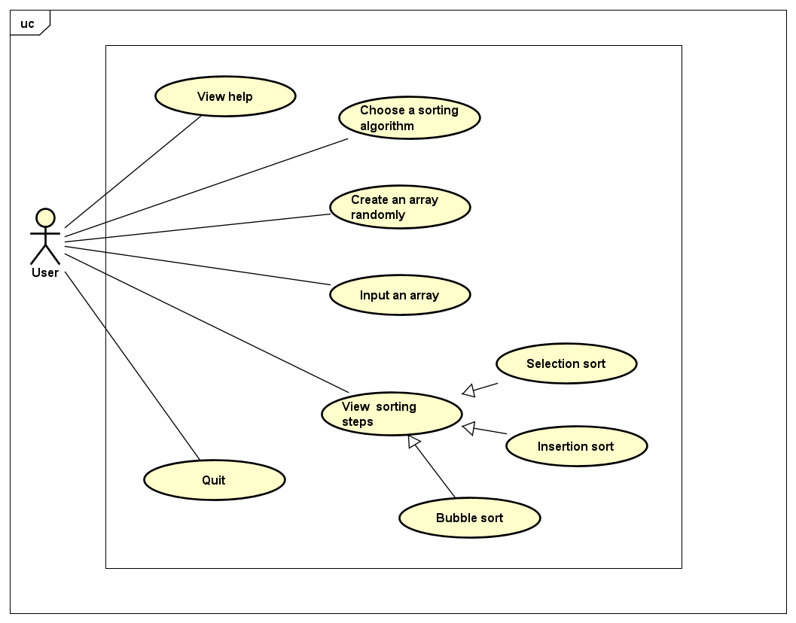

After the user start launching the application, a main menu screen will be shown. In the main menu screen user can:

* View help: Help menu show the basic usage and aim of the program
* Quit: Exit the program
* Choose a sorting algorithm: Click in one of three buttons corresponding to three algorithms to see the visualization of the sorting

After choosing one of 3 algorithm, the demostration screen will show up. In this screen, user can:

* Create an array randomly: by choosing the length and the type of the array
* Input an array: input the array using a textfield. The application only accepts arrays with elements are integers.
* View sorting steps: after creating an array either randomly or through input, user can click the sort button to see each step of the chosen sorting algorithm on the created array.

3. Design

Relation ship between package:

- Element class inherits from Rectangle class

- QuickSort, BubbleSort and InsertionSort inherit from the class GeneralSort

- SortController class is associate with CreateArray class, BubbleSort, QuickSort, InsertionSort class

- Main class inherit from the Application class and associate with Stage class.

- SortController and MainScreenController are associate with many elements from JavaFX to create the GUI.

3.2 Several class diagrams

**Package**: element

*Some important method:*

* createRandom: create a random array of elements with given length, value of each element range from 1 to length.
* createSorted: create an array with elements from 1 to length, descending or ascending order.
* createNearlySorted: create a sorted array, then randomly swap some elements

***Some important method*:

* swap: Swap two elements in the array and add a parallel transition swapping two corresponding rectangle on the screen.
* colorElements: add a parallel transition, contains fill transitions of some specific elements.
* colorArray: add a parallel transition, contains fill transitions of all elements in the array.
* bubbleSort: repeatedly comparing swapping the adjacent elements if they are in wrong order
* insertionSort: The array is virtually split into a sorted and an unsorted part. Values from the unsorted part are picked and placed at the correct position in the sorted part
* quickSort: It picks an element as pivot and partitions the given array around the picked pivot. In this program, we pick the last element as pivot.

**Packages**: application

*Some important method:*

* btnSortPressed: Since we use only one controller for 3 fmxl file, we create an instance of a sort class base on the text on the sort button (Bubble sort/Quick sort/Insertion sort). We use this sort class instance to perform sorting algorithm on the created array.