~LISTENING {.}

@[1]PART 1
##
For each questions choose the correct answers.
//
Question 1. What time will the flight to Brussels leave?

- 
- 
- 

Question 2. What does the man enjoy most about flying?
- 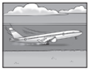
- 
- 

Question 3. Where will Maggie’s family stay on holiday this year?
- 
- 
- 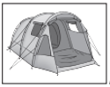

Question 4. What has the woman left behind?

- 
- 
- 

Question 5. What will the weather be like when the plane arrives?
- 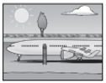
- 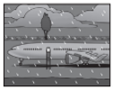
- 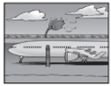

Question 6. What was damaged during the journey?
- 
- 
- 

Question 7. Where can you park your car for free?

- 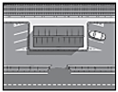
- 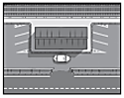
- 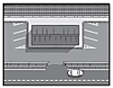

/#

@[1]PART 2
##
For each question, choose the correct answer.
//
Question 1. You will hear two friends talking about going skiing.
The girl thinks that going skiing is
C. only exciting for the first few days.
A. less fun than beach holiday.
B. too dangerous for her and her family.

Question 2. You will hear two friends talking about professional football.
They agree that
B. the managers have a difficult job.
A. footballers are paid too much.
C. there should be less shown on TV.

Question 3. You will hear two friends talking about a cycling club.
The boy is
A. suggesting that the girl goes on a ride with him.
B. persuading the girl to join the club.
C. describing where the members usually cycle to.

Question 4. You will hear two friends talking about sailing course they did.
They enjoyed the course because
C. the conditions were perfect for sailing.
A. the equipment was high quality.
B. the instructor gave clear instructions.

Question 5. You will hear two friends talking about a video game.
They think that it would be better if
B. the characters were more interesting.
A. there were more levels.
C. it had better music.

Question 6. You will hear two friends talking about a basketball game they went to.
Why were they disappointed with it?
A. The game was boring.
B. Their favorite team lost.
C. A player they like got hurt.
/#

@[1]PART 3
##
For each question, write the correct answer in the gap.
Write one or two words or a number or a date or a time.

You will hear a part of a training session for people who are going to work as sales assistants in a large shop.
Training session for new sales assistants
//
Question 1. The training manager is called Mandy (………).
/
{ Hickets}
Question 2. New assistants will work on the (……..) floor.
/
{ ground}
Question 3. Part-time workers have a rest day on (……) every week.
/
{ Thursday}
Question 4. Workers who live in the town can use the store’s (………) service for free.
/
{ bus}
Question 5. The staff discount cannot be used to buy (……….).
/
{ food}
Question 6. Assistants need to collect their (…………) on the first day.
/
{ ID card}

/#

@[1]PART 4
##
For each question, choose the correct answer.
You will hear an interview in which a TV actress called Brittany Briers.
//
Question 1. Brittany realized that she really enjoyed acting when
C. she took part in a school play.
A. she played at being an actor at home.
B. she attended some acting classes.
Question 2. How did Brittany feel before her first theatre performance?
B. anxious that she would use the wrong accent.
A. worried about forgetting her lines.
C. nervous about appearing in front of a large audience.
Question 3. Why did Brittany move into TV acting?
C. She wanted to try something new.
A. She needed to earn more.
B. She lost interest in theatre work.
Question 4. What does Brittany still find difficult about screen acting?
B. learning to speak more quietly
A. having to repeat scenes
C. not having an audience
Question 5. Brittany particularly enjoys
A. receiving a new part to learn.
B. attending special events for actors.
C. seeing her new films for the first time.
Question 6. What does Brittany dislike about being an actor?
C. starting work early in the morning
A. not having many holidays
B. being recognized in the street
/#

