~SPEAKING {.}

@Part 1 (10)
#Answer the following questions
1. Do you work or are you a student? What are you studying? / What do you do?
2. What do you like most about your study/ job?
3. How do you get to work/ school/ university every day?
4. What did you do last weekend?
/
[video]
Answers vary.

@Part 2 (10)
#Look at the photograph below.
Talk about what you can see in the picture.
You should speak for about one minute.

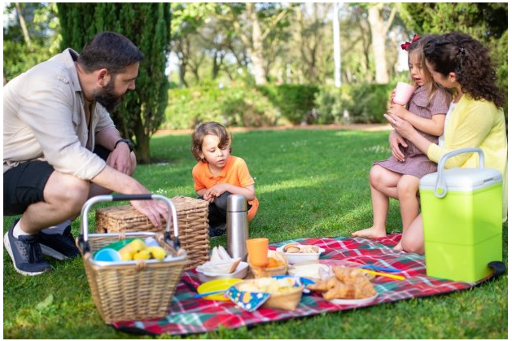
/
[video]
Answers vary.

@Part 3 (10)
#Now you’re going to speak on your own for about two minutes about what food you could bring to the party to celebrate the end of the school year. Talk about these different types of food you could bring to the party and say what would be best. 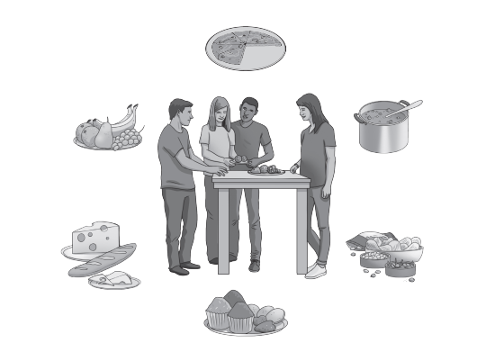

/
[video]
Answers vary.

@Part 4 (10)
#Answer the questions related to ‘food’
1. What foods and drinks do you especially enjoy having at parties?
2. How often do you go out to eat in a restaurant?
3. What kinds of things do you enjoy cooking?
4. How important is it for people to eat healthy food?
/
[video]
Answers vary.

