~WRITING {.}

@Part 1 (20)
#Question 1
Read this email from your English-speaking friend Marley and the notes you have made.
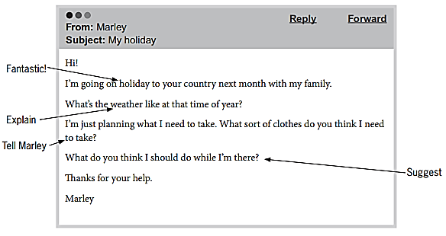

Write your email to Marley, using all the notes, in about 100 words.

/
[text]
Answers vary.

@Part 2 (20)
#Choose one of these questions
Write your answer in about 100 words

- Question 2
You see this notice on an English-language website.
Articles wanted!
The best holiday I’ve ever had

Where did you go? What did you do there?
How did you travel?
What made it so special?
Write an article answering these questions. We will publish the most interesting ones on our website.

Write your article in about 100 words.

- Question 3
Your English teacher has asked you to write a story.
Your story must begin with this sentence.

I felt nervous when the phone rang.

Write your story in about 100 words

/
[text]
Answers vary.

