~SPEAKING {.}

@Part 1 (10 pts) (10)
#Answer the following questions in about 3 minutes.
1. How often do you read the news online?
2. What websites do you usually visit to get information?
3. Do you prefer watching news videos or reading articles? Why?
/
[video]
Answers vary

@Part 2 (10 pts) (10)
#Compare 2 provided pictures and give some comments on the activities shown in the photos in about 3 minutes.
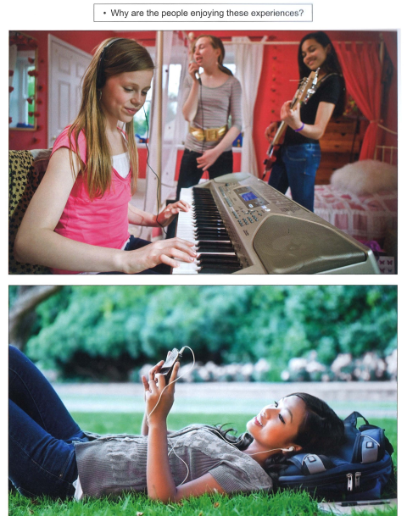

/
[video]
Answers vary

@Part 3 (10 pts) (10)
#Use the ideas provided to make a short talk in about 3 minutes.

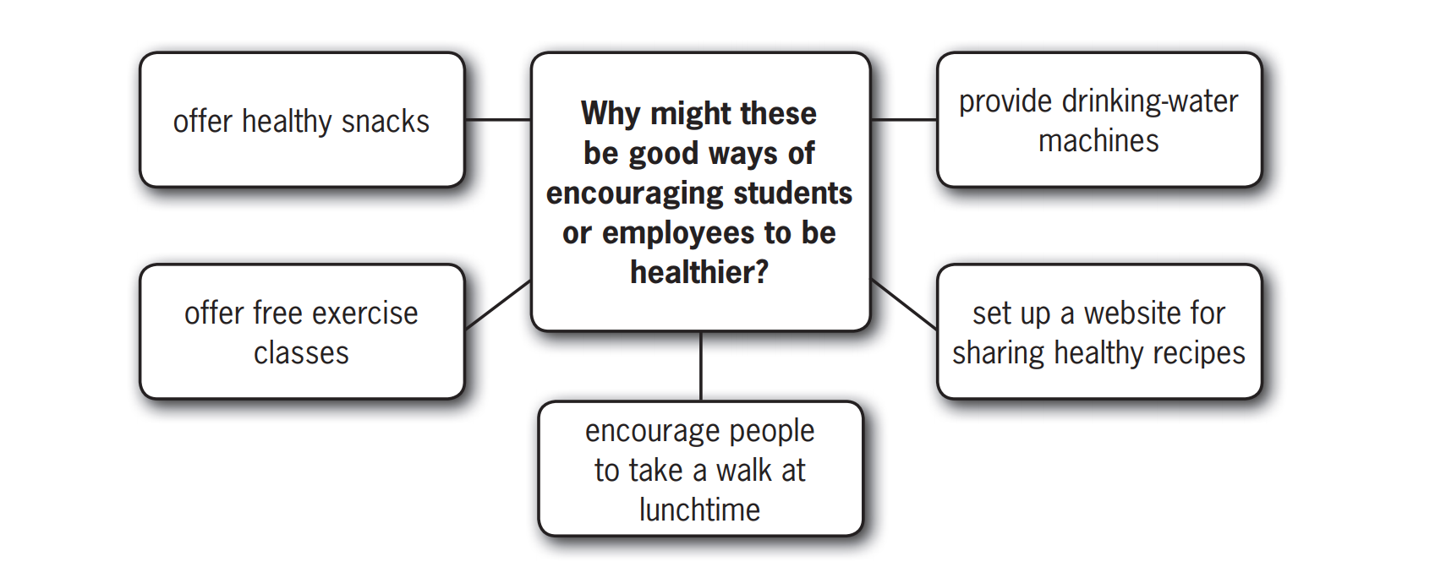
/
[video]
Answers vary

@Part 4 (10 pts) (10)
#Answer some questions relating to the topic in Part 3 in about 3 minutes.
- ﻿Apart from a healthy diet, what else can you do to stay healthy?
- How important do you think it is to spend some time outdoors every day? Why?
/
[video]
Answers vary

