~WRITING {.}

@WRITING TASK 1
Câu 1. You should spend about 20 minutes on this task.
The graph gives information about the percentage of the population of four different Asian countries living in cities between 1970 and 2020 with additional predictions for 2030 and 2040.
Summarize the information by selecting and reporting the main features and making comparisons where relevant.
Write at least 150 words.
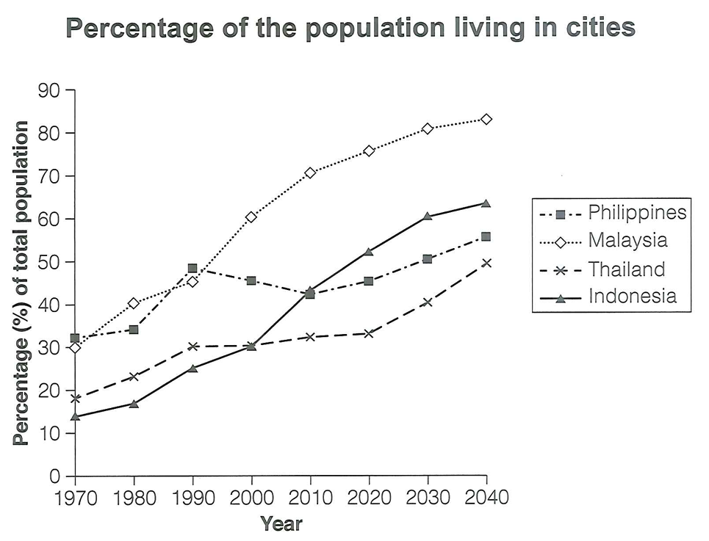
/
[text]
Answers may vary.
- Task Achievement: (0.25 point)
- Coherence And Cohesion: (0.25 point)
- Lexical Resource: (0.25 point)
- Grammatical Range and Accuracy: (0.25 point)

@WRITING TASK 2
Câu 2. You should spend about 40 minutes on this task.
Write about the following topic:
Some people believe that studying at university or college is the best route to a successful career, while others believe that it is better to get a job straight after school. Discuss both views and give your opinion.
Give reasons for your answer and include any relevant examples from your own knowledge or experience. Write at least 250 words.
/
[text]
Answers may vary.
- Task Achievement: (0.25 point)
- Coherence And Cohesion: (0.25 point)
- Lexical Resource: (0.25 point)
- Grammatical Range and Accuracy: (0.25 point)

