Personal Project - Simple MCU
Architecture and Implementation

Change History
Date | Revision | Change | Author
... | 1.0 | First release | Long Nguyen

Contents

List of Figures

List of Tables

Chapter 1: Introduction
<Some introductions about main function>

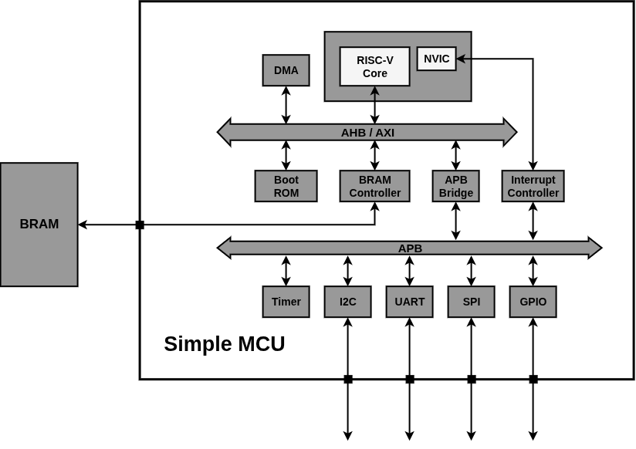
Figure 1 - Top block diagram
Features:
- RISC-V privileged M-mode 32I core
- DMA supports
- Peripherals: I2C, UART, SPI, GPIO

Chapter 2: Design Configurations
- Defines
Table 1 - Top define macros
Define | Detail | *Status
USE_AHB | Turn on this to use AHB as the main bus | On
USE_AXI | Turn on this to use AXI as the main bus | Off

*To ON/OFF these defines, modify ‘${PROJ_ROOT}/rtl/spmcu_define.svh’
- Parameters
Table 2 - Top parameters
Parameter | Detail | Value

These parameters are defined in ‘${PROJ_ROOT}/rtl/spmcu_param_pkg.sv’.

Chapter 3: Architechture and Implementation

For reuse purpose - each section (from section 4 to 8) in this chapter can be reused as an independent design document of the corresponding top module mentioned in that section.

<Top block diagram, more detail, focus on clk & rstn>
- Clock and Reset

- Port List
Table 3 - Top port list
Port name | I/O | Clock | Width | Detail
rstn | Input | --------- |  | Asynchronous reset, active low
clk | Input | --------- |  | MCU clock - 500MHz
BRAM interface --------------------------------------------------------------------------------------------------
 | Input | ---------
 | Ouput
UART interface ---------------------------------------------------------------------------------------------------
 | Input | ---------
 | Ouput
I2C interface -------------------------------------------------------------------------------------------------------
 | Input | ---------
 | Ouput
SPI interface -------------------------------------------------------------------------------------------------------
 | Input | ---------
 | Ouput
GPIO interface ----------------------------------------------------------------------------------------------------
 | Input | ---------
 | Ouput

- Addressmap
- Common
  - Round Robin Arbiter
Directory: | “${PROJ_ROOT}/rtl/common/”
Top module: | “spmcu_rr_arbiter.sv”

<Chuc nang, tinh nang, diem dac biet>: The Arbiter is an module that is responsible for used for determine which device sent request to it is granted and

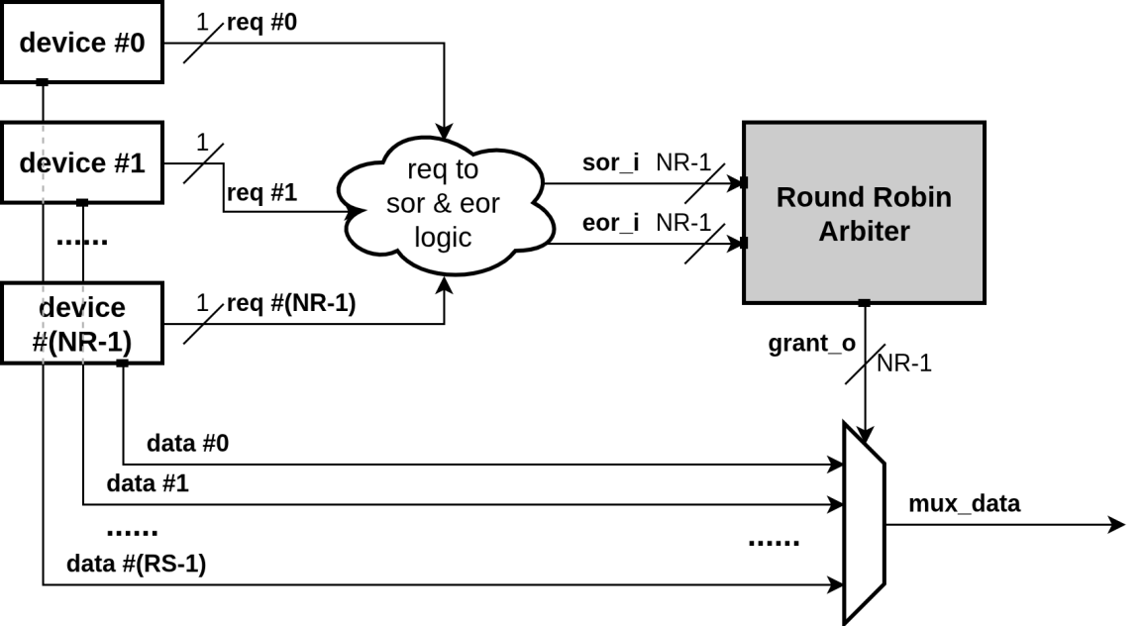

Figure 2 - Overview usage of Round Robin Arbiter
    - Design Configurations
Table 4 - Round Robin Arbiter parameters
Parameter | Detail
NR | Number of request sent to the arbiter  - Default value = 4  - Legal value: NR > 1

    - Port List
Table 5 - Port list of Round Robin Arbiter
Port name | I/O | Width | Detail
rstn | Input | 1 | Asynchronous reset, active low
clk | Input | 1 | Clock
sor_i | Input | NR | Start of request
eor_i | Input | NR | End of request
grant_o | Ouput | NR | Granted request

    - Operation

This
    - Implentation
- RISC-V Core
  - Boot ROM
  - BRAM Controller
- DMA
- AHB

<Chuc nang, tinh nang, diem dac biet>

The block diagram in figure below describe how three top module (AHB Interconnect, AHB Master, AHB Slave) are connected together to form a comprehensive bus system which support high performance communicating between several AHB Master devices (CPU, DMA,...) and Slave devices (BRAM Controller, APB bridge,...).

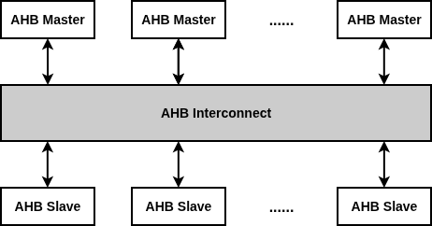

<Block diagram tong quan connection inter, mst, slv>
  - AHB Interconnect
Directory: | “${PROJ_ROOT}/rtl/ahb/interconnect/”
Top module: | “spmcu_ahb_interconnect.sv”

<Chuc nang, tinh nang, diem dac biet>

<Block diagram tong quan cau tao ben trong>
    - Design Configurations
Table 6 - AHB Interconnect parameters
Parameter | Detail
NM | Number of AHB Master devices connected to the interconnect  - Default value = 4  - Legal value: NM > 0
NS | Number of AHB Slave devices connected to the interconnect  - Default value = 4  - Legal value: NS > 0
AW | Address width  - Default value = 16  - Legal value: 9 < AW < 65
DW | Data width  - Default value = 32  - Legal value: 32, 64, 128, 256

    - Port List
Table 7 - AHB Interconnect port list
Port name | I/O | Width | Detail
rstn | Input | 1 | Asynchronous reset, active low
clk | Input | 1 | MCU clock - 500MHz
AHB Master side --------------------------------------------------------------------------------------------------
mst_haddr_i | Input | NMxAW | Byte address of transfer
mst_hburst_i | Input | NMx3
mst_hsize_i | Input | NMx3
mst_htrans_i | Input | NMx2
mst_hwdata_i | Input | NMxDW
mst_hwstrb_i | Input | NMx(DW/8)
mst_hwrite_i | Input | NM
mst_hrdata_o | Ouput | NMxDW
mst_hresp_o | Ouput | NM
mst_hready_o | Ouput | NM
AHB Slave side ----------------------------------------------------------------------------------------------------
slv_hrdata_i | Input | NSxDW
slv_hresp_i | Input | NS
slv_hreadyout_i | Input | NS
slv_haddr_o | Ouput | AW
slv_hburst_o | Ouput | 3
slv_hsize_o | Ouput | 3
slv_htrans_o | Ouput | 2
slv_hwdata_o | Ouput | DW
slv_hwstrb_o | Ouput | DW/8
slv_hwrite_o | Ouput | 1
slv_hsel_o | Ouput | NS

    - Operation

    - Implementation

  - AHB Master
  - AHB Slave
- AXI
  - AXI Interconnect
  - AXI Master
  - AXI Slave
- APB Sub-system
  - Addressmap
  - Timer
  - I2C
  - UART
  - SPI
  - GPIO

Chapter 4: FPGA Validation

<dsdsdsd>

