UrBox Test Answer
Candidate Name: Ngo Thanh Luan
Position Applied For: Business Intelligence Analyst

Important Notice
Analysis Scope Clarification

This report is a User Lifecycle Analysis, not a Loyalty Scoring analysis.
The age groups used in this test (New, Early, Growth, Loyal) are based on UrBox Age
—the time between a user’s first and last redemption.

These labels indicate how long users have been active on the platform, but they do not represent true customer loyalty levels.

To evaluate real user loyalty, additional metrics such as frequency, recency, and value would be required (e.g., RFM or engagement scoring).
In this analysis, we focus only on behavior differences between users with different platform usage durations.

PART I
SQL Test
Source Code:
Please check file “SQL_Code.sql” in folder “Code”

Result

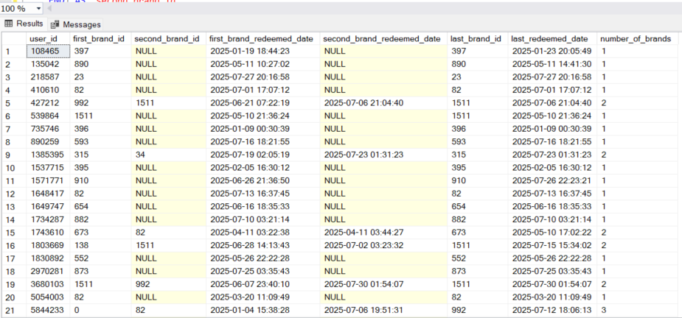

Analytics Test 1
I. Analysis Summary (Only for User & Transaction Numbers)
Based on the UrBox dataset, I have aggregated the key numbers for each age group. The results show clear differences in both the number of users and the level of activity across the groups.

Segmentation
New Users (0–7 days)
Early Users (8–30 days)
Growth Users (31–90 days)
Loyal Users (>90 days)
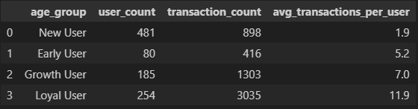

- New Users (481 users, 898 transactions)
- New Users have an average of 1.9 transactions per user, which is the lowest among all groups.
- This means most new users only redeem once or twice.

- Early Users (80 users, 416 transactions)
- Early Users have 5.2 transactions per user, which is a strong increase compared to New Users.
- However, the group size is very small (only 80 users).
- This suggests that many New Users do not continue into the Early stage, indicating a retention issue.

- Growth Users (185 users, 1,303 transactions)
- Growth Users make 7.0 transactions per user, showing consistent engagement.
- This group is stable and shows good potential to become long-term users.
- Their activity level is higher than Early Users and contributes a medium share of total transactions.

- Loyal Users (254 users, 3,035 transactions)
- Loyal Users have the highest activity with 11.9 transactions per user.
- This group also produces the largest total number of transactions (over 3,000).
- They play an important role in the overall performance of the platform.

II. Brand Switching Analysis by Age Group
This table shows how many different brands each user redeems inside each age group. It helps us understand how user behavior changes when they stay longer on UrBox.
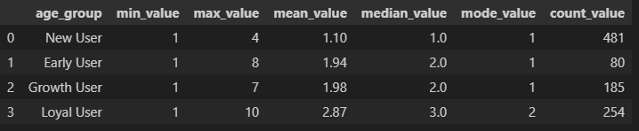
- New Users (481 users)
  - Mean = 1.10 brands, Median = 1, Mode = 1
  - Most New Users redeem only 1 brand.
  - This is normal for a first-stage user, as they are still trying the platform.
  - The range is 1 to 4 brands, but the majority stay at 1 brand.
Meaning:
New Users have very simple behavior and low brand exploration. Our main focus here should be helping them discover a second brand and move to the next stage of the funnel.

- Early Users (80 users)
  - Mean = 1.94 brands, Median = 2
  - Early Users begin to explore more brands compared to New Users.
  - Even though the group is small, their brand switching almost doubles.
Meaning:
This group shows that once users make more than 1–2 transactions, they start exploring new brands.
This is the transition stage where recommendations and light incentives can help them expand their usage.

- Growth Users (185 users)
  - Mean = 1.98 brands, Median = 2
  - Brand switching remains similar to Early Users, but this group is larger and more stable.
  - Users redeem 1–7 different brands.
Meaning:
Growth Users maintain steady exploration behavior.
They use more features and brands regularly, but the pattern is still moderate.
This is a good stage to strengthen habits and build long-term engagement.

- Loyal Users (254 users)
  - Mean = 2.87 brands, Median = 3, Mode = 2
  - Loyal Users explore the most brands and have the widest range (1 to 10 brands).
  - They have almost 3× more brand diversity than New Users.
Meaning:
This group shows the highest level of trust and activity on the platform.
They are open to trying many brands and different categories, which makes them suitable for cross-sell and upsell strategies.

Key Insights
Brand exploration increases with user age.
New Users stick to 1 brand, while Loyal Users explore up to 10.
The biggest behavior change happens after the New stage.
Users who stay become more open to trying different brands.
Loyal Users have the highest brand diversity, meaning they interact with multiple brand clusters.

What we should do
New Users: guide them to try a second brand
Early Users: recommend similar or related brands
Growth Users: strengthen habits with category promotions
Loyal Users: apply cross-sell & upsell, promote premium brands

III. Analysis of Brand Cluster Differences Across UrBox Age Groups
This section analyzes whether users in different UrBox Age Groups redeem different sets of brands.
To answer this question, we use two pieces of evidence:
- Top 5 most redeemed brands per age group (brand concentration)
- Total number of distinct brands redeemed per age group (brand diversity)
Combining both allows us to understand not only which brands users prefer, but also how broad or narrow their brand clusters are.
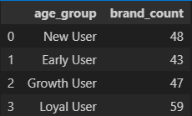
1. Summary of Distinct Brand Counts

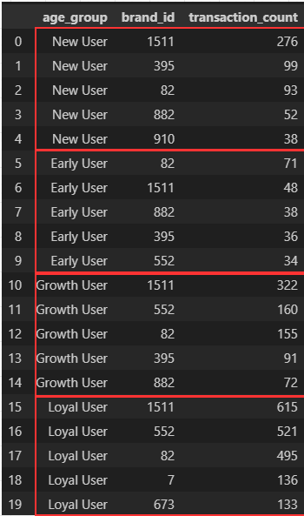
2. Top 5 Brands per Age Group (Ranked by Transactions)

3. Combined Analysis (Brand Concentration + Brand Diversity)
3.1 New Users – Wide pool (48 brands) but highly concentrated usage
Although New Users touched 48 different brands, the vast majority of transactions come from only 5 brands (especially 1511). This means New Users behave with broad but shallow brand exploration.
Meaning:
New Users don’t truly explore clusters; they mostly stick to 1–2 dominant brands.

3.2 Early Users – Brand diversity drops (43 brands), behavior stabilizes
Early Users redeem fewer distinct brands than New Users (43 vs 48). Their top brands remain almost identical to New Users. This shows that Early Users begin to stabilize preference,
focusing on the brands they like rather than trying new ones randomly.
Meaning:
Early Users form clearer brand preferences and narrow their cluster.

3.3 Growth Users – Diversity increases again (47 brands) + higher depth
Growth Users expand diversity from 43 → 47 brands. They show increased usage of brand 552 and maintain strong usage of the known brands. This stage represents intentional exploration, not random like New Users.
Meaning:
Growth Users discover additional clusters and engage deeper across brands.

3.4 Loyal Users – Highest diversity (59 brands) + new categories emerge
Loyal Users redeem the most distinct brands: 59 brands. They introduce new top brands (7 and 673) not seen in earlier stages. This means they explore new categories, not only the popular ones.
Meaning:
Loyal Users are multi-cluster users with the widest and deepest brand behavior.

4. Conclusion
Users in different UrBox Age Groups redeem different sets of brands.
- New Users use a few main brands, even though the whole group touches many brands. Their behavior is still simple and not very deep.
- Early Users show more stable behavior. They focus on a smaller and clearer set of brands that they like, and do not explore much at this stage.
- Growth Users start to open up again. They use more brands and show stronger activity with both old and new brands.
- Loyal Users have the widest brand usage. They redeem many different brands, including some brands that do not appear in younger groups.
Overall, as user age increases, brand usage becomes more stable, broader, and more diverse.

IV. BASKET ANALYSIS TO FIND BRAND IDS FOR CROSS-SELL
In this case, I use the Apriori method to find which brand_id we should cross-sell.
First, I need to calculate some basic metrics for Apriori:

1. Support
Support shows how often a brand appears in all transactions.
$$\text{Support}(A,B)=\frac{\text{Number of users who redeemed both A and B}}{\text{Total number of users}}$$

2. Confidence
Confidence shows the percentage of times users redeem brand B when they redeem brand A.
$$\text{Confidence}(A→B)=\frac{\text{Number of users who redeemed both A and B}}{\text{Number of users who redeemed A}}$$

3. Lift
Lift compares how often brand A and brand B appear together versus how often they would appear by chance.
$$\text{Lift}(A→B)=\frac{\text{Confidence}(A→B)}{\text{Support}(B)}$$

Here, I calculated the rules using the Apriori library in Python. Let’s look at the results.
ASSOCIATION RULES TABLE
antecedents | consequents | support | confidence | lift
(992) | (552) | 0.029 | 0.453125 | 4.157110
(552) | (992) | 0.029 | 0.266055 | 4.157110
(7) | (552) | 0.025 | 0.438596 | 4.023821
(552) | (7) | 0.025 | 0.229358 | 4.023821
(552) | (673) | 0.031 | 0.284404 | 3.843293
(673) | (552) | 0.031 | 0.418919 | 3.843293
(82) | (673) | 0.038 | 0.163793 | 2.213420
(673) | (82) | 0.038 | 0.513514 | 2.213420
(82) | (992) | 0.027 | 0.116379 | 1.818427
(992) | (82) | 0.027 | 0.421875 | 1.818427
(82) | (7) | 0.023 | 0.099138 | 1.739262
(7) | (82) | 0.023 | 0.403509 | 1.739262
(82) | (552) | 0.043 | 0.185345 | 1.700411
(552) | (82) | 0.043 | 0.394495 | 1.700411

STRONG RULES TABLE
antecedents | consequents | support | confidence | lift
(992) | (552) | 0.029 | 0.453125 | 4.157110
(7) | (552) | 0.025 | 0.438596 | 4.023821
(673) | (552) | 0.031 | 0.418919 | 3.843293
(673) | (82) | 0.038 | 0.513514 | 2.213420
(992) | (82) | 0.027 | 0.421875 | 1.818427
(7) | (82) | 0.023 | 0.403509 | 1.739262
(552) | (82) | 0.043 | 0.394495 | 1.700411
Note:
- Association Rules Table
  - This table contains all generated association rules, along with their key metrics such as support, confidence, and lift.
  - It provides a complete view of every possible relationship identified between brands.

- Strong Rules Table
  - This table is a filtered version of the association rules, showing only the most meaningful and actionable relationships.
Rules are included in this table only if they meet all three threshold conditions:
  - Support ≥ 0.02 (the rule must appear in at least 2% of users)
  - Confidence ≥ 0.30 (at least 30% of users who used the antecedent also used the consequent)
  - Lift ≥ 1.20 (the relationship is at least 20% stronger than random chance)
These filters ensure that only strong, reliable, and business-relevant rules are selected for cross-sell recommendations.

Based on the Strong Rules criteria (Support ≥ 0.02, Confidence ≥ 0.30, Lift ≥ 1.20), the 7 brand pairs with the strongest cross-sell potential are:
- 992 → 552
- 7 → 552
- 673 → 552
- 673 → 82
- 992 → 82
- 7 → 82
- 552 → 82

Summary Meaning
- 552 and 82 are the strongest target brands for cross-sell (they appear in most rules).
- 992, 7, and 673 are good starting brands because they lead users to many other brands.
These insights can help improve product suggestions, create better combos, increase conversion, and build cross-sell flows based on real user behavior.

What we should do after getting these metrics
- In-App Cross-Sell Recommendations
- Show the target brand right after the user redeems the source brand.
- Combo / Bundle Offers
- Create special combo discounts for strong brand pairs to increase redemption and order value.
- Remarketing & Retargeting
- Send push or email messages to remind users to redeem the target brand based on their source brand history.
- Loyalty / Progressive Offers
- Give a reward for the target brand after the user redeems the source brand to increase LTV.
- Co-Marketing Partnership
- Recommend strong-related brands to run joint campaigns and drive traffic between them.

Analytics Test 2
I. How to Increase the Average Number of Brands Users Engage In
A. Analysis Plan
This plan explains how to analyze user behavior and find ways to increase the number of brands they redeem.
- Measure current brand engagement
  - Count how many brands each user redeems
  - Calculate average and median brands per user
  - Compare results across age groups (New, Early, Growth, Loyal)
Identify which group has low brand diversity
- Identify low-engagement users
  - Find users who redeem only 1–2 brands
  - These users need support or guidance to try more brands
- Analyze brand overlap
  - Check which brands are often redeemed together
  - (Brand A → Brand B)
Find natural cross-sell opportunities
- Analyze time behavior
  - See when users start trying new brands
  - Check if New Users stay with only a few brands
Identify the best timing to recommend new brands
- Identify possible barriers
  - Low awareness of other brands
  - Repeated or limited brand suggestions
  - No incentive to explore new brands
- Recommend simple actions
  - Better brand recommendations
  - Cross-sell based on user behavior
  - Bonus or rewards for trying a new brand
  - Highlight new brands in the app
B. What Customer Data We Should Collect
To help users try more brands, we should collect the following data:
- Brand Data
  - Brand category
  - Brand tags (type, price, voucher style)
Helps us recommend the right brand.
- User Profile
  - Age, gender, location
  - Device type
Helps us understand different user groups.
- User Behavior
  - Clicks on brand pages
  - Search keywords
  - Time spent on brand pages
Shows which brands the user is interested in.
- Transaction Details
  - Order of brands redeemed
  - Time between redemptions
Helps identify cross-sell opportunities.
- Campaign Interaction
  - Promotions seen
  - Notifications opened
  - Offers clicked
Helps understand motivation to try new brands.
- User Feedback or Habit
  - Ratings or liked brands
Helps improve personalized suggestions.

II. How To Increase The Average Frequency Of Transactions Per User Each Month
A. Analysis Plan
      - Measure current transaction frequency
        - Count how many transactions each user makes per month
        - Calculate average and median transactions per user
        - Compare across age groups (New, Early, Growth, Loyal)
Identify low-frequency groups
      - Segment users by activity level
        - Users with 0–1 transactions/month
        - Users with 2–4 transactions/month
        - High-frequency users
Helps find which user groups need support
      - Analyze behavior differences
        - Compare low-frequency vs high-frequency users
        - Check time between transactions
        - Check which brands high-frequency users prefer
Helps understand what drives active users
      - Study drop-off patterns
        - When do users stop redeeming?
        - How long from last transaction to churn?
Helps find the right time to re-engage them
      - Identify barriers to higher frequency
Possible reasons:
        - Not enough relevant offers
        - Users forget to redeem
        - No reminders or weak notifications
        - Limited voucher availability
        - Poor user experience
      - Propose actions
        - Stronger notifications or reminders
        - Personalized brand suggestions
        - Monthly reward or loyalty points
        - “Come back” promotions
        - Auto-suggest vouchers when balance is available

B. What Customer Data We Should Collect
To understand why users do not redeem more often, we should collect:
- Transaction Behavior
  - Time between transactions
  - First transaction date
  - Last transaction date
  - Monthly spending or voucher usage
Helps identify churn patterns and user habits.

- User Engagement Data
  - App open frequency
  - Daily/weekly active time
  - Clicks on promotions or banners
Helps understand how active a user is.

- Campaign & Notification Data
  - Which notifications users open
  - Which promotions they view or ignore
  - Response to discount campaigns
Helps optimize re-engagement and reminders.

- User Profile
  - Age, gender, location
  - User segment (New, Early, Growth, Loyal)
Helps target the right users with the right offers.

- User Preferences / Habit
  - Favorite brands
  - Categories used often
  - Time-of-day or day-of-week activity
Helps offer relevant vouchers to increase usage.

PART II
Based on the transaction data and gift information, we evaluated the campaign across three key objectives: user acquisition & retention, used ratio, and profitability.
1. User Acquisition & Retention – Good acquisition, weak retention
- The campaign successfully attracted many new users (high number of first-time redemptions).
- However, most users only redeemed once, and the repeat-user rate is low.
- This indicates the campaign brings people in, but does not keep them active long term.
Insight:
The client needs stronger engagement flows (reminders, bonus points for second redemption, personalized suggestions).
2. Used Ratio – Strong performance
- The overall used ratio is high, meaning most redeemed vouchers are actually used.
- Several categories (e.g., Café/Thức uống, Siêu thị) show very healthy usage.
- A few categories show lower used ratio and longer delays, which may require review.
Insight:
The campaign is effective in getting users to use vouchers instead of abandoning them.
3. Profitability (PnL) – The campaign is currently unprofitable for UrBox
- After applying the client_discount_rate = 0.02, UrBox revenue per gift is lower than the cost of buying the gift from merchants.
- Many gifts have very low merchant discounts (0–1%), but UrBox only earns 2% from the client.
- This creates negative margins on the majority of used vouchers.
- Profit heatmap and gift-level table highlight several gift IDs with significant losses.
Insight:
The campaign structure does not cover UrBox’s cost → UrBox is losing money per used voucher.

Final Conclusion
The campaign is successful in attracting users and maintaining a good used ratio.
However, it is not financially sustainable because:
- Merchant discounts are too low
- Client discount rate (2%) is not enough to cover cost
- High-volume categories are generating negative profit
To improve profitability, UrBox needs to renegotiate rates, rebalance gift categories, or introduce minimum discount thresholds.

