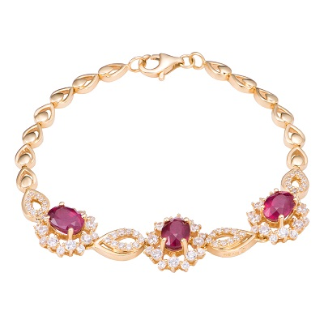

### Women's Charm Bracelet Brand AAA (AAA.3)

##### 41 reviews

**91% of buyers enjoyed this product! (87 votes)**

**Women's Charm Bracelet Brand AAA are made from high quality components, under the talented hands of leading artists for exquisite beauty. The product is the perfect combination in every detail and advanced technology, showing stylish fashion and sophistication for the user.**

##### Brand: AAA

##### Size: Medium

#### Old Price: ~~$2100~~

#### Current Price: $2050