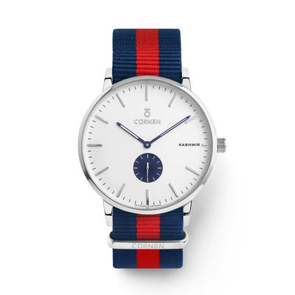

The Cornon W.01 Men's Watch is a perfect combination in every detail and advanced technology, demonstrating stylish fashion and sophistication for the user.

**Analog White Men's Watch Brand CURNON (W.02)**

**60 reviews**

**95% of buyers enjoyed this product! (100 votes)**

**Cornon W.01 men's watches are made from high quality components, under the talented hands of leading artists for exquisite beauty. The product is the perfect combination in every detail and advanced technology, showing stylish fashion and sophistication for the user.**

**Brand: Cornon**

**Size: 40 mm**

**Old Price: ~~$180~~**

**Current price: $160**