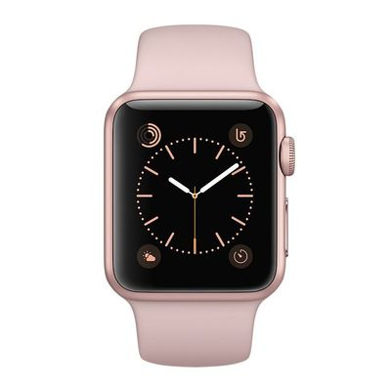

Apple Watch Sport 38mm Series 2 - Gold (A.02) is a perfect combination in every detail and advanced technology, demonstrating stylish fashion and sophistication for the user.

### Apple Watch Sport 38mm Series 2 - Gold (A.02)

##### 45 reviews

**89% of buyers enjoyed this product! (87 votes)**

**APPLE WATCH are made from high quality components, under the talented hands of leading artists for exquisite beauty. The product is the perfect combination in every detail and advanced technology, showing stylish fashion and sophistication for the user.**

##### Brand: APPLE

##### Size: 38 mm

#### Old Price: ~~$350~~

#### Current price: $300