Potato Leaf Disease Classification
HOG + SVM versus a custom CNN, with a data-integrity audit and robustness evaluation
Technical report | Companion to the plant-disease-classification-benchmark repository | October 2026

Abstract
This report compares a traditional computer-vision pipeline (Histogram of Oriented Gradients features with an RBF-kernel Support Vector Machine) and a custom convolutional neural network (CNN) for classifying potato leaves into early blight, late blight and healthy. An audit of the public image archive shows that it contains 2,152 unique images (1,000 / 1,000 / 152), whereas an earlier experiment had reported 4,304 images and a CNN accuracy of 99.38%. Because 4,304 is exactly twice 2,152, the earlier figures are consistent with every image having been used twice, which would place copies of the same image in both the training and test sets. Re-running the HOG + SVM pipeline with identical code and parameters shows the size of this effect: 96.4% accuracy on the duplicated data versus 81.1% on the clean, de-duplicated split. On the clean split the SVM reaches a macro F1 of 0.674 and detects only 5 of 23 healthy leaves (recall 0.217). Robustness tests show that the SVM is insensitive to brightness changes but degrades under blur (accuracy 0.650 at sigma = 2). The CNN has not yet been re-evaluated on the clean split, so the earlier CNN figures are reported only as unverified.

1. Introduction
Plant pathogens cause substantial yield losses in major food crops [1]. Potato is affected by early blight, caused by Alternaria solani, and late blight, caused by Phytophthora infestans. Both diseases produce distinctive visual patterns on leaves, which makes image-based screening a natural application of machine learning.
This work asks four questions:
- How does a custom CNN compare with an HOG + SVM baseline?
- How does performance vary across classes, particularly for the under-represented healthy class?
- How sensitive are the models to changes in lighting, noise and blur?
- How much can duplicated images inflate reported performance?
The main contribution is methodological: the fourth question turned out to determine how the first three can be answered. All numbers in this report are generated by the accompanying code, from fixed seeds and configuration files, so that they can be reproduced.

2. Dataset and Integrity Audit

2.1 Dataset
The data is the potato subset of the PlantVillage collection [4]: JPEG photographs of single leaves taken under controlled laboratory conditions, organised in three class folders. Early blight produces dark lesions with concentric rings; late blight produces irregular, water-soaked dark patches, often with white sporulation at the leaf margin.
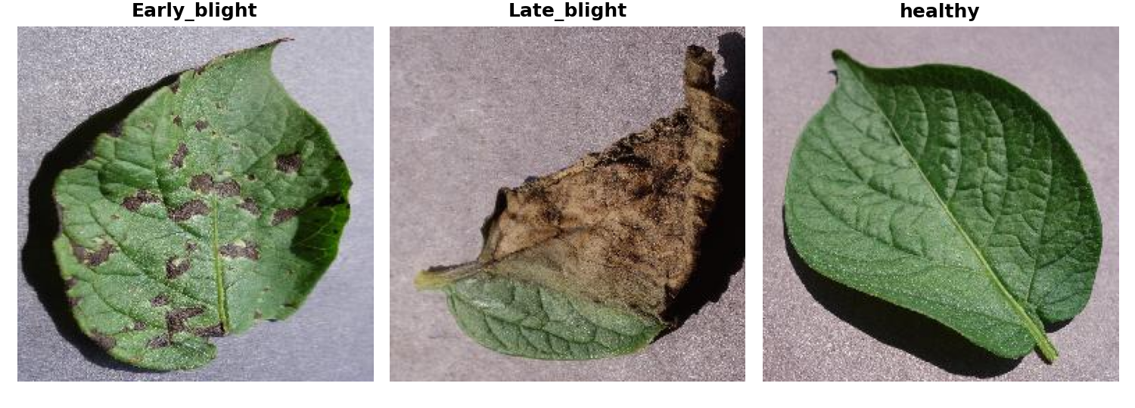
Figure 1. Representative images of early blight, late blight and healthy leaves.

2.2 Audit results
Every file was opened with an image library and fingerprinted with an MD5 hash of its bytes. The archive used in this study contains 2,152 readable images and no byte-identical duplicates, and the three classes are strongly imbalanced: the healthy class is 7.1% of the data.
Table 1. Image counts per class after the integrity audit.
Class | Files | Unique (MD5) | Share
Early blight | 1,000 | 1,000 | 46.5%
Late blight | 1,000 | 1,000 | 46.5%
Healthy | 152 | 152 | 7.1%
Total | 2,152 | 2,152 | 100%

An earlier experiment reported 4,304 images with class counts of 2,000 / 2,000 / 304 (Figure 2). Each of these is exactly twice the audited count. Section 4.3 tests whether duplication explains the discrepancy.
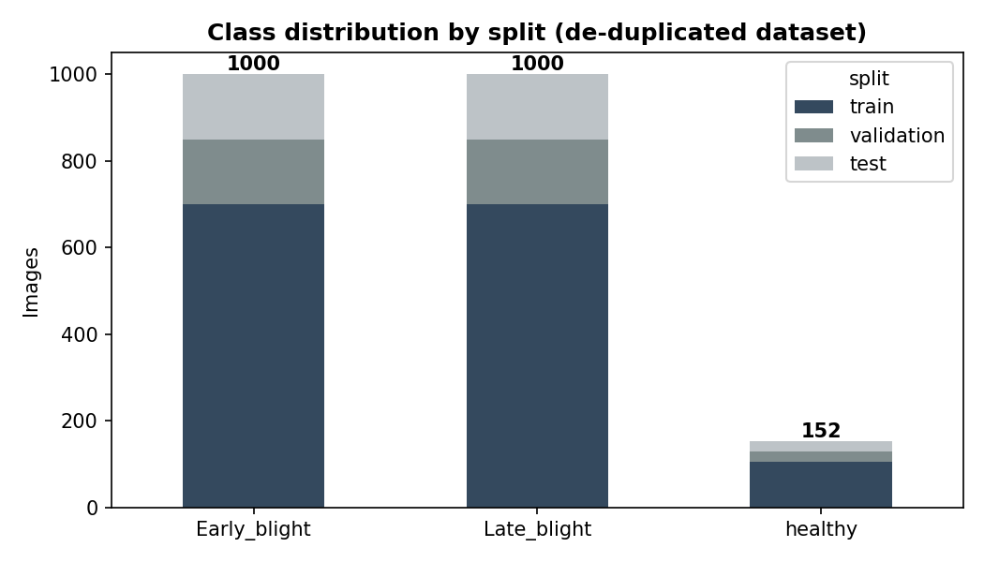
Figure 2. Class distribution of the audited dataset by split (1,506 train / 323 validation / 323 test). The earlier experiment reported 2,000 / 2,000 / 304 images per class.

2.3 Data split
A single stratified 70 / 15 / 15 split with seed 42 is created once, saved to disk, and shared by every model: 1,506 training, 323 validation and 323 test images (test: 150 early blight, 150 late blight, 23 healthy). The pipeline checks that no image fingerprint appears in more than one split. The test set is used only for final evaluation; the validation set is used for early stopping and learning-rate scheduling.

3. Methods

3.1 Preprocessing
Images are resized to 96 x 96 pixels with bilinear interpolation. For HOG, images are converted to grayscale. For the CNN, pixel values are scaled to [0, 1] and the full RGB image is used. During CNN training, an image generator applies random rotations (up to 20 degrees), width and height shifts (10%), horizontal flips and zoom (15%) to diversify the training distribution and encourage spatial invariance [8].

3.2 HOG + SVM
HOG describes local regions by histograms of gradient orientation [3]. Cells of 8 x 8 pixels with 9 orientation bins are grouped into overlapping 2 x 2-cell blocks and normalised with the L2-Hys scheme for robustness to illumination. For a 96 x 96 input this gives 11 x 11 blocks x 4 cells x 9 bins = 4,356 features per image. Features are standardised and classified with an RBF-kernel SVM [6] (C = 10, gamma = "scale", balanced class weights to compensate for the imbalance).
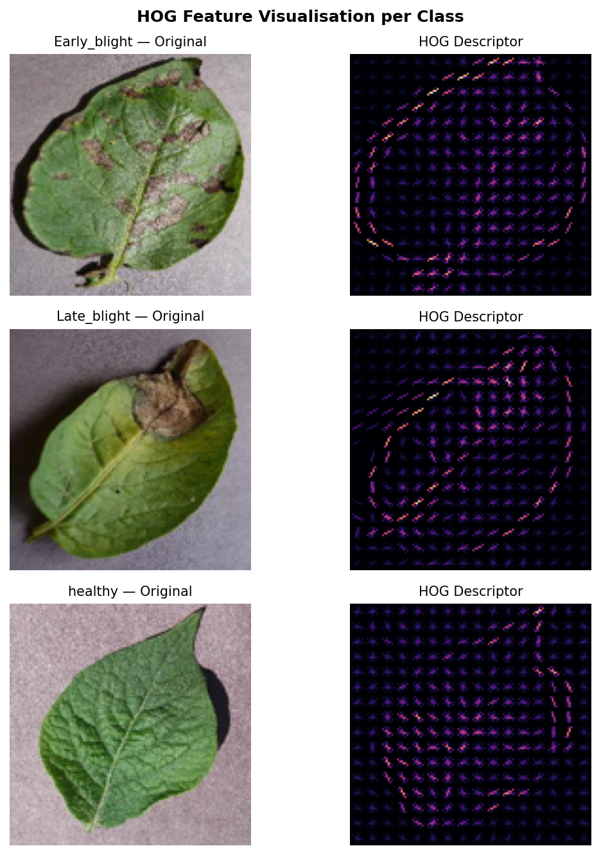
Figure 3. HOG visualisation: original image (left) and gradient-orientation descriptor (right) for each class.

3.3 Custom CNN
The CNN is a compact network trained from scratch; no pretrained weights are used. It has three convolutional blocks with batch normalisation [7], max-pooling and dropout, followed by global average pooling [10] in place of a flatten layer to reduce the parameter count (Table 2). Training uses Adam (learning rate 1e-3), batch size 64, a maximum of 30 epochs, early stopping on validation loss (patience 5, best weights restored) and learning-rate reduction on plateau (factor 0.5, patience 3).
Table 2. CNN architecture (input 96 x 96 x 3).
Block / layer | Filters / units | Output shape
Conv2D + BatchNorm (block 1, x2) | 32 | 96 x 96 x 32
MaxPool + Dropout 0.25 | - | 48 x 48 x 32
Conv2D + BatchNorm (block 2, x2) | 64 | 48 x 48 x 64
MaxPool + Dropout 0.25 | - | 24 x 24 x 64
Conv2D + BatchNorm (block 3) | 96 | 24 x 24 x 96
MaxPool + Dropout 0.30 | - | 12 x 12 x 96
Global average pooling | - | 96
Dense (ReLU) + Dropout 0.40 | 64 | 64
Dense (softmax) | 3 | 3

3.4 Evaluation protocol
Models are compared on accuracy, macro F1, weighted F1 and per-class precision, recall and F1, together with confusion matrices and timing. Because the healthy class is only 7% of the data, macro F1 and healthy-class recall are the primary metrics; accuracy alone can hide a failure on the minority class.
For robustness, the models trained on clean images are evaluated on the same 323 test images after three controlled corruptions: brightness scaling (factors 0.7, 0.85, 1.15, 1.3, with clipping), additive Gaussian noise (standard deviation 0.01, 0.03, 0.05 on a [0, 1] intensity scale) and Gaussian blur (sigma 1 and 2 pixels). Labels are unchanged, since none of these operations alters the disease shown. No corruption is used during training.

4. Results

4.1 Clean baseline: HOG + SVM
Table 3. HOG + SVM on the clean, de-duplicated test set (323 images).
Metric | Early blight | Late blight | Healthy | Overall
Precision | 0.843 | 0.776 | 1.000 | -
Recall | 0.860 | 0.853 | 0.217 | -
F1 | 0.851 | 0.813 | 0.357 | -
Test images | 150 | 150 | 23 | 323
Accuracy / macro F1 / weighted F1 |  |  |  | 0.811 / 0.674 / 0.798

Overall accuracy of 81.1% conceals a marked weakness on the healthy class. Only 5 of 23 healthy leaves are recognised; 16 are labelled late blight and 2 early blight. Precision for the healthy class is 1.000, so the model almost never calls a diseased leaf healthy, but it flags most healthy leaves as diseased. The gap between accuracy (0.811) and macro F1 (0.674) reflects this. Early and late blight are confused with each other in 21 and 22 cases respectively. Training took 14.5 s and inference on the test set 3.5 s (including feature extraction) on a single CPU core.
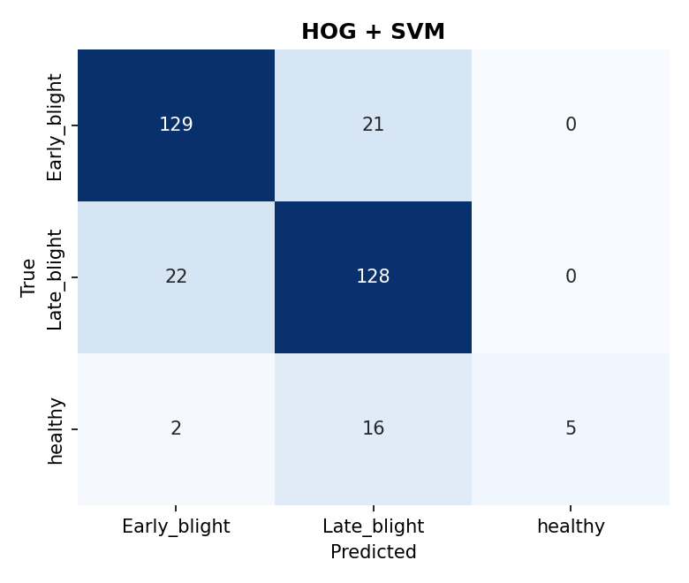
Figure 4. Confusion matrix of HOG + SVM on the clean test set.

4.2 Custom CNN
Status. The CNN has not yet been re-evaluated on the clean split. The training and evaluation pipeline is included in the repository (scripts/run_experiments.py) and will fill the table below with the measured results. The CNN figures from the earlier experiment are listed in Appendix A and should not be cited as clean results.

Table 4. Clean-split comparison (test set, 323 images).
Model | Accuracy | Macro F1 | Weighted F1 | Healthy recall
HOG + SVM | 0.811 | 0.674 | 0.798 | 0.217 (5/23)
Custom CNN | pending | pending | pending | pending

4.3 Effect of duplicated images
To test whether duplication explains the earlier figures, the HOG + SVM pipeline was run twice with identical code, features and parameters: once on the 2,152 unique images, and once on a dataset in which every image appears twice (4,304 images). Both are split at random in the same proportions.
Table 5. HOG + SVM on clean versus duplicated data.
Dataset | Test images | Images in train and test | Accuracy | Macro F1
Clean (2,152 unique) | 323 | 0 | 0.811 | 0.674
Duplicated (4,304 = 2 x 2,152) | 646 | 987 | 0.964 | 0.931

Duplication raises accuracy by 15 percentage points and macro F1 by 0.26. On the duplicated data, 987 test-set images also appear, byte for byte, in the training set. The 96.4% obtained here is close to the 96.28% reported earlier for the same model, and the 646-image test set matches the earlier test-set size. This supports duplication as the explanation, but it remains an inference: the original archive used in the earlier run was not available for inspection.
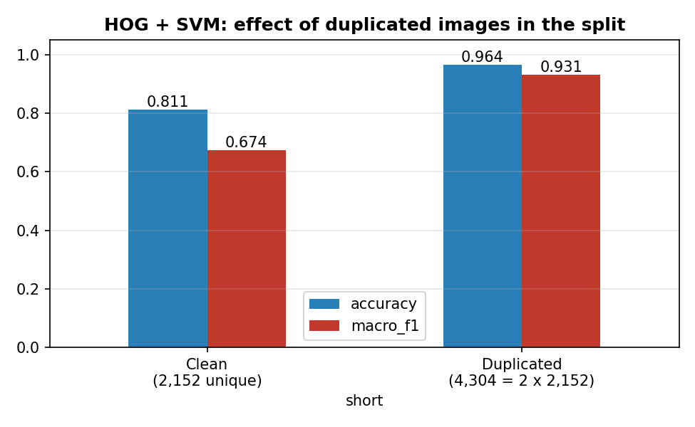
Figure 5. HOG + SVM accuracy and macro F1 on clean versus duplicated data.

4.4 Robustness of HOG + SVM
Table 6. HOG + SVM accuracy (macro F1) under image corruptions; clean baseline 0.811 (0.674).
Corruption | Level 1 | Level 2 | Level 3 | Level 4
Brightness x 0.7 / 0.85 / 1.15 / 1.3 | 0.814 (0.676) | 0.827 (0.666) | 0.814 (0.657) | 0.824 (0.663)
Gaussian noise 0.01 / 0.03 / 0.05 | 0.811 (0.674) | 0.839 (0.742) | 0.762 (0.666) | -
Blur sigma 1 / 2 | 0.774 (0.561) | 0.650 (0.440) | - | -

HOG is insensitive to global brightness changes, as expected from a gradient-based descriptor with block normalisation. Blur is the most damaging corruption: accuracy falls to 0.650 and macro F1 to 0.440 at sigma = 2, because blur removes the fine edge structure on which HOG relies. Strong noise (0.05) also reduces accuracy to 0.762. The small increase at noise level 0.03 should not be read as a benefit: with 323 test images the 95% binomial interval on an accuracy near 0.81 is about +/- 4 percentage points, and only 23 images are healthy.
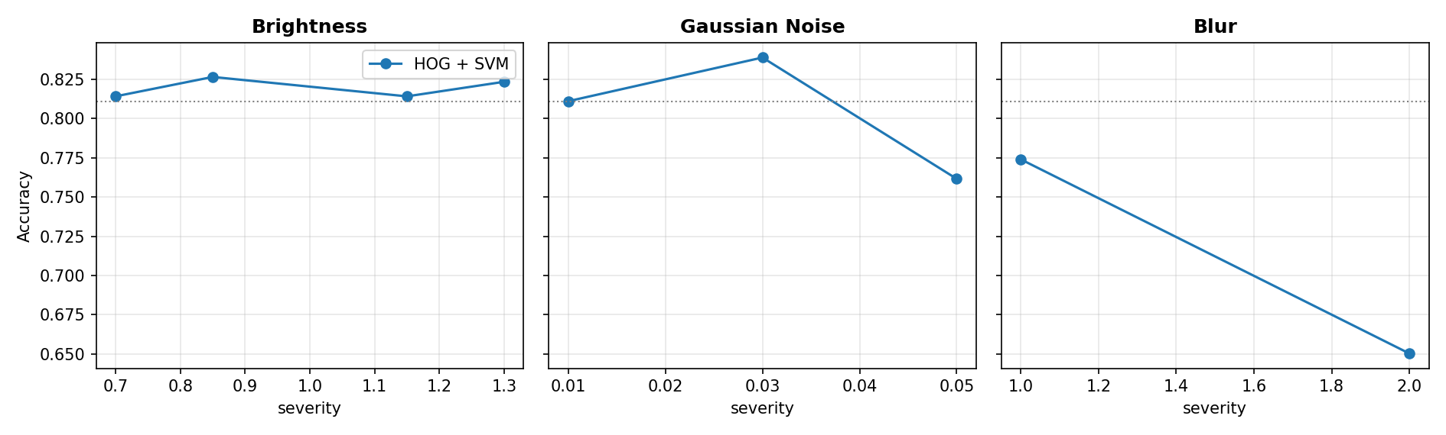
Figure 6. HOG + SVM accuracy as a function of corruption severity. Dotted lines mark the clean accuracy.

5. Discussion
Accuracy is a poor summary for this dataset. With 7% healthy images, a model can reach a respectable accuracy while failing on the minority class. The SVM does exactly this: balanced class weights were not enough to give it a usable healthy-class recall. In an agricultural setting the cost is practical, because healthy plants flagged as diseased trigger unnecessary treatment. Reporting macro F1 and per-class recall exposes the problem immediately.
Evaluation integrity matters more than model choice. The difference between the clean and the duplicated evaluation (0.811 versus 0.964 for the same model) is larger than the differences usually reported between competing architectures. Any model comparison made on a split that shares images between training and test is uninformative, and a flexible model such as a CNN, which can memorise training images, is likely to profit from leakage even more than a linear or kernel method. The CNN comparison should therefore be repeated on the clean split before any conclusion is drawn.
What to expect from the CNN. Learning filters end to end on RGB images, combined with augmentation, may help on the healthy class and under blur, since colour and texture cues are unavailable to the grayscale HOG pipeline. This is a hypothesis to be tested, not a result of this report.

6. Limitations and Future Work
- Exact duplicates only. The audit detects byte-identical files. Near-duplicates (for example several photographs of one leaf, or re-encoded copies) are not detected and could still inflate results; perceptual hashing or grouped splitting would address this.
- Single seed and split. No confidence intervals are available. The healthy test set contains only 23 images, so healthy-class metrics are highly variable. Repeated stratified runs are needed.
- CNN pending. The CNN comparison and the CNN robustness curves require a re-run on the clean split.
- Laboratory images. Field images vary in lighting, angle and background, and performance there is untested.
- Future work. Transfer learning with pretrained backbones such as ResNet [11] or EfficientNet, class-weighted losses and targeted augmentation for the healthy class, robustness-aware training, and field data collection.

7. Conclusions
- The audited dataset contains 2,152 unique images; the 4,304 images reported earlier are twice this number, and the earlier accuracy figures are consistent with train/test leakage caused by duplication.
- On a clean, de-duplicated split, HOG + SVM reaches 81.1% accuracy and a macro F1 of 0.674, with a healthy-class recall of only 0.217.
- The same SVM reaches 96.4% on duplicated data, which quantifies how strongly duplicated images distort evaluation.
- HOG + SVM is robust to brightness changes but sensitive to blur and strong noise.
- The CNN comparison and CNN robustness analysis remain to be completed on the clean split.

8. Reproducibility
All experiments are driven by configuration files (configs/baseline.yaml, configs/robustness.yaml) with a fixed seed of 42. The results above are produced by the following commands, which also write the CSV tables and figures used in this report:
python scripts/inspect_dataset.py
python scripts/leakage_audit.py
python scripts/run_experiments.py --models svm cnn
python scripts/make_figures.py
Unit tests cover dataset discovery, unreadable files, duplicate detection, split disjointness, preprocessing, corruptions and metrics.

Appendix A. Earlier Results and Reconciliation
An earlier experiment reported the results below. They are kept for traceability only. They were obtained on a dataset of 4,304 images that is inconsistent with the audited archive (Section 2), so they must not be compared with the clean-split results in Section 4.
Table A1. Earlier results (4,304 images; split 3,012 / 646 / 646; unverified).
Model | Accuracy | Weighted F1 | Healthy recall | Healthy F1 | Test images (per class)
HOG + SVM | 0.9628 | 0.9610 | 0.674 | 0.805 | 646 (300/300/46)
Custom CNN | 0.9938 | 0.9938 | 0.957 | 0.967 | 646 (300/300/46)

Cross-checking the stored results against the report text and the code revealed the following inconsistencies:
Table A2. Inconsistencies between the earlier run, its description and the audited archive.
Item | Code / description | Stored results | Audited archive
Total images | 4,304 | 4,304 | 2,152
Healthy images | 304 | 304 (test: 46) | 152
Image size | 96 x 96 | 128 x 128 | 96 x 96 (used here)
Maximum epochs | 30 | 50 epochs run | 30 (used here)
Train accuracy at epoch 44 | 99.44% | 98.44% | -

The earlier run therefore appears to have used a different code version and a different (larger) dataset from the ones described. Until the CNN is re-run on the clean split, the earlier CNN figures should be regarded as unverified, and the duplicated-data replication in Section 4.3 suggests they are likely to be inflated.

References
[1] S. Savary et al., "The global burden of pathogens and pests on major food crops," Nature Ecology & Evolution, vol. 3, pp. 430-439, 2019.
[2] H. Nazki, S. Yoon, A. Faisal, and S. Park, "Unsupervised image translation using adversarial networks for improved plant disease recognition," Computers and Electronics in Agriculture, vol. 168, p. 105117, 2020.
[3] N. Dalal and B. Triggs, "Histograms of oriented gradients for human detection," in Proc. IEEE Conf. Computer Vision and Pattern Recognition (CVPR), San Diego, CA, USA, 2005, pp. 886-893.
[4] D. P. Hughes and M. Salathe, "An open access repository of images on plant health to enable the development of mobile disease diagnostics," arXiv:1511.08060, 2015.
[5] C. M. Bishop, Pattern Recognition and Machine Learning. New York, NY, USA: Springer, 2006.
[6] C. Cortes and V. Vapnik, "Support-vector networks," Machine Learning, vol. 20, no. 3, pp. 273-297, 1995.
[7] S. Ioffe and C. Szegedy, "Batch normalization: Accelerating deep network training by reducing internal covariate shift," in Proc. Int. Conf. Machine Learning (ICML), Lille, France, 2015, pp. 448-456.
[8] C. Shorten and T. M. Khoshgoftaar, "A survey on image data augmentation for deep learning," Journal of Big Data, vol. 6, no. 1, p. 60, 2019.
[9] Y. LeCun, Y. Bengio, and G. Hinton, "Deep learning," Nature, vol. 521, no. 7553, pp. 436-444, 2015.
[10] M. Lin, Q. Chen, and S. Yan, "Network in network," in Proc. Int. Conf. Learning Representations (ICLR), Banff, Canada, 2014.
[11] K. He, X. Zhang, S. Ren, and J. Sun, "Deep residual learning for image recognition," in Proc. IEEE Conf. Computer Vision and Pattern Recognition (CVPR), Las Vegas, NV, USA, 2016, pp. 770-778.

