Project Report

Enterprise Web Software Development



|  |  |  |
| --- | --- | --- |
| Group 4 | |  |
| Group Members | Do Hoang Son  Nguyen Ba Thanh  Bossan Ibrahim  Hoang Anh Tuan  Prince Ebuka Ejimonyeibe |  |
| Instructor | Pham Thuy Duong |  |
| Batch |  |  |
| Semester | 7 |  |
| URL of Website |  |  |
|  | User | Password |
|  |  |  |
|  |  |  |
|  |  |  |

Contents

Introduction 3

Built System Description 3

Development Environment 3

Architecture 4

Model – View - Controller (MVC) 5

JSF Architecture 5

Function 5

Screenshot 6

Evaluations 6

Product Evaluation 6

Individual Contribution 8

Group Criteria 9

Methodology 10

Conclusion 11

References 12

Appendices 12

Appendix A: Requirement specification 12

Appendix B: Database Design 13

Appendix C: Interface Design 13

Appendix D: Role Based Security System 34

Appendix E: Validation Implementation 34

Appendix F: Work Flow Implementation 36

Appendix G: Test Plan and Test Log 42

Appendix H: Minutes of Meeting 47

Appendix I: Scrum Documentation 48

# Introduction

The purpose of this report is to make the development of a management system for the Course Monitoring Report (CMR) in a large university. This system will bring the improvement of planning, reporting, and monitoring the course. The report on the course regularly monitor and report progress periodically to the management unit. In this report, we will introduce the development, analysis, testing and evaluation in order to create this system.

# Built System Description

## Development Environment

1. Java Programing Language

2. JSF Architecture

3. Netbeans 7.3.1

4. Microsoft SQL Server 2014

* MySQL Server address: localhost

- Login name: sa

* Login password : 1234

5. Github

6. Bootstrap Framework

## Architecture

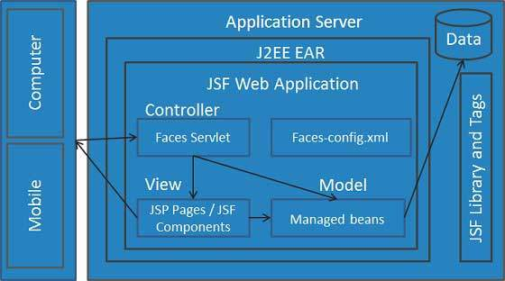

*JSF Architecture (*[*http://www.tutorialspoint.com/jsf/jsf_architecture.htm*](http://www.tutorialspoint.com/jsf/jsf_architecture.htm)*)*

### Model – View - Controller (MVC)

MVC (Model - View - Controller) is a software architecture and design patterns used in software engineering. This device model helps developers separate their software into three different components. Each component has a separate mission and independently of the other component.

Model: Component contains all operation logic, method of handling, database access, data object described as the classes, processing functions, etc.

View: Responsible for displaying information, interact with users.

Controller: navigation task is getting requests from users and call the correct ways to deal with them, etc.

### JSF Architecture

JSF developed based on MVC design pattern. A JSF application runs in a Java servlet container. In CMR system, JSF architecture contains:

Model: Entities

View: JSF pages

Controller: Managed beans

## 

## Function

In this section, follow requirements specification in **Appendix A: Requirement specification**, we will describe more details about the system includes functions, identify users and including annotated screen shots.

Users of the system: Pro-Vice Chancellor (PVC), Director of Learning and Quality (DLT), Course Leader (CL), Course Moderator (CM), Guest and Admin.

|  |  |  |  |  |  |
| --- | --- | --- | --- | --- | --- |
| TEST NO. | TITLE | PRECONDITION | INPUT or STEP | EXPECTED  OUTPUT | POST CONDITION |
| 1 | Login | A valid user credentials must be available. | Fill in username  and password  fields | Logged in successfully | Redirect home page |
| 2 | Fill in wrong username or password | Show validation message | User would not be able to login and would be required to try again. |

# Evaluations

## Product Evaluation

|  |  |  |  |
| --- | --- | --- | --- |
|  | Content Evaluation | The criteria | Rating |
| 1 | Friendliness | Beautiful design | Good |
| Suitable Color | Good |
| Easy to use | Good |
| Clear folder structure | Good |
| Font Unicode | Good |
| Fast show | Good |
| Page Layout | Succinct |
| 2 | Techniques | Stability | Good |
| Quick Access | Good |
| Compatible | + IE  + Firefox  + Chome |
| We standard size | 1024 x 768 |
| Photos major web | JPG |
| Support for Mobile Access | Good |
| Full Functions | Still not |
| Operation Support | No |
| Integrated social network or not | +Facebook  +Google  +Twitter |
| The ability to search keywords and speed of gathering information | Fast |
| 3 | Content | Information updated regularly or not | Sometime |
| Information of are full or not | Full |

## 

## Individual Contribution

A Japanese programming engineer who said, "You can do a better job than me three times, but only if you do it alone. But a group of three people as I can do a better job than you three times! ". Therefore, in life, no one is perfect, and a person cannot do all the work of three people for a while. In the projects, too, the combination of a group will concentrate the strengths of each to complement each other. A development team will make the resolution work faster, more efficiently. During the operation, the team members will contribute or bring or stimulate creative potential. In this project, too, our team has developed this project with SCUM model. Here are the parts I had to contribute and participate in the development process of this project.

Functions:

* Login

Login is the formality to Admin confirm you are member of an university,an organization or a club,etc. Such it is like when the student show them card to get in school. In here, instead of using the card, you will use your username and password. Username will identify who you are, and secret passwords to help you avoid other people in the name of you to do bad things.

+Message

Here is the function exchanges between supervisors and students, with this function the students will have the opportunity to raise questions of themselves in the learning process as well as doing projects. Towards the supervisor, this function helps them checking the learning process and students's homework, answer questions and give answers

Designing

+ Font unicode

+ Support for Mobile Access

+ Page Layout

+Clear folder structure

System Analysising

+ Gatharing requests from text(COMP1640_CW_T2_1415.docx)

+ Analysis and establish the processes will be developed

+ Authentication requirements / features of the system

Testing

+Writing testcase

## Group Criteria

|  |  |  |  |
| --- | --- | --- | --- |
|  | Criteria | Member | Rate |
| 1 | Significance and contribution to the team | Son | Very good |
| Thanh | Very Good |
| Bossan | Very Good |
| Tuan | Very Good |
| Prince | Very Good |
| 2 | Meeting dateline on a Task | Son | Very good |
|  |  | Thanh | Very Good |
| Bossan | Very Good |
| Tuan | Very Good |
| Prince | Very Good |
| 3 | Java programming knowledge | Son | Very good |
| Thanh | Very Good |
| Bossan | Very Good |
| Tuan | Very Good |
| Prince | Very Good |
| 4 | Team work and communication | Son | Very good |
| Thanh | Very Good |
| Bossan | Very Good |
| Tuan | Very Good |
| Prince | Very Good |

## 

## Methodology

In this project,we using Scrum model to developing website.That is a software development process based on the model flexible (agile).Agile Technology provides a lot of methodologies, processes and experiments for the development of software to be quickly and easily.

In this model, the team leader will create the Product Backlog contains the requirements of the project with categories are arranged in order of priority. The members will perform the realization of the requirements from leader with the the repeated sprint stages 1 to 4 weeks of work (called Sprint) with input is the items in the Product Backlog, output is the complete package can be transferred (Potentially shippable Product Increment).

Before the group to speed up in the Sprint, both groups will meeting together to built plan for each Sprint. The results of the planning is the Sprint Backlog contains works to do during a Sprint.

During development, all of team update Sprint Backlog and perform the daily meeting (Daily Scrum) to share the progress of work as well as the difficulties in the process of working together.

At the end of the Sprint, team created of software packages with fully functional, ready to demo for teacher guide.

The meeting at the end of the Sprint will help instructors see the group was able to transfer what, and what to do or nothing to change or improve.

# Conclusion

After a period time learning and researching to build a website, I was:

* Strengthening knowledge and proficiency in Html, Css.
* Having new knowledge about PHP.
* Have more experience when analyzing, designing database. - Improve teamwork, analysis system,skills testing skills.

Limited :

* The way to sorted code,declared,etc. No succint, scientific Website Devemopment Direction:

PHP is really a wonderful tool to develop websites, but with a heavy workload in a limited period of time, there are still many problems that students can not solve perfection. If the subject can be further developed, first of all need to overcome the following:

* Build more search engine for administrators to help them working easier, once the database enlargement
* Design web compatible on mobile devices

# References

http://www.w3schools.com/ http://www.tutorialspoint.com/php/

# Appendices

## Appendix A: Requirement specification

|  |  |  |
| --- | --- | --- |
| NO. | Requirements | Status. |
| 1. | All courses are identified by a Course Code (e.g. C12345) and are assigned to Faculties. | Done |
| 2. | All Faculties have a Pro-Vice Chancellor (PVC) and a Director of Learning and Quality (DLT). | Done |
| 3. | Every course is assigned a Course Leader (CL) and a Course Moderator (CM) for an academic year. | Done |
| 4. | A CL may have one or more courses to report on, and needs to do a CMR each academic year for each course. | Done |
| 5. | The CMR is stored in a database across a number of fields (not as a document). The University of Greenwich example CMR can be used as the template (available from http://www.gre.ac.uk/offices/aqu/qa_handbook), or the product owner can research to find appropriate requirements. | Done |
| 6. | Once a CMR is submitted by the CL, the system emails a copy of the CMR to the CM for approval. | Done |
| 7. | Once approved by the CM, a copy of the CMR is also sent to the PVC and DLT of the Faculty. | Done |
| 8. | The CL and CM can only access their own CMRs until they are approved, and PVCs and DLTs can view all approved CMRs for all Faculties. | Done |
| 9. | An administrator account is to be used to maintain the data of courses, staff and roles. | Done |
| 10. | A guest account for each Faculty can be used to view approved CMRs and to see statistical reports and exception reports. | Done |
| 11. | All CMRs must be commented on by the DLT for the Faculty within 14 days. |  |
| 12. | When the DLT response is submitted a copy of the CMR is sent to the CL and CM of the course, and a copy is also sent to the PVC and DLT of the Faculty. |  |
| 13. | The interface must be suitable for all devices (e.g. mobile phones, tablets, desktops). |  |

## Appendix B: Database Design

## Appendix C: Interface Design

Figure 24 : Login Page On PC

Figure 245 : Login page On Mobile

Figure 26 : Supervisor Dashboard On PC

Figure 27 : Supervisor Dashboard On Mobile

Figure 28 : Supervisor Create New Meeting On PC

Figure 29 : Supervisor Create New Meeting On Mobile

Figure 30 : Supervisor Timeline On Mobile

Figure 31 : Supervisor Have a Meeting on PC

: Supervisor Have Meeting On Mobile

Figure 33 : Supervisor Create New Meeting On PC

: Supervisor Create New Meeting On Mobile

Figure 35 : Supervisor Change Skin On PC

: Supervisor Change Skin On Mobile

Figure 37 : Student Have a Meeting on Mobile

Figure 38: Student have a Meeting on PC

Figure 39 : Supervisor Manages all Student's Project On Mobile

Figure 40 : Student Timeline On PC

Figure 41 : Supervisor Manages Student's Project on Mobile

: Maker locates student for Supervisor On Mobile

Figure 43 : Maker allocate on PC

: Maker Dashboard on Mobile

Figure 45 : Maker dashboard on PC

: List Screenshot Of Supervisor on Mobile

## 

## Appendix D: Role Based Security System

PHP is the programming language used in building this system, the security system that was implemented in this management system is called

“Cryptography”. This has to do with Encryption that is the method of encrypting or hiding secrets and confidential data or information for making sure that they are secured while being transferred over the network.

Password encryption

The password was secured using the MD5 encryption method.MD5 is a tested and trusted encryption method, it converts the passwords into long length of character harsh. There fore the password stored in the database will not be stored as a plain text but stored as a long length character hash there by making it safe.

## Appendix E: Validation Implementation

|  |  |  |
| --- | --- | --- |
| Options | Validated | Comment |
| Login Page | Yes | A valid user must provide his/her username or email address and password to login. |
| Message | Yes | A valid user must provide the required fields and it should not be null |
| Create Meeting | Yes | A valid user must provide the required fields and it should not be null |
| View Meeting | No | Null |

|  |  |  |
| --- | --- | --- |
| Make a comment | Yes | A valid user must provide the required fields and it should not be null |
| View Project | No | Null |
| Search | No | Null |
|  |  |  |

## Appendix F: Work Flow Implementation

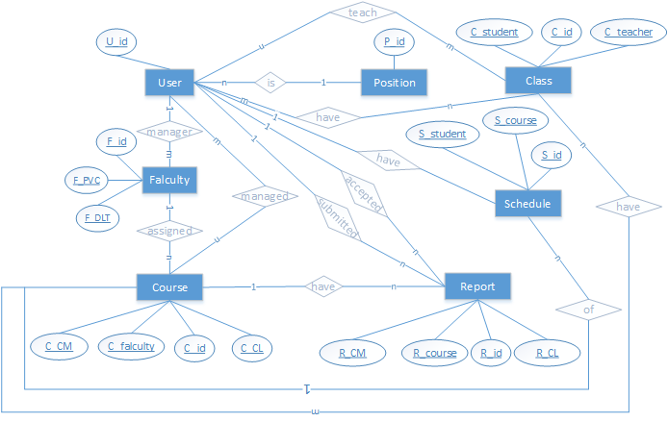

*ERD diagram*

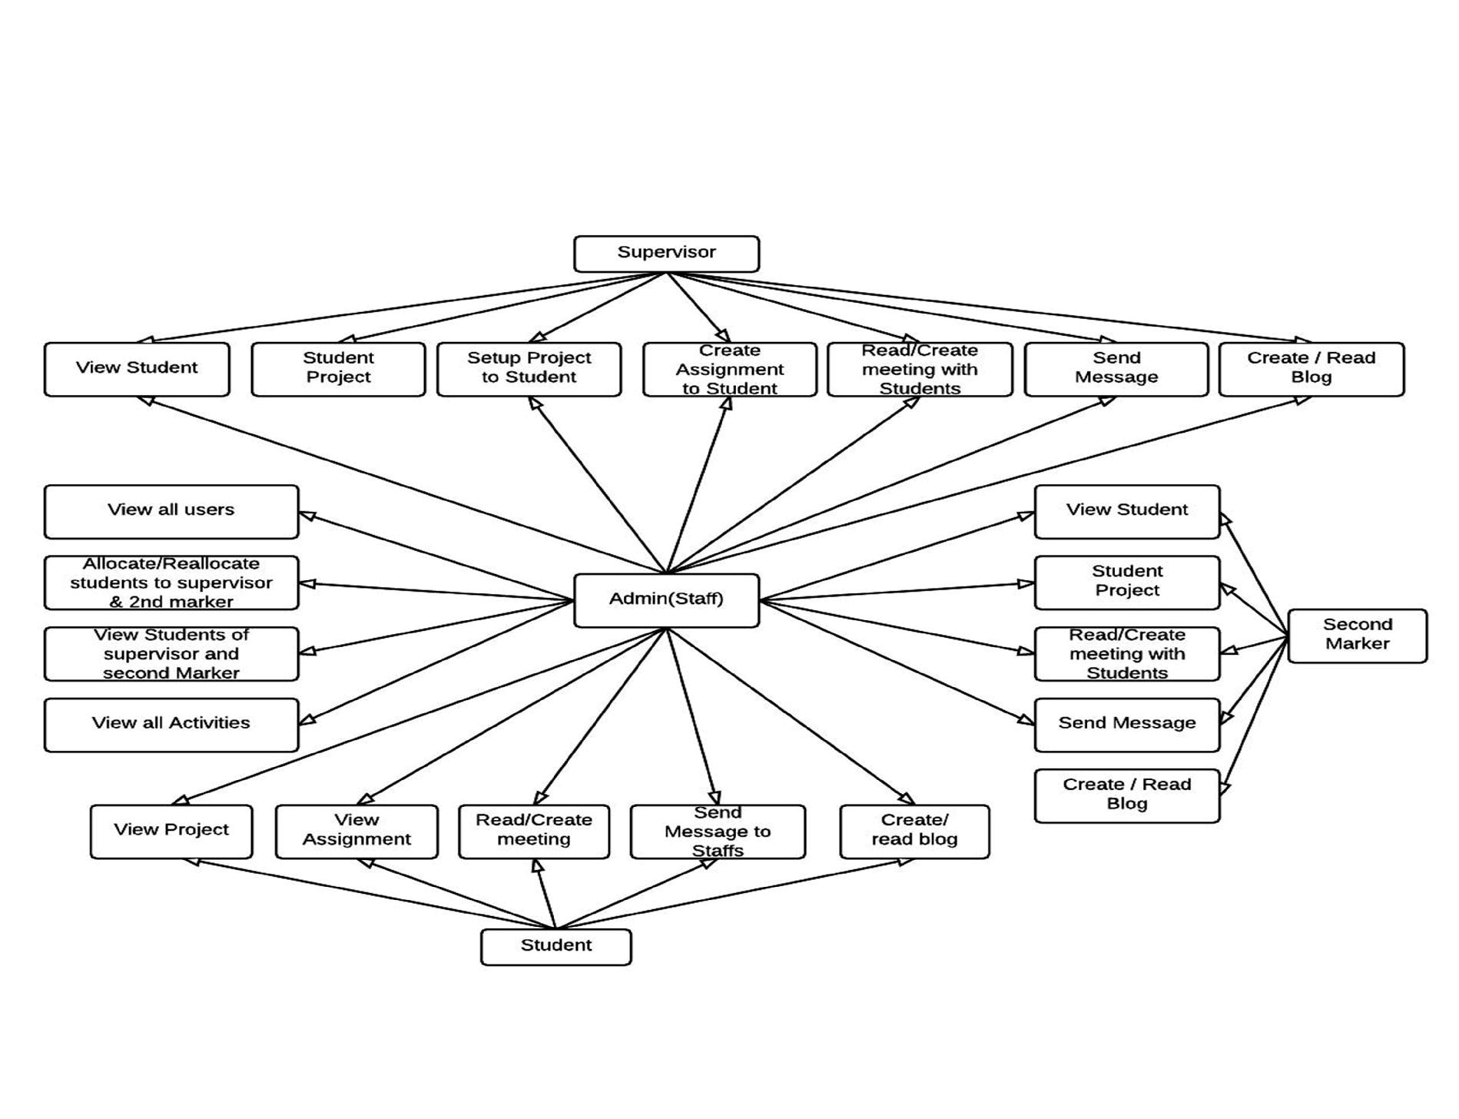

State transition diagram of meeting

Figure 1.2 Test state transition diagram

|  |  |  |  |
| --- | --- | --- | --- |
| Current State | Event | Action | Next State |
| Login page | Enter Authentication | The staff is logged in successfully. | Staff personal information is displayed. |
| Login page | Enter Authentication | Error message displayed | Null |
| Login page | Enter Authentication | Supervisor logged in. | Supervisor personal information is displayed. |
| Login page | Enter Authentication | Error message displayed | Null |
|  |  |  |  |
| Login page | Enter Authentication | Second maker logged in. | Second marker personal information is displayed. |
| Login page | Enter Authentication | Error message displayed | Null |
| Login page | Enter Authentication | Student logged in. | Student personal information is displayed. |
| Login page | Enter Authentication | Error message displayed | Null |
| Send message | Enter message details | Sent message | Delivered |
| Receives Message | Read message | Read Message | Null |
| Reply message | Enter message details | Sent message | Null |
|  |  |  |  |
| Send message | Enter message details | Sent message | Delivered |
| Receives Message | Read message | Read Message | Null |
| Reply message | Enter message details | Sent message | Delivered |
|  |  |  |  |
| Send message | Enter message details | Sent message | Delivered |
| Receives Message | Read message | Read Message | Null |
| Reply message | Enter message details | Sent message | Delivered |
|  |  |  |  |
| All users | Enter message details | Message not sent | Null |
|  |  |  |  |
| Request meeting | Send request | Pending request | Requested |
| null | Accept Request | Pending request | Null |
| null | Time to attend | Pending request | Null |
| null | Recording | Pending request | Null |
| null | cancel | Pending request | Null |
| null | Not recorded | Pending request | Null |
| null | Time not attended | Pending request | Null |
| null | Request rejected | Pending request | Null |
|  |  |  |  |
| Requested | Send request | Pending request | Requested |
| Requested | Accept Request | Pending request | Accepted |
| Requested | Time to attend | Pending request | Null |
| Requested | Recording | Pending request | Recorded |
| Requested | cancel | Pending request | Cancelled |
| Requested | Not recorded | Pending request | Null |
| Requested | Time not attended | Pending request | Null |
| Requested | Request rejected | Pending request | Null |
|  |  |  |  |
| Accepted | Send request | Pending request | Requested |
| Accepted | Accept Request | Pending request | Accepted |
| Accepted | Time to attend | Pending request | Happened |
| Accepted | Recording | Pending request | Recorded |
| Accepted | cancel | Pending request | Cancelled |
| Accepted | Not recorded | Pending request | Null |
| Accepted | Time not attended | Pending request | Null |
| Accepted | Request rejected | Pending request | Null |
|  |  |  |  |
| Happened | Send request | Pending request | Requested |
| Happened | Accept Request | Pending request | Accepted |
| Happened | Time to attend | Pending request | Null |
| Happened | Recording | Pending request | Recorded |
| Happened | cancel | Pending request | Cancelled |
| Happened | Not recorded | Pending request | Null |
| Happened | Time not attended | Pending request | Missed |
| Happened | Request rejected | Pending request | Null |
|  |  |  |  |
| Create assignment | Enter assignment details | Successfully created | Null |
| Create assignment | Enter assignment details | Unsuccessfully created | Null |
|  |  |  |  |
| Create assignment | Enter assignment details | Successfully created | Null |
| Create assignment | Enter assignment details | Unsuccessfully created | Null |
|  |  |  |  |
| Student view assignment | Select assignment and view | View Assignment | Null |
| Comment on assignment | Add comment | Adding comment | Added successfully |
| Comment on assignment | Add comment | Adding comment | Added Unsuccessful |
|  |  |  |  |
| Supervisor view assignment | Select assignment and view | View Assignment | Null |
| Comment on assignment | Add comment | Adding comment | Added successfully |
| Comment on assignment | Add comment | Adding comment | Added Unsuccessful |
|  |  |  |  |
| Second marker view assignment | Select assignment and view | View Assignment | Null |
| Comment on assignment | Add comment | Adding comment | Added successfully |
| Comment on assignment | Add comment | Adding comment | Added Unsuccessful |
|  |  |  |  |
| Current Project | Add project details | Adding | Viewed successfully |
| Project marks | Add project details | Adding | Viewed successfully |
|  |  |  |  |
| Search | Enter Keyword |  | Displayed |
| Check project | Select student | Selecting | Project displayed |
| Check project | Select student | Selecting | Project not displayed |
|  |  |  |  |
| Search | Enter Keyword |  | Displayed |
| Check project | Select student | Selecting | Project displayed |
| Check project | Select student | Selecting | Project not displayed |
|  |  |  |  |
| Create Project | Select student | Selecting | Project created |
| Create Project | Select student | Selecting | Project created |
| Create Project | Select student | Selecting | Project not created |
|  |  |  |  |
| Assigning | Select staff | selecting | Assigned successfully |
| Assigning | Select staff | selecting | Assigned successfully |
| Assigning | Select staff | selecting | Assigned  Unsuccessful |
|  |  |  |  |
| Create blog | Blog details | Adding details | Added successfully |
| Create blog | Blog details | Adding details | Added  Unsuccessfully |
|  |  |  |  |
| View Blog | Select blog | selecting | Displayed |
|  |  |  |  |

## Appendix G: Test Plan and Test Log

Test Plan

|  |  |  |  |  |
| --- | --- | --- | --- | --- |
| Test | What is being tested | How | Test Data used | Expected Result |
| 1 | Working validation in all forms. | Input correct and incorrect values in all the required fields that should be accepted or rejected | System Data set 1 | Accept correct data and reject incorrect data. |
| 2 | All modules have been properly integrated and functional | Selecting or clicking on a button on any of the module | System Data set 2 | Successfully Return the selected result or unsuccessfully result. |
| 3 | All the design standards have been followed and implemented. | Type, View and selection of data on the interface | System Data set 3 | Successfully displays the output clearly to the user. |
| 4 | Navigation working as | Clicking on any | System Data set | Redirect the |
|  | expected | kind of menu or on a link in the site page. | 4 | user to the clicked module. |
| 5 | Is exception handling used everywhere? | Searching or Viewing nonexistence data that has been deleted in the database. | System Data set 5 | Catch an exception and Display an error message to the user. |

Test Log

|  |  |  |  |  |  |  |  |
| --- | --- | --- | --- | --- | --- | --- | --- |
| Tes  t | What is being tested | How | Test Data used | Expected Result | Date | Actual  Result | Action Taken |
| 1 | Working  validation in all forms. | Input correct and incorrect values in all the required  fields that should be accepted or rejected | Syste m Data set 1 | Accept correct data and reject incorrect data. | 6  Marc  h | Login not working for every user. | Recode and retest  the  system  . |
| 2 | All modules have been properly integrated and functional | Selecting or clicking on a button on  any of the module | Syste m Data set 2 | Successfully Return the selected result or unsuccessfull y result. | 8  Marc  h | Viewing meeting and assignment not displaying the informatio n | Recode and retest  the  system  . |
| 3 | All the design standards have been followed and implemented | Type, View and selection of data on the interface | Syste m Data set 3 | Successfully displays the output clearly to the user. | 8  Marc  h | OK | None |
|  | . |  |  |  |  |  |  |
| 4 | Navigation working as expected | Clicking on any kind of  menu or on a link in the site page. | Syste m Data set 4 | Redirect the user to the clicked module. | 6  Marc  h | Ok | None |
| 5 | Is exception handling used everywhere? | Searching or Viewing nonexistenc e data that has been deleted in the database. | Syste m Data set 5 | Catch an exception and Display an error message to the user. | 9  Marc  h | Displaying  an error in when  retrieving data from the database | Recode and retest the system |
| 6 | Retest; Working  validation in all forms. | Input correct and incorrect values in all the required  fields that should be accepted or rejected | Syste m Data set 1 | Accept correct data and reject incorrect data. | 11 Marc  h | OK. Login working for every user. | None |
| 7 | Retest; All modules have been properly integrated and functional | Selecting or clicking on a button on  any of the module | Syste m Data set 2 | Successfully Return the selected result or unsuccessfull y result. | 11 Marc  h | OK. Viewing meeting and assignment displaying the informatio n | None |
| 8 | Retest; Working  validation in all forms. | Input correct and incorrect values in all the required  fields that should be | Syste m Data set 1 | Accept correct data and reject incorrect data. | 15 Marc  h | Text Fields and text area not validating | Recode and Retest the  system  . |
|  |  | accepted or rejected |  |  |  |  |  |
| 9 | Retest; All modules have been properly integrated and functional | Selecting or clicking on a button on  any of the module | Syste m Data set 2 | Successfully Return the selected result or unsuccessfull y result. | 15 Marc  h | Unable to add a comment on meeting and  assignment  . | Recode and Retest the  system  . |
| 10 | Retest; Working  validation in all forms. | Input correct and incorrect values in all the required  fields that should be accepted or rejected | Syste m Data set 1 | Accept correct data and reject incorrect data. | 17 Marc  h | OK. Text Fields and text area are validating | None |
| 11 | Retest; All modules have been properly integrated and functional | Selecting or clicking on a button on  any of the module | Syste m Data set 2 | Successfully Return the selected result or unsuccessfull y result. | 17 Marc  h | OK. Able to add a comment on meeting and  assignment  . | None |
| 12 | Retest; Working  validation in all forms. | Input correct and incorrect values in all the required  fields that should be accepted or rejected | Syste m Data set 1 | Accept correct data and reject incorrect data. | 25 Marc  h | Date picker not validating | Recode and Retest the system |
| 13 | Retest; All modules have been properly integrated and | Selecting or clicking on a button on any of the module | Syste m Data set 2 | Successfully Return the selected result or unsuccessfull | 25 Marc  h | Unable to  download a  file | Recode and Retest the system |
|  | functional |  |  | y result. |  |  |  |
| 14 | Retest; Working  validation in all forms. | Input correct and incorrect values in all the required  fields that should be accepted or rejected | Syste m Data set 1 | Accept correct data and reject incorrect data. | 30 Marc  h | OK. Date picker validating | None |
| 15 | Retest; All modules have been properly integrated and functional | Selecting or clicking on a button on  any of the module | Syste m Data set 2 | Successfully Return the selected result or unsuccessfull y result. | 30 Marc  h | OK. Able to download a  file | None |
| 16 | Retest; Working  validation in all forms. | Input correct and incorrect values in all the required  fields that should be accepted or rejected | Syste m Data set 1 | Accept correct data and reject incorrect data. | 30 Marc  h | Notificatio n not validating | Recode and Retest the  system  . |
| 17 | Retest; All modules have been properly integrated and functional | Selecting or clicking on a button on any of the module | Syste m Data set 2 | Successfully Return the selected result or unsuccessfull y result. | 30 Marc  h | Creating and replying message, Posting blog not functioning | Recode and Retest the  system  . |
| 18 | Retest; All modules have been properly integrated and | Selecting or clicking on a button on  any of the module | Syste m Data set 2 | Successfully Return the selected result or unsuccessfull y result. | 1  April | OK. Creating and replying message, Posting blog | None. |
|  | functional |  |  |  |  | functioning |  |
| 19 | Retest; All modules have been properly integrated and functional | Selecting or clicking on a button on any of the module | Syste m Data set 2 | Successfully Return the selected result or unsuccessfull y result. | 1  April | Setting project not functioning | Recode and Retest the  system  . |
| 19 | Retest; All modules have been properly integrated and functional | Selecting or clicking on a button on any of the module | Syste m Data set 2 | Successfully Return the selected result or unsuccessfull y result. | 1  April | OK. Setting project not functioning | None |

Test Case

Enterprise Web Software Development_Report_COM1640.zip\Test Case.xls

## Appendix H: Minutes of Meeting

Enterprise Web Software

Development_Report_COM1640.zip\Communitymeetingminutes.pdf

## Appendix I: Scrum Documentation

Sprint Backlog

Enterprise Web Software Development_Report_COM1640.zip\ Sprint-Backlog.xls

Produc Backlog

Enterprise Web Software Development_Report_COM1640.zip\ ProductBacklog.xls