Part 1:

Question 1:

Do you consider writing unit tests as equally important as writing production code?

Select one:

No, production code is more important. Unit tests are only needed if the production code if of poor quality

No, production code is more important. Unit tests should only be created if time allows for that.

Yes because the only way to easily maintain correctly working production code is by having a lot of unit tests for it.

Yes and production code must be 100% covered with unit tests.

Question 2:

Which of the following statements best describes the difference between  *java.util.Date*and *java.sql.Date*?

Select one:

There is no difference; they both hold the same information.

java.sql.Date represents the date without time information.

java.sql.Date does not exist.

java.sql.Date holds information in nanoseconds.

java.sql.Date holds the database’s time zone information.

Question 3:

Different ways of asynchronous communication between web browsers and web servers include:

Select one:

a. JNI

b. JSP

c. Websockets

d. Servlet 2.1

e. NIO

Question 4:

Which of the following are marker interfaces in Java?

Select one or more:

Cloneable

Externalizable

Serializable

Comparable

Question 5:

John is writing a new class. That class has 5 methods but one of those methods (method A) has some fundamental logic that John doesn't want to be overriden by any subclass. What should John do ?

Select one:

a. define the class as final

b. defined method A as final

c. there is nothing that he can do about

d. defined method A as static

Question 6:

We've decided to override equals() method. And hashCode() made a constant value e.g. (return 1;) What will be in this case?

Select one:

Compilation error

Run-time exception

No impact

HashMap with such keys will handle only one element

  
  
Time to get element from HashMap will be longer

Question 7:

In Maven , what is the typical configuration file called?

Select one:

pom.xml

build.xml

settings.xml

config.xml

Question 8:

Which of the following options best describes the output of the code shown below?

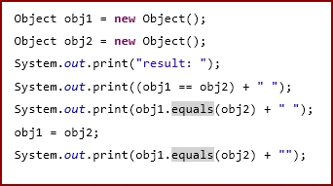

Select one:

result: false false true

result: true false true

result: true false false

result: false false false

None of the above; an error occurs.

Question 9:

Which of the numbered code snippets below is a valid way to handle more than one type of exception without duplicating the code?

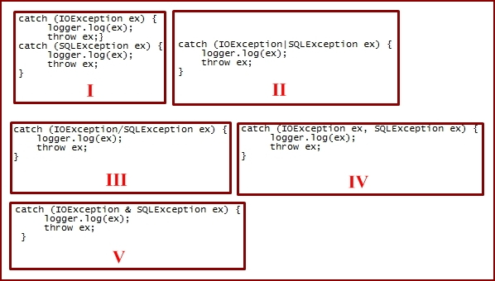

Select one:

I

II

III

IV

V

Question 10:

Which is the true assertion about nested classes:

Select one:

Nested classes can only be declared as private.

Nested classes are not allowed in the Java language.

NNested classes can not be static.

Nested classes declared as static do not have access to the other members of the enclosing class.

Question 11:

Which of these statements concerning the use of standard collection interfaces are true?

Select one:

None of the standard collection classes are thread safe.

class HashSet implements SortedSet.

Collection classes implementing List cannot have duplicate elements.

ArrayList can only accommodate a fixed number of elements.

Some operations may throw an UnsupportedOperationException.

Question 12:

Considering the following code snippet, please select the best phrase that explains what this code supposed to do.

Select one:

Get an employee with a certain code and print the result.

Get all employees and print the result.

Call a stored procedure to get an employee with certain code and print the result.

None of the above.

Question 13:

Which pattern do you see in the code below:

java.util.Calendar.getInstance();

Select one:

Singleton Pattern

Factory Pattern

Facad Pattern

Adaptor Pattern

Question 14:

Which of the below statements are true about ArrayList and Vector in Java ?

Select one:

Vector can be resized while ArrayList cannot be

Vector is synchronized while ArrayList is not

ArrayLists can grow but cannot shrink in size, while Vector can both grow and shrink

Vectors allow duplicate values while ArrayList doesnot

Question 15:

What will happen if you try to compile and run this program?

Select one:

Compiler error

Compiles and runs printing out 2

Compiles and runs printing out 1

An ArrayIndexOutOfBounds Exception at runtime

Question 16:

You have a very large XML file containing the personal data of a group of people. You want to count the persons that are 18-years old. What kind of XML parser should you use in order to achieve this in an efficient manner?

Select one:

a. a DOM parser

b. a SAX parser

c. a tree-based parser

d. a graph-based parser

Question 17:

Which of the following information is used for static binding ?

Select one:

a. Object Type

b. Class Type

c. Class Type and Object Type Both

d. None of the Above

Question 18:

Adam wrote a new service. His service runs on a single processor server and uses a small data set (less than 100Mb). Which garbage collector type, in principle, is indicated for his case:

Select one:

Serial collector.

Parallel collector.

Mostly concurrent  collector.

None of the above.

Question 19:

You have the following code in a file called "Gcd.java":

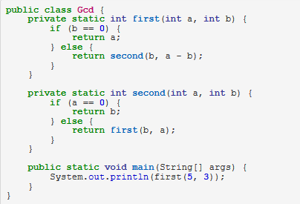

What will happen if you try to compile and run this?

Select one:

The code fails to compile.

"1" will be printed to standard output.

"-1" will be printed to standard output.

A StackOverflowError will be thrown.

Question 20:

Suppose there is a class named MyUser.@PersistenceUnit is already injected, which produces an EntityManagerFactory emf. Which of the following statements, when inserted into the method body, will retrieve the values from the database using Java Persistence API 2, and retrieve the 0th element from the list?

Select one:

MyUser user = (MyUser)emf.createEntityManager().createQuery("SELECT u FROM MyUser u").getResultList();

MyUser user = (MyUser)emf.createEntityManager().createQuery("SELECT u FROM MyUser u").setResultList(0);

MyUser user = (MyUser)emf.EntityManagerFactory().createQuery("SELECT u FROM MyUser u").get(0).getResultList();

MyUser user = (MyUser)emf.createEntityManager().createQuery("SELECT u FROM MyUser user").getResultList().get();

MyUser user = (MyUser)emf.createEntityManager().createQuery("SELECT u FROM MyUser u").getResultList().get(0);

Question 21:

what property do you need to set to make your entity in hibernate immutable?

Select one:

a. mutable="false".

b. immutable = “true”.

c. @Immutable annotation.

d. b & c.

e. a or c

f. None of the above.

Question 22:

Which of the following information is used for dynamic binding ?

Select one:

a. Object Type

b. Class Type

c. Class Type and Object Type Both

d. None of the Above

Question 23:

Given the following code what is the effect of a = 5:

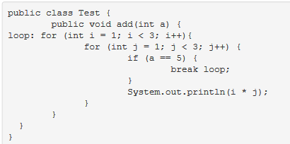

Select one:

Generate a runtime error

Throw an ArrayIndexOutOfBoundsException

Print the values: 1, 2, 2, 4

Produces no output

Question 24:

A situation where a bunch of threads cannot gain regular access to shared resources is described as:

Select one:

Race conditions

Livelock

Deadlock

Starvation

Question 25:

Which of the following statements are correct?

Select one or more:

A List stores elements in a Sorted Order.

A Set keeps the elements sorted and a List keeps the elements in the order they were added.

A SortedSet keeps the elements in the order they were added.

An OrderedSet keeps the elements sorted.

An OrderedList keeps the elements ordered.

A NavigableSet keeps the elements sorted.

Question 26:

Which of the following prefixes can be added to a number in order to indicate a binary literal?

Select one or more:

0b

0B

oA

0S

0s

Question 27:

We've deployed new release on the production. And it became very slow. What are your suggestion how to analyze and find bottleneck?

Select one or more:

Check the logs

Run with profiler

Turn on monitoring tools

Enable debug logging

Add more instances to the cluster

Call SaasOps

Check the difference in source code from previous version

Pray your favorite God.

Question 28:

You see a colleague write the following code, stating that since JDK1.6+ replaces string concatenation with StringBuilder, he does not need to use the append method. What are your thoughts?

String s = "";

**for** (**int** i = **0**; i < **100**; i++) {

s += String.valueOf(i);

}

Select one:

He is correct, append should be reserved for situations where the builder object is long lived.

He is forgetting that the java compiler can only replace + with append for string literals

He is forgetting that the java compiler will not optimize the use of + across loop iterations.

He is correct, the JIT compiler will optimze this code to be identica to StringBuilder and his code is more readable

Question 29:

Which of the following phrases best describes what would happen if you attempted to compile and run code that calls the method in the snippet below on Java 7?

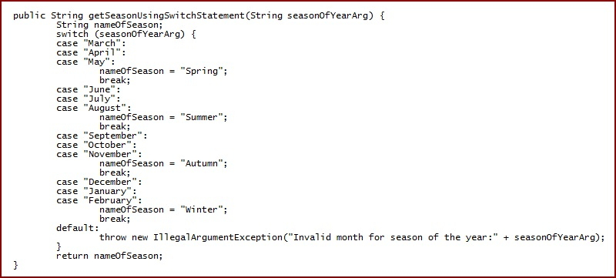

Select one:

compilation error, because the switch statement does not call the getSeasonUsingSwitchStatement()method

compilation error, because a String object is used in the expression of the switch statement

compilation error, because IllegalArgumentException is used instead of java.lang.Exception

compilation error because the variable nameOfSeason may not have been initialized

none of the above, the code will compile correctly

Question 30:

Which of the following libraries allow you to mock the private methods ?

Select one:

mockito

powermock

Mocking private methods is not allowed.

Question 31.

Which of the following allows you to mock private methods ?

Select one:

Mocking of private methods is not allowed as only public methods should be tested.

Mockito

PowerMock

Mockito.spy

Question 32:

You have changes in your working directory that you are not ready to commit, and you need to temporarily switch to another branch. Which Git command could you use to store you changes (without committing them) and come back to them later.

Select one:

a. git stash / git stash apply

b. git cherry-pick

c. git reset HEAD --hard

d. There is no such command. You must manually save your changes somewhere on the filesystem.

Question 33:

Sam found some discrepancies in has team's codebase. His manager wants him to use Git to analyse who committed the problem code. Which of the below commands could Sam use to make his task easier?

Select one:

a. git-bisect

b. git-blame

c. git-apply

d. git-verify-pack

Question 34:

John clones an open source project in Github. He wants to contribute to the project with some minor changes. Arrange the tasks below in the correct order to allow John to have his changes accepted on the open source project:

1. Open a Pull Request
2. Make commit with his changes
3. Push branch to Github Project
4. Create a branch from master
5. Project owner merges Pull Request

Select one:

a. 14325

b. 32145

c. 42135

d. 42315

Question 35:

To create a Git repository, which command do you run?

Select one:

a. git create <project-name>

b. git new

c. git new <project-name>

d. git init

Question 36:

How do you stage files for a commit?

Select one:

a. git stage

b. git commit

c. git add

d. git reset

Question 37:

Consider the 2 queries below

Query 1

**SELECT** e_name  
**FROM** EMP  
**WHERE** (sal, age ) =   
      (**SELECT** **MAX** (sal), **MAX** (age)  
       **FROM** EMP_details)  
**AND** dept = 'Maths';

Query 2

**SELECT** e_name  
**FROM** EMP  
**WHERE** sal = (**SELECT** **MAX**(sal) **FROM** EMP_details)  
**AND** age = (**SELECT** **MAX**(age) **FROM** EMP_details)  
**AND** dept = 'Maths';

Which of the below statements are true?

Select one or more:

a. Both queries are different and print different output.

b. Query 1 is correct in syntax and Query 2 will throw an error.

c. Query 1 and Query 2 will print the same output.

d. Considering query performance, Query 1 is faster than Query 2

e. Considering query performance, Query 2 is faster than Query 1

Question 38:

Which of the below statements is incorrect about SQL query optimization?

Select one:

It is always recommended to split the databases onto multiple physical disks.

It is always recommended to split the contents of a table on multiple physical disks.

It is always recommended to keep the contents of a table on single physical disk.

Most of the system tables in a database avoid foreign key constraints for better performance optimization.

Both a and b are incorrect.

Question 39:

Which of the following is **true**concerning triggers?

Select one:

a. You cannot create them with SQL

b. They execute against only some applications that access a database

c. They have an event, condition, and action

d. They cannot cascade (cause another trigger to fire)

Question 40:

Which of the following queries are not correct SQL statements?

Select one or more:

a. Select product_id, product_price, product_name LIKE ‘a%’ from products;

b. Select emp_id,sal,emp_name from employee where sal >= 2000;

c. Select emp_id, sum(bonus) from employee having sum(bonus) > 2000;

d. All are correct

Question 41:

Consider the this materialized view using DBMS_MVIEW.PMARKER function

**CREATE** MATERIALIZED **VIEW** sales_Product_mv  
BUILD **DEFERRED**  
REFRESH FAST **ON** DEMAND  
ENABLE QUERY REWRITE **AS**  
**SELECT** DBMS_MVIEW.PMARKER(p.rowid),t.calendar_yr,p.product_cat,**COUNT**(*),  
      **SUM**(s.unit_price), **SUM**(s.units_sold),  
      **COUNT**(s.unit_price), **COUNT**(s.units_sold)  
**FROM**   FCTsales s, Dimtime t, Dimproduct p  
**WHERE**  s.product_id = p.product_id **AND** s.time_id = t.time_id  
**GROUP** **BY**  DBMS_MVIEW.PMARKER (p.rowid), p.product_cat, t.calendar_yr;

Which statement below is not correct?

Select one:

a. This materialized view contains DBMS_MVIEW.PMARKER function on Dimproduct in Select statement.

b. Partition Change Tracking is enabled on DimProduct table only.

c. Use of DBMS_MVIEW.PMARKER function allows the cardinality of this materialized view to be increased only by number of partitions in DimProduct table.

d. As presence of Calender_Yr join dependant expression in Select, PCT is enabled on FCTSales table.

Question 42:

Consider the Materialized view below with parallel attribute in master table:

**ALTER** **TABLE** FCT_SALES PARALLEL (DEGREE 2);  
  
**CREATE** MATERIALIZED **VIEW** MV_FCT_SALES    
**AS**  
**SELECT** ID, DATE, **SUM**(QTY_SOLD) **FROM** FCT_SALES **GROUP** **BY** ID, DATE;  
**EXECUTE** DBMS_MVIEW.REFRESH(LIST=>'MV_FCT_SALES',PARALLELISM=>2);  
**EXECUTE** DBMS_MVIEW.REFRESH(LIST=>'MV_FCT_SALES');

Which of the below statement is/are true for using PARALLEL in materialized views and master table?

Select one:

a. In the case above, the refresh process in materialized view is not parallelized; only creation is parallelized.

b. Refresh of materialized view will be serialized.

c. It will parallelize create and refresh and doesn't depend on PARALLELISM attribute in REFRESH clause.

d. Both A and B are correct.

e. A, B and C are correct.

Question 43:

Which of the below techniques can be used for optimization in SQL?

Select one or more:

a. Add indexes on columns used in WHERE clause

b. Minimize number of full table scans in query

c. Design tables in a way to maximize space on the disk for faster retrieval

d. Use smallest data types possible

e. Do not Declare columns to be NOT NULL

Question 44:

Which query would you use to find the number of students attending classes starting on or after April 2, 2012?

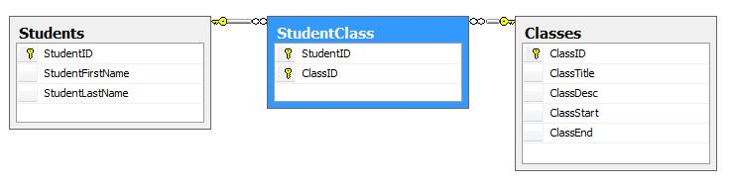

Select one:

a. SELECT COUNT(DISTINCT StudentID) AS "NumberOfStudents" FROM StudentClass sc INNER JOIN Classes c on sc.ClassID = c.ClassID INNER JOIN Students s on sc.StudentID = s.StudentID WHERE c.ClassStart >= '2012-4-1'

b. SELECT COUNT(DISTINCT sc.StudentID) AS "NumberOfStudents" FROM StudentClass sc INNER JOIN Classes c on sc.ClassID = c.ClassID INNER JOIN Students s on sc.StudentID = s.StudentID WHERE c.ClassStart >= '2012-4-1'

c. SELECT COUNT(DISTINCT StudentID) AS "NumberOfStudents" FROM StudentClass sc INNER JOIN Classes c on sc.ClassID = c.ClassID INNER JOIN Students s on sc.StudentID = s.StudentID WHERE c.ClassStart > '2012-4-1'

d. SELECT DISTINCT COUNT(sc.StudentID) AS "NumberOfStudents" FROM StudentClass sc INNER JOIN Classes c on sc.ClassID = c.ClassID INNER JOIN Students s on sc.StudentID = s.StudentID WHERE c.ClassStart > '2012-4-1'

Question 45:

Which of the following is/are true about REST? (Select all that apply)

Select one or more:

a. REST is a protocol

b. REST allows the use of different data formats (e.g. JSON, XML)

c. REST supports WS-Security

d. REST has better performance and scalability over SOAP

Question 46:

**Which of the following is/are true about client-side caching in regards to RESTful web services?**

Select one or more:

a. Client-side caching refers to storing responses from a server in the client itself so that a client does not need to make a server request for the same resource(s) repeatedly.

b. The server response should include information about whether caching should be performed.

c. Only the client should determine if a specific resource should be cacheable or not (Most commonly done by HTTP method).

d. The server response should include data on how long the client should cache each resource.

e. Only clients should determine how long of a cache is appropriate for a given resource based on client needs.

Question 47:

Which of the following HTTP methods are considered 'safe' AND 'idempotent'?

Select one or more:

a. GET

b. HEAD

c. POST

d. PUT

Question 48:

How to make sure that a docker container is restarted automatically when it exits due to the application code running inside it.

Select one:

a. It is not possible

b. Add a script to the container which automatically restarts container

c. Add restart policy to dockerfile

d. Set restart policy when running the container

Question 49:

How Docker helps DevOps?

Select one or more:

a. Both infrastructure and the application can be included in the container image

b. Simplify non-functional requirements like security and performance, so DevOps can keep focused in more important tasks

c. Eliminates the need of tools for continuous integration/deployment (like Jenkins)

d. Allows the deploy on a wide variety of platforms securely

Question 50:

**Coding Challenge**

The next question(s) in this step are algorithm coding tasks. Please note that the “check” button is disabled in our system and will NOT provide you feedback on syntax errors or computational results. You are required to make sure the code compiles and works as required in the question and can do so using your own IDE or text editor.

Conan Edogawa got tired of solving cases, and invited his friend, Professor Agasa, over. They decided to play a game of cards. Conan has n cards, and the ithcard has a number ai written on it. They take turns playing, starting with Conan. In each turn, the player chooses a card and removes it. Also, he removes all cards having a number strictly lesser than the number on the chosen card. Formally, if the player chooses the ith card, he removes that card and removes the jth card for all j such that aj < ai.

A player loses if he cannot make a move on his turn, that is, he loses if there are no cards left. Predict the outcome of the game, assuming both players play optimally.

## Input Format:

The first line contains an integer n — the number of cards Conan has.

The next line contains n integers a1, a2, ..., an, where ai is the number on the ith card.

## Constraints:

* (1 ≤ n ≤ 105)
* (1 ≤ ai ≤ 105)

## Output Format:

If Conan wins, print "Conan" (without quotes), otherwise print "Agasa" (without quotes).

## Sample Input (0):

3

4 5 7

## Sample Output (0):

Conan

## Sample Input (1):

2

1 1

## Sample Output (1):

Agasa

## Note

In the first example, Conan can just choose the card having number 7 on it and hence remove all the cards. After that, there are no cards left on Agasa's turn.

In the second example, no matter which card Conan chooses, there will be only one card left, which Agasa can choose. After that, there are no cards left when it becomes Conan's turn again.

**For example:**

| **Input** | **Result** |
| --- | --- |
| 3  4 5 7 | Conan |
| 2  1 1 | Agasa |

Answer:(penalty regime: 0 %)

import java.io.*;

import java.util.*;

import java.text.*;

import java.math.*;

import java.util.regex.*;

public class Tester {

/**

* Complete the function below.

* DONOT MODIFY anything outside this function!

*/

static String conanOrAgasa(int[] cards) {

return null;

}

/**

* DO NOT MODIFY THIS METHOD!

*/

public static void main(String[] args) throws IOException {

Scanner in = new Scanner(System.in);

int n = in.nextInt();

int[] cards = new int[n];

for (int i = 0; i < n; i++) {

cards[i] = in.nextInt();

}

// call conanOrAgasa function and print output

System.out.println(conanOrAgasa(cards));

}

}

Part 2:

Next Questions will be for one project called “Cross-Ride”. Please start reading and answering

questions in same order, because they will increase your knowledge about Cross-Ride

incrementally.

First question is a hands-on coding exercise. Remaining questions are free response and

asking how you would approach the problem and what solutions you'd consider without any

implementation. All Questions are mandatory.

Make sure to answer all 5 questions before submission. [Go to first question](https://app.crossover.com/x/)

Question 1:

We have prepared a project assessment. Please download the project from [this link](http://techtrial.s3.amazonaws.com/TrialAttachments/cross-ride-java.zip).  Review the Readme file with instructions on how to proceed. You can use an IDE of your choice.

Once completed please extract a git patch file<steps are in readme file>, Store your file in a shared location where Crossover team can access and download it for evaluation. and add your sharable link in the answer field of this question.

Please extract the patch file using provided commands not using IDE.

Question 2:

Product Owner asked you to implement a new feature to send SMS notification on every completed ride request. SMS notification is a rest based service and is only available in staging server. You are provided with detailed API specifications for SMS notification service.

How will you start development and test your code without access to actual rest API?

 NO IMPLEMENTATION REQUIRED IN THIS QUESTION.

Question 3:

After launching, the users of Cross-Ride application grows and database size grows exponentially. As a consequence, this API of top ride sharing users /api/top-rides becomes very slow. Keeping in mind the current structure of database tables, propose three different possible solutions/improvements to increase the response time of this API?

NO IMPLEMENTATION REQUIRED IN THIS QUESTION.

Question 4:

Describe one hard technical problem you faced in your last major project.

Please describe:

* What was the problem and the impact of it?
* What were the solutions considered and final choice?
* What was the outcome?
* What did you learn from solving this problem and what would you re-use in your future projects?

Question 5: CCAT Test.