Question 1:

Do you consider writing unit tests as equally important as writing production code?

Select one:

No, production code is more important. Unit tests are only needed if the production code if of poor quality

No, production code is more important. Unit tests should only be created if time allows for that.

Yes because the only way to easily maintain correctly working production code is by having a lot of unit tests for it.

Yes and production code must be 100% covered with unit tests.

Question 2:

Which of the following statements about the code shown below is true?

https://es.eskill.com/imgsbj/1384851773450~!~mr2_java12_2013.jpg

Select one:

"ints" is a reserved word.

List belongs to java.lang package.

List cannot instantiated.

System.out.println() cannot take List as a parameter.

The left-hand List needs to be parameterized because the right-hand is a parameterized List.

Question 3:

Which of the following integers is the output of the code shown below?

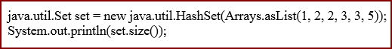

Select one:

1

2

3

4

5

Question 4:

Which of the numbered code snippets below is a valid way to handle more than one type of exception without duplicating the code?

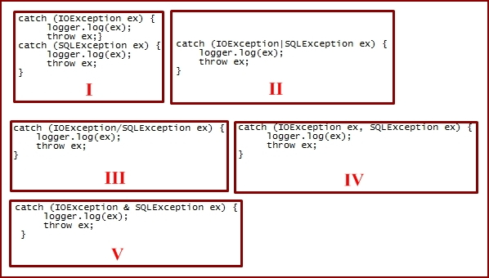

Select one:

I

II

III

IV

V

Question 5:

What can you do to define and start a thread?

Select one:

Extend from class Thread, override method run() and call method start().

Extend from class Runnable, override method run() and call method start().

Extend from class Thread, override method start() and call method run().

Extend from class Thread, override method start() and call method start().

Implement interface Runnable and call start().

Question 6:

Different ways of asynchronous communication between web browsers and web servers include:

Select one:

a. JNI

b. JSP

c. Websockets

d. Servlet 2.1

e. NIO

Question 7:

Which of the following statements best describes the output of the code shown below?

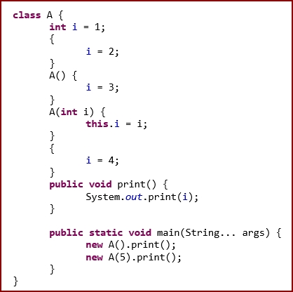

Select one:

It throws an exception at runtime.

34

35

45

Compiler Error

Question 8:

Which are legal Java statements from the following?

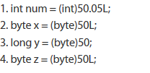

Select one:

1 and 2

2 and 3

2, 3 and 4

All statements are correct.

Question 9:

Which of the following collections maintains the natural order of its elements?

Select one:

HashMap

TreeSet

HashSet

LinkedMap

Question 10:

Which is the true assertion about nested classes:

Select one:

Nested classes can only be declared as private.

Nested classes are not allowed in the Java language.

NNested classes can not be static.

Nested classes declared as static do not have access to the other members of the enclosing class.

Question 11:

Which of the following is an example of an inline Javadoc tag?

Select one:

<@code>

/*@code*/

{@code}

@code

/@code/

Question 12:

Java Generics are useful to :

Select one:

a. Ensure compile-time type safety

b. Ensure compile and runtime type safety

c. Have nothing to do with type safety

d. Are useful only for Java collections

Question 13:

In Maven , what is the typical configuration file called?

Select one:

pom.xml

build.xml

settings.xml

config.xml

Question 14:

Which of the following are marker interfaces in Java?

Select one or more:

Cloneable

Externalizable

Serializable

Comparable

Question 15:

Which of the following items is the correct lambda expression for testing string nullability?

Select one:

(value) -> value != null;

(value) => value != null;

[String value] -> value != null;

(auto value) -> value != null;

Question 16:

Five threads are accessing a shared resource.

The common variable being accessed by all Threads is 'x' and the common code being executed by them is:

**for** ( **int** i = **0**; i < **10000000**; i++ )

{

x = x + **1**;

}

Assuming that the original (initial) value of 'x' was zero, after each of the threads have finished running this loop, the value of 'x' is:

Select one:

50000000

10000000

A specific value F, less than 50000000; which remains fixed across multiple runs.

A specific value F, greater than 50000000; which remains fixed across multiple runs.

The value may differ/vary each time, across runs.

Question 17:

Suppose there is a class named MyUser.@PersistenceUnit is already injected, which produces an EntityManagerFactory emf. Which of the following statements, when inserted into the method body, will retrieve the values from the database using Java Persistence API 2, and retrieve the 0th element from the list?

Select one:

MyUser user = (MyUser)emf.createEntityManager().createQuery("SELECT u FROM MyUser u").getResultList();

MyUser user = (MyUser)emf.createEntityManager().createQuery("SELECT u FROM MyUser u").setResultList(0);

MyUser user = (MyUser)emf.EntityManagerFactory().createQuery("SELECT u FROM MyUser u").get(0).getResultList();

MyUser user = (MyUser)emf.createEntityManager().createQuery("SELECT u FROM MyUser user").getResultList().get();

MyUser user = (MyUser)emf.createEntityManager().createQuery("SELECT u FROM MyUser u").getResultList().get(0);

Question 18:

Which of the following statements about the code shown below is true?

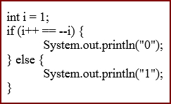

Select one:

It prints "0".

It prints "1".

It throws an ArithmeticException at runtime.

It throws a ClassCastException at runtime.

It throws an IllegalArgumentException at runtime.

Question 19:

Consider the following code:

class TaskBase {  
        int getStatusCode(Object obj) throws NullPointerException {  
                if (obj != null ) {  
                    return 1;  
                } else {  
                    return 0;  
                }  
        }  
}

class ParallelTask extends TaskBase {

        //override getStatusCode method.

}

 Which of the following statements are valid?

Select one or more:

Overriding method can take String as a parameter.

Overriding method can return a long instead of int.

Overriding method can throw any Runtime exception.

Overriding method cannot throw any checked exception.

Overriding method may declare the return type as byte.

Question 20:

Which of the following statements are correct?

Select one or more:

A List stores elements in a Sorted Order.

A Set keeps the elements sorted and a List keeps the elements in the order they were added.

A SortedSet keeps the elements in the order they were added.

An OrderedSet keeps the elements sorted.

An OrderedList keeps the elements ordered.

A NavigableSet keeps the elements sorted.

Question 21:

Which of the following information is used for dynamic binding ?

Select one:

a. Object Type

b. Class Type

c. Class Type and Object Type Both

d. None of the Above

Question 22:

Which of the following items is true for functional interfaces:

Select one:

Must have exactly one abstract method

Can have multiple abstract methods

Must provide a default method

Must have exactly one concrete method

Question 23:

If you need to find one item in a large unsorted collection but only once. What is faster way?

Select one:

Sort the collection using quick sort and get the element by binary search

Iterate through all entries and compare each item

Question 24:

Which of the following interfaces is helpful in message-passing applications, in which producers sometimes use the transfer(E) method and wait to receive elements by users who invoke the take or the poll command?

Select one:

Collection

BlockingQueue

TransferQueue

Queue

Iterable

Question 25:

Given the following code what is the effect of a = 5:

Select one:

Generate a runtime error

Throw an ArrayIndexOutOfBoundsException

Print the values: 1, 2, 2, 4

Produces no output

Question 26:

When using Java reflection, which of the following is most appropriate way to get public constructor of a class which takes a String as a parameter ?

Select one:

a. Constructor constructor = classObject.getConstructor(new Class(String.class));

b. Constructor constructor = classObject.getConstructor(new Class[]{String.class});

c. Constructor constructor = classObject.getConstructor(String.class);

d. Constructor constructor = classObject.getConstructor(new []{String.class});

Question 27:

This class allows users to write a series of messages.

Each message is identified with a timestamp and the name of the thread that wrote the message:

How can we ensure that instances of this class can be safely used by multiple threads?

Select one:

This class is already thread-safe

Replacing StringBuilder with StringBuffer will make this class thread-safe

Synchronize the log() method only

Synchronize the getContents() method only

Synchronize both log() and getContents()

This class cannot be made thread-safe

Question 28:

In Java 8, lambda expressions can also be represented as:

Select one:

functional interfaces

method references

default methods

None of the above

Question 29:

You have the following code in a file called "Gcd.java":

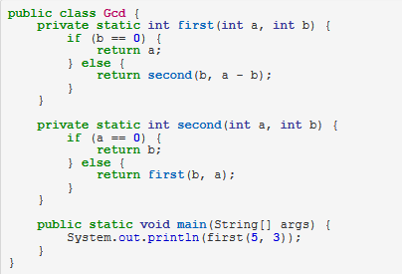

What will happen if you try to compile and run this?

Select one:

The code fails to compile.

"1" will be printed to standard output.

"-1" will be printed to standard output.

A StackOverflowError will be thrown.

Question 30:

Which of the following libraries allow you to mock the private methods ?

Select one:

mockito

powermock

Mocking private methods is not allowed.

Question 31:

Which of the following allows you to mock private methods ?

Select one:

Mocking of private methods is not allowed as only public methods should be tested.

Mockito

PowerMock

Mockito.spy

Question 32:

Sam found some discrepancies in has team's codebase. His manager wants him to use Git to analyse who committed the problem code. Which of the below commands could Sam use to make his task easier?

Select one:

a. git-bisect

b. git-blame

c. git-apply

d. git-verify-pack

Question 33:

How to merge branch A into branch B?

Select one:

a. git checkout A  
git merge B

b. git checkout B  
git merge A

c. git checkout B  
git stash A

d. git checkout B  
git apply A

Question 34:

How to create a new local branch in git?

Select one:

a. git new branchName

b. git branch -local branchName

c. git branch -n branchName

d. git checkout -b branchName

Question 35:

To create a Git repository, which command do you run?

Select one:

a. git create <project-name>

b. git new

c. git new <project-name>

d. git init

Question 36:

How to unstage newly staged files?

Select one:

a. git unstage

b. git reset

c. git rm

d. git fetch

Question 37:

The SQL WHERE clause:

Select one:

a. limits the row data returned.

b. limits the column data returned.

c. Both A & B

d. Neither A or B

Question 38:

What will be the output for these SQL statements?

**CREATE** **view** Customer1 **AS**  
**SELECT** Cust_Id, Cust_Name, Phone, Gender  
**FROM** Cust  
**WHERE** Gender=M **with** **read**-**only**;  
  
**UPDATE** Customer1  
**set** Phone=8882224444  
**WHERE** Cust_Name=John;

Select one:

a. This will update Phone number of Customer John.

b. This will print all the Male customers and update Phone number of Customer John.

c. This will print Cust_Id, Cust_Name, Phone, Gender of all male customers from table Cust and update Phone number of customer John.

d. Syntax Error

Question 39:

Which query would you use to find the number of students attending classes starting on or after April 2, 2012?

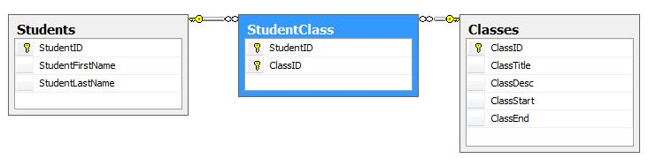

Select one:

a. SELECT COUNT(DISTINCT StudentID) AS "NumberOfStudents" FROM StudentClass sc INNER JOIN Classes c on sc.ClassID = c.ClassID INNER JOIN Students s on sc.StudentID = s.StudentID WHERE c.ClassStart >= '2012-4-1'

b. SELECT COUNT(DISTINCT sc.StudentID) AS "NumberOfStudents" FROM StudentClass sc INNER JOIN Classes c on sc.ClassID = c.ClassID INNER JOIN Students s on sc.StudentID = s.StudentID WHERE c.ClassStart >= '2012-4-1'

c. SELECT COUNT(DISTINCT StudentID) AS "NumberOfStudents" FROM StudentClass sc INNER JOIN Classes c on sc.ClassID = c.ClassID INNER JOIN Students s on sc.StudentID = s.StudentID WHERE c.ClassStart > '2012-4-1'

d. SELECT DISTINCT COUNT(sc.StudentID) AS "NumberOfStudents" FROM StudentClass sc INNER JOIN Classes c on sc.ClassID = c.ClassID INNER JOIN Students s on sc.StudentID = s.StudentID WHERE c.ClassStart > '2012-4-1'

Question 40:

Which of the following statements would be the most efficient way to select all customers without an address from the following tables?

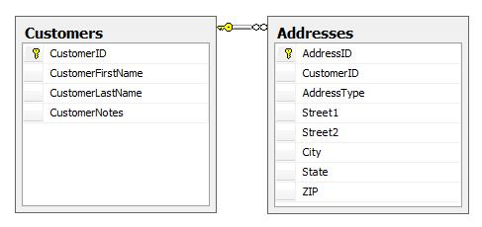

Select one:

SELECT * FROM customers c INNER JOIN addresses a ON c.CustomerID=a.CustomerID WHERE a.CustomerID IS NULL

SELECT * FROM customers c CROSS JOIN addresses a WHERE a.CustomerID IS NULL

SELECT * FROM customers c LEFT OUTER JOIN addresses a ON c.CustomerID=a.CustomerID WHERE a.CustomerID IS NULL

SELECT * FROM customers c RIGHT OUTER JOIN addresses a ON c.CustomerID=a.CustomerID WHERE a.CustomerID IS NULL

Question 41:

The SQL statement

SELECT SUBSTR( ‘l23456789', INSTR( ‘abcabcabc', ‘b’ ), 4)  FROM DUAL ;

prints

Select one:

a. 6789

b. 2345

c. 1234

d. 456789

Question 42:

Consider the 2 queries below

Query 1

**SELECT** e_name  
**FROM** EMP  
**WHERE** (sal, age ) =   
      (**SELECT** **MAX** (sal), **MAX** (age)  
       **FROM** EMP_details)  
**AND** dept = 'Maths';

Query 2

**SELECT** e_name  
**FROM** EMP  
**WHERE** sal = (**SELECT** **MAX**(sal) **FROM** EMP_details)  
**AND** age = (**SELECT** **MAX**(age) **FROM** EMP_details)  
**AND** dept = 'Maths';

Which of the below statements are true?

Select one or more:

a. Both queries are different and print different output.

b. Query 1 is correct in syntax and Query 2 will throw an error.

c. Query 1 and Query 2 will print the same output.

d. Considering query performance, Query 1 is faster than Query 2

e. Considering query performance, Query 2 is faster than Query 1

Question 43:

What is wrong with this SQL statement?

SELECT ID,

      YEAR(BillDate) AS BillYear

FROM Invoices

WHERE BillYear >= 2010;

Select one:

a. You cannot define a field alias like this

b. Comparison operator cannot be used in WHERE clause

c. Expression in where clause is incorrect

d. There is no error in this SQL statement

Question 44:

Which of the following two conditions should be met to be able to use 'Union' in a SQL query?

Select one:

a. a) The two results sets be logically connected data b) The two sets of data should have Foreign Key defined between them

b. a) The two results need not necessarily be logically connected data b) The two sets of data should have Foreign Key defined between them

c. a) The two results should have the same number of columns in the result set b) The two sets of data should have Foreign Key defined between them

d. a) The two results should have the same number of columns in the result set b) The data types of all the columns in both the result set should be the same

Question 45:

Which of the following is true about Restful web services?

Select one:

a. RESTful web services provide access to resources

b. Each resource is identifiable by an Id / URI

c. RESTful web services can represent resources in various formats (e.g JSON, XML)

d. All of the above

Question 46:

**Which of the following is/are true about client-side caching in regards to RESTful web services?**

Select one or more:

a. Client-side caching refers to storing responses from a server in the client itself so that a client does not need to make a server request for the same resource(s) repeatedly.

b. The server response should include information about whether caching should be performed.

c. Only the client should determine if a specific resource should be cacheable or not (Most commonly done by HTTP method).

d. The server response should include data on how long the client should cache each resource.

e. Only clients should determine how long of a cache is appropriate for a given resource based on client needs.

Question 47:

Let's consider that we have a REST web service for handling interview questions deployed at *http://interview-questions.com*. What HTTP method should this web service support in order to allow clients to create new questions at a particular location (e.g. at *http://interview-questions.com/question/1*)?

Select one:

a. PUT

b. POST

c. GET

d. PATCH

Question 48:

How to make sure that a docker container is restarted automatically when it exits due to the application code running inside it.

Select one:

a. It is not possible

b. Add a script to the container which automatically restarts container

c. Add restart policy to dockerfile

d. Set restart policy when running the container

Question 49:

It’s possible to execute commands inside a running docker container without access the container’s console?

Select one:

a. No, there’s no way to do that

b. Yes, using the command: “docker run -it <command>”

c. Yes, using the command: “docker exec <container_name> <command>“

d. Yes, using the command: “docker attach <container_name> <command>”

Question 50:

**Coding Challenge**

The next question(s) in this step are algorithm coding tasks. Please note that the “check” button is disabled in our system and will NOT provide you feedback on syntax errors or computational results. You are required to make sure the code compiles and works as required in the question and can do so using your own IDE or text editor.

Conan Edogawa got tired of solving cases, and invited his friend, Professor Agasa, over. They decided to play a game of cards. Conan has n cards, and the ith card has a number ai written on it. They take turns playing, starting with Conan. In each turn, the player chooses a card and removes it. Also, he removes all cards having a number strictly lesser than the number on the chosen card. Formally, if the player chooses the ith card, he removes that card and removes the jth card for all j such that aj < ai.

A player loses if he cannot make a move on his turn, that is, he loses if there are no cards left. Predict the outcome of the game, assuming both players play optimally.

## Input Format:

The first line contains an integer n — the number of cards Conan has.

The next line contains n integers a1, a2, ..., an, where ai is the number on the ith card.

## Constraints:

* (1 ≤ n ≤ 105)
* (1 ≤ ai ≤ 105)

## Output Format:

If Conan wins, print "Conan" (without quotes), otherwise print "Agasa" (without quotes).

## Sample Input (0):

3

4 5 7

## Sample Output (0):

Conan

## Sample Input (1):

2

1 1

## Sample Output (1):

Agasa

## Note

In the first example, Conan can just choose the card having number 7 on it and hence remove all the cards. After that, there are no cards left on Agasa's turn.

In the second example, no matter which card Conan chooses, there will be only one card left, which Agasa can choose. After that, there are no cards left when it becomes Conan's turn again.

For example:

| **Input** | **Result** |
| --- | --- |
| 3  4 5 7 | Conan |
| 2  1 1 | Agasa |

Answer:(penalty regime: 0 %)

import java.io.*;

import java.util.*;

import java.text.*;

import java.math.*;

import java.util.regex.*;

public class Tester {

/**

* Complete the function below.

* DONOT MODIFY anything outside this function!

*/

static String conanOrAgasa(int[] cards) {

return null;

}

/**

* DO NOT MODIFY THIS METHOD!

*/

public static void main(String[] args) throws IOException {

Scanner in = new Scanner(System.in);

int n = in.nextInt();

int[] cards = new int[n];

for (int i = 0; i < n; i++) {

cards[i] = in.nextInt();

}

// call conanOrAgasa function and print output

System.out.println(conanOrAgasa(cards));

}

}

Part 2:

Next Questions will be for one project called “Cross-Ride”. Please start reading and answering

questions in same order, because they will increase your knowledge about Cross-Ride

incrementally.

First question is a hands-on coding exercise. Remaining questions are free response and

asking how you would approach the problem and what solutions you'd consider without any

implementation. All Questions are mandatory.

Make sure to answer all 5 questions before submission. [Go to first question](https://app.crossover.com/x/)

Question 1:

We have prepared a project assessment. Please download the project from [this link](http://techtrial.s3.amazonaws.com/TrialAttachments/cross-ride-java.zip).  Review the Readme file with instructions on how to proceed. You can use an IDE of your choice.

Once completed please extract a git patch file<steps are in readme file>, Store your file in a shared location where Crossover team can access and download it for evaluation. and add your sharable link in the answer field of this question.

Please extract the patch file using provided commands not using IDE.

Question 2:

Product Owner asked you to implement a new feature to send SMS notification on every completed ride request. SMS notification is a rest based service and is only available in staging server. You are provided with detailed API specifications for SMS notification service.

How will you start development and test your code without access to actual rest API?

 NO IMPLEMENTATION REQUIRED IN THIS QUESTION.

Question 3:

After launching, the users of Cross-Ride application grows and database size grows exponentially. As a consequence, this API of top ride sharing users /api/top-rides becomes very slow. Keeping in mind the current structure of database tables, propose three different possible solutions/improvements to increase the response time of this API?

NO IMPLEMENTATION REQUIRED IN THIS QUESTION.

Question 4:

Describe one hard technical problem you faced in your last major project.

Please describe:

* What was the problem and the impact of it?
* What were the solutions considered and final choice?
* What was the outcome?
* What did you learn from solving this problem and what would you re-use in your future projects

Question 5:

CCAT Test