

[De on tap PE NWC203c so 2 - Đề ôn PE SU21](https://www.studocu.com/vn/document/fpt-university/networking/de-on-tap-pe-nwc203c-so-2-de-on-pe-su21/16849789?utm_campaign=shared-document&utm_source=studocu-document&utm_medium=social_sharing&utm_content=de-on-tap-pe-nwc203c-so-2-de-on-pe-su21)

[Networking (FPT University)](https://www.studocu.com/vn/course/fpt-university/networking/3477603?utm_campaign=shared-document&utm_source=studocu-document&utm_medium=social_sharing&utm_content=de-on-tap-pe-nwc203c-so-2-de-on-pe-su21)

StuDocu is not sponsored or endorsed by any college or university

**ĐỀ ÔN TÂP PE NWC203c số 2 – Summer 2021**

1. Let g1(x) = x + 1 and let g2(x) = x3+ x +2 1. Consider the information bits (1,1,0,1,1,1).
   1. Find the codeword corresponding to these information bits if g1(x) is used as the generating polynomial.

Ans:

1 1 0 1 1 0 0

1 1

0 0

0 0

0 1

0 0

1 1

1 1

0 0

0 0

0 0

0 0

0

r(x)= 0

q(x)=1 0 0 1 0 0

codeword=1 1 0 1 1 0 0

* 1. Find the codeword corresponding to these information bits if g2(x) is used

Ans:

1 1 0 1 1 0 0 0 0

1 1 0 1

0 0 0 1

0 0 0 0

0 0 1 0

0 0 0 0

0 1 0 0

0 0 0 0

1 0 0 0

1 1 0 1

1 0 1 0

1 1 0 1

1 1 1

r(x)= 1 1 1

q(x)=1 0 0 0 1 1

codeword=1 1 0 1 1 0 1 1 1

1. Consider the 7-bit generator, G=10111, and suppose that D has the value 1010100001. What is the value of R? Show your all steps to have result.



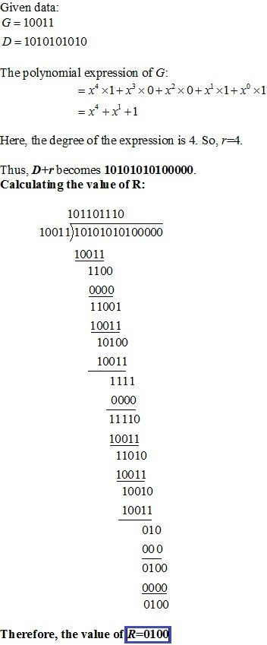

1. Consider the following network Figure 1. With the indicated link costs, use Dijkstra’s shortest-path algorithm to compute the shortest path from u to all network nodes. Show how the algorithm works by computing a table.

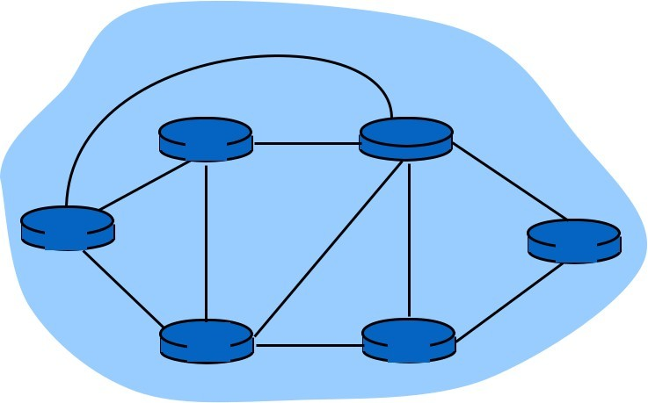

5

2

v

3

w

5

u

1

2

x

3

4

z

3

1

y

***Figure 1***

1. A router has the following CIDR entries in its routing table:

*Address/mask Next hop* 135.46.56.0/22 Interface 0 135.46.60.0/22 Interface



* + - 1. /23 Router 1

default Router 2

* + - * 1. What does the router do if a packet with an IP address 135.46.63.10 arrives?

*Taking the first 22 bits of 135.46.63.10 as network address, we have 135.46.60.0.*

*The bit pattern of 135.46.63.10 is 10000111.00101110.00111111.00001010*

*When we perform the bit and operation with 22 leading bit 1s and 10 bit 0s, it is equivalent of making the last 10 bit zero. We get the following network address bit pattern: 10000111.00101110.00111100.00000000. The first two bytes are not changed. The 3rd type changes from 63 to 60 while the 4th byte become zero.*

*Match with network address in the routing table. The 2rd row matches. The router will forward the packet to Interface 1.*

* + - * 1. What does the router do if a packet with an IP address 135.46.57.14 arrives?

*Taking the first 22 bits of the above IP address as network address, we have 135.45.56.0. It matches the network address of the first row. The packet will be forwarded to Interface 0.*

1. Suppose two hosts, A and B, are separated by 30,000 kilometers and are connected by a direct link of *R* = 3 Mbps. Suppose the propagation speed over

the link is 2.5 x 108 meters/sec.

* 1. Calculate the bandwidth-delay product, *R* _ *d*prop.

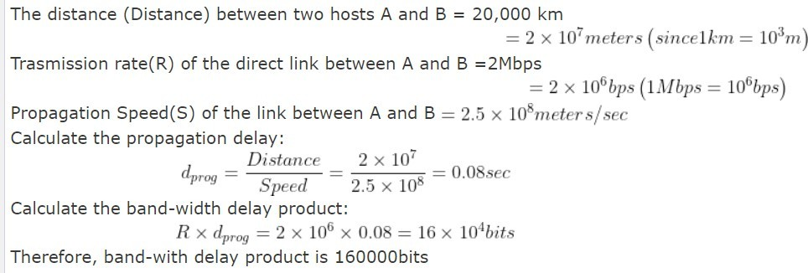

* 1. Consider sending a file of 900,000 bits from Host A to Host B. Suppose the file is sent continuously as one large message. What is the maximum number of bits that will be in the link at any given time?

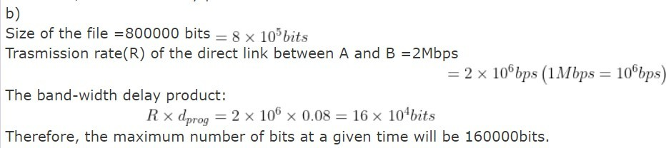

1. 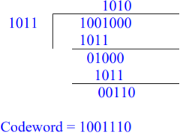Let g(x)=x3+x+1. Consider the information sequence 1011. Find the codeword corresponding to the preceding information sequence. Using polynomial arithmetic we obtain:
2. A packet switch receives a packet and determines the outbound link to which the packet should be forwarded. When the packet arrives, one other packet is halfway done being transmitted on this outbound link and four other packets are waiting to be transmitted. Packets are transmitted in order of arrival.

Suppose all packets are 2,500 bytes and the link rate is 3 Mbps. What is the queuing delay for the packet? More generally, what is the queuing delay when all packets have length *L*, the transmission rate is *R*, *x* bits of the currently-being- transmitted packet have been transmitted, and *n* packets are already in the queue?

1. Suppose a header consists of four 16-bit words: (11111111 11111111, 11111111 00000000, 11110000 11110000, 11000000 11000001). Find the Internet checksum for this code

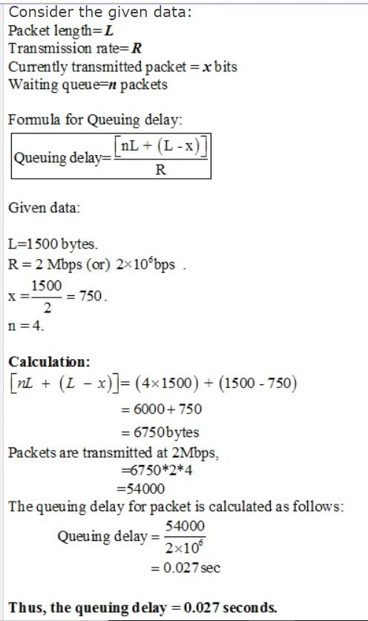

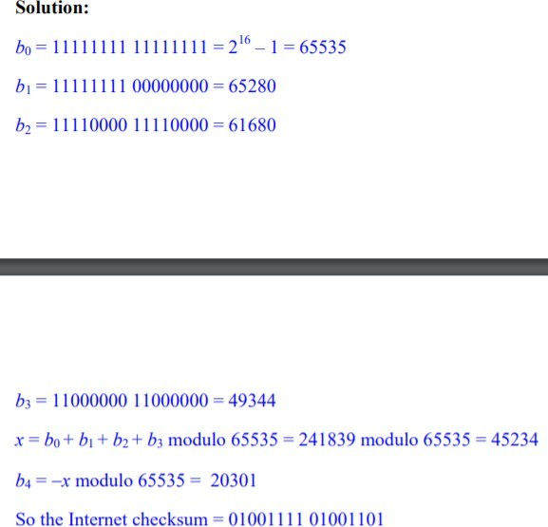

1. Consider a packet of length 2,000 bytes that propagates over a link of distance 3,500 km with propagation speed of 2,5 · 108 m/s, and transmission rate **2**Mbps?
   1. How long does the packet propagation take?
   2. Does this propagation delay depend on the packet length?
   3. Does this propagation delay depend on the transmission rate?

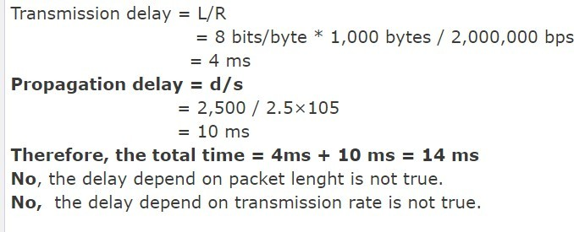



1. Suppose Host A wants to send a large file to Host B. The path from Host A to Host B has three links, of rates R1 = 250 kbps, R2 = 3 Mbps, and R3 = 2 Mbps.
2. Assuming no other traffic in the network, what is the throughput for the file transfer?
3. Suppose the file is 4 million bytes. Dividing the file size by the throughput, roughly how long will it take to transfer the file to Host B?

